CURRICULUM VITAI 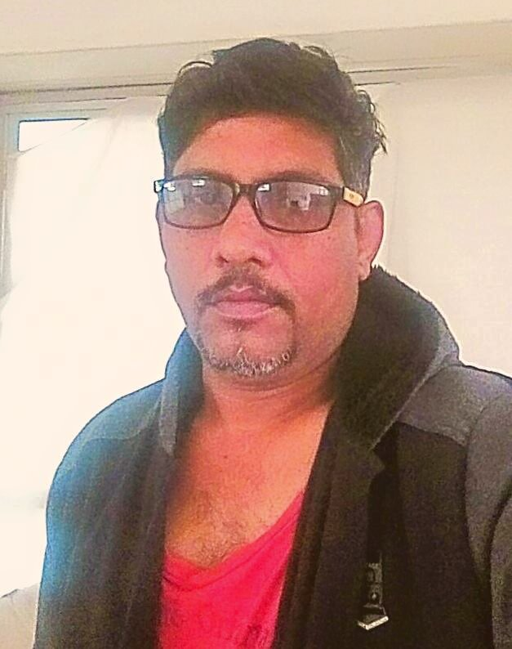

Himalaya Nautiyal

Career summary

I have possess more than 22 years of diversified experience in Hospitality Industry. My career consists, dealing with diverse nature of hospitality process. I have done so many hotel opening and done so many hotels kitchen set- up.

Objective:

To work in professional and challenging environment, which provides opportunities to learn, apply skills, to meet organization requirements and become an indispensable part in organizations growth.

Personal Details

Name : Himalaya Nautiyal

Fathers name : Shri. Rameshwar Nautiyal

Date of Birth : 3rd march 1972

Sex : Male

Nationality : Indian

Marital status : Married

Permanent Address : Vill. & P.O.Ghansali Tehri Garhwal,
Pin. code, 249155 .Uttranchal

Current Address : flat no 204 sindhi colony plot no 12, aurangabad

Languages known : English , hindi

Contact No : 0091-8153882039

E-mail id : himalaya963@gmail.com

Academic Qualification

S.S.C From "U.P board. Gic Ghumetidhar ghansali" with IInd class

H.S.C. From" U.P board. Gic Ghumetidhar ghansali" with IInd class.

Work Experience

Institution : Mumbai Masala
Designation : Exec, CHEF

Job Profile : To take care of the staff allocation to handle the
kitchen for the smooth operation

Responsiblities : MENU planning, Staff Traning. Cost controlling.

Maintain store. take care of purchasing ..
Party book for banquet. Cover charge controll.
take care of man power in the kitchen..
Duration : Joined on 20th March 2015 till date.

Institution : Wonder Land Residency
Designation : Exec, CHEF

Job Profile : To take care of the staff allocation to handle the
kitchen for the smooth operation

Responsiblities : MENU planning, Staff Traning. Cost controlling.

Maintain store. take care of purchasing ..
Party book for banquet. Cover charge controll.
take care of man power in the kitchen..
Duration : Joined on 15th Sep 2014 till March 2015.

Institution : Hotel Bagga International.

Designation : Exec, CHEF

Job Profile : To take care of the staff allocation to handle the
kitchen for the smooth operation

Responsiblities : MENU planning, Staff Traning. Cost controlling.

Maintain store. take care of purchasing ..
Party book for banquet. Cover charge controll.
take care of man power in the kitchen..
Duration : Joined on 15th may 2009 till august 2014.

Institution : SASA food LTD. Delhi

Designation : Exe. Chef

Duration : Worked for 2 yrs

Job profile : Opening chef. Menu planning. man power.
Kitchen set up. cost planning. ETC

Institution :The Grand Bhagwati ( the TGB. hotels and
banquet LTD Ahemdabad

Designation :Master chef

Duration : 2 yrs

Job profile : Opening chef.Menu planning Kitchen set up

Institution : Copper Chimney Rest...

Designation : Coperate chef

Duration : worked for 5 yrs

Job Profile : Handle all the copper chimney branches all
over the India

Institution : Hotel Marques Goa and Pen.

Designation : Corporate chef

Duration : Worked for 5 yrs

Institution : Hotel Shubhangan Khar. mumbai

Duration : Worked for 6 yrs

Designation : Pre- opening Exec. chef

JOB PROFILE : Kitchen Set up . making new menu and receipe.
TRAINING : taking inteview to hire a new staff.

Institution : Wonderland Resorts Silvassa

Designation : Pre-Opening Exec. Chef

Duration : 2 Years

Job Profile : Kitchen Set up . making new menu and recepie.
taking inteview to hire new staff. staff traning
making standard for a new recepie.. teaching staff

1 years experience ANMOL RITURAJ ( Ahmedabad )
2 years experience in URBAN SPIICE GROUP
6 month experience in Hotel SunStar (RATNAGIRI)

Strength :

Adaptive, Willingness to learn, Confident of Shouldering responsibilities Positive attitude, Sincere, Hard working & Ethical.

Interest & Hobbies

Playing cricket and listening Music

Date:

Place: INDIA ( NAME: Chef Himalaya Nautiyal )

