INDRANIL CHAKRABARTY
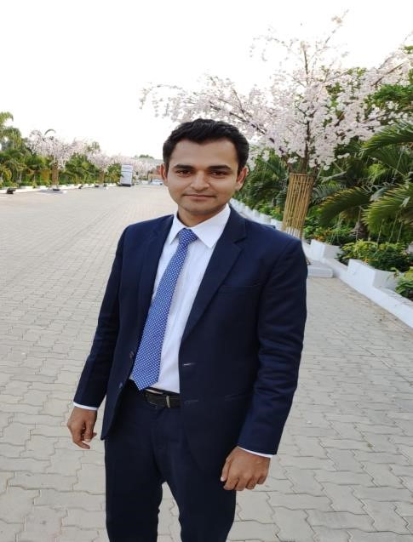

Mailing Address: AN 1 Sec V, Salt Lake, Kolkata 700102
Mobile number: 09739875427
Secondary phone number: 07585988459
E-Mail Address: indranil.chakrabarty17@gmail.com

Objectives:
- I desire to work in a company/organization which aims to achieve their organizational growth as well as my professional growth.
- To reach an apex in the prospective field of hospitality by learning through experience.

Personnel Skills:
- Problem solving abilities.
- Good eye for detail.
- Good verbal and written communication skills.
- Willingness to learn.
- Well focused.
- I am very patient, and I can adjust with people very well.
- I can handle situations without taking any stress.

Computer skills:
- Property management system (PMS)
  - Opera
  - IDS &Fortune, Protel

Professional Qualification:

- Completed B.Sc. in hotel management from INSTITUTE OF ADVANCED MANAGEMENT, Kolkata.

Educational Qualification:

- Passed intermediate from G.P. high school in 2008
Board.
- Passed 10th from K.J.G.G.M. school in 2005

Work Experience:

- Currently working with Grand Mercure, Candolim Goa as an Executive Housekeeper from 20th December 2023 – Present
- Worked with Pema Wellness Resort, Visakhapatnam as an Executive Housekeeper from 7th June 2023- 31st November
- Worked with ITC Welcome Heritage Resort & Spa Coorg as an Executive Housekeeper From 5th October 2020 – 10th May 2023
- Worked with Ramada by Wyndham Yelahanka Bangalore (pre-opening) as Executive
housekeeper from 5th January 2020 - 30th September 2020
- Worked with Apollo specialty hospital, Nashik as Executive housekeeper from 17th August 2018 - 31st March 2019
- Worked with Radisson Blu Atria Bangalore (pre-opening) as Assistant manager
Housekeeping, Since 12th October 2016 - 30th April 2018
- Worked with Swiss organization MOEVENPICK Hotel & Spa Bangalore as housekeeping supervisor Since 18th November 2013 - 07th October 2016
- Worked for Le MERIDIEN Bangalore as housekeeping supervisor since 25th March 2013 - 17th November 2013
- Worked with HYATT REGENCY Chennai since 2nd Jan 2012 - 20th March 2013 as a housekeeping associate.
- Completed 6 months Industrial Training from Swiss SWISSOTEL Kolkata.

Job Responsibilities:
- Cost management
- Training and sustainability
- Knowledge of interior design
- Knowledge of chemicals and cleaning equipment
- Knowledge of horticulture and landscaping
- Property management and guest feedback system
- Equipment knowledge and management
- Safety and hygiene practice
- Taking care of scheduled inventories
- Care and Maintenance of equipment
- Taking care of floors and public areas
- Taking care of all the venders
- Recruiting housekeeping employees
- Standardizing the product
- To ensure defect free clean room on time
- Process setting as per SOP

Languages known:
- English and Hindi

Strength:
- Honesty, ability to accept challenging work and easily incorporate with new team
Hobbies:
- Playing cricket and listening to music
Extracurricular activity:
- Tablas.
Personal Details:
Date of birth- 12.11.1988
Sex- Male
Nationality- Indian
Marital status – Single

I declare all the information given above is true to the best of my knowledge & belief

