CURRICULUM VITAE
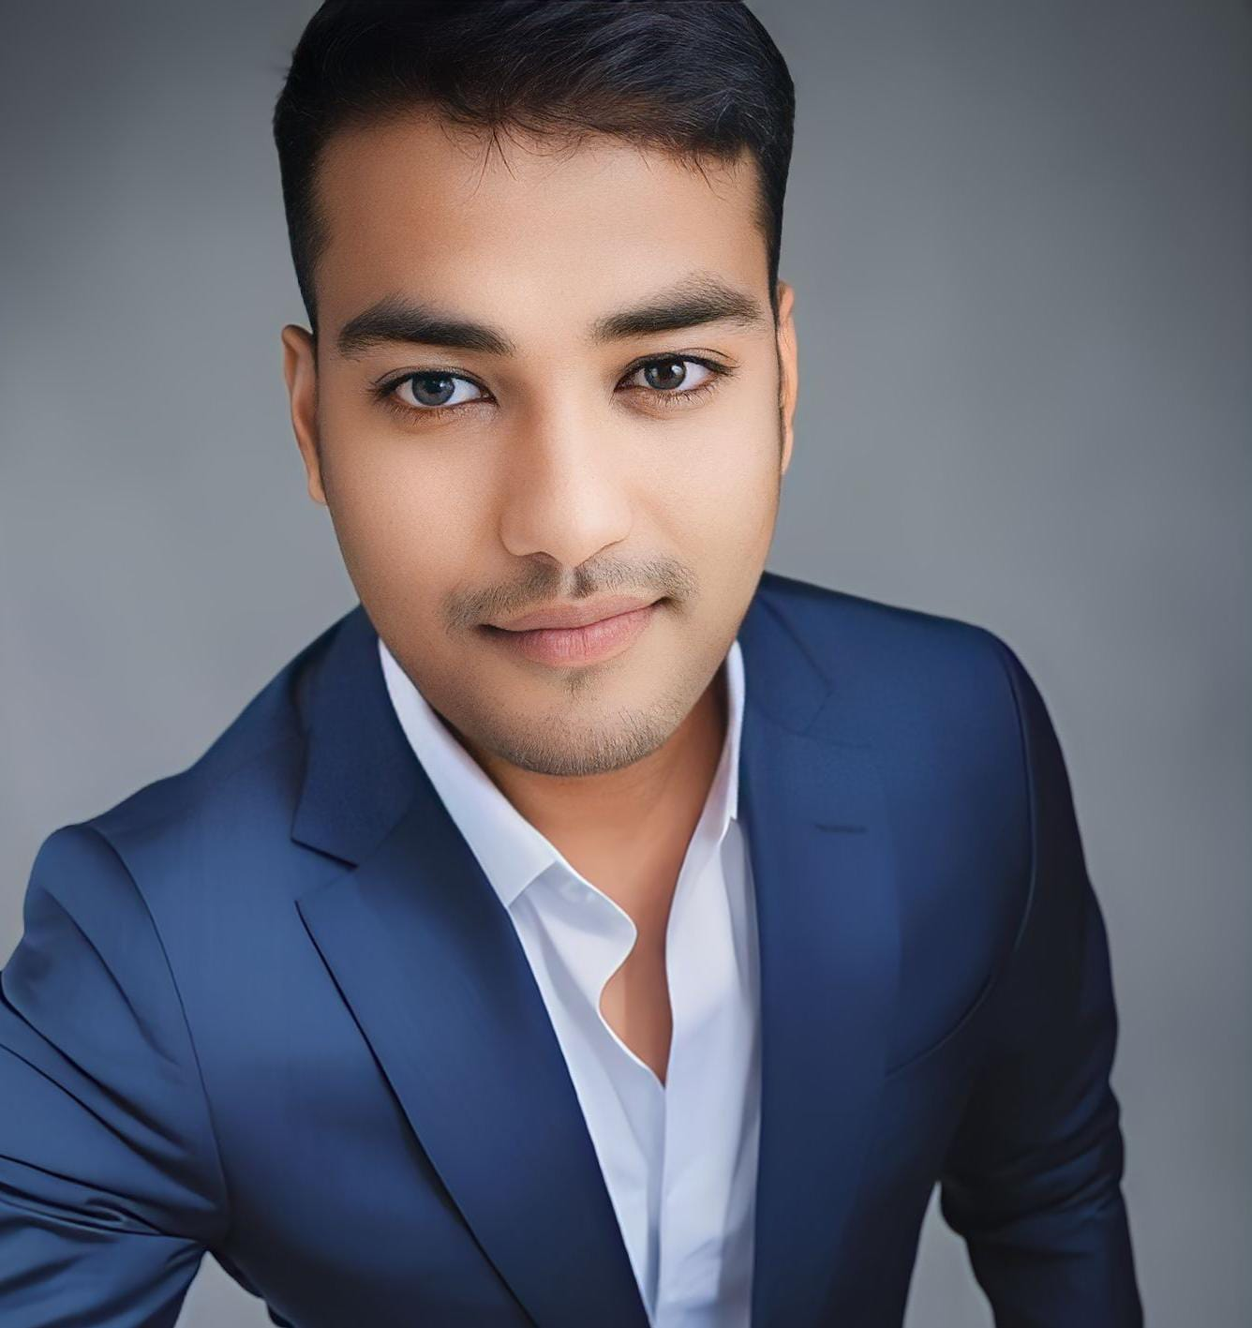

PERSONAL INFORMATION

Joydeep Debnath

Village + PO Deorachhara, PS - Kailashara, Dist - Unakoti, Tripura 799279 India
Contact: +91 6354612531, Email: debnathj366@gmail.com

Food and beverage service Professional
Offering a sterling experience of over 6.3 years across the industry
- EDUCATIONAL CREDENTIALS
Higher Secondary from Kailashara, Unakoti.
HSLC from Tripura School Examination Board, Kailashara.

LANGUAGES KNOWN

- English/Hindi/Bangali (Read, Write, Speak)
- Gujarati (Understand)

PROFESSIONAL EXPERIENCE

TOTAL EXPERIENCE - 6.3 Years.
CURRENT EXPERIENCE

16th December 2022 to till date, F&B Captain- Hospitality , Adani Power Mundra Limited, Mundra, Kutch - payroll in M/S Sodexo India Pvt ltd.

JOB PROFILE:

- Preparing various reports like VIP visit MIS, maintenance report, weekly reports, monthly management reports, etc.

SAP:- Create Materials Purchase Requisition/ Create Emergency Purchase Requisition/Create Service Purchase Requisition/ Service Entry Sheet Processing/ Create Sales service Order/ Create returnable and Non-returnable Gate pass/ Create Materials Issue Reservation and printing reservation slip/Create SES Checklist with print/ Check day to day department Budget/ Clear Quality inspection of GRN

- Facility Management :
- Handling complete facilities & infrastructure set up (Centralize Guest house total 96 rooms at Four different Guest Houses), and liaising with contractors & interiors for the same.
- Handling all kind of VVIP visit like Investor, Bankers ,Ministers, various ambassador from various country, MP’s MLA’s, IAS & IPS officers etc.

PREVIOUS EXPERIENCE

M/S. ISS facility management services  Senior Butler, Mundra, Gujarat | 2019 to 2022
Agartala Ginger Hotel  Senior Steward, Agartala, Tripura | 2017 to 2019

REFERENCES:

- Mr. Praful Pradhan (operations manager - ISS facility management services),
Mundra, Gujarat
Ph-07208945770.
(2) Mr. Tapan Dawoka, (operations manager For Hotel - Agartala Ginger Hotel),
Agartala, Tripura,
Ph-09725840215.

OTHER DETAILS:

Date of Birth : July 29th, 1995
Marital Status : Married

CURRENT CTC:

Salary : 2.28 Lakhs + Free Company Furnish Accommodation + Food + Laundry + Transportation + Electricity

DECLARATION:

I declare that the above mentioned information is true and correct to the best of my knowledge and belief.

Date: 27/10/2023 Signature

Place: Mundra (Joydeep Debnath)

