Resume for the post of-

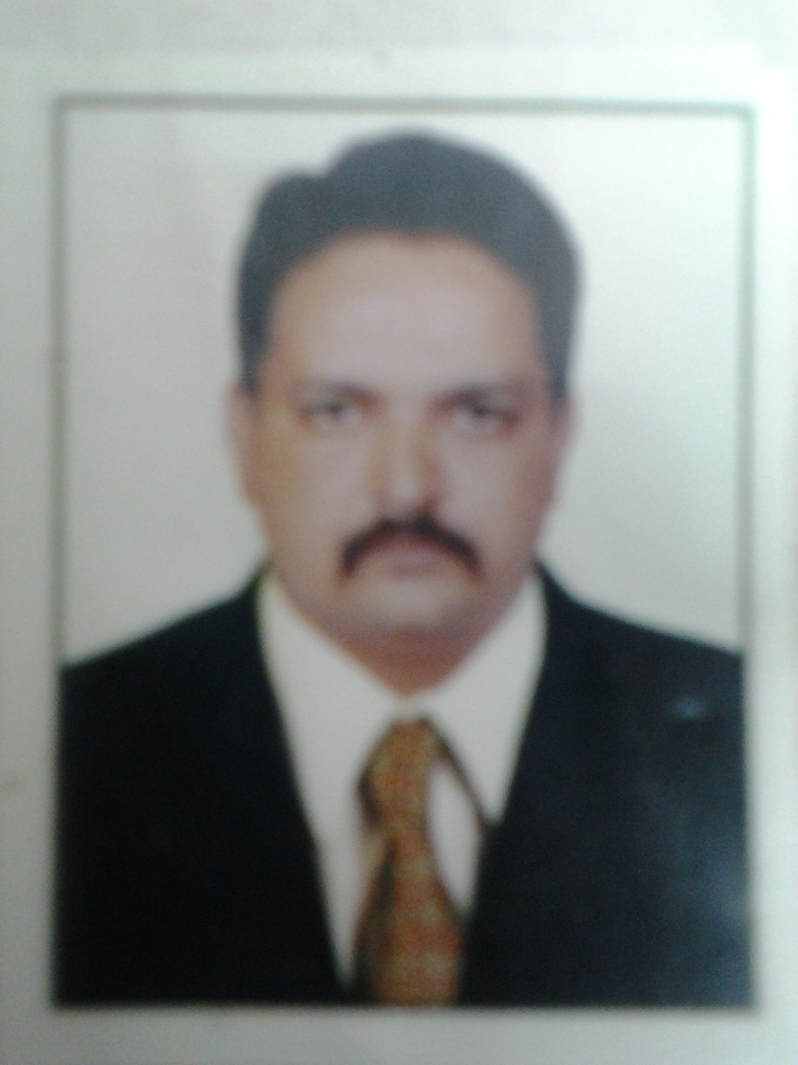

KIRAN VIJAY PATIL.
7th matruchhaya Chawl
Behind Nitin Raj Bar,
Laxmibaug, Katemanivali,
Kalyan (East)  421306
Maharashtra.
Cell:7021909141, 8552858855
Email Address:kiran_patilme@rediffmail.com / 75kiranpatil@gmail.com

Certification:
- Certificate of Completion of  FSSC 22000 Version 5.1 with HACCP & ISO 22000 : 2018.
Date of Issue : 16th July 2022
Certificate Number : HIF / 22 / 131

- Certificate of competence  FOOD SAFETY SUPERVISOR Conducted by FOSTAC Parikshan.
Roll No : ACACOVID200001645523
Batch code : ACACOVID200/01794
Certificate Number : ACACOVID2001645523
Date of issue : 19-10-2022

Personal Objective:

- To serve reputed organizations with my utmost abilities so as to enhance my aptitude to be a
Good service provider.
- To gain exposure towards the field andPerfection in the work that will be allotted to me
In the future.

Principal Duties andResponsibilities:

- Directly supervises the Dish wash, Pot wash and Glass wash.
- Instructs and trains the staff to the required work standards and hotel requirements.
- In compliance with guidelines, and record the daily temperature of dish, glass and pot wash machines and take immediate action where required.
- Report any problem with equipment to the Chef and Eng. Dept.in a timely manner and follows up on all corrective actions.
- Ensure that all standards with regards to cleanliness practices in all areas and related areas are met. Including ice machines and hand washing facilities.
- Responsible for day and night cleaning and sanitizing of all related areas.
- Set up cleaning schedules and proceduresfor routine daily cleaning of all areas Set up schedules for night cleaning and supervise the quality of performances of the night cleaning personnel. Schedule periodic in-depth cleaning.
- Control and ensure that the transportation and sorting of garbage from all areas is conducted according to company policies/ standards.
- Monitor the provision of equipment and supplies to all areas.
- Conduct daily Inspection in the areas and report findings to the Exe. Chef and FNB Office.
- Responsible for the organization of duty rosters.
- Responsible for the instruction of new joining steward about Emergency Stations Responsibilities.
- Responsible for the overall control of chemicals including proper storage and use. This includes the preparation of requisitions for approval.
- Responsible to ensure that all food and beverage outlets are adequately stocked with clean crockery, cutlery and glassware for all service periods.
- Responsible for the control of breakage by enforcing polices upon dishwashers,
- Must be present during all meal periods to assist with the smooth operation of the service of food and beverage.
- Perform all other duties as related to the overall cleanliness of the related areas as assigned.
- Responsible for the different kinds of banquet setups.
- Responsible for the all kinds of C.C.G & Kitchen Utensil Inventories.
- Helping in different Outlets at busy times. Training the Casual stewards.

Management Skills :
- Budgeting and P&L Management knowledge of business needs financial reporting and productivity Requirements.
- Develops with the Human Resources department training plans, develops training material and Implements training plans for the Kitchen stewarding employees
- Establishes implements and controls performance standards for the Stewarding Operation in the Kitchen, Restaurant and bar so as to achieve the highest possible hygiene standards, minimize Operating Equipment Breakage and streamlined and efficient resources and equipment flows.
- Establishes and implements performance standards for the Kitchen stewarding and coordinate purchasing to establish and maintain a streamlined and efficient operation.
Employment History:
- Presently working with The Orchid Hotel, Mumbai, As KST Manager from 1St Nov 2022.
- Della Adventure & Resorts Lonavala. As Stewarding Manager (July 2021 to Oct 2022)
- Soho house & Co. Mumbai As Stewarding Manager ( Nov. 2018 to OCT 2020). Pre- Opening Team.
- Le -Meridien, Calangute, Goa - Manager Kitchen Stewarding (June 2017 to Feb 2018).
As Pre-Opening Team.
- Radisson Blu, Indore Manager Kitchen Stewarding (Sept. 2016 to April 2017)
- Club Mahindra, LonavlaSr. Executive KST (Oct 2013 to Sept 2016).
- Club Mahindra, Varca, Goa --Sr. Executive KST (Feb 2013& Transfer to Lonavla)
- Courtyard Marriott, Pune Hinjewadi  KST Executive (may2012 to Jan2013).
- ITC Grand Central, Parel. - F N B Support Coordinator(July 2011-may2012).
- Thunderbird resort, Daman) (Indias first Casino Resort) - Sr. Stewarding Supervisor(Oct 2010 to June 2011) Pre Opening Team.
- Grand Mercure, Bangalore(Accor Group) -Sr. Stewarding Supervisor From (Jan 2009 to Sept.2010)Pre-Opening Team.
- Radisson Resort & Spa Alibaug, As Stewarding Supervisor (June2007 to Jan 2009) Pre Opening Team.
- Select Services Branch of Techno Clean India at Sahara Aamby Valley As Sr. Stewarding Supervisor, (Jan2006 to June 2007.)
- Mayfair Rooms & Outdoors at Corinthian Club, Pune, As Stewarding Supervisor (July 2005 to Dec.2006).
- Hotel Oberoi, Mumbai as Casual Trainee Supervisor (May 2004 to July 2005.)
- BindraCaterers At Infosys-Sr.stewarding Supervisor,(May 2003 to may 2004)
- Shiva Krupa Enterprises, Pune.-Canteen Supervisor (March 2002 to May 2003.
- Cleantec Hospitality Ser. Ltd.- Guest House Supervisor (June 2001 to Feb 2002)
- Radha Krishna Hospitality Ser. Ltd.- Steward Cum Caretaker (Oct.1997 to June 2001)

Personal Details:

Name : Kiran Vijay Patil.
Permanent Address : Same as Above.
Date of Birth : 14th may 1975.
Marital Status : Married.
Gender : Male.
Languages Known : Hindi, Marathi, and English.

Passport Details:
N0169655
Date of Issue: 02/06/2015,
Date of Expiry: 01/06/2025.
Educational Qualification :

Course | University / Institute | Passing Year | Marks in %
Diploma in Hotel Management | Institute of Technology Management Studies | 2014 | 67 %
T. Y. B. Com | Institute of Technology Management Studies | 2013 | 63 %
S. Y. B. Com | Institute of Technology Management Studies | 2012 | 60 %
F. Y. B. Com | Institute of Technology Management Studies | 2011 | 57 %
H.S.C. (Com.) | Mumbai University | 1993 | 45 %
S.S.C. | Mumbai University | 1990 | 67%
Additional Skills:
- Attended training of Yes I Can & Fire Fighting at hotel Radisson Resort & Spa, Alibaug.

Signature:

( KIRAN V. PATIL.)Date:

