CURRICULUM VITAE
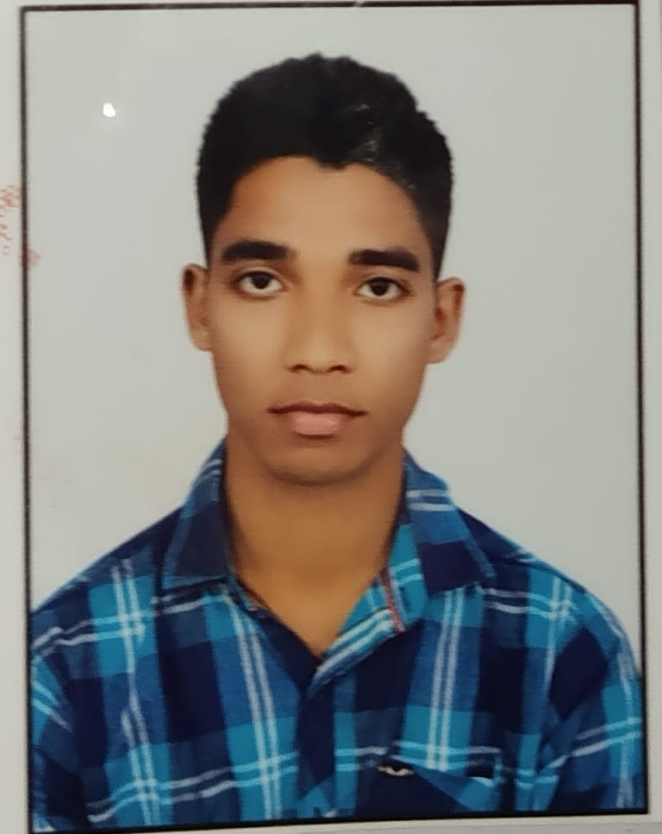

Passport size colour Photograph

KIRTIRANJAN SAMAL
C/O-Nabakishore Samal
At- Kanaka House, Near Sidheswar High School
Po- Naraj, Via Mundali
Dist-Cuttack
Pin-754006
State-ODISHA
Email ID- kirtiranjansamal85@gmail.com
Ph no- (+91)6370878092

CAREER OBJECTIVE

A respectable position which can give me an interesting, innovative and Challenging working environment with targets and responsibilities that will utilize my education, professional skills and offer scope for learning advancement opportunity and continuous professional development through teamwork and self-expression.

SKILLS

● Ability to take new initiatives and challenges
● Industrious
● Punctual
● Good communication skills

EDUCATIONAL QUALIFICATION

● Master in Hotel Management from Xavier College of Hotel Management, Cuttack Pursuing.

● Graduation under Utkal University form Raghunath Jew Degree Colllege, Deulasahi with First Division in the year 2023.

● 12th under CHSE, Odisha from Raghunath Jew Higher Secondary School, Deulasahi with Second Division in the year 2020.

● 10th under BSE, Odisha from Orissa Police High School, Tulasipur with Second Division in the year 2018.

HOBBIES

Watching Movies.
Listening Music.

EXPERIENCE

- Completed Industrial Training from The Hilton Goa Resort, Goa about Front Office, Housekeeping and F & B Service Department in 06 May 2024 to 11August 2024.

COMPUTER SKILLS

PGDCA from Star Software Education, Kanika Chhak with 77% in the year 2019.

PERSONAL PROFILE

Father Name : Nabakishore Samal
Date of Birth : 07 March 2002
Gender : Male
Marital status : Unmarried
Nationality : Indian
Religion : Hindu
Language : Oriya, Hindi and English
Permanent address : Kirtiranjan Samal
C/o-Nabakishore Samal
At- Kanaka House, Near Sidheswar High School
Po- Naraj, Via Mundali
Dist-Cuttack
Pin-754006
State-Odisha

DECLARATION

I do hereby declare that all the above information is true to the best of my knowledge and belief.

Date: Kirtiranjan Samal
Place: Naraj (Signature)

