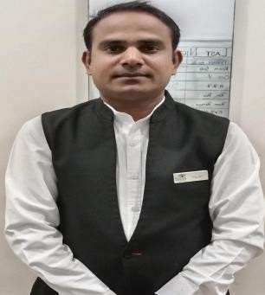

Name: - Tilak Lilhare
Email Id: - tilaklilhare@gmail.com Contact: -7693938335

OBJECTIVE
To be a part of an organization that offers challenging and motivating work environment and growth while adding value to the organization and at the same time improving my qualities as an individual.

Educations Qualifications: -
- SSC Passed from MP Board,
- Intermediate passed from MP Board.
- IDS FORTUNE NEXT-V6.5006.20 & V7.0.008.85

Work Experience: -
Currently working in Singhania Sarovar Portico Raipur as Security Executive (HOD) 25th Jan 2024 to till Date.
Worked with Maira Resort & convention Center Raipur as Sr. Loss Prevention Executive 28th Sep. 2023 to 15 Jan 2024. As Pre-opening
Worked with Sayaji Hotel Raipur as Sr. Guest Service Associate 09th April 2017 to 22th Sep. 2023. As Pre-opening
Worked with Courtyard Marriott Raipur as Loss & Prevention Sr. Associate 04th January 2016 to 06th April 2017. As Pre-opening

Worked with Courtyard Marriott Bilaspur as Loss & Prevention Associate 02th September 2014 to 07th November 2015. As Pre-opening

Worked with Courtyard Marriott Bilaspur as Security Supervisor under Contract G4S security Service.12th April 2012 to 04th July 2014. As Pre-opening.

Computer Proficiency: -
- MS-Office
- Property Management System Opera & IDS

Pleasant personality: -
  - IDS & Opera System
  - Positive attitude
  - Honest and hardworking
  - Co-operative can work well in a team
  - Willingness to learn, open to new innovations and ideas
  - Guest relations

HOBBIES:

  - Plying Cricket
  - Singing.

Personal Details: -

- Father name: - Mr. Joshiram Lilhare
- Date of birth: - 07th June 1990
- Marriage status: - Married
- Language proficiency: - Hindi English & Marathi
- Permeant Address: - Village. Sawargaon. Post. Miragpur district Balaghat Pin code 481449

DECLARATION:-
I hereby declare that the Information given is correct to best of my knowledge and Belief and that I have not withheld any information, which might affect my suitability for Employment.

Place: - Raipur (C.G) Tilak Chand Lilhare

