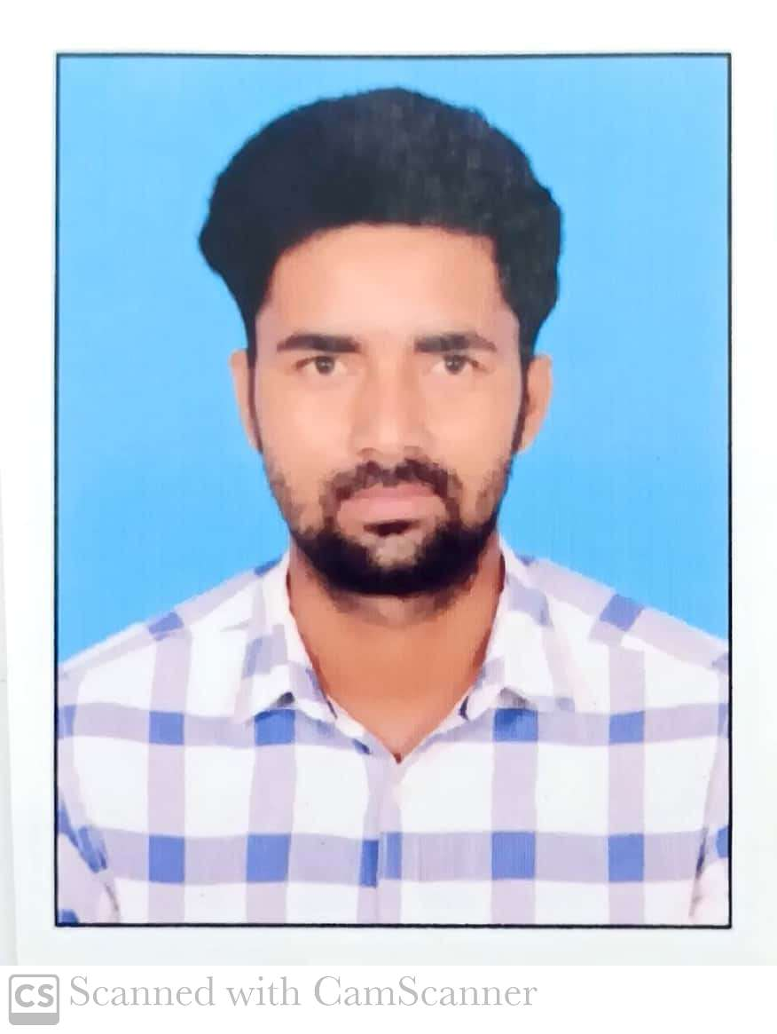

CURRICULUM VITAE

MUKESH RAY
Mobile: +91-8759020887
E-mail: mukeshray449gmail.com
Passport No: R8961830.

Objective

To work in respectable organization as in my chosen field of Mechanical engineering with good career prospect.

Highlight

- A person who is eager, enthusiastic, optimistic and determined.
- Able to examine a complicated problem in all its aspects in a cool, detached and systematic manner and pin out the critical areas.
- Confident and ready to shoulder new responsibility.

Profile

A Mechanical Engineer having approx. 6+ years of experience in the Projects field of City Gas Distribution & Refinery and Petrochemical plants Piping Projects, Vessel Fabrication Erection, Various Type Projects Supervision & Quality control assurance and Inspection in Field of Oil & Gas sector.

Professional Experience

Currently Working As Executive Engineer with Torrent Gas Pvt Limited .At CGD Projects Moradabad Uttar Pradesh.Project Management, Project planning, Project execution, Operation and Maintenance, survey estimation, Site Engineering, , project Engineering, Project expansion.

Client : Reliance Industries Ltd
Project : J3 project (Refinery And Petrochemical Complex)
Designation : Execution Engineer
Duration : 11 June 2016 to 15 Nov 2017
Location: : Jamnagar, Gujarat.
Department : Project Fabrications & erection Commissioned.
Company Profile: - M/s Tarachand Engineering Pvt. Ltd. is a Mechanical Construction Company which working as Underground Gas Pipe line & fabrication, erection contractor in the field of refinery construction, Rake, Rake Piping, Power plant construction, and construction of Underground storage tanks.

Client : Essar Heavy Engineering Services
Project : Dangote Refinery Vassel Fabrication Projects
Designation : Execution Engineer
Duration : 17 November to 15 June 2018
Location: : Jamnagar, Gujarat.
Department : Project (Fabrication and Erection)
Company Profile: - M/s Tarachand Engineering Pvt. Ltd. is a Mechanical Construction Company which working as Pipeing fabrication, contractor in the field of refinery construction, Rake, Rake Piping, Power plant construction, and construction of Underground storage tanks.

Client : Indraprastha Gas Limited (Delhi)
Project : Steel Pipeline Project Delhi
Designation : Inspection Engineer
Duration : 25 June 2018 to 31 August 2019
Location : West , Delhi
Department : Project
Company Profile : Bonace Engineers Pvt Ltd. are committed To achieving excellence in the field of Manpower Recruitment Consultancy & CGD Project related activities, meeting requirements of our customers in all types of industries across the globe, by enhancing our service performance through Compliance of Quality Management System Requirement and its continual improvement.

Client : Indraprastha Gas Limited (Delhi)
Project : City Gas Distribution Project Delhi
Designation : Inspection Engineer
Duration :01 September 2019 to 28 eb
Location : West , Delhi
Department : CNG Projects
Company Profile : DR. Amin Controller Pvt Ltd. has specialized in Agro Inspections, Consumer Products, Marine & Insurance Surveys, & Collateral & Stock Management, Engineering Inspections & Laboratory Testing assignments for a wide variety of clients, including multinational corporations, mid-cap companies, aid institutions, agro foundations, trade associations and governmental units.

Client. : AG&P CGD India Private Limited)
Project : L-CNG STATION & CNG PROJECTS.
Designation. : Sr. Inspection Engineer
Duration :16 July 2020 21 October
Location : West , Delhi
Department : Project
Company Profile : GULF LOYED INDUSTRY SERVICE PVT LTD (GLIS) is ISO 9001 & OSHAS 18001 Certified Established in 1967 as an Independent Inspection body with its main objective to safeguard life, Property and Environment through Quality Assurance and total Quality Management.
GLIS has been providing their value-added Third-Party Inspection Services to the Government, Public and Private Sector. Organizations involved in Onshore, Offshore.

Client : Indraprastha Gas Limited (Delhi)
Project : City Gas Distribution Project Delhi
Designation : Sr. Site Engineer
Duration : 1 September 2021to 12 January 2022
Location : West , Delhi
Department : Projects
Company Profile : VCS Quality Services Pvt limited. VCS is Indias leading provider of Engineering and Project Management Consultancy services (EPMC), construction supervision, compliance assessment, Testing, and Third-Party Inspection in cross-country pipelines and City Gas distribution networks, VCS also undertakes specialist investigative studies and provides technical advisory related to integrity and asset life-cycle managements provides these services across Hydrocarbon (Onshore and Offshore), Power, Infrastructure, Marine, alternate
energy, and general engineering industries.

Project : City Gas Distribution Projects.(Utter Pradesh)
Designation : Executive Engineer
Duration : 20 January 2022 till date
Location. : Moradabad Uttar Pradesh.
Department. : Projects & O&M
Company. : Torrent Gas Pvt Limited.Torrent Group has recently forayed into City Gas Distribution business to meet another critical need – Green Fuel – in different parts of India. Torrent Gas has its presence in 17 Geographical areas spread across 34 districts covering 7 States and 1 UT in India.
We as an organisation adopt best industrial practices, standards and compliance to regulatory requirements to ensure safe supply of Natural Gas to our customers.
Various safety features have been incorporated in our steel and MDPE network to take care of any undue situation.Our entire network and operational assets have been laid and commissioned by qualified agencies / engineers with highest safety standards.

JOB PROFILE:

- Project Engineering Management.
- Day-to-day planning and execution of the projects to meet annual business plans.
- lead the team from front and have good communication skills.
- for project at each contractor, its verification and also for all instruments used in project execution activities, their calibration certificates, etc .
- Planned and executed the laying and Commissioning of MDPE pipeline (Dia 20mm,32mm, 63mm, 90mm, 125mm) 350 km Approx in Moradabad And New Delhi
- Negotiate with external vendors on contract agreements.
- Obtain the appropriate permits and licenses from authorities for construction sites.
- Planning and ensuring timely resources for arrengement Static & Rotary equipmen and Installation and commissioned handover on Time.
- Preparation of necessary documents for third party Inspection .
- Planing as per budget and estimate costs and creating of PO in SAP.
- day to day planning and monitor daily progress report and Circulate Mis data Ho.
- review, and preparation documents for ISO Audits
- Pressure vassel and Columns fabrication installation and commissioning of Reliance industries Jamnagar
- Vassel fabrication of Essar heavy engineering Services Surat
- Many Deference types Pump installation Commissioned for fire fighting and Liquid and gas transfer.
- Interface management for all engineering disciplines with the customer, contractor and vendors.
- Coordination of contractors for all engineering activities
- Achieve completion of task in digital format and get automation of field force
- Final Commissioning of Piped Natural Gas in Domestic & Industrial and Commercial Customers.
- Achieve a Target domestic customer in a financial year
- Processing of Contractor bill after completion of set of task assigned to them
Coordination of engineering team and management of engineering progress
- Prepare Daily progress report for various tasks and also monitor contractor work.
- Prepare System for analyse gas loss and taken initiative to minimize Gas loss
- Planning and ensuring the documentation as per ISO Guidelines
- Preparing all Reports related to Commissioning of Piped Natural Gas.
- Time-to-Time Training to team member for smoothly co-ordination
- To prepare daily progress report for various task to be done within my area.
- Project Engineering Report Management.
- Day-to-day planning and execution of the projects to meet annual business plans.
- Manage the budget and estimate costs.
- Determine the necessary equipment, materials, and manpower needed.
- Keep track of inventory, tools and equipment.
- Ensure compliance with safety regulations and building codes.
- Train and mentor Site Engineer and Project Team depending on the size of the project.
- Collaborate with subcontractors, Client Engineersand key team members of the project team.
- Fabrication inquipment Spool fit up, Alignment, Dimension, flange Orientation of the joints as per ISO Drawings. of pipe according to plan drawing and P & ID.
- Isometric drawings and guiding the team to execute the work.and fit up and welding , arranging recourses. and issue of require material as per the drawing.
- Fabrication of piping spool vassel and colums according to isometric drawing.
- fabrication, erection of pipeline and supports and its modification at site. Inspection of material before fabrication. & Erection.
- Welding Work Inspection As per API1104.
- WPS WQR WQT, WPQR, Preparation Work.
- Welder Qualification and verification of WPS as per ASME Sec IX.
- Specification for welding Electrodes and Filler Materials (ASME Sec. II C).
- Welding application with various processes i.e., SMAW, GTAW, SAW, FCAW.
- Supervision of Activities VT, DPT, MPT/MPI, RT Film interpretation.
- Flowing the ASME Required Standard like ASME B31.3 ASME B31.8 API 1104, ASME Sec II, V, VIII, IX, ASTM
- Ensure supplies and equipment are ordered and delivered according to schedule.
- Resolve Site problems tryin Smoothly Projects Completed at Given Time.

Key Learning :

L-CNG Mother Station Project, & CNG Daughter Booster Station - Inspection, quality procedures and various Site management functions.

- L-CNG Upper ground Station Piping Instruments Installation Piping & Vessel fabrication & Erection According To P&ID.
- Equipments installation according to P&I diagrams.
- 1 LCNG Station 8 CNG Stations installation And Commisoned
- Station piping isometrics, pipe support Fabrications & Erection Isometric drawing.
- CNG Mother Stations CNG Buster Compressor Commissioning Executions.
- PRS & MRS DRS Foundation, Installation & Commissioning Executions.
- Gas Trench, Dispenser Foundations, & LCV Filling Post Compressor Foundation, Work Inspection & Supervision Cascade Foundation.
- Specifications and piping plan drawing based on pre-Designed piping line classes.
- Modification in drawing according to site condition.
- Pre-construction survey and modification.
- Hydrocarbon Pipeline & Vessel Installation According to P&ID.
- Weld visual of 100% joints and randomly visual checking with client and clearance of joints, documents maintaining of all joints and take clearance from client, and release joints for RT.
- Maintaining the Welding quality using NDT techniques like RT, UT, PT & MPT.
- Cascade Cylinders shall be as per design/drawings approved by Petroleum and Explosive Safety Organization (PESO), Govt of India.
- Station Upper ground Piping Systems & SS Tubing Installation Hydrotest testing Gas N2: Flashing & Commissioning Work.
- BUSTER Compressor Installation & Commissioning Work.
- Material used for tubing shall be SS 316 high quality annealed seamless confirming to ASTM A269. Tubing shall be SANDVIK / PARKER make ferrule Fittings verify heat No. with Pipe TC.
- Prepration Document for Internal And ISO Audits
- Final clearance and documents review with Government opproval Ajency.

Educational Qualification:

- B. Tech in Mechanical Engineer with 70.00% from KANAD INSTITUTE OF ENGINEERING & MANAGEMENT DURGAPUR (WEST BENGAL)
- H.S.C. with 58% from RAMJAYPAL COLLEGE CHAPRA, Affiliated to B.S.E.B. (BIHAR) in 2012.
- S.S.E with 62.6 from MDH/S KANHAULI BANIYA SARAN. Affiliated to B.S.B.E (BIHAR)

Certifications:

- ASNT LEVEL-II Certification in

- RT-Radiographic Testing
- UT-Ultrasonic Testing
- DPT- Dye Penetrant Test
- MT-Magnetic Particle Test

Computer Proficiency

- Good working knowledge of SAP, CRM,Auto CAD, PMS DESIGN ,Ms Projects,Microsoft Office( Word, Advance excel and Power point).

Personal Detail

Fathers Name : Dineshwar Ray
Address : Tawakal Tola
Paigambar pur,
Saran-841403
Birth Date : 10 oct 1995
Marital Status : Single.
Sex : Male.
Languages Known : English & Hindi

Declaration

I am confident on my ability to work in a team & I hereby declare that the information furnished above is true to the best of my knowledge.

Date: - Mukesh Ray
Place: -

