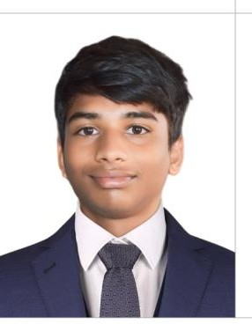
RESUME

KONAKALASATYASAISRINIKHIL
Mobile:9121279443
Email:nikhilkonakalla@gmail.com

CAREEROBJECTIVE:
To be proactive and efficient member in a reputed organization, which will help me to explore myself, realize my potential and utilize my skills in a challenging and creative environment.

EDUCATIONALQUALIFICATION:

2023-2024: Pursuing Diplomas in Food Production Chennai’s Amirta vijawada on Board of JNTE.

2022-2023: completed SSC from P.L.S .Z. P High school Akividu on Board of Secondary Education Andhra Pradesh

STRUCTURE THE INTERNSHIP ENTRY:
Food Production intern
Lemon Tree premium hotel–Vijaywada, Andhra Pradesh
Date of Internship – April 2024 – Aug 2024
Trained North Indian Department

EXPERIENCE:

I had a 3 months experience as North Indian at Varun Novtel Vijayawada Andhra Pradesh
date of on job training from October 2024 to December 2024

ACHIVEMENTS:

Highly participated in food competition at college.

STRENGTH:

- Ability to work in Team as well as independently.
- Hardworking and able to pursue work with responsibility.
- Soft-Spoken,Co-operative,and Friendly in nature.
- Quick Learner

PERSONALPROFILE:

Father’s Name : K. Narayana Rao

Date of Birth : 17/04/2006

Nationality : Indian

Gender : Male

Languages known : Telugu, English

Marital Status : Single

Hobbies : Cooking

DECLARATION:

I hereby declare that the information furnished above is true to the best of my knowledge.

Place: Akividu Yours Sincerely,
Date: K. Nikhil

