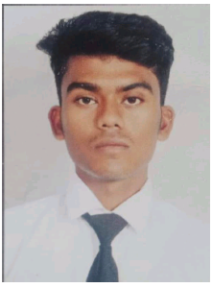 | - RAHUL CHAKRABORTY  EDUCATIONS –  Madhyamik ( X EXAMINATION) PASSED FROM WBBSE BOARD IN 2019  HIGHER SECONDARY (XII EXAMINATION)PASSED FROM WBCHSE BOARD IN 2021  PROFESSIONAL SKILL- DIPLOMA IN HOTEL MANAGEMENT  COMPUTER SKILL- DIPLOMA IN COMPUTER APPLICATION
CONTACT  Vill Birrah  Po Ramharipur  Ps Beliatore  Dist- Bankura  Pin-722203  Mobile no- 7001017025  Email Rahulchakraborty2001@gmail.com  PERSONAL DETAILS  FATHER’S NAME-  LATE RUPAK CHAKRABORTY  MOTHER’S NAME-  SULEKHA CHAKRABORTY  DATE OF BIRTH-  16/11/2001  Gender- MALE  NATIONALITY-  INDIAN  RELIGION- HINDUISM  MARITAL STATUS- SINGLE  COMMUNICAION  BENGALI  HINDI  ENGLISH | Experience  I HAVE COMPLETED INDUSTRIAL TRAINING FROM SILVER CLOUD HOTEL IN AHMEDABAD.  I HAVE COMPLETED JOB TRAINING FROM SILVER CLOUD HOTEL AHEMDABAD.  I HAVE ONE YEAR OF EXPERIENCE IN UDAY PALACE NAVSARI (RADISSON INDIVIDUAL)  HOBBIES  PLAYING FOOT BALL AND CRICKET.  STRENGTH- HARD WORKING AND ABILITY TO WORK UNDER PRESSURE HIGHLY MOTIVATED AND AMBITIOUS.  BELIEVE IN ETHICS AND RESPECT FOR EVERY INDIVIDUALS OPENIONS.  MENTAL STRENGTH,FAITH IN SELF AND BELIEVE IN MORALITY. ABLE TO LEAD THEM.  SIGNATURE

