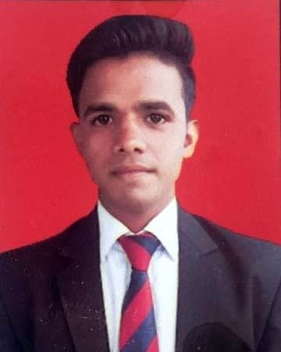
Rahul Sengar rahulthakurhrs@gmail.com Phone .9837529588
OBJECTIVE:-
A Carrier in the Hospitality Industry with special interest in Hk Department. I would like to enhance my professional skills with new concepts in order to achieve successful carrier in respective Department. Positive and Self-motivated person seeking challenging and new concepts which helps me in my professional growth.
EDUCATIONAL CONTRUST:-
YEAR OF PASSING | QUALIFICATION | EDUCATIONAL INSTITUTION
2019 | Diploma in hotel management | Amrapali Insititute of Hotel Management Haldwani , Uttrakhand  Affiliated to kumaon University.
2014 | Up Board | Shri M S Inter College Thulai Hathras
2012 | Up Board | Shri M S Inter College Thulai Hathras

WORK EXPERIENCE:-
- Currently working in Country Inn suites ( Radisson Ghaziabad ) from jul'23 to till now as a Floor Supervisor.
- Worked in The Westin Hotel (Marriott) Gurugram from Mar'22 to Jun'23.
- One Year Experience Hyatt Regency Hotel Gurugram.

DUTIES AND RESPONSIBILITY:-

- To conduct daily briefing for the team.
- Handle the operation of the shift.
- Knowledge of opera software.
- Clean and maintain guest rooms and cooridoor including stairways and lounge area,for cleanliness.
- To ensure that all housekeeping standard,policy and guidelines are followed.
- Coordinate with the frontoffice on releasing of the rooms and VIP guest request.
- Coordinate with the engineering regarding the area of repaire and maintainance.
- Coordinate supply needs with laundry team.
- Maintain hygienic standard by using by proper cleaning products.
- Trained staff on safe operation of cleaning equipment,tools,devices,and chemicals and cleaning agents to efficiently to perform duties and reduce harm to floors,fixtures, staff and environment.
- Distributed supplies and and goods to staff at begning of shift to manage inventory and maintain proper supplies while controlling .
PROFESSIONAL TRAINING:-

- On job training at PARK HYATT HYEDRABAD for 1 year in Hk Attendent.

DEXTERITY:-
  - Ability to work flexibly as a team member.
  - Zeal to learn new technologies.
  - Positive thinking, hard working and sincere.
  - Quick learner.
  - Flexibility at work.
PERSONAL VITAE:-

Name : RAHUL SENGAR

Father’s Name : Mr.Anil Kumar

Mother`s Name : Mrs. Madhubala

Date of Birth : 27/02/1997

Permanent address : Vill Nagla Tajna Post Thulai Dist Hathras 204102 Blood group : AB+ve
Languages Known : Hindi, and English.

Hobbies : I like to play cricket and watch movies in my free time .

DECLERATION:-
I here by declare that above mentioned information is true to the best of my knowledge and belief.

RAHUL SENGAR

