RAMESH BABU
Contact: +91 8008744696 | E-Mail: rameyshm@gmail.com | Skype Id: ramesh.babu.maloth | Bangalore, Karnataka, India

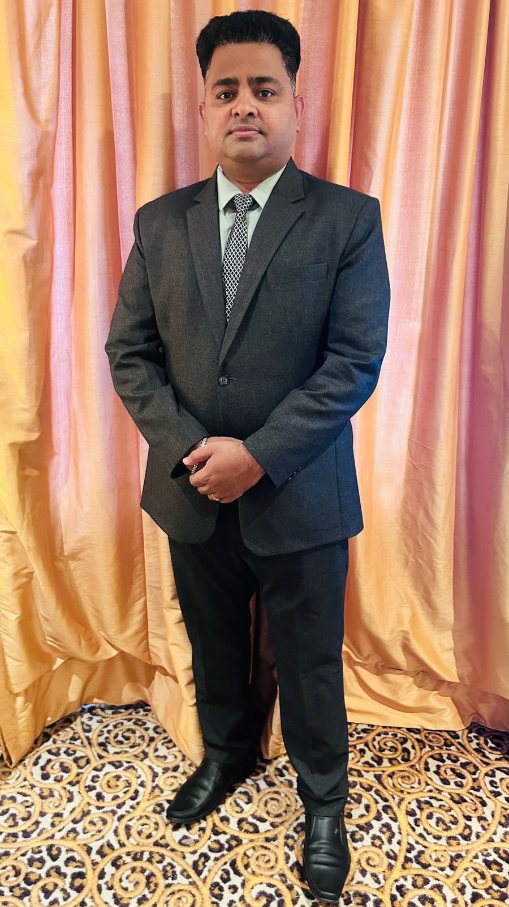
PROFILE SUMMARY

Experienced and knowledgeable hospitality professional responsible for overseeing the day-to-day operations of a hotel. A successful Hotel General Manager with strong leadership, communication, and problem-solving skills, as well as extensive knowledge of the hospitality industry , And having 10 years of experience as a Hotel General Manager and Have 20 years of experience in Hospitality Industry

Proven track record of successfully managing hotel operations, increasing revenue up to 25% YOY, and maintaining high levels of guest satisfaction. Have a strong understanding of budget management, sales and marketing, human resources, facility management, and compliance

Excellent interpersonal skills, able to communicate effectively with guests, staff, and vendors, and be able to build and maintain strong relationships. Also be able to think creatively and strategically to develop and implement long-term plans for the hotel's success

Core Competencies: ♦ Hotel Operations ♦ Food & Beverage Operations ♦ Guest Relationship Management ♦ Team Management ♦ Sales & Marketing ♦ Quality Assurance & Control ♦ Asset Management ♦ Business Development ♦ Project Development ♦ Handling P & L ♦ Strategic Planning ♦ Contract Management ♦ Budget Management ♦ Financial Reporting ♦ Market Analysis ♦ HR Operations ♦ Recruitment ♦ Training ♦ Brand Management ♦

ORGANIZATIONAL EXPERIENCE

SINCE JULY 2024 -- General Manager @ Katriya Hotel & Towers, Hyderabad, Telangana

Katriya Hotels is a luxurious full-service hotel with 225 rooms and 18 banquets halls that perfectly represents Hyderabad’s renowned tradition of hospitality, warmth and an extravagant lifestyle with its world-class services and facilities.

Situated at Raj Bhavan Road, Katriya hotel & towers beautifully blends space and functionality in a contemporary ambience. Katriya, inspired by Gautam Buddha’s family name, means delightful in Irish, and true to its meaning, the hotel delights its customers with the high level of service it provides.



Chancery Group of Hotels, Bangalore, Karnataka, India

- March 2022 to June 2024– General Manager @The Chancery Hotel, Bangalore, Karnataka

- Oct 2019 – March 2022 – General Manager @ Native by Chancery Hotels, Belagavi , Karnataka

- Jan 2018 –Sep 2019 |Operations Manager @ Native by Chancery Hotels, Belagavi, Karnataka (Pre-Opening)

The Chancery Hotel offers 126 Rooms and comfortable space for business / leisure travellers, strategically located in the heart of Bangalore - Lavelle Road, near MG Road. Equipped with superior amenities, a stay in this 4 star property is nothing short of a mini vacation. Explore the city or stay indoors; there are numerous options to choose from. When you’re done attending meetings, wind up the day at any of the dining outlets serving global cuisines in a relaxing ambience

All our 126 rooms define comfort and luxury at its best. Designed with cherry picked items and beautiful interiors, these rooms offer a sojourn that’s complemented by prompt service and exceptional facilities. Whether you’re travelling with family or alone, you’ll be spoilt for choice while planning to stay with us. An ideal retreat replete with indulgence and comfort, The Chancery Hotel is your best bet while travelling to Bangalore
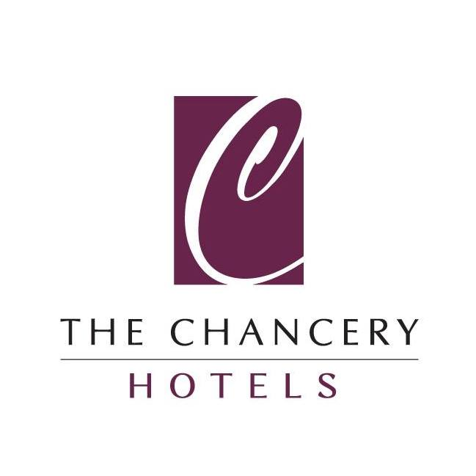

Chancery Group of Hotels, Starting its journey in the 1960s, The Chancery Group of Hotels has successfully become a renowned name, carving a niche for itself in the Indian hospitality industry by providing a world class experience infusing the essential elements of luxury and business in the heart of Bangalore. Its myriad properties bear the hallmark of finesse and focus on delivering nothing but the best to the guests

Nov 2015 – Nov 2017 | Continental Hotels & Resorts | General Manager Chennai, India

25 rooms are designed in striking light and dark shades with flowing curtains, false ceilings, and wall decals. Keeping up with modern tastes, the property offers popular video streaming service Netflix, free WiFi, a common seating area, dining area, laundry service, power backup and card payment option. Along with a Night Club, Fine Dining Restaurant and a Coffee shop

Dec 2012 – Oct 2015 | Savy Hospitality WLL, Doha, Qatar (Pre – Opening)
Growth Path:
Apl 2014 – Oct 2015 Operations Manager
Dec 2012 – Mar 2014 Restaurant Manager

PREVIOUS EXPERIENCE
May 2011-Jul 2012 | Land Mark Group Food Mark Division Zafran Restaurant, Kuwait (A Modern Contemporary Indian Cuisine) | Food & Beverage Service Supervisor (Pre - Opening)

Zafran Indian Restaurant inspired by Michelin Stared Chef Atul Kochhar, the award-winning contemporary Indian restaurant. Led by a team of highly skilled and experienced chefs, Zafran focuses on North West Indian cuisine with subtle and complex flavours



Oct 2006 – Apr 2011 | Hotel Taj Krishna (A Luxury Collection) Hyderabad, India
Growth Path:
Oct 2009 – Apr 2011 Guest Service Supervisor
Oct 2006 – Sep 2009 Guest Service Associate

Programmes Attended: On Job Training
- Food & Beverage Supervisory Programme for theory classes at Skill Certification Centre located at Hotel Taj West-end, Bangalore India from 7th September 2009 to 7th October 2009

TRAININGS ATTENDED

- Leadership
- Train The Trainer Work Shop
- Quality Tools
- Problem Solving Management
- Process Management Flow Charts
- Communication Skills
- Customer Feedback System
- Cultural Sensitivity Workshop
- Team Building & Spirits

- Successfully worked in Commonwealth Games 2010 Delhi with Delaware North Companies & Taj SATS for 2 months 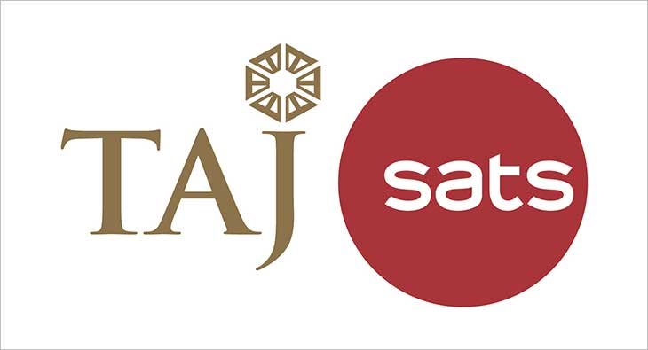 

Nov 2004 – Sep 2006 | Hotel NKM’s Grand (Pre Opening) Hyderabad, India
Growth Path:
May 2005 – Sep 2006 Guest Service Supervisor
Nov 2004 – April 2005 Guest Service Associate

Hotel NKM’s Grand is a luxury up market Business Class Hotel, Comes of an age creating a rage in the world of Hospitality. As a part of group that is well known for its hospitality since 42 years


Key Result Areas:

Managing staff: Overseeing all hotel staff, including front desk personnel, housekeeping, maintenance, and food and beverage staff. And manage all employees to ensure that they provide excellent service to guests

Guest relations: Ensuring that guests have an enjoyable and comfortable stay at the hotel. And resolve any guest complaints and ensure that all guests are satisfied with their experience.

Budget management: Responsible for managing the hotel's budget and finances. Creating and maintaining a budget, monitoring expenses, and ensuring that the hotel is profitable

Sales and marketing: Responsible for promoting the hotel and increasing occupancy rates. Developing and implementing marketing strategies to attract new Guests and retain existing ones

Facility management: Responsible for ensuring that the hotel's facilities are maintained and in good working condition. Overseeing maintenance and repair work and ensure that the hotel meets safety and health regulations

Operational management: Responsible for overseeing the day-to-day operations of the hotel, including check-in and check-out, room reservations, housekeeping, and food and beverage service
Strategic planning: Responsible for creating and implementing long-term strategic plans for the hotel, including expanding the business, improving Guest service, and increasing profits

Compliance: Responsible for ensuring that the hotel complies with all relevant laws and regulations, including employment laws, health and safety regulations, and local business licensing requirements

Developing and implementing policies and procedures: Responsible for creating and implementing policies and procedures for the hotel to ensure that all staff members understand their roles and responsibilities

Monitoring and analyzing performance: Monitoring the hotel's performance, including occupancy rates, revenue, and expenses. And analyzing this data to identify areas for improvement and implement changes accordingly

Ensuring high-quality standards: Responsible for maintaining high-quality standards throughout the hotel, including in the guest rooms, food and beverage service, and public areas

Managing relationships with vendors and suppliers: Developing and maintaining relationships with vendors and suppliers to ensure that the hotel has access to the resources it needs to operate efficiently

Managing reservations and inventory: Responsible for managing room reservations and inventory to ensure that the hotel is always fully booked but not overbooked

Managing safety and security: Responsible for ensuring that the hotel is a safe and secure environment for guests and staff members. This includes implementing safety and security measures, such as CCTV cameras, security personnel, and fire safety protocols

Ensuring compliance with brand standards: Responsible for ensuring that the hotel complies with the brand's standards for service, cleanliness, and quality

Significant Highlights across the Tenure:

- Acknowledged as:
- Employee of the Day in Front Of the House at Commonwealth Games 2010
- Silver Star, Gold Star & Platinum Star in the area of guest satisfaction; Special Thanks and Recognition System

- Bagged a TV Show on Fresh Fruit Based Cocktails in Hotel Taj Krishna for Local TV Channel of Hyderabad, India

- Attended the Red Bull Bartender Academy on October 3rd 2007 Hyderabad, India

- Received certificate of participation from Edge Academy for Personal Grooming Department & Power Dressing in Bangalore, India on September 26th 2009

- Certified by Delaware North Companies (Australia) & Taj SATS (India) for participating in catering to the Games Village for Delhi 2010 India Commonwealth Games

- Awarded for successfully achieving Basic Food Hygiene from Food Mark Group Dubai 2011

- Received an Appreciation Letter for Outstanding performance from CEO at Savy Hospitality

- Successfully completed Wine Appreciation & Service Programme of Big Banyan Wines

- Awarded as the Best Employee of the Department – F & B Service for the year of 2005-2006 at Hotel NKM’s Grand

EDUCATION

- MBA in Hospitality Management – From Jaipur National University. Jaipur , Rajasthan , India

- Bachelor of Arts from Dr. BR. Ambedker Open University, Hyderabad, Telangana, India

- Completed Certified Hospitality Training Programme From The Livelihood Advancement Business School (July 2004 to October 2004) DR.Reddy’s Foundation Hyderabad, Telangana, India

PERSONAL DETAILS
Date of Birth: 29th June 1986
Fathers Name: Champalal Maloth
Languages Known: English, Hindi, & Telugu
Passport Details: Passport No.- Z3980609, Place of Issue: Hyderabad, India, Date of Issue: 30 –Nov-2016,
Date of Expiry: 29 – Nov – 2026
Nationality: Indian
Address Shubhlabh Cypress Apartment, B004, Mallasandra, Bangalore, Karnataka, India

