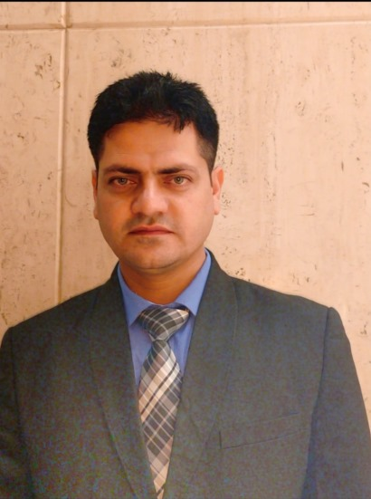
SANDEEP SHARMA
E-Mail: sandysharma088@gmail.com
Contact No. +91 7018733612

EMPLOYMENT RECITAL
Excellent service industry professional with over13+ years of extensive experience in Housekeeping in reputed 5* Deluxe hotels with a consistent track record of growth and producing results even in high pressure environment.

Dec 2025 to till now Room Division Manager in The Cabbana Resort & Spa
Jalandhar.

March 2024 to Dec 2025 Executive housekeeper in ITC Welcomhotel Bella Vista Punchkula.

March 2023 to March 2024 Executive housekeeper in Radisson Individuals Uday Palace Navsari Gujarat 102 keys, 04 Banquet Hall 500 pax capacity each and 02 lawn 5000 pax capacity.
- Handling floor operations, budget & making indent of housekeeping, preparing cleaning schedule, equipment & machine, duty roaster.
- Collaborating with engineers for necessary preventive measures as per maintenance.
- Maintaining guest preferences and standards, interior decoration, placements of all amenities & supplies, hygiene standards, safety standards and sanitary requirements of the hotel as specified.
- Monitoring inventory and stock management for housekeeping cleaning agents, consumables and guest supplies.
- Assigning duties to Supervisors, Attendants and acted on the complaints if any about housekeeping services
- Involving in conducting strict inventory control, managing par levels, ordering supplies accordingly and assuring proper cleanliness is maintained in the hotel rooms.
- Organizing orientation and in-service training about policies, work procedures, maintenance of equipment’s and prepared daily allocation.
- Ensured housekeeping service remained in alignment with management, maintenance and other departmental directives; interacted with departmental managers to assure customer service excellence.
- Ensured smooth running, hygiene and safety standards are met by the Housekeeping Department in the hotel.
- Ensured timely change of upholstery, uniforms, polishing, tapestry, noble, flower arrangements etc.

March 2022 to Feb 2023 Housekeeping Manager in Qatar global sports events (FIFA world cup) 2022 the living adventure managed by Accor 60,000 rooms with 13,000 staff.

July'18 to Feb 2022, Assistant Executive Housekeeper in lemon Tree Hotel Amritsar 64 keys.
- Responsible to train the employee so it meets the standards set by the organization.
- Identifying if and where processes are not working as they should and advising on changes to be made.
- Ensuring procedures, policies, legislation and regulations are correctly followed and complied with.
- Ensures that organizational processes – and the goods and services that result – comply with the requirements of standards as well as customer, regulatory, and the organization’s own requirements.

Apr'16 till Jun'2018 housekeeping executive in Accor hotel Pullman and Novotel New Delhi Aero city 670 keys.
- Handing 58 associates in guest floor area,
- Responding to all guest requests in an enthusiastic manner and ensuring they are expedited quickly and effective.
- Communicating with guest at every opportunity to get their feedback.
- Maintaining a harmonious relationship and proper coordination with other departments
- Implying hygienic standards and motivating the staff to maintain the hygienic atmosphere at the work.
- Practising and promoting effective and timely recovery of guest complaints.
- Reducing waste material and supplies by adhering to reuse and recycle method.
- Conduct, checks and discards linen audit from time to time.
- Defines service standards regarding cleanliness and maintenance in rooms.
- Follow up with purchase department supplier for scheduled deliveries.
- Personally, conducts key training.
- Possesses in depth know-how of leading housekeeping processes in accordance to hotel policies and procedures.
- Adept at monitoring and developing team member performance in terms of professional development and evaluations.
- Special Skills include-
- Profound ability to deal with a variety of people from different cultures
- Extensive experience in recruiting and training of staff
- Well versed with MS-Word, Excel, PowerPoint & Outlook Express
- Proficient in working on Property Management Systems like Opera

Nov'14_Apr’16 Team leader, IBIS Hotel Accor Jaipur 150 keys

- Proven expertise in successful experience in housekeeping management and Operations and with a fast-track record of growth through consecutive promotions with increasing responsibilities.
- Possesses in depth know-how of leading housekeeping processes in accordance to hotel policies and procedures.
- Adept at monitoring and developing team member performance in terms of professional development and evaluations.
- Proficient in formulation of budgets, cost controls with effective implementation with in-depth knowledge of property, laundry services, purchasing, renovation, safety and accommodation.
- Consistent effectiveness in handling queries and complaints in a professional and resolution-oriented manner.

Nov'11 – Oct'14 Team Member, The Oberoi Cecil Shimla 75 keys

Role:

Entrusted with the role for Housekeeping in the Rooms, Floors, Public area, Laundry and managing the H/K Desk.

Accomplishments:

- Was appreciated for the excellent feedback received by a guest on the email to the General Manager.
- Was acknowledged for taking the initiative to personally manage the ‘Lost and Found case' for a guest by going out of the way to get the stuff delivered to guest even after the check-out, setting an example for others.

SCHOLASTICS & PROFESSIONAL ENHANCEMENT

- B.A in Hospitality & Hotel Administration from HCMI, Chandigarh- 2011

PERSONAL DETAILS

Date of Birth 15 June 1987
Address Sandeep Sharma VPO Sainj Tehsil Theog district Shimla Himachal Pradesh-171220
Languages Proficiency English & Hindi
Marital Status Married

