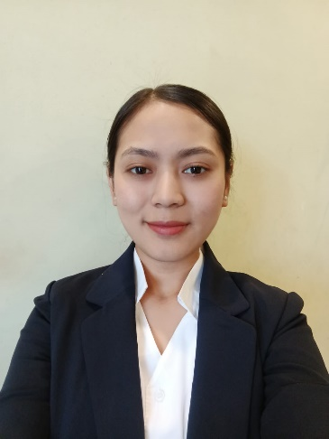  SARDHA GURUNG  D/O. Mr. Rabin Gurung  Mobile Phone Number  +91 9733784176  E-Mail:  gurungshradha2@gmail.com  Permanent Address  Vill- Ging Mali Gaon  P.O- Lebong  DT- Darjeeling  ST- West Bengal  PN- 734105  Personal Details  Date of Birth  14th September 2001  Nationality  Indian  Marital Status  Un-Married  Area Of Interest  Food and Beverage Service  Religion  Hindu  Hobbies  - Cooking  - Shopping  Languages Known  - English  - Hindi  - Nepali | CURRICULUM VITAE  Career Objective  To be associated with a progressive organization which can provide me with a dynamic work sphere to extract my inherent skills as a Professional. By acquiring knowledge, expertise and familiarity with the organization’s culture, I want to contribute towards realizing organization’s vision and become its integral part of it  Education  Academic Qualifications:  - 10th from Siksha Sangh Higher Sec. School.  - 12th from Siksha Sangh Higher Sec. School.  - B.A. History Hons from Darjeeling Govt. College.  Professional Experience:  - Presently working as Guest Service Associate with Courtyard by Marriott Siliguri since October 2023 to till date.  - Guest Service Associate since date March, 2023 to September, 2023 with “Basil Restaurant City Centre”.  Key Skills  - Ability to work under pressure and under deadlines  - Self-motivated and hard working  - Quick learner  - Punctual, disciplined  - Dealing with varied nature of the people  Declaration  I do here by declare that all the information furnished above is true & correct to the best of my knowledge and belief.  Date:  Place: SARDHA GURUNG

