 | 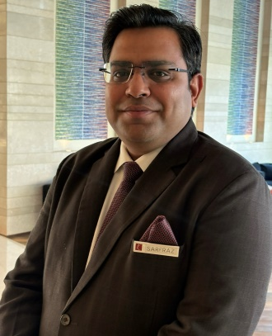    srfrzlm@gmail.com    +918130685710    Rishra, West Bengal 712248  Education  NSHM SCHOOL OF HOTEL MANGEMENT, DURGAPUR, Durgapur  January 2014  - Aggregate: 7.62  - Board: WBUT  12th, Higher Secondary  SHREE JAIN VIDHYALAYA, HOWRAH,  January 2010  - Aggregate: 60%  - Board: WBCHSE  10th, MadhyamikPariksha  RISHRA VANI BHARTI, RISHRA,  January 2008  - Aggregate: 68%  - Board: WBBSE  Languages  English, Hindi, Bengali |  | Professional Summary  Productive Manager with excellent skills in customer service, office management and administrative support. Remains professional and tactful in all situations with focus on increasing satisfaction and retention. Versed in managing vendor and service provider relationships while maintaining meticulous records.  Skills  Work History  April 2023 – Current  The Lalit Chandigarh, Front Office Manager (179 Keys)  - Leading team of young & energetic members in Front Office  - Closely coordinating with Reservation, House Keeping and F&B Department  - Formulating Upselling practices to support achievement of Upselling Budget  - Promotion of Inter & Intra-Hotel sales and in-house facilities by virtue of Rooms Division Marketing techniques in line with FIT marketing program  - Responsible for Achieving Enrolment Targets  - Participating in the preparation of weekly and period end P&L Reports  - Handling of Guest complaints and feedback to increase Guest satisfaction on GSS Report  - Communicating and applying change management skills to implement changes in process or systems  - Overall motivation, team building and training of the Division  - Radisson Rewards Loyalty program enrolments and Reward points update at unit level.  Company Name : Radisson Blu, Greater Noida (175 Keys)  Position : Duty Manager  Duration : June 2022 - April 2023  December 2020 - June 2022  Worked as an Entrepreneur and developed my Family Business (Automobile Sector)  Company Name : The Surya, New Delhi (244 Keys)  Position : Assistant Manager  Duration : November 2019 - December 2020  Company Name : Vivanta, Kolkata (196 Keys)  Position : Front Office Executive  Duration : June 2019 - October 2019  Company Name :IHG Crowne Plaza, Greater Noida – (398 Keys)  Position :Front Office Supervisor  Duration : September 2016 - February 2019  Company Name : The Piccadily, New Delhi  Position : Front Office Associate  Duration : May 2016 - September 2016 (224 Keys)  Company Name :The Lalit, New Delhi (461 Keys)  Position : Front Office Associate  Duration :  February 2015 - March 2016  Company Name : Crowne Plaza Today, Gurugram  Position : Industrial Trainee  Duration : 6 Months  Accomplishments  - Handled PMO Movement in the year 2024.  - Migration from Opera V5 to Opera Cloud  - Awarded Manager of the Month for Nov’2023, Dec’2023 and Jan’2024.  - Winning Ways Champion of the Year 2018, Crowne Plaza, Greater Noida  - Winning Ways Champion of the Month January 2018, Crowne Plaza, Greater Noida  - Winning Ways Champion of the Month December 2016, Crowne Plaza, Greater Noida  - Nominated 3 more times for winning ways champion  - Highest Upselling for the last 18 months continuously  - Personal Information  - Father's Name: MD.ASLAM  - Date of Birth: 07/01/91  - Nationality: Indian  - Marital Status: Married  Hobbies and Interests  - Cooking  References  On Request
  Sarfraz Alam
   | - Knowledge of Opera PMS, Opera Cloud, Symphony, Micros, Triton, Touche  - Heading the Front Office Department  - Large experience in large and upscale Brands  - Good knowledge of Front Office Department Functioning as well as Reservations Department  - Excellent planning, delegation and problem solving skills | - Excellent verbal and written communication skills  - Excellent ability to develop talent and teams  - Good knowledge of Reservations, inventory control  - Good knowledge of Hotel Loyalty Program  - Good ability to establish structure and discipline in organization
.

