CHEF DEBAJIT BHADRA +91-9830988153 / +91-7980960556

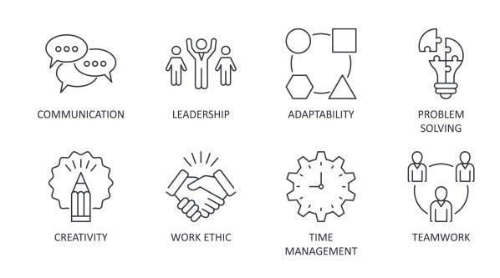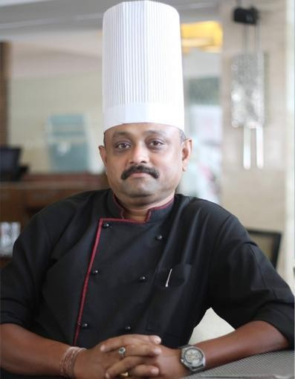PERSONAL DOSSIER ACADEMIC DETAILS

Call Us:
9830988153 / 7980960556
Mail Us:
debajit_bhadra@yahoo.com

CHEF DEBAJIT BHADRA
S / O : RAMENDRA NATH BHADRA.

D.O.B : 25TH ⁻ Dec - 1978

Language Known : Bengali , Hindi & English

9830988153 / 7980960556
debajit_bhadra@yahoo.com
Passed Secondary Examination from
W.B.B.S.E in 1995.

Passed Higher Secondary Examination from W.B.H.S.C in 1997.

Completed 3 yrs Diploma in Hotel and Restaurant Management Catering technology & applied nutrition from International Institute of Advance Studies (I.I.A.S) from KOLKATA, in the year 2000.

IT CREDENTIALS

EXPERT IN EXCELL, WORD , IDS

INDUSTRIAL EXPLOSURE

Completed six months Industrial Training from “WELCOME GROUP” UMED BHAWAN PALACE, Kota, Rajasthan (04-10-1998 to 31-03-1999).

CAREER OBJECT

- To achieve the highest level of guest satisfaction in the hospitality industry. I amlooking for challenging opportunities for broadening my experience with globally reputed organizations. I always want to work in creative, challenging and learning atmosphere, which provides ample opportunities for growth.
- Applying for a suitable position in Food production Department in Indian Cuisine at your Organization compatible with my experience, qualification and abilities.



REFERENCE POINT

On Request

PROFILE SNAPSHORT

A dynamic professional with over 18years of experience in Managing Hospitality & Entertainment Operations, Food & Beverage Production offering an exceptionalteamwork spirit and a positive attitude.

Experienced in managing within budget guidelines, maintaining an effective flow of inventory, and developing a strong team attitude among employees; Proven skills in setting andachieving goals, supplying above-average training skills, and adding to the bottom-dollar profit margin by improving service, reducing waste, and increasing efficiency.

Work well with all types of personalities; able to perform hiring and termination duties effectively and professionally; Conscientious, customer- service-oriented, and highlyfocused, with strong follow-through skills and effective time-management abilities. Loyal, possess strong common sense with a keen sense of humor, and committed to a job well done.

debajit_bhadra@yahoo.com ①

CHEF DEBAJIT BHADRA +91-9830988153 / +91-7980960556

Core Competencies

Kitchen Operation Management | Customer & Guest | Service | VIP Client Service / VIP Menu
Personal Oversight | Excellence Kitchen Design |  | Developing Organizing Food
Management Cost Containment |  |  | Festival F&B Production
 |  |  | Budgeting
Special Event Development Team Building Training / Supervision | Even Planing , Five Star Dining , Menu Development |  | Production Management | Inventory
SOP Training | H.A.C.C.P Maintain |  | Cost Control Management
Menu Creation | Complaint Resolution |  | G.O.P Maintain
Food & Beverage Production | Food Cost Control |  | Negotiation

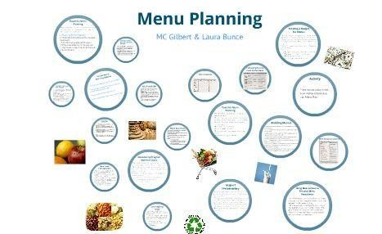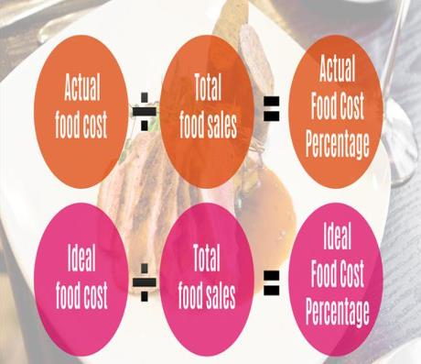MENU PLANING

  - Toensure that the food prepared is hygienic and in good quality.
  - Toprovide guests with maximum efficiency of services, comfort and Guest satisfaction.
  - Toensure company standards of uniform and grooming are Implanted throughout the department and the entire property according set standards.
  - Toimpart training to the departmental staff and evaluate work Performance of the staff.
  - Tohold regular departmental meetings.
  - Tokeep and maintain accurate records according the set standards and procedures.
  - Toimplement Standard Operating procedures of the department.
  - Toprepare the departmental annual budget and control the cost as per the budgets.
  - Toensure the services provided by the contractors are monitored for quality.
  - Toensure high performance and maximum efficiency are achieved.
  - To ensure that all the departmental staff are completely familiar with safety security procedures and follow the rules and regulations of the strictly.
  - Tomaintain, administrate and supervise entire Kitchen department Operations of the resort which includes Continental Kitchen, Indian Kitchen, Grade manger, butchery, specialty kitchen etc.

FOOD COST CONTROL

- To ascertain the food cost of particular item on the menu.
- To ascertain the total expenditure on food over a period of time.
- To control cost, price, profit margins and provide information for formulating an effective pricing policy.
- To disclose faulty purchasing and inefficient storing.
- To prevent pilferage and wastage.
- To ensure customer satisfactions.
- To bring cost- consciousness among the employees.
- To reduce cost and improve quality.
- To provide cost estimates to manager for developing budgets.
- To assist manager in making control decision.

debajit_bhadra@yahoo.com ②

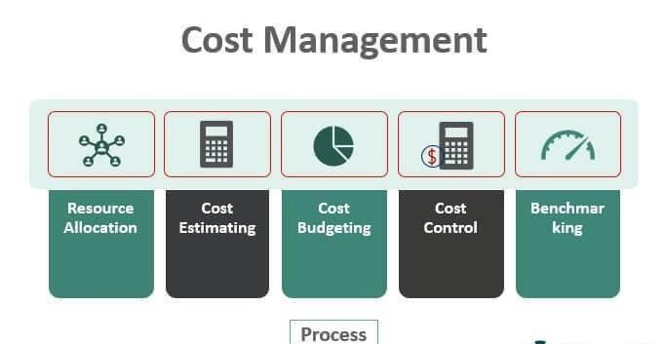CHEF DEBAJIT BHADRA +91-9830988153 / +91-7980960556

COST CONTROLL MANAGEMENT

- Able to effectively control the Food & Beverage Cost.
- Control the Food and Beverage outlets in terms of wastage, pilferage and efficiency.
- Prepare variance analysis for food & beverage and Communicating with relevant parties.
- Update and maintain receipts into the systems .
- Check and verify voids in the POS systems.
- Check and verify discounts on the POS systems.
- Check and verify any happy hours discounts.
- Check and verify all complimentary sales in POS systems.
- Check and verify all staff meals and staff discounts.
- Check and verify all Package meals.
- Check and verify all settlements done on the POS system.
- Check and cross verify if all sales have been transferred correctly.
- Check and verify for any lost postings.
- Check the cost of sales in all F&B outlets and ensure that the costs are within budget.
- Check the menu pricing on the POS systems and ensure the correct prices are loaded.
- Check the restaurant and bar checks on daily.
- Check the complimentary and confirm that all are approved.
- Daily Import of Micros Sales to Materials Control system.
- Tally all end of shift reports generated from all POS tills.

WASTE CONTROL MANAGEMENT

- Supervise the transportation of waste to ensure that it takes place efficiently without contaminating air, land or water sources.
- Assist with the development, promotion and implementation of new waste disposal schemes.
- Ensure compliance with current legislation in the transportation, handling and disposal of waste
- Formulate and control budgets for waste disposal.
- Collate statistics and compile reports often to strict deadlines.
- Monitor the quality and performance of waste services, including contract management of external providers.
- Assist with the development of information and promotional materials.
- Aim to meet waste reduction and recycling targets.
- Deal with enquirers and complaints from members of the public both in person and by phone or email.
- Investigate and follow up claims of the illegal dumping of waste and work with other waste regulation enforcement staff.
- Identify and target areas with fly tipping or black bag problems, working to find solutions to eliminate these.
- Consult with residents, community groups, councilors, housing associations and traders' associations about waste management issues, identify their requirements and provide appropriate solutions.
- Develop research projects and contribute to the activities of national groups concerned with waste disposal.

F&B PRODUCTION

- Responsible for ensuring food specifications and labor objectives meet all Company and customer requirements.
- Keeps account of attendance, sets up paperwork, sets up each shift and assigns employees to specified sections (schedule optimization).
- Orders raw material from storeroom and produces extra meals at last minute as needed.
- Prepares daily production sheet and assigns tasks to employees; works with and directs employees through the use of the production sheet and passenger counts.
- Responsible for all food items after requisitioning them from the storeroom; training and recurrent training of all employees on proper procedures of preparation.
- Ensures safety procedures are adhered to; maintain cleanliness through shift to ensure quality product.
- Manages daily production of hot and/or cold kitchens for quality and consistency.
- Trains and monitors employees on proper work procedures to ensure maximum productivity with minimum labor and food expenses.
- Monitors daily manpower planning and schedules employees.
- Responsible for employee retention and reducing employee turnover.
- Reviews and ensures employees in chain of command are in correct cost centers and correct job titles.

debajit_bhadra@yahoo.com ③

CHEF DEBAJIT BHADRA +91-9830988153 / +91-7980960556

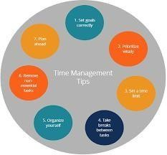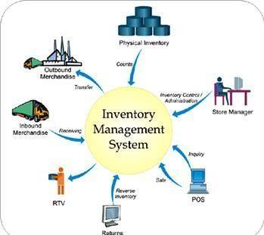G.O.P MAINTAIN

As the role responsible for managing all finance and accounting operations, it’s critical that a Financial Controller job description captures the breadth, diversity and seniority of the role. A Financial Controller’s duties and responsibilities generally include :

  - Developing financial strategy, including risk minimization plans and opportunity forecasting.
  - High-level financial reporting and analysis.
  - Regular budget consolidation.
  - Cash flow management.
  - Improving efficiencies and reducing costs across the business.
  - Stakeholder management.
  - Debt management and collection.
  - Preparing company tax and BAS statements.
  - Ensuring compliance with statutory law and financial regulations.
  - Developing financial reviews and providing investment advice.
  - Payroll processing.
  - Working closely with management or executive teams to share reports and analysis findings.
  - Well-developed leadership skills.
  - Mentoring.

TIME MANAGEMENT

Time management means the maximum use of time for the productivity and achievement. It concerns with the management of schedules of work with advanced planning, organizing and implementation in order to achieve the aims and objectives of their and the organizations. Time is probably the most valuable asset available to people and organizations to understand the process of the management of time and the contribution of one’s to the success of personal and professional lives. However,
as any other asset it may be wasted if it is not valued. Time management concerns with the discovery and the application of the most efficient methods of completing assignments of any length with in the required time with quality but do not waste the time. It is human nature to waste time according to their interests and easiness in order to deviate from the work and responsibility in any organization. But on the other side some people have good time management skills to develop their habits to get success in their life. But others have
developed poor habits related to time which are not proclaimed or admitted by the people as weaknesses.
INVENTORY, EQUIPMENT & QUALITY:

  - Directing inventory for bonded items, liquor & other food supplies by developing a chain of vendors.
  - Conducting hygiene inspections and conveying feedback to operating staff as well as managers.
  - Performing quality checks & regular physical inventories of food supplies, assessing projected needs and orders of food, evaluating recipes and ensuring standardization.

debajit_bhadra@yahoo.com ④

CHEF DEBAJIT BHADRA +91-9830988153 / +91-7980960556

CAREER SYNOPSIS

Presently working as a “ Executive Chef “ in “ Sterling Fernhill , Ooty “ ,Tamilnadu .
    - Worked as an “ Executive Chef “ in “ Nourlaya” a “ IndoSrilankan “ contemporary fine dine restaurant , Doha , Qatar from 30 May 2023 to 30th June 2024.
    - Worked as an “Executive Sous Chef” at Crown Hotel in Port Moresby , Papua New Guinea from 17.07.2021 to 10.05.2023.
    - Worked as an “Executive Chef” in HOTEL SONAR TORI, Agartala (TRIPURA) from 01.11.2018 to 31.03.2020.

    - Worked as a “Sous Chef” in THE SONNET, Salt Lake, Kolkata from 17.05.2017 to 07.10.2018.

    - Worked as a “Sous Chef” in AMBUJA NEOTIA GROUP, in fine dining from 17.08.2015 to 06.04.2017.

    - Worked as an “Executive chef” in Hotel Niharika, 5 A.J.C. Bose Road, Kolkata from 01.06.2014 to 07.07.2015.

    - Worked in RED CHERRY HOSPITALITY, BLUE HUGLI BANQUET as an “EXECUTIVE CHEF” from 01.08.2013 to 14.05.2014.

    - Worked in FLOATEL as a “Jr. SOUS CHEF” from 14.10.2011 to Nov, 2012.

    - Worked in ITC FORTUNE SELECT LOUDON by WELCOME GROUP as a “CHEF-DE PARTIE” from 24.10.2010 to October,2011.
    - Worked in PARK HOTEL, Kolkata as “DEMI CHEF- DE PARTIE” from 16.12.2006 to 24.10.2010 in Banquet Kitchen.

    - One year as an “Indian Kitchen Assistant” at OUTRAM CLUB Kolkata 10.03.1999 to 10.03.2000.

    - One year as an “Indian Kitchen Assistant” VIJAY INTERNATIONAL, Puri (Orissa).

    - Worked in TAJ SATS AIR CATERING, Kolkata as “Commie – 2”.

    - Worked in “AMBY VALLEY SAHARA LAKE CITY”, Pune, Lonavla in Indian Kitchen as Commie - II.(Awadh, the Banquet Kitchen)
    - Worked in HYATT REGENCY, Kolkata, as “Commie” banquet Kitchen; with 24 hrs. Coffee shop, 3 luxurious bar, one 75 cover Indian Restaurant called GUCCHHI & 1200 capacities banquet.

CHEF DEBAJIT BHADRA +91-9830988153 / +91-7980960556

SIGNIFICANT ACHIEVEMENT

      - Two times awarded from most guest satisfied award(HYSTAR GOLD AWARD FROM HYATT REGENCY, KOLKATA)

      - Given best service to all VVIPs like LAURIOUS SPORTS ACADEMY, MRS WORLD PAGENT 2005, SAHARA OFFICIAL MEETS, ANDMANY MINISTERS, BOLLYWOOD’S FILM ACTOR & ACTRESS.

      - Given Service to MRS. PRATIBHA DEVI SINGH PATIL, President of India, MR. GOPAL KRISHNA GANDHI, His Excellency the Governor of West Bengal, MR. SOMNATH CHATTERJEE, Hon’ble Speaker of Loksabha & ARMY CHIEF OF EASTERN COMMAND ON visit to Kolkata.
      - Got the recognition from APEEJAY Group, and Paul Family.
      - Got the recognition from Dr. Pranav Dasgupta (PRESIDENTEAST
BENGAL CLUB) for best Chinese Lunch on dated 05.01.2014.
      - Completed FSSAI (FOOD SAFETY) TRAINER PROGRAM.

CUISINE KNOWLEDGE

Indian, North West frontier, Gujrati, Bengali, Halwai

DECLARATION

I do hereby declare that all the above statements are true to the best of my knowledge and belief.

DATE : -------------------------------------------------------

PLACE : CHEF DEBAJIT BHADRA

debajit_bhadra@yahoo.com ⑥

