Uday Thakur

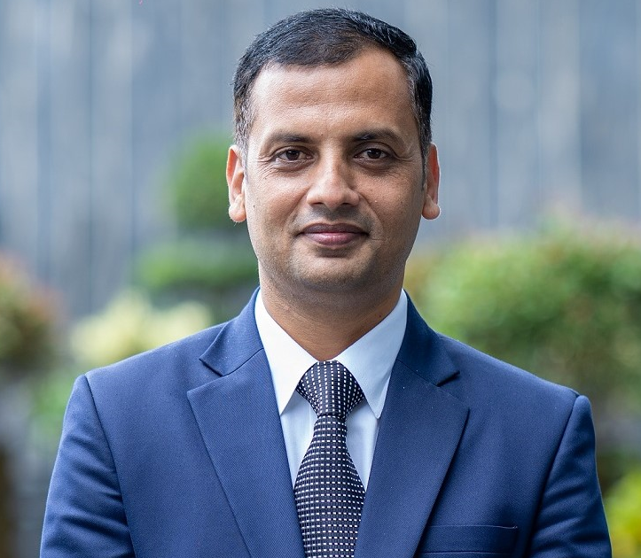
CONTACT DETAILS

India: +918130450766
Email: ustt@ymail.com

SKILLS
Establish cleaning, excellent written, verbal and listening, Team Player, Problem Resolution, Customer Service, Sales, Quality Assurance, Effective Trainer, Team Building, Inventory and parLeadership ability Housekeeping and Laundry Management, Hiring, Budgeting, Microsoft Office. Organizational and Entrepreneurial, drive change operational efficiencies

LANGUAGES
English, Hindi, Urdu, Nepali, Bengali, (Arabic Basic)

PERSONAL DETAILS

Male
Height: 176 CMS
Weight: 76 KG
Nationality: Indian

Executive Housekeeper/ Director of Housekeeping

CAREER OBJECTIVE
To obtain head of Housekeeping and Laundry position to utilize my management skills, experience and education.

ACADEMIC PROFILE

- MBA From Subharti University Meerut India
- Diploma in hotel management DIHM India

EMPLOYMENT SUMMARY

Jaypee hotels and resorts

Executive Housekeeper (June 2024 – Present)

Hilton Hotel Gurugram (DT) NCR (India)

Executive Housekeeper (Mar 2023 – Mar 2024)

Key achievements:

Achieved the best GTMS departmental Score 98%

SALT From 62% Last Year to 72.8% YTD

Rooms Profitability 84%

The Westin Pune India (Marriott International)
Executive Housekeeper (June 2022 – Mar 2023)
Inspired by natural elements premium luxury wellness Marriott Hotel is located at a prime
Location in the city.
Reporting to EAM Rooms & General Manager of the hotel.

Key achievements:
- BSA: Operations 86.5%
- Guest Voice: Cleanliness K
- Associates Engagement score 100%

Angsana Oasis Spa and Resort (India) by Banyan Tree Hotels
Executive Housekeeper (July 2021- May 2022)

Located near the Bangalore international airport owned by prestige group and
Managed by Banyan tree luxury hotels & resorts.
Reporting to General Manager & Managing Director of the resort and direct the
Administration of all Housekeeping services, all housekeeping projects and
Program, Supervises all housekeeping and Laundry employee.

Aloft Hotel Al Ain Executive Housekeeper
Marriott international December 2018 – April 2020
United Arab Emirates

Key achievements:
- BSA&LRA: Operations Standards 100% Cleanliness 91.3%
- Employee Engagements score 89%
- Room’s profitability 100.04 % against 2019 budget

Rotana Hotels & Resorts Executive Housekeeper/Director of Housekeeping
(Dubai UAE) February 2016 – October 2018

- Under the guidance of the General Manager within the limits of Rotana hotel management policies, directs all aspects of the housekeeping and Laundry departments as outlined in the room’s division manual. Joined as Executive Housekeeper at Centro Rotana Dubai and promoted as Cluster director of housekeeping to Iraq Rotana.

Waldorf Astoria by Hilton Hotels Assistant Executive Housekeeper
(Ras al Khaimah UAE) July 2013 to Jan 2016
Pre-Opening Team

- Being a part of housekeeping pre-opening team at this landmark property Reports and Replace Cluster Director of Housekeepingand all functions such as operations & admin of housekeeping and laundry.

Grand Hyatt Doha (Qatar)/Hyatt Regency Delhi Assistant Manager Housekeeping
(Hotel & Residences with Villas) Jan 2011 to June 2013

- Report and Replace Head of department and responsible for all functions such as operations & admin of housekeeping and laundry department.

Emirates Palace Senior Supervisor Housekeeping (Pre-opening team)
Kempinski hotels & Resorts Jan 2005 to Dec 2010 (Six Years)
Abu Dhabi, UAE

- Being a part of housekeeping pre-opening team at this landmark property (managed by Kempinski Hotels & Resorts) through the consistent delivery of the highest standards of products and service with a passionate approach to exceeding our guest’s expectations. We have hosted many VIPS i.e. Prince Andrew (UK) Prince Al Saud from K.S.A., Provided valet service to U.S. vice President and Royal families of G.C.C. countries and Protocols of different countries.

GRAND HYATT NEW DELHI Housekeeping Team Leader

India Jan 2003 to Dec 2004

- Establish a rapport with guests maintaining good customer relationship. Ensure the upkeep and cleanliness of the Guest rooms, public areas, Back of the House areas including Employee Lockers, etc. to luxury brand of Hyatt.

Joined as room attendant and promoted as a housekeeping team leader.

THE IMPERIAL NEW DELHI Housekeeping Associate
India Jan 2002 to Dec 2002
- Most stately and historical five-star hotel in New Delhi. This hotel is as a beautiful oasis with its sprawling garden and palm trees, Worked as Room & Public area Attendant, linens & uniform room attendant and at HK Desk.

TRAINING & ACHIEVEMENTS

- Fire & safety training
- Telephone handling antiquates
- Guest expectations & Service recovery
- Brand training
- Housekeeping standard operating procedures
- Training the trainer skills. (Housekeeping Dept. Certified Trainer by Kempinski, Hyatt, Hilton, Rotana ,Marriott and Banyan tree Hotels & Resorts
- Chemicals and machinery trainings Ecolab and Diversey
- Completed six and half months of industrial training in 5-star deluxe hotel at “The Imperial” New Delhi
- Honored with certificate from General Manager as part of pre-opening team From Emirates Palace Abu Dhabi and Waldorf Astoria Ras al Khaimah United Arab Emirates
- Honored with certificate outstanding contribution 26th& 30th summit for the cooperation council for the Arab states of the gulf (GCC) meeting 2005 & 2010 held at Kempinski Emirates Palace Abu Dhabi United Arab Emirates
- (Attended standard of training, certification and watch keeping for seafarers (STCW) course provided by “N. Y. vaptsarov naval academyin Abu Dhabi United Arab Emirates.

