mm
prashant thakur  MBA – HR AND Marketing  Ph no. : +91- 8580433726  Email : bonythakur868@gmail.com  Dalhousie , Himachal Pradesh, India - 176301 |  | 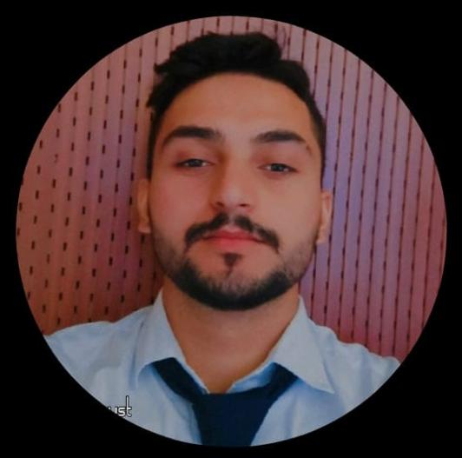
OBJECTIVE
To get an opportunity where I can make the best use of my potential and contribute to the organization’s growth. Dedicated management professional with strong leadership and team management skills .

EXPERIENCE
- Currently working as an Human Resource Associate in Suryavilas Luxury Resort & Spa in Solan Himachal Pradesh .  - Working as a job trainee in HR Department with Fortune Park ITC Hotel, Dalhousie from 22 July 2024 to 31 January 2025 .  - Worked as an intern with Times of India , Chandigarh. [ 2 months]  FUNCTIONAL ROLE  - Taking care of the joining formalities procedure new employees, FT.C break employees & trainees.  - Prepare personal files of employees.  - Giving offer letter and appointment letter to employees.  - Preparing of salary annexure. PF register of new employees.  - Property orientation of employees and trainees.  - Taking care of the exit formalities procedure employees & trainees  - Giving experience letter to employees and trainees. Updating database of employees & trainees.  - Taking Pre-Interviews of candidates.  - Co-ordinate with colleges for industrial trainee and staff.  - Taking care of employee engagement activities.  - Preparing multifarious HR report (QMS report, Night manning report, HODs & Executives arrival report).  - Making presentation like THACC report on monthly basis.  - IDS knowledge (Indent entries, Attendance entries of employees, Birthday list, Payslip printing).  - Checking grooming of employees on daily basis.  DECLARATION  I hereby declare that all the above given information are true and correct to the best of my knowledge and belief. |  | EDUCATION  - Completed Post Graduation in Master’s in business administration from DAV University , Jalandhar  - Completed my Graduation  In Bachelor’s of Arts at BTC DAV College  - Completed my Higher Secondary education from BTC DAV College  - Completed my Secondary education from Sai Public School.  ACHIEVEMENTS  - Done certification under quiz conducted by WTO.  - Completed certification under course of basic excel.  Done certification under Market Research course  TECHNICAL KNOWLEDGE  - Fluent in Microsoft excel, Microsoft Power point, Microsoft Word  - Fluent in E-mail & internet

