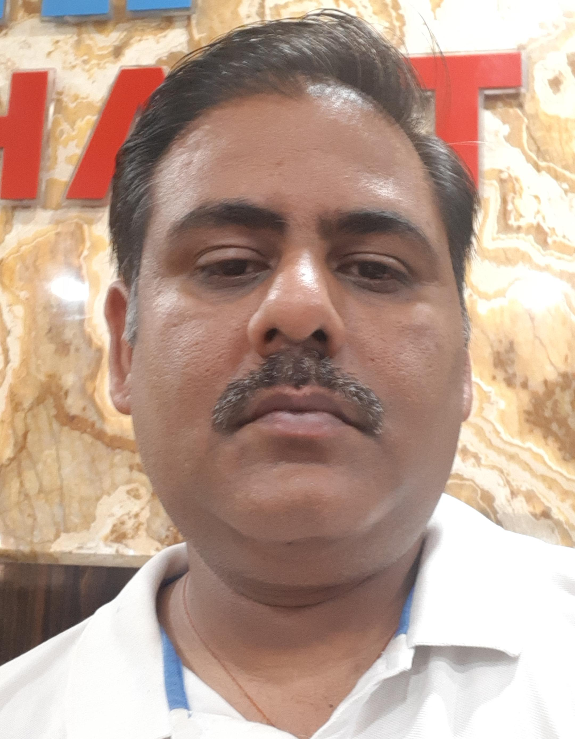
PUSHPENDRA SINGH CHAUHAN

MOB.- 8085101213
EMAIL_ID- chauhanpsc1984@gmail.com

ADD. – 612 A Tulsi Nagar Nipaniya Road Indore

CAREER OBJECTIVE

Seeking a challenging and rewarding opportunity with an organization of repute which recognizes and utilizes my true potential while nurturing my skills across the Industries.
EXPERIENCE

Present time I am working in hotel siddhant as FOM manager. opp. Arbindo hospital.

8 year (2016-2022) working experience in school field
Shri ashoka vidya niketan sanwer road Indore.

2 year (2013-2015) working experience in school field.
- Ram Krishna ashram vidya peeth indore (MP).
- Innovative Tutorial Indore (MP).

1 year of working experience in i MASTRO TECHNOLOGIES .(2012-2013)
Key skills- software developer in Dot Net Technologies (.net).
ERP software developed for kirloskar pump Dewas (MP).

ACADEMIC PROFILE

- Completed MCA, from MPCT -Gwalior, RGPV university.Percentage-62%
- Completed B.Sc, from Govt. Holkar science college Indore,
DAVV University Percentage-52.5%
- Completed DCA, from MCRPESV- Bhopal. Percentage-61%
- 12th from (MP board) with 63%.
- 10th from (MP board) with 50%.
- NCC (C) Certificate ‘B’ grade.
KEY SKILLS

- Hard working
- Problem solving
- Planning & Organizing
- Public relationship
PERSONAL DETAILS

- Date of birth:- 08/10/1984
- Blood group:- B⁺
- Language known:- English, Hindi
- Father’s name:- Mr. Pratap singh chauhan
- Nationality:- Indian
- Marital status:- Married
PERSONAL INTERESTS & HOBBIES

- Listening soft music, dancing.
- Playing cricket, Badminton etc.
- Suffering social networking sites.
STRENGTHS

- Self disciplined & Problem solving .
- Diligence
- Co-operative nature.

DECLARATION

I confirm that the above information provided by me is true to the best of my knowledge & belief.

Place: - INDORE ………………………………………

Date:- Pushpendra singh chauhan

