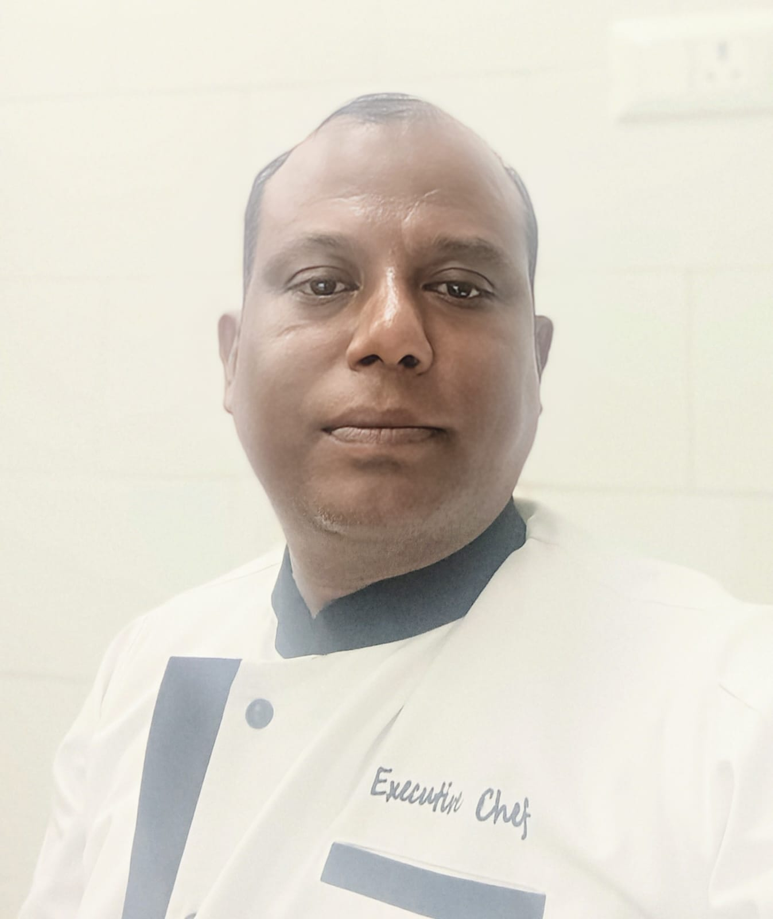 |  | raj kumar das  Head Chef
Profile  Self-motivated professional with more the 20 years of experience kitchen operations. Quality-focused and efficient Sous Chef adept at preparing and plating food in high energy fast-paced kitchens.  Contact  PHONE:  9650783612  EMAIL:  Rajdass2575@gmail.com  Personal Details  Date of Birth : 2nd Jan 1982  Marital Status : Married  Address: S/O-Mahadev Das  Village-Karkari, Hazaribagh  825301(Jharkhand) |  | educational qualification  Hotel Management (2000- 2002)  Holy Cross VTI. Hazaribagh  Jharkhand  Intermediate (2000 pass out)  St. Columbus College, Hazaribagh  Matriculation (1997)  St. Robert High School, Hazaribagh  WORK EXPERIENCE  ODR (ON DA ROCK), RANCHI (JHARKHAND)  AS AN EXECUTIVE CHEF (15TH NOV 2024 TILL NOW)  New opening kitchen team for 350-400 cover Event Bar & kitchen  - Oversees back-of-house operations  - Hires, trains kitchen staff.  - Sets the staffing schedule.  - Leads pre-shift meetings.  - Develops recipes and menus.  - plating and presentation plans.  - evaluates the quality of new food.  - Stocks the kitchen with necessary supplies.  - financial planning and budgeting  - Handles and resolves customer complaints.  - Makes sure the kitchen staff follows all food safety laws.  - Sets and implements the kitchen policies and procedures.  IREO UPTOWN CLUB, (QUICK REAL HOSPITALITY PVT,)  SOUS CHEF  (20TH FEB 2016 TO 28FEB 2023)  GOLF COURSE EXTENSION ROAD, SECTOR- 66, GURGAON  - Operating two Club kitchen  - Make food promotion in a monthly base  - Make Food counter in every festival/ event  - Hiring new staff and trained him  STRIKER PUB AND KITCHEN GROUP, (11TH FEB 2013 TO 2016)  GURGAON  AS A SENIOR CDP  HARD ROCK CAFÉ’ NEW DELHI & BANGALORE  OCT 2009 TO TILL 10TH FEB 2013 & 16TH JUNE 2008 TO 23TH APRIL2009  AS A COMMI 1ST TO CDP  CHILLI’S GRILL & BAR AT BANGALORE AS A TRAINER.  INDIA FIRST OUTLET OF CHILLI BAR & GRILLED OPEING TEAM  24th April 2009 to 28th Sept2009  TGI FRIDAY'S BANGALORE AS LINE COOK  9TH APRIL2007 TO 13TH JUNE2008  JAYAKA RESTAURANT BASAVANAGUDI, BANGALORE  14TH AUG 2004 TO 25TH DEC2006  AS A COMMI 1ST IN INDIAN CURRY SECTION.  HOTEL CHANAKYA, PATNA,  F&B SERVICE & PRODUCTION  1ST APR 2003 TO7TH AUG 2004  AS AN APPRENTICE TRAINING  HOTEL SAYAJI, INDORE  2ND MAY 2001 TO 1ST JULY 2001  INDUSTRIAL TRAINING  SKILLS  • Consistently working to high standards.  • Can quickly gain an in-depth familiarity with any kitchen’s operations.  • knowledge of operational health & safety.  • Understanding of food labeling and temperature controls.  • Constantly working hard to achieve personal goals and objectives.  • Having strong and effective leadership skills, along with the ability to successfully manage a team of BOH.  ACHIEVEMENTS &AWARDS  International Trainer In Chills Bar & Grill, Bangalore  Get Two Times Employee Of The Month In Hard Rock Café’ New Delhi Get Employee Of The Years In Hard Rock Café ’New Delhi  Raj Kumar Das
DATE:

