NAME: VASUDEV SIDDH

Roll No. : 34

Reg. No. : 12305855

Section: KM009

CA: 1

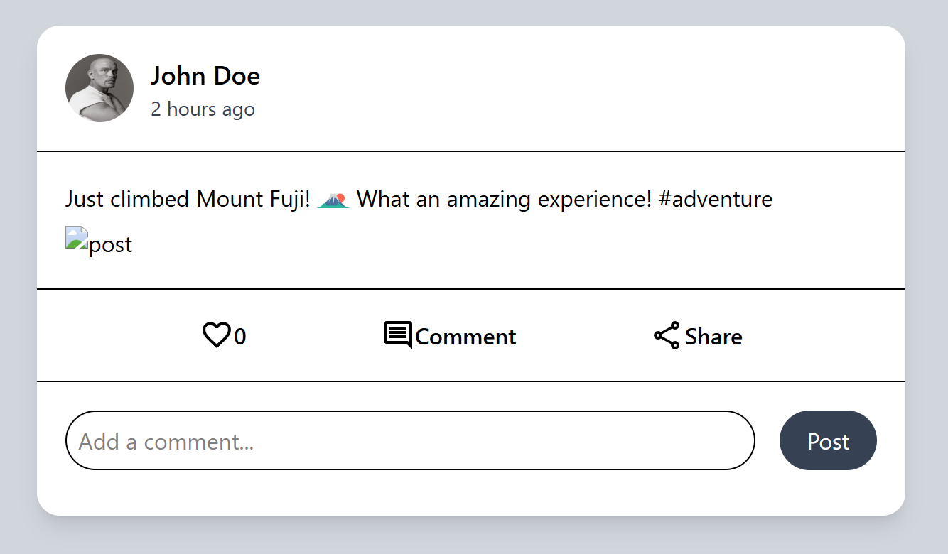

<!DOCTYPE html>

<html lang="en">

<head>

    <meta charset="UTF-8">

    <meta name="viewport" content="width=device-width, initial-scale=1.0">

    <title>Document</title>

    <script src="https://unpkg.com/@tailwindcss/browser@4"></script>

</head>

<body class="bg-gray-300 flex items-center justify-center mt-5 mb-5 min-h-screen w-full">

    <div class="bg-white rounded-2xl  shadow-lg w-[50%]">

        <div class="flex m-5">

            <img src="att/pp.webp" alt="profile" class="rounded-4xl h-12 w-12 mr-3">

            <div >

                <h2 class="font-medium text-lg ">John Doe </h2>

                <p class="text-gray-700 text-sm">2 hours ago</p>

            </div>

        </div>

        <hr>

        <div class="m-5">

        <p class="flex mt-4" >Just climbed Mount Fuji! <img src="att/mtfj.svg" alt="pic" class=" h-6 ml-1 mr-1"> What an amazing experience! #adventure</p>

        <img src="" alt="post" class="mt-2 ">

    </div>

        <hr>

    <div class="m-5 flex justify-evenly font-medium">

        <p class="flex"><img src="att/like.svg" alt="" > 0</p>

        <p class="flex"><img src="att/cm.svg" alt=""> Comment</p>

        <p class="flex"><img src="att/share.svg" alt=""> Share</p>

    </div>

    <hr>

    <div class="flex justify-between m-5 mb-8">

        <input type="text" name="" id="" placeholder="Add a comment..." class="w-[85%] rounded-3xl p-2 border-1">

        <button class="bg-gray-700 w-[12%] text-white rounded-3xl">Post</button>

    </div>

    </div>

</body>

</html>