NAME: VASUDEV SIDDH
Roll No. : 34
Reg. No. : 12305855
Section: KM009
CA: 1

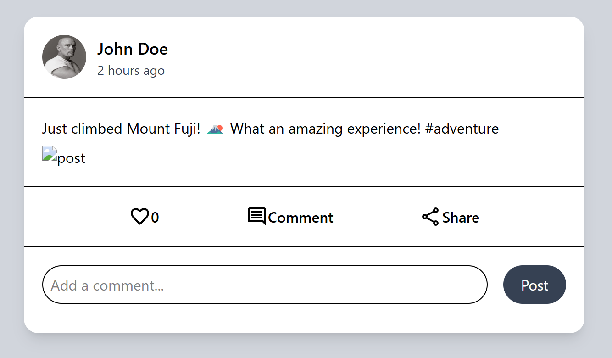

<!DOCTYPE html>
<html lang="en">
<head>
<meta charset="UTF-8">
<meta name="viewport" content="width=device-width, initial-scale=1.0">
<title>Document</title>
<script src="https://unpkg.com/@tailwindcss/browser@4"></script>
</head>
<body class="bg-gray-300 flex items-center justify-center mt-5 mb-5 min-h-screen w-full">
<div class="bg-white rounded-2xl shadow-lg w-[50%]">
<div class="flex m-5">
<img src="att/pp.webp" alt="profile" class="rounded-4xl h-12 w-12 mr-3">

<div >
<h2 class="font-medium text-lg ">John Doe </h2>
<p class="text-gray-700 text-sm">2 hours ago</p>
</div>
</div>
<hr>
<div class="m-5">
<p class="flex mt-4" >Just climbed Mount Fuji! <img src="att/mtfj.svg" alt="pic" class=" h-6 ml-1 mr-1"> What an amazing experience! #adventure</p>
<img src="" alt="post" class="mt-2 ">
</div>
<hr>

<div class="m-5 flex justify-evenly font-medium">
<p class="flex"><img src="att/like.svg" alt="" > 0</p>
<p class="flex"><img src="att/cm.svg" alt=""> Comment</p>
<p class="flex"><img src="att/share.svg" alt=""> Share</p>
</div>
<hr>
<div class="flex justify-between m-5 mb-8">
<input type="text" name="" id="" placeholder="Add a comment..." class="w-[85%] rounded-3xl p-2 border-1">
<button class="bg-gray-700 w-[12%] text-white rounded-3xl">Post</button>
</div>

</div>

</body>
</html>

