Q2. Frequency De-Mixer: Unwanted Solo
In music production, sound engineers often need to manipulate audio to restore or enhance recordings. One common challenge is removing unwanted sounds from a mixture — whether it’s background noise, an instrument played out of sync, or an element that simply doesn’t belong.
You are given a music track that has been corrupted by the presence of unwanted instrumental beats, disrupting the intended harmony.
Your task is to:
1. Analyse the frequency characteristics of the input.
2. Design and implement an appropriate filtering technique using Python to suppress the interfering component.
3. The goal is to recover the original song as faithfully as possible and export the cleaned version.
Requirements
- Use various analysis tools:
  - Bode graphs
  - Power Spectral Density (PSD)
  - Pole-zero plots of your system design
- Isolate frequency regions that contain the unwanted instrumental beats.
- Design filters accordingly to remove the unwanted solo instrumental music.
Deliverables
- Your Python code for the filter design and implementation.
- The restored audio file.
- A detailed explanation of:
  - Your method
  - Your filter design choices
  - Your frequency isolation strategy
- Include transfer function plots, Bode plots, PSD plots, and pole-zero plots.
This system is known as a Frequency De-Mixer.

Analysing the Frequency content of the audio file:
From what sir told in class that human voice has low frequency content and any instrumental music especially the flute-noise which is present in the audio is a high frequency component. For more detailed analysis I studied the exact frequency range of male human voice and flute music from google.
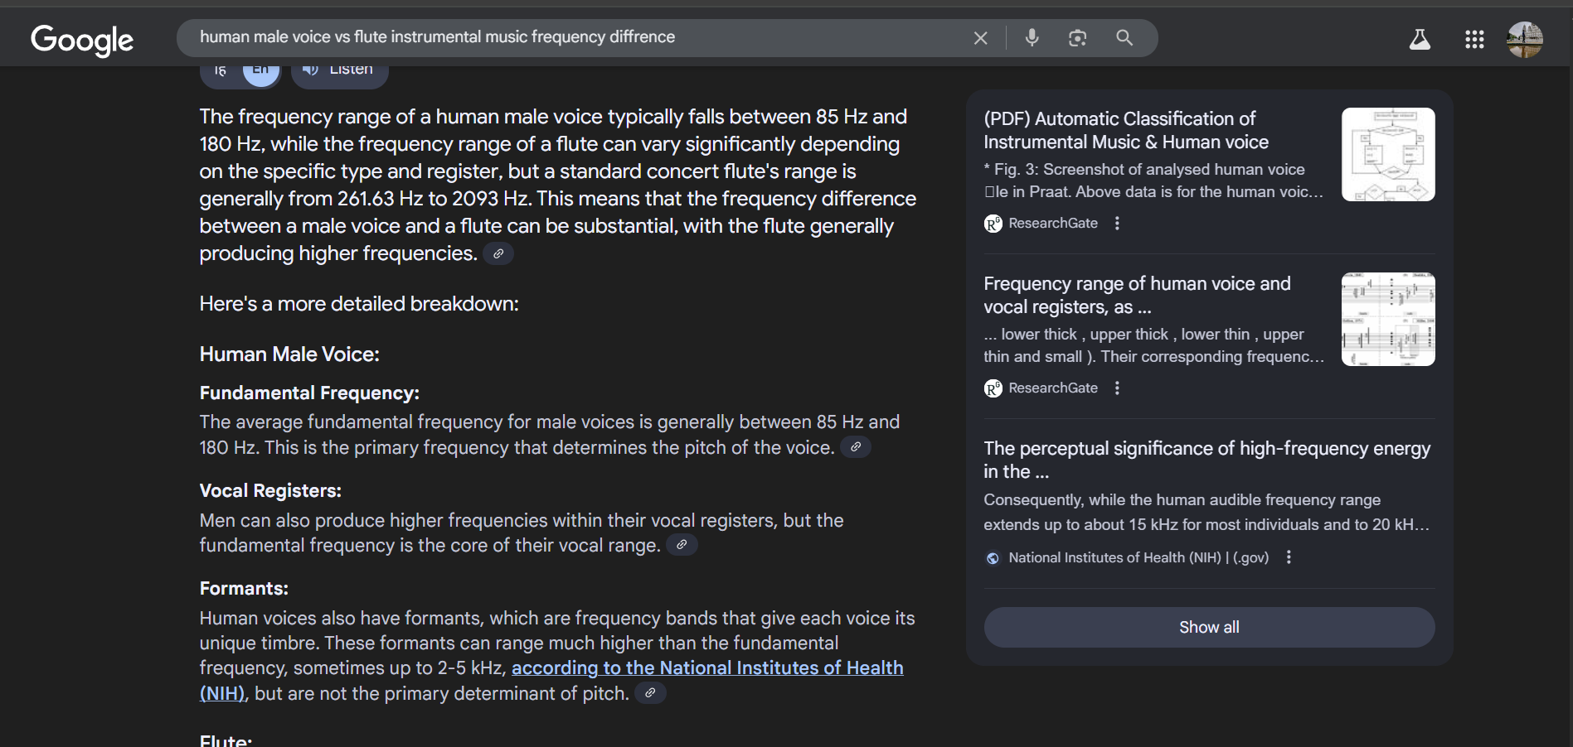

The waveform of the audio file:
From this making any observation is tough. It does not give any visual clarity of what frequency and what is running in the audio file.
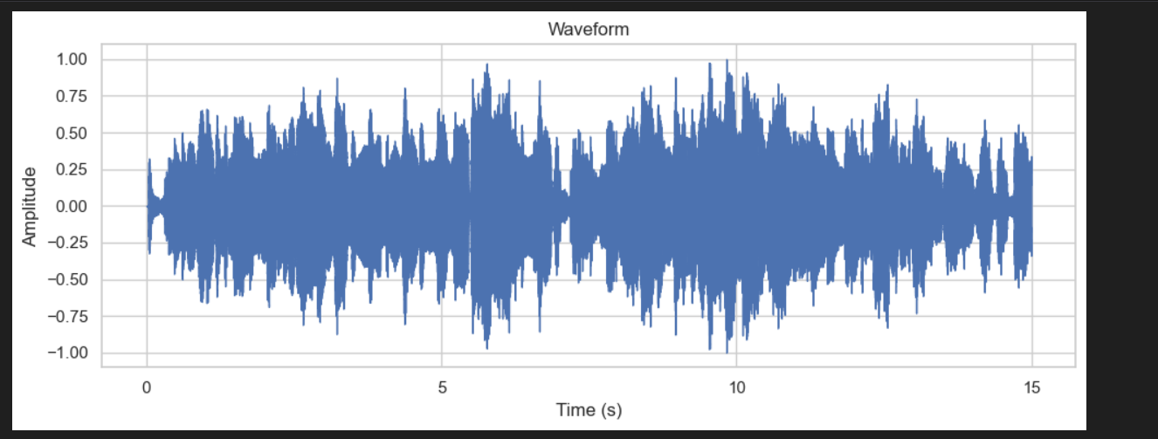
The magnitude(dB) of each frequency component in audio vs frequency plot 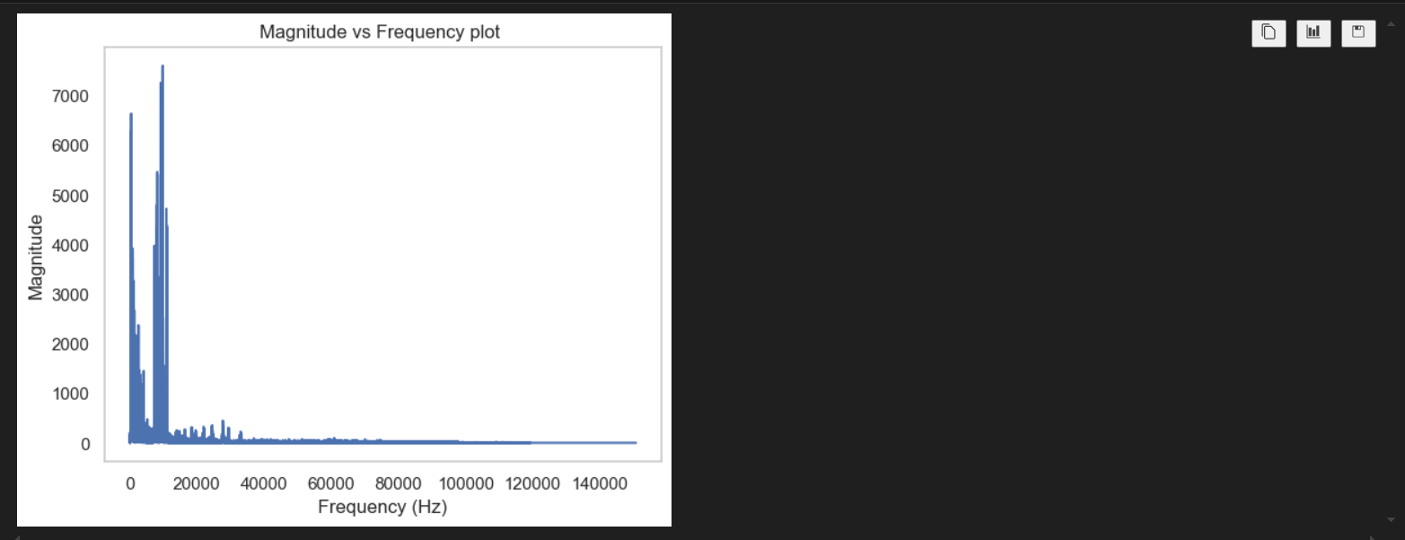
So, we can see that there are two major peaks in the graph. One frequency component naturally corresponds to human male voice and the other higher frequency component corresponds to flute music.

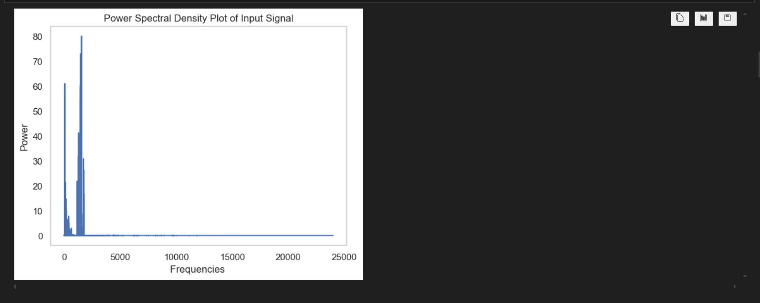
The same observation can be drawn from the Power Spectral Density. Here the observation is even clearer as power spectral density uses the square of the mod of the Fourier Transform.

Design and implement an appropriate filtering technique using Python to suppress the interfering component.
Filter Choice:
From all the analysis that I did in the previous pages, it is clear there is need for a low pass filter to filter out the human male voice and to remove the flute sound as cleanly as possible
For this, naturally we need a low pass filter. But now question is of what type of low pass filter.
I had done two attempts. My progress in both the approaches are given and filter design and everything is given below:

Attempt 1: Ideal Low Pass Filter Use
Status: semi-failure or semi-success
I have used the ideal low pass filter to filter out the audio earlier. This somewhat worked and give pretty decent removal of flute sound but the sound of the man became bit muffled which was a issue.
The Transfer function:
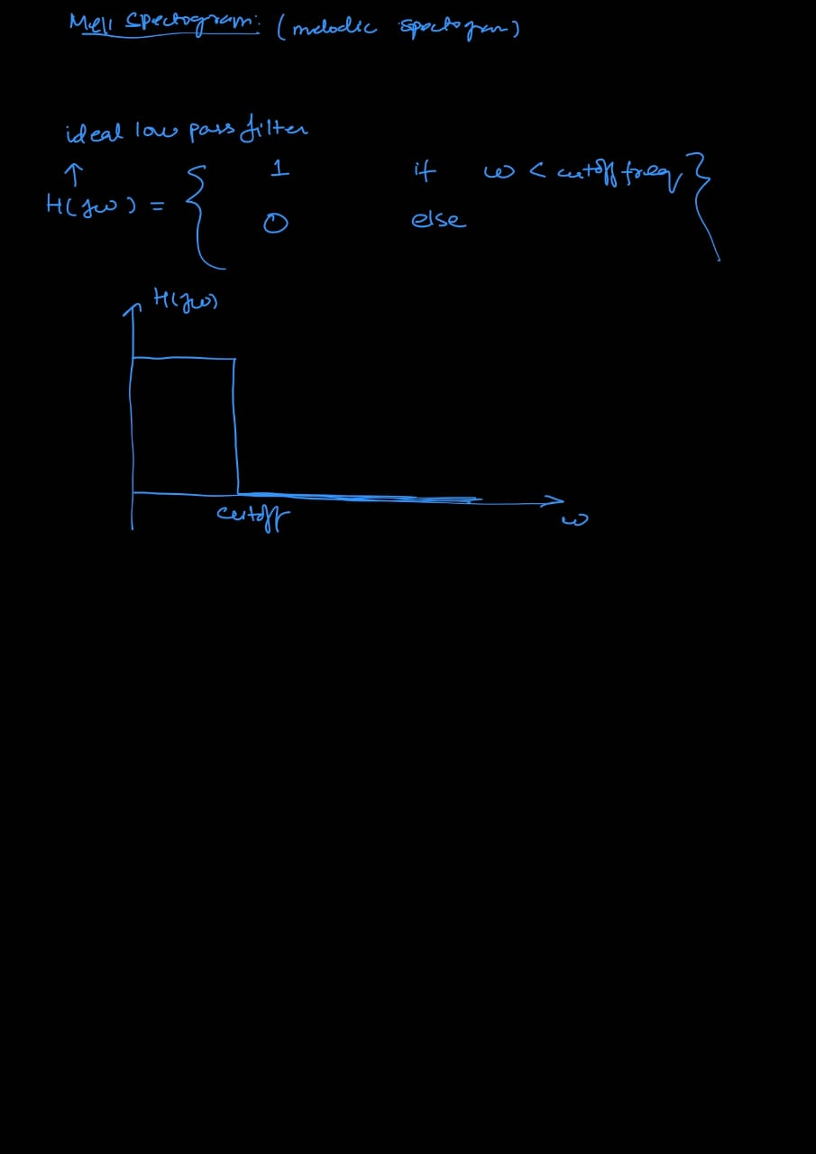

The Transfer function plot:

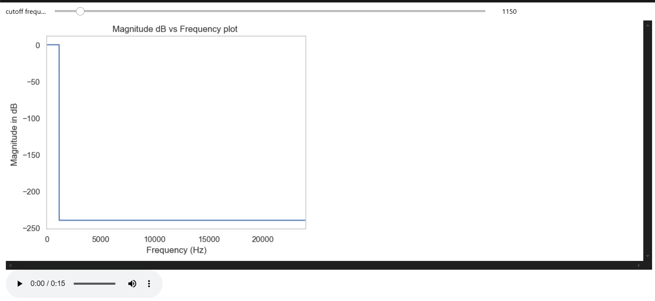
Here again I have implemented interactive python in the code where we can change the cutoff frequency as per our ears to know where there is no flute music. From my playing with the slider, it comes down at 1150 cutoff frequency for this ideal low pass model.

Transfer function Pole-zero Plot:
Since I have used the ideal low pass filter, the pole-zero plot for this function is not possible as there is no rational polynomial by rational polynomial representation of the transfer function. So pole-zero analysis can not be done. That is why I switched for a different model in attempt 2 as if I do not list the pole-zero plot I would not get marks.
Output:
The output of this model is pretty decent actually just there is some distortion of the human male voice.

Attempt 2: Butterworth filter use
Status: 0.51Success
I have implemented the Butterworth filter which is in the slides of the lecture containing Laplace Transform Part 2. This slide was not taught in class but took inspiration from it and implemented in python
    - The Transfer Function:
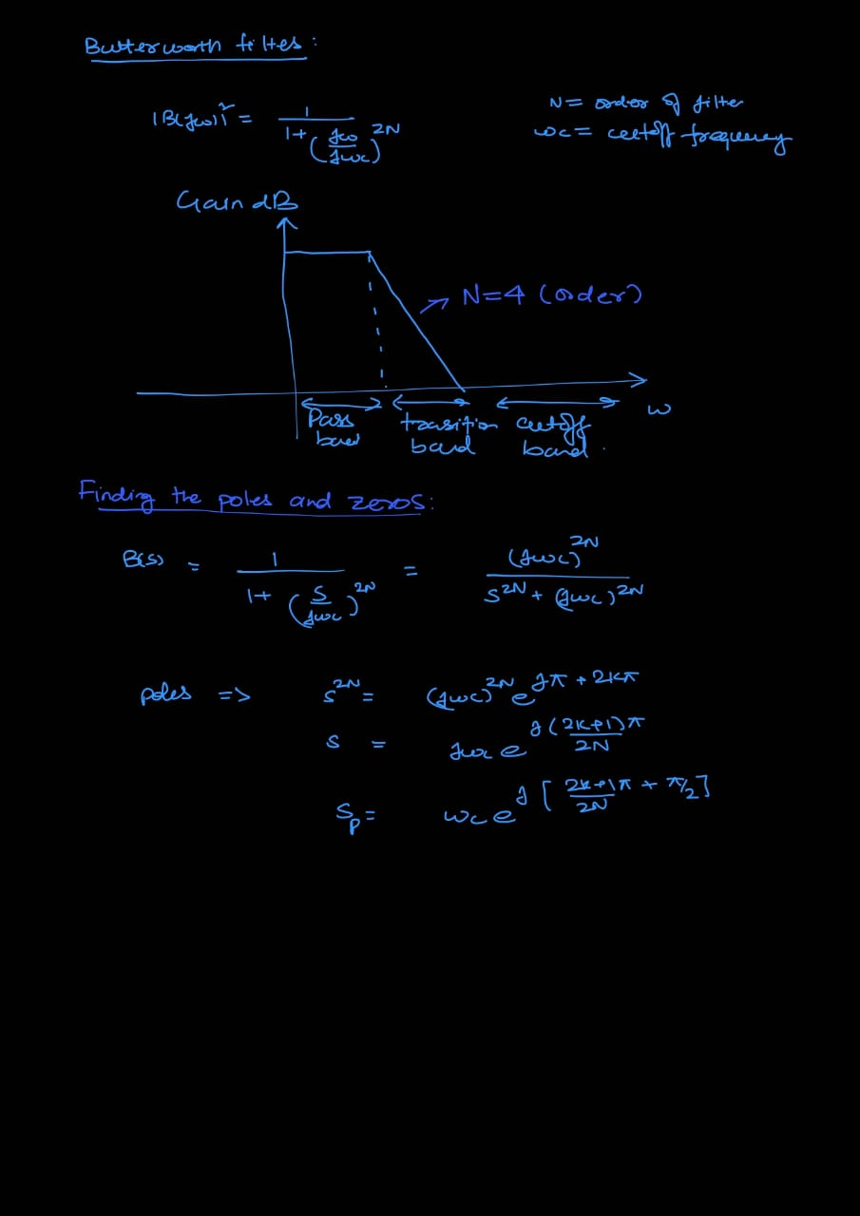

Dependence on N:
For different order of the Butterworth filter, the filtering becomes sharper. If we increase the value of N, then the transition bands become more and more narrower and hence there is more rigid filtering and we decrease it the filtering is a bit relaxed. I did not know what order is suitable for my purpose so I added slider where we can adjust the filter order also. From observation, 4-6 work best. There is no significant improvement if I increase the order more than 6.

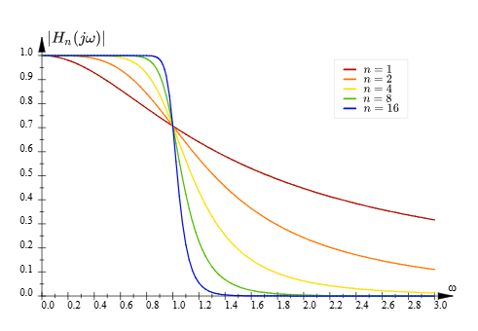
2. The Transfer function Plot:
a. Magnitude Bode’s Plot
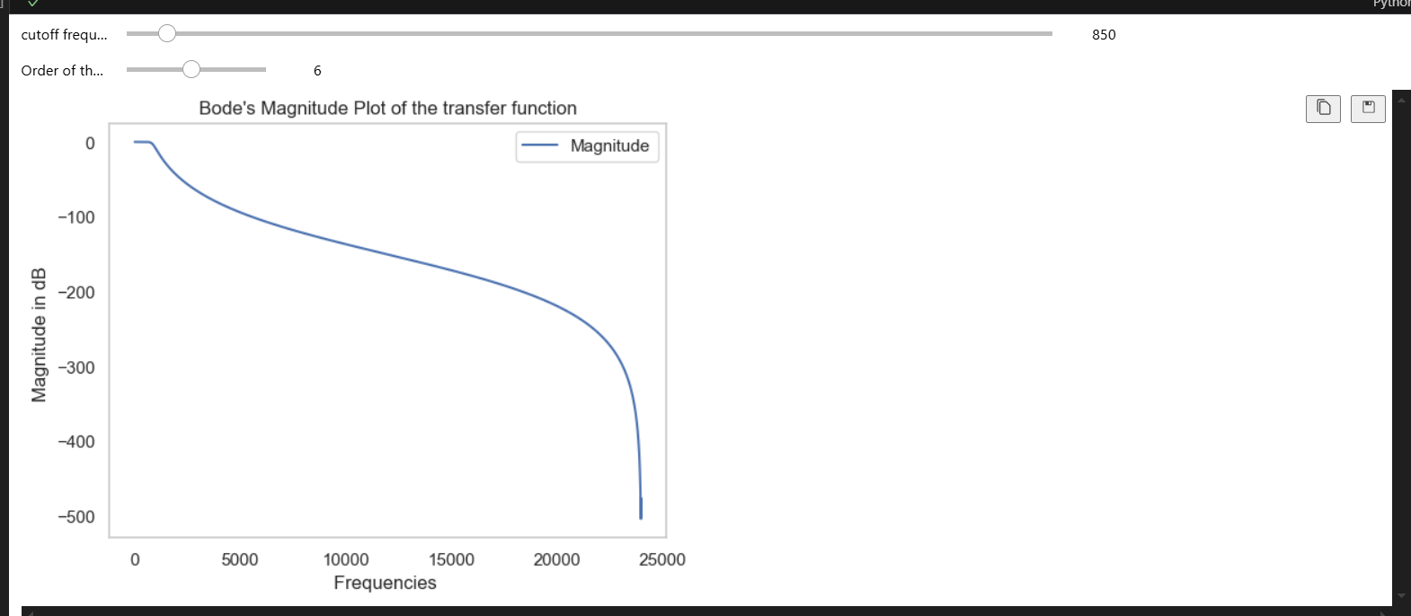

b. Phase Bode’s Plot:
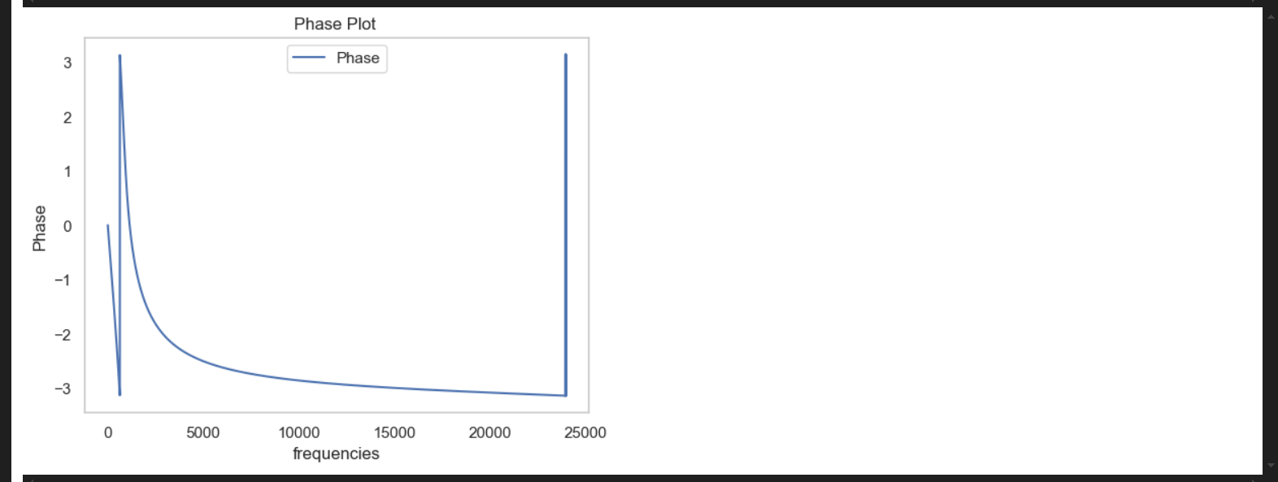

3. Pole zero plot:
I have calculated the zeros and poles of the plot by hand also. And we can see there is no zeros for the transfer function only there are poles. Also all the poles lie on a circle of radius wc which is our cutoff frequency.


But what we observe is different in python. I searched for it and found out using GPT that the digital Butterworth filter which is predefined in python is different from the theoretical Butterworth filter. Both are pretty close but there is difference. The digital one for the sake of stability pushes the poles inside the unit circle which makes sense and in this process of changing the poles, it automatically induces one zero on the left of the graph which we can see.
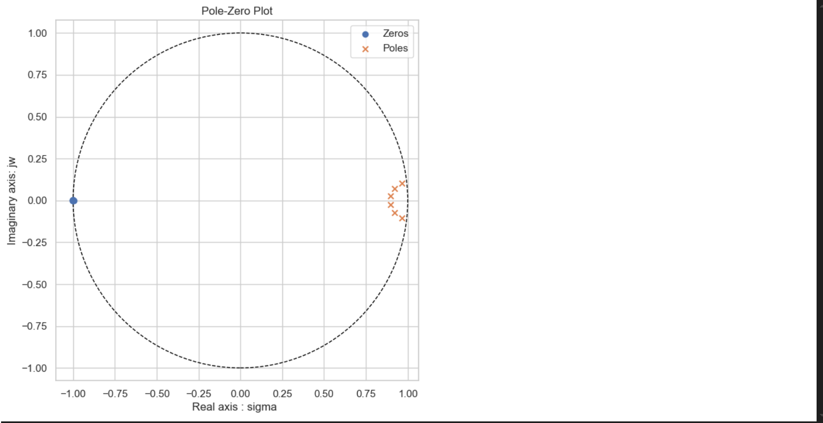

Output:
I have implemented again the interactive layout to actually now what should be the right cutoff frequency and the right order of the Butterworth Filter.
Best results are in:
Cutoff range from 800 to 850
Order of the filter: 6
For this audio a cutoff of 800 frequency was applied. This result not as great as the previous one. The attempt1 audio seems to be better.

BIBLOGRAPHY:
ChatGPT Prompts: GPT has only been used to enhance the code
https://chatgpt.com/share/68693da7-684c-8010-8952-b7589709f917
https://chatgpt.com/share/68693dd2-8c44-8010-b5c9-e5eb575dbef7
Geeks for geeks: For implementation of Butterworth filter
https://www.geeksforgeeks.org/python/digital-low-pass-butterworth-filter-in-python/
Theory part of Butterworth filter:
From lecture of Laplace transform part 2
https://www.electronics-tutorials.ws/filter/filter_8.html
Audio Processing Tutorials used:
https://youtu.be/ZqpSb5p1xQo?si=RTa5S496643IkHEo
Also the tutorial attached with this file

