Problem Statement

Q1. Frequency Mixer: Beauty and the Blur
Our visual system instinctively selects the appropriate scale to extract relevant details from an image. For instance, signs of aging — like fine wrinkles — are usually captured in the high spatial frequency components of an image. Thus, the visual system uses various spatial frequencies for different face categorizations.
An image I (x, y) is a finite aperiodic 2D discrete signal with intensity variations in both the x and y directions. To analyse its frequencies, we need to find the 2D discrete variable Fourier transform of I (x, y).
When you look at the example image from close proximity (or when you widen your eyes from the same distance), you can see Einstein. When you look from far away (or when you squint your eyes, keeping only a narrow part of the eyelid open from the same distance), you can see Marilyn Monroe.
This demonstrates that low-frequency components carry the overall structure (e.g., colour gradients), while high-frequency components capture fine details (e.g., edges).
Tasks
1. Write the equations governing the 2D discrete variable Fourier transform.
2. Use Python programming to:
- Directly calculate (using available library functions) the 2D Fourier transform of any one of the input images given to you.
- Plot its magnitude spectra in:
  - Normal form
  - dB form
3. Answer these questions:
- Where is this spectrum centred at?
- Can you shift it to make the lower frequencies located at the centre of the 2D transform?
4. Answer the following questions
- Rotate the input image anti-clockwise by 90 degrees.
- Plot its 2D Fourier transform magnitude spectra.
- Compare this spectrum with the original image’s spectrum.
- Write your observations.

5. Write a Python code to creatively fuse the given two images.
- One image provides the fine details.
- The other provides the overall structure.
- This will result in a new image where different frequencies contribute to different perceptual information.

6. Write all the details and transfer function 2D plots of your designed system. This system is known as a Frequency Mixer.

Deliverables
- Equations.
- Python code.
- Plots (original, shifted, rotated spectra).
- New fused image.
- Transfer function plots.
- Your written observations.

Image,part1 code refers to the Q1 to Q4
Image.part2 code refers to Q5 and Q6

Answer

- Here is handwritten solution:
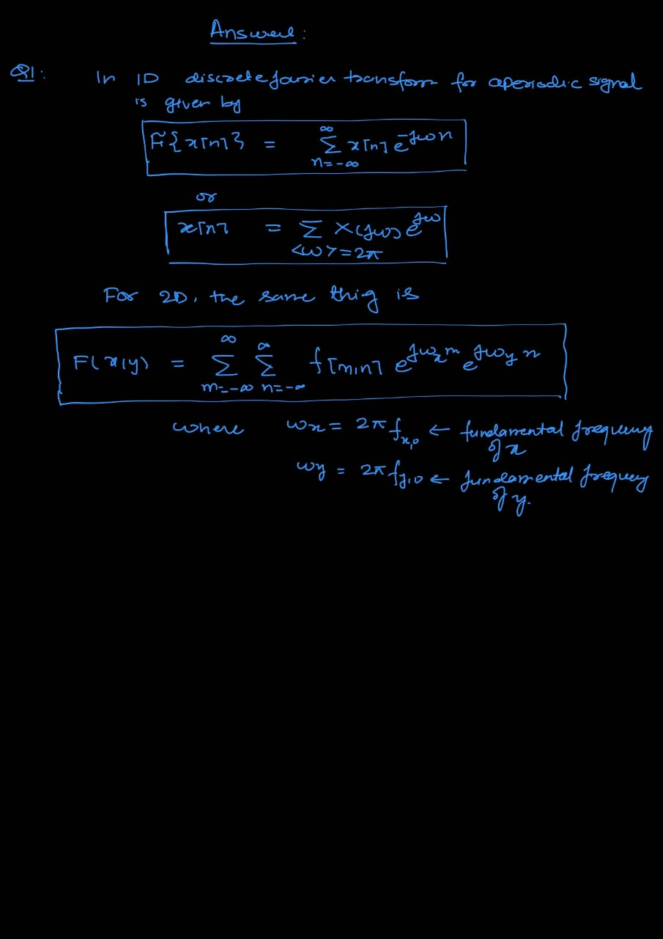

- I have taken the cat image as my image for the image_processing part. Here is the output of the cell
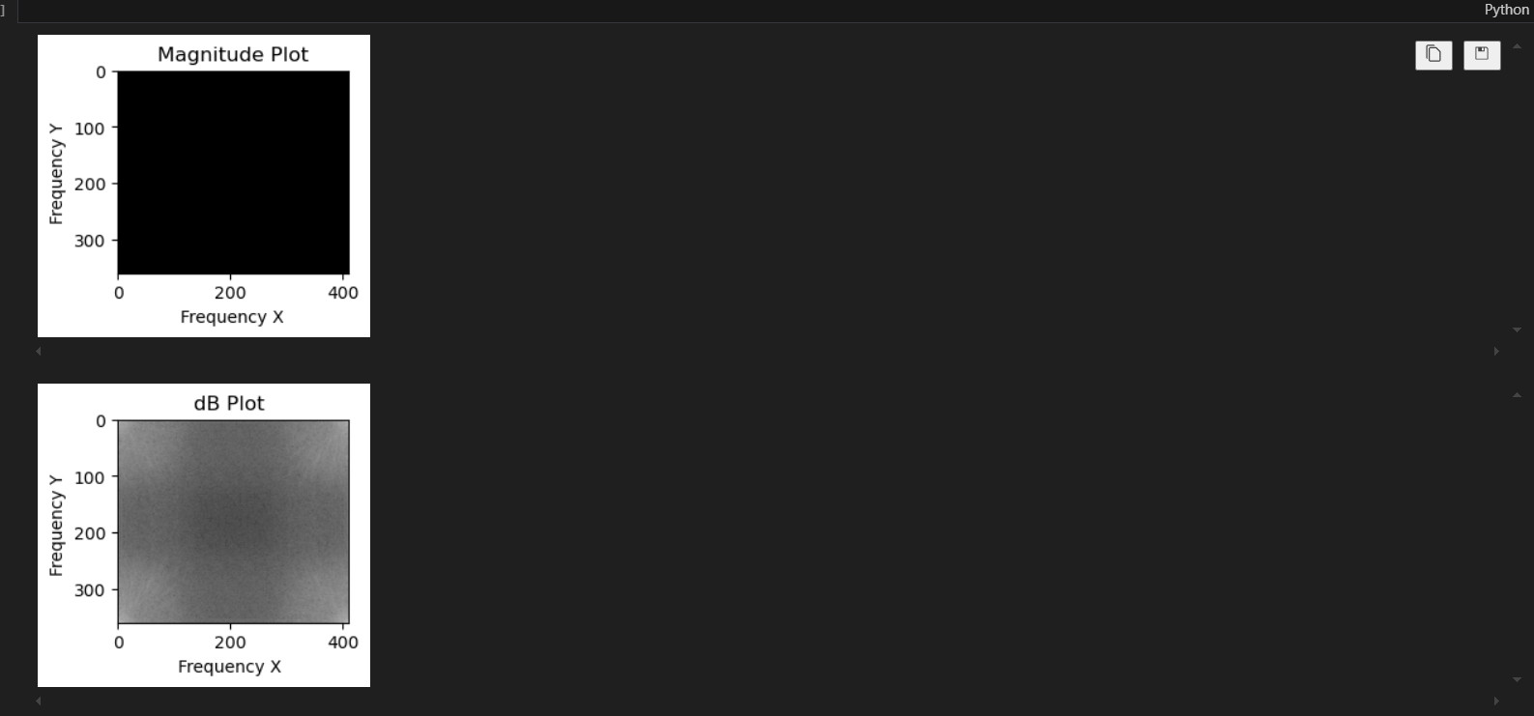

- Where is the spectrum centred at ?
Ans: The spectrum is centred usually refers to the DC component of the 2D discrete Fourier transform so for that m=0, n=0 and that is the origin. In our plot, by default np.fft.fft2(img) function sets the spectrum at the top left corner of the output image

- Can you shift it to make the lower frequencies located at the centre of the 2D transform?
I have implemented the code in python by using the function np.fft.fftshift and the DC component now is centred at the centre of the 2D transform. The output cell is attached for verification

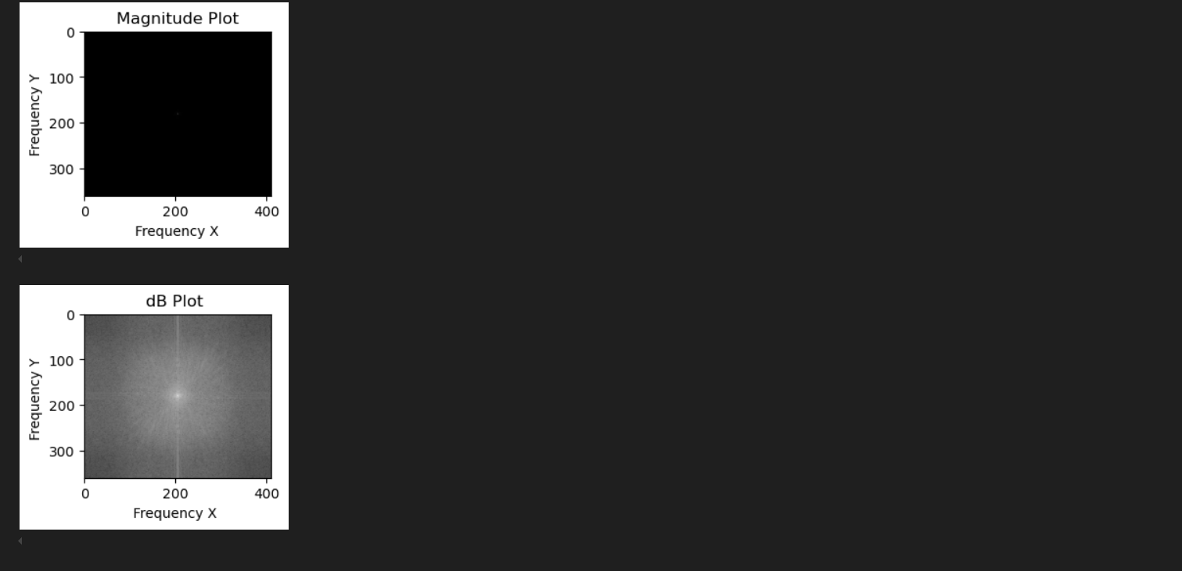

- Answer the following questions
- Rotate the input image anti-clockwise by 90 degrees.
- Plot its 2D Fourier transform magnitude spectra.
- Compare this spectrum with the original image’s spectrum.
- Write your observations.
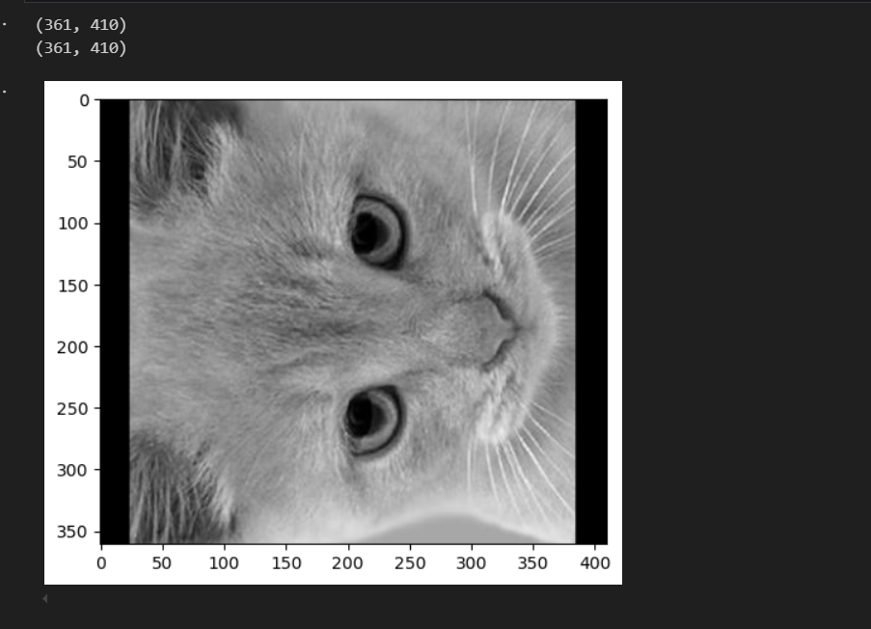

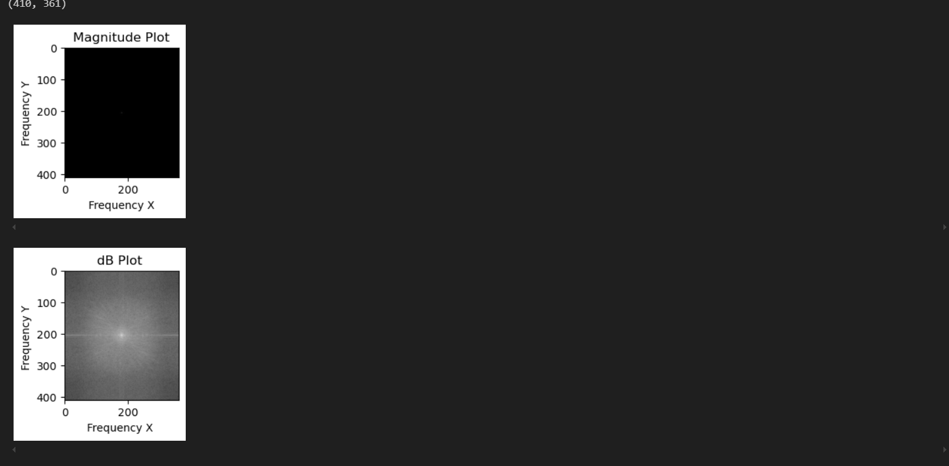

Observation:
My observation is that the Fourier transform of the original signal rotated by 90 CCW is equal to the Fourier transform of the 90-degree CCW rotated image. This can be confirmed from the graph of the two plots. I have tried for mathematical array equivalence for the two but have failed and my failed work is attached in the code also. Also, my intuition and logic how did I come up with this thought is also attached in some trials here and there in from of code.

- Write a Python code to creatively fuse the given two images.
- One image provides the fine details.
- The other provides the overall structure.
- This will result in a new image where different frequencies contribute to different perceptual information.

The inspiration for the code has been taken from the last two python tutorials given in the website tut-6 and tut-8. I have added interactive python template used in tut-8 to decide the right cutoff frequency for the fusion. Moreover, my code is very flexible and we can change which image we want as low frequency fine details and high frequency base image.

For the best results, what I have observed by playing with my code countless number of times, cat should be the fine detailed image component while dog is best for the base component of the fused image and cutoff of around 14-16 works the best. Depending on the perception of vision one can change the fusion mixture very easily on his own perception of eyes.

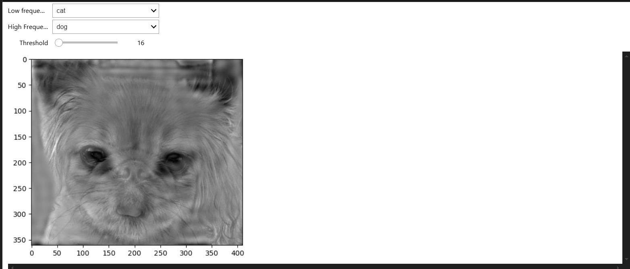
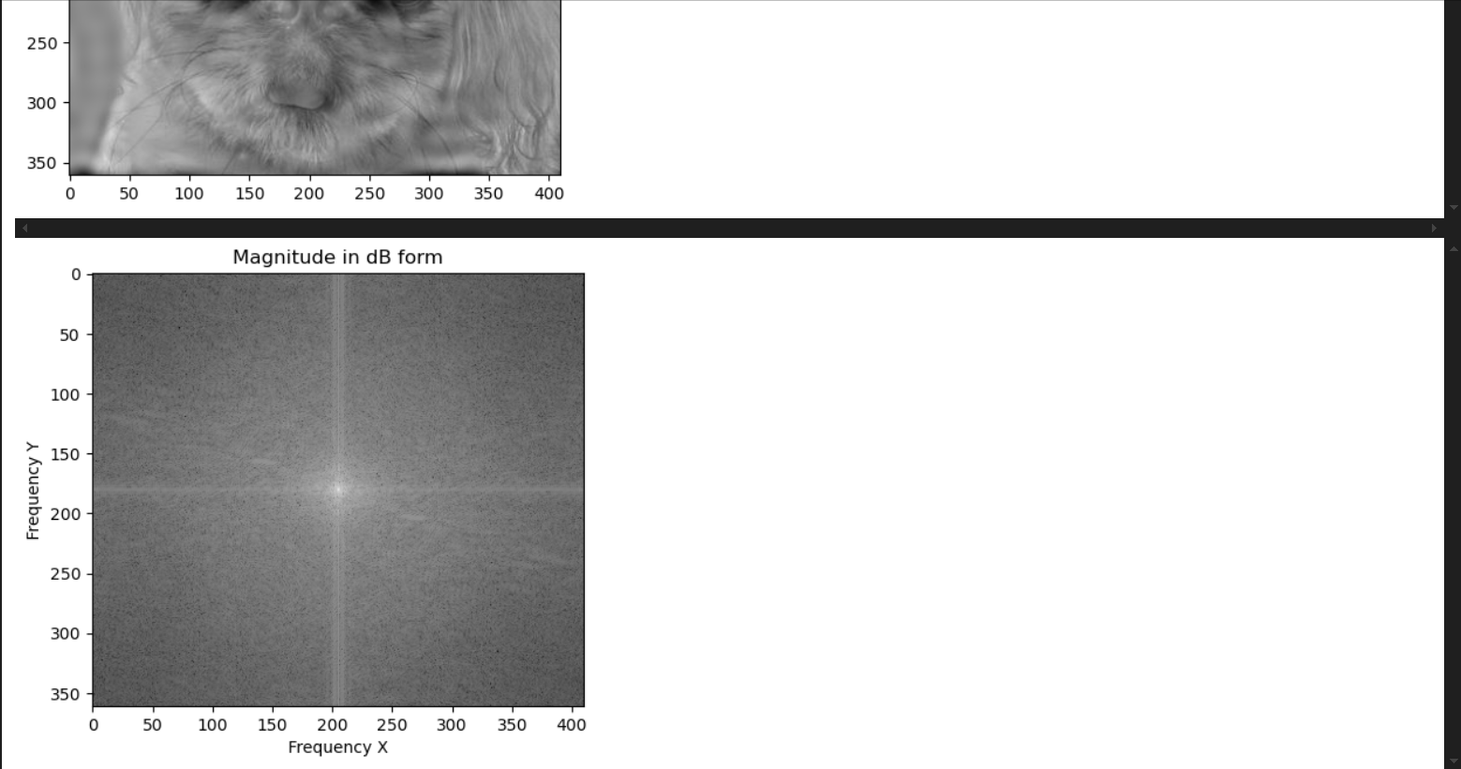
Above is the interactive fusion layout. Panels are there for you to change the cutoff or threshold as per your convenience and also the low and high frequency component images can be decided what you want. The graph of magnitude in db vs frequency is also linked to widgets.

Here is the more zoomed fusion mixture image:
Near viewing: Dog image
Far-viewing: Cat image
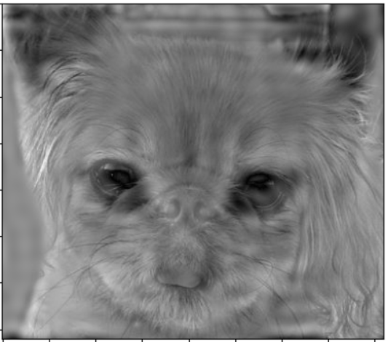
- Write all the details and transfer function 2D plots of your designed system. This system is known as a Frequency Mixer.
Working of the code explained in brief.
So, in simple sense we have the two images. I found out the shifted Fourier transform of both the signals using Fshifted function, then I created LPF function and HPF function which stands for Low pass and High Pass naturally. We pass one image we decide to be the fine detailed component through the LPF and the base image component through the HPF. Then our filter function merges the two Fourier transform obtained upon filtering and then takes the Fourier inverse of the net Fourier transform to get out fused image and we have plotted the Fourier transform of the fused image against frequency in dB plot for visualization purposes.

Working of the Filter:
Inspiration for the filter has been taken from the aperiodic rectangular pulse taught in class. So, what comes natural to mind is a circular filter for the 2D world of signals. I have implemented this.
Now I extend the idea in 2D. Our filter is a radial filter. Since i shifted Fourier transform matrix, all the lower frequencies are attached at centre and higher frequencies at the corners, I have used D: distance matrix to calculate the distance between each index of the Fourier shifted matrix.
Now I have defined the threshold which is user-based input similar to what has been taught in assignment 6 and 8 of the coding portion. Our LPF function removes all the higher frequencies from the signal based on the threshold and vice versa the HPF does it job using the same threshold. Filter function merges the two images as linear combination of LPF and HPF of the two images respectively.
And we get our fused image!!

Transfer Function 2D plots:
Here is the handwritten transfer function and the hand-drawn 2D plots for the same

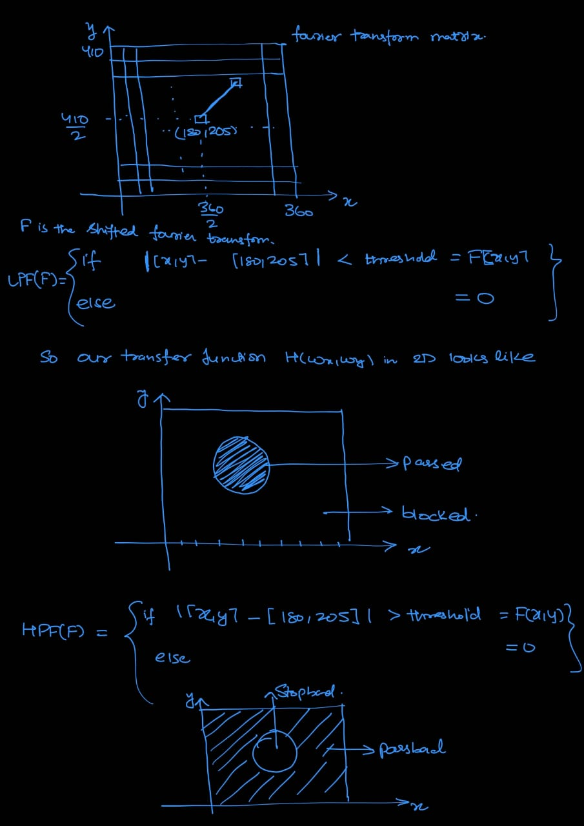

BIBLOGRAPHY
ChatGPT prompts:
https://chatgpt.com/share/68694165-b20c-8010-adc3-72f114681aa8
https://chatgpt.com/share/68694175-48b4-8010-a6e3-531e5475fde6

Theory for 2D fourier transform:
chrome-extension://efaidnbmnnnibpcajpcglclefindmkaj/https://www.di.univr.it/documenti/OccorrenzaIns/matdid/matdid027832.pdf
https://youtu.be/Iz6C1ny-F2Q?si=_NQGl5EVTXsrk6lr
https://youtu.be/3gAZ0U66AEA?si=DjelDoAW7CO0y7RG
https://youtu.be/YYGltoYEmKo?si=j_91ifps6EsORVFY

Image processing tutorials used:
Tutorial given in the folder
https://youtu.be/kSqxn6zGE0c?si=Dwvjmi000i07mFi4

