* Method: GET
* URL: http://localhost:4000/api/users

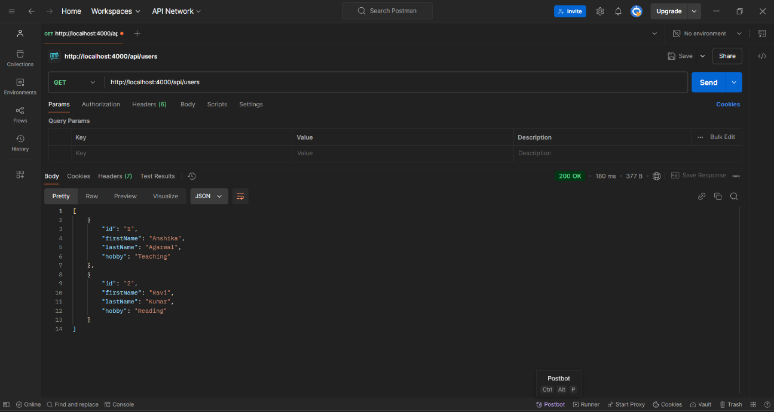

GET User by ID

* Method: GET
* URL: http://localhost:4000/api/users/1

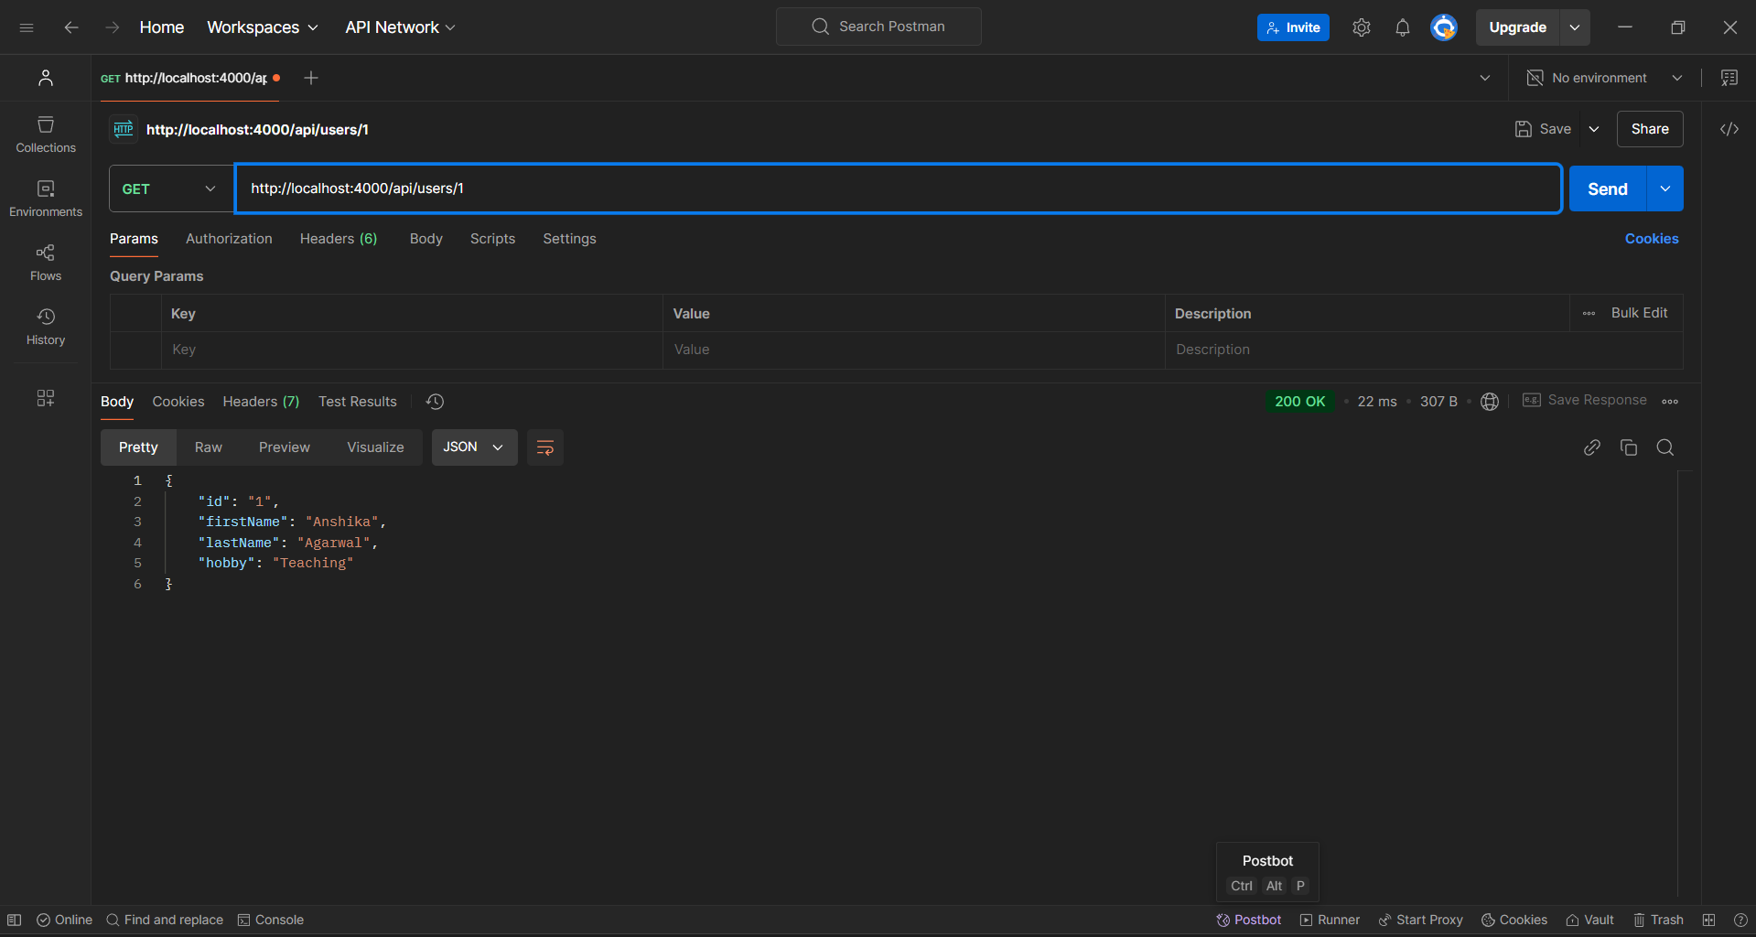

* Method: POST
* URL: http://localhost:4000/api/users

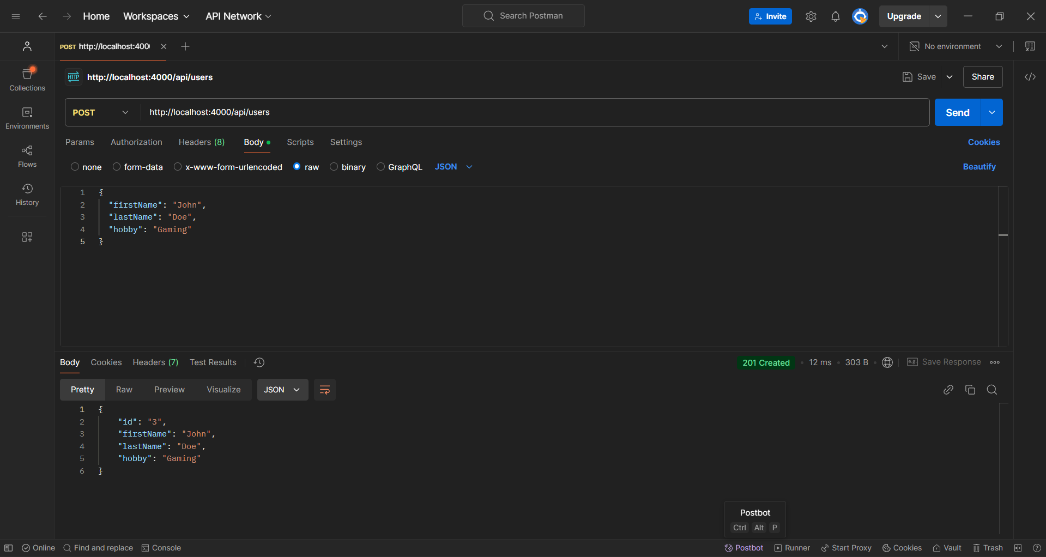

* Method: DELETE
* URL: http://localhost:4000/api/users/3

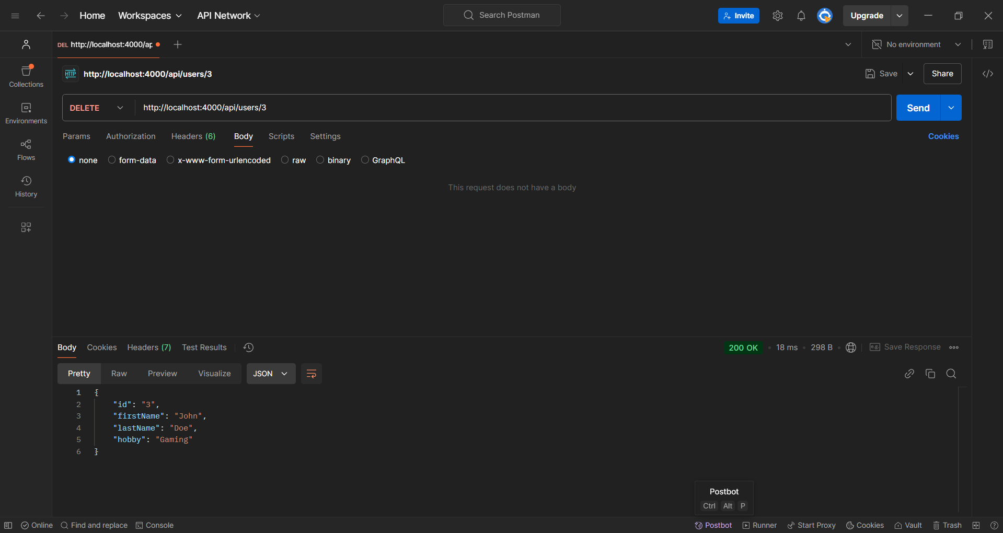

* Method: POST
* URL: http://localhost:4000/api/users

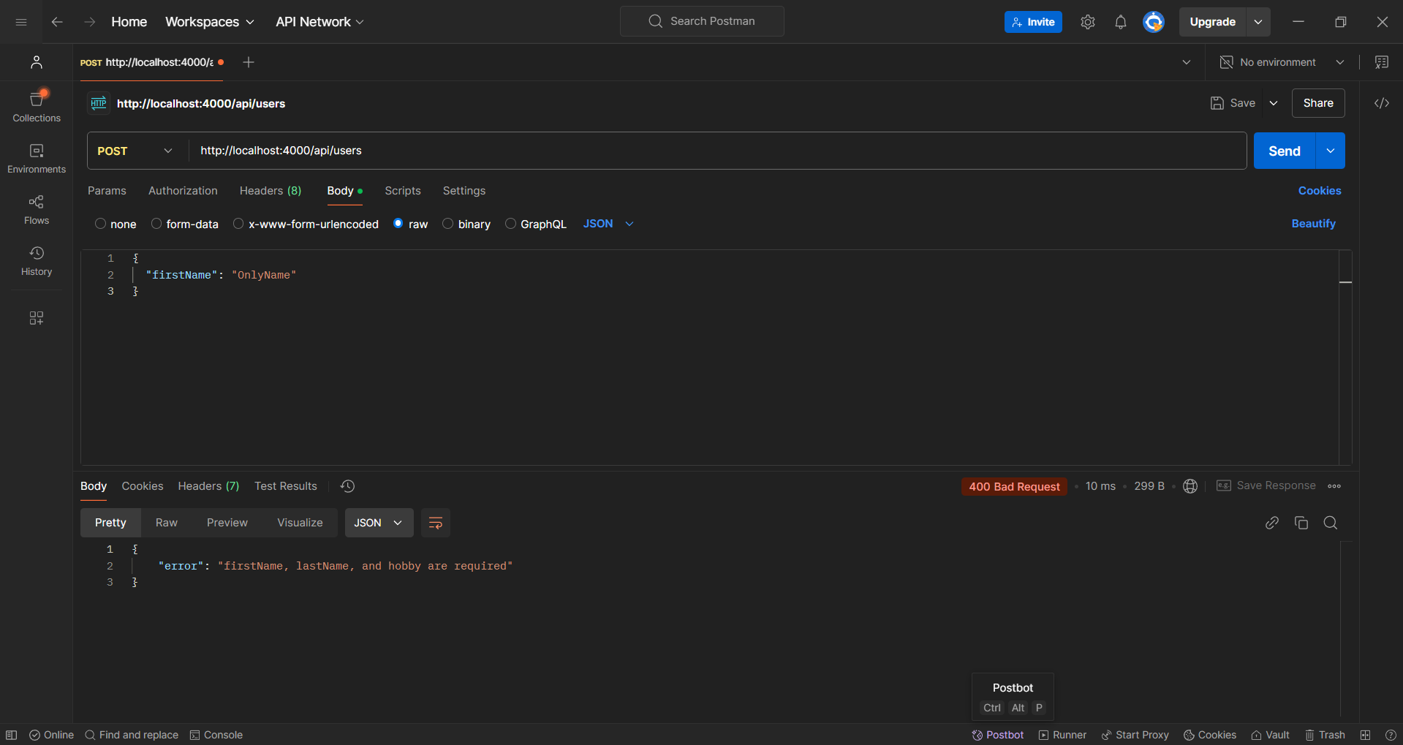

* GET http://localhost:4000/api/users/99

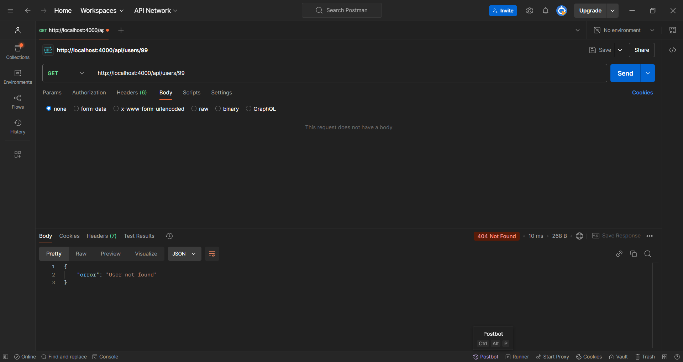

* PUT http://localhost:4000/api/users/88 with full body.

