* Method: POST
* URL: http://localhost:4000/api/users

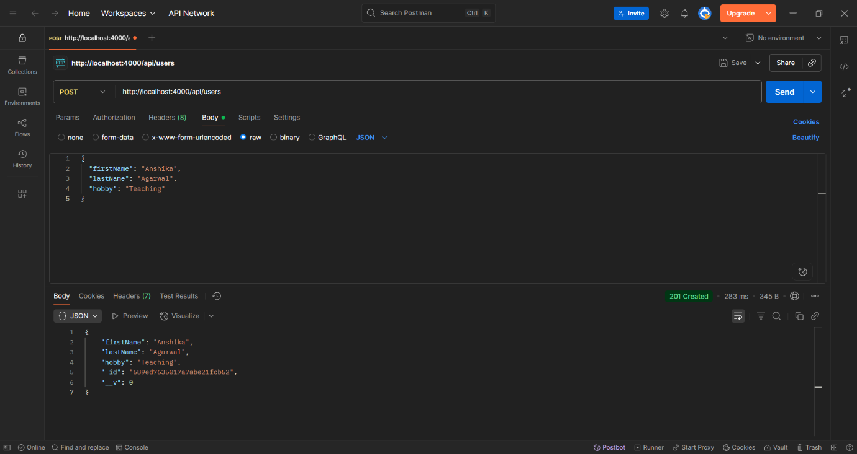

**Update Users:**

* Method: PUT
* URL: [http://localhost:4000/api/users/<id](http://localhost:4000/api/users/%3cid)>

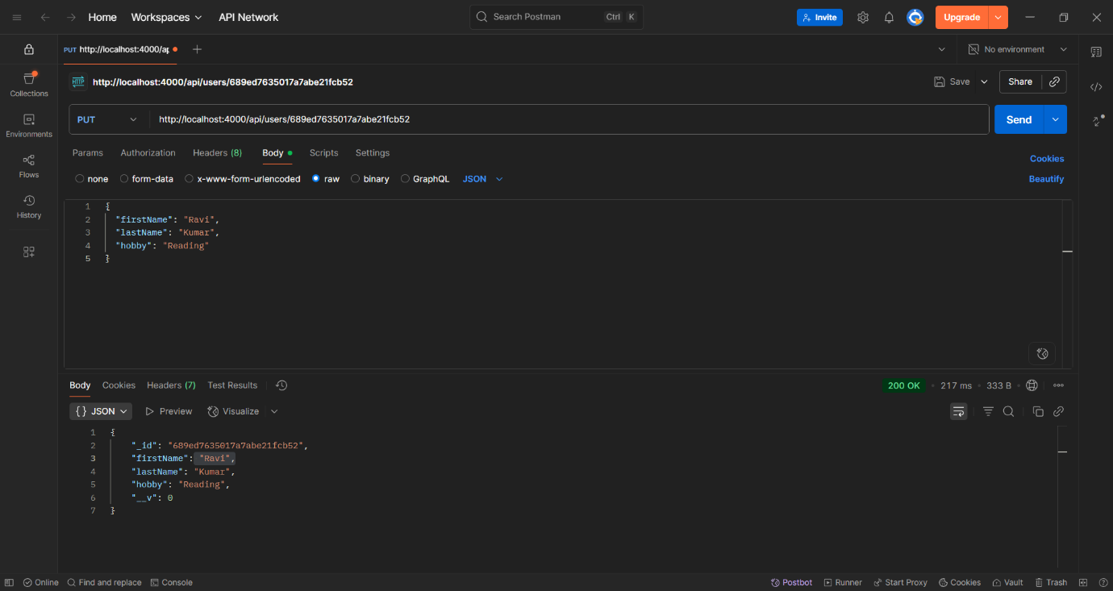

**Delete a User:**

[**http://localhost:4000/api/users/<id**](http://localhost:4000/api/users/%3cid)**>**

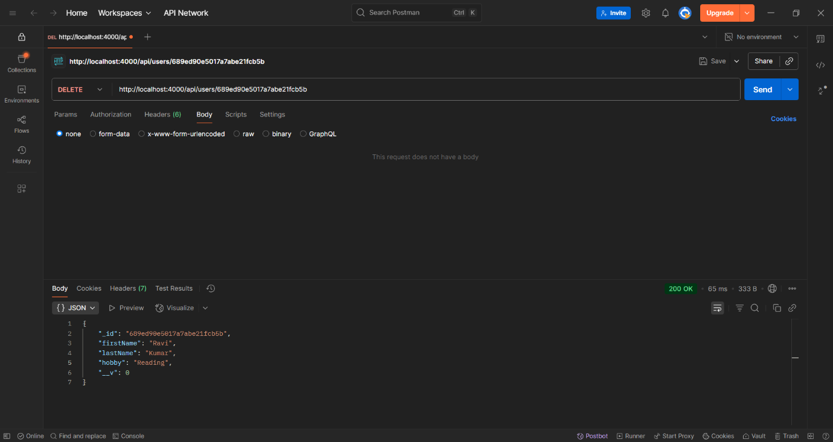

**MongoDB**

