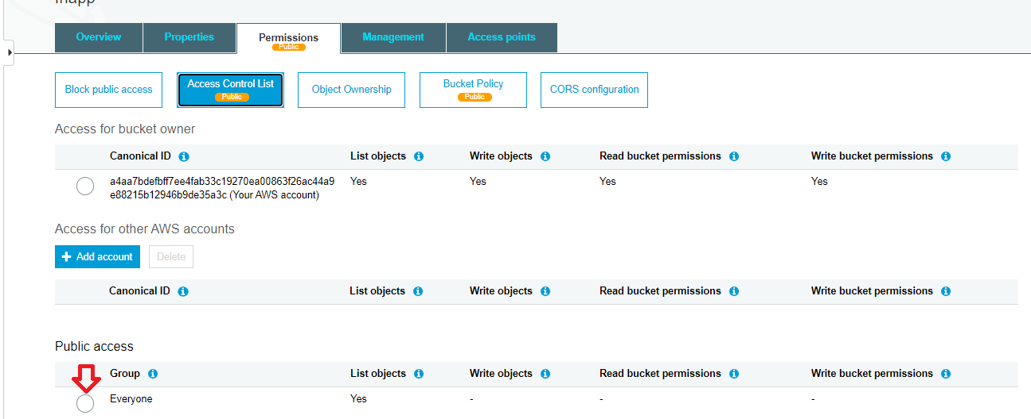

Bucket policy.

{

"Version": "2012-10-17",

"Id": "Policy1601736261212",

"Statement": [

{

"Sid": "Stmt1601736257828",

"Effect": "Allow",

"Principal": "\*",

"Action": "s3:\*",

"Resource": "arn:aws:s3:::fhapp"

}

]

}

CORS

<?xml version="1.0" encoding="UTF-8"?>

<CORSConfiguration xmlns="http://s3.amazonaws.com/doc/2006-03-01/">

<CORSRule>

<AllowedOrigin>\*</AllowedOrigin>

<AllowedMethod>GET</AllowedMethod>

<AllowedMethod>PUT</AllowedMethod>

<AllowedMethod>POST</AllowedMethod>

<AllowedMethod>DELETE</AllowedMethod>

<AllowedMethod>HEAD</AllowedMethod>

<MaxAgeSeconds>3000</MaxAgeSeconds>

<AllowedHeader>\*</AllowedHeader>

</CORSRule>

</CORSConfiguration>