**Process the upload video functionality in local environment.**

Front end application built in: Angular

Back end application build in: Node

Database Server: Mysql.

I have crated the below three repositories.

<https://github.com/VasudevaKumar/videoclient> - Angular application

<https://github.com/VasudevaKumar/videoserver> - Node application

<https://github.com/VasudevaKumar/videodb> - Database table script.

Once download all the source code into localhost, then run the following commands to install the dependencies.

Step 1 : Create db called “vonexpy” and import the sql file.

Step 2:

For angular application :

1. npm install
2. ng server – to start angular application in localhost:4200

Step 3:

For Node application:

1. npm install
2. node app.js – to start node application in localhost:3000

Step 4:

Make sure that upload folder in a correct path in app.js file under node application. Please find the screenshot below.

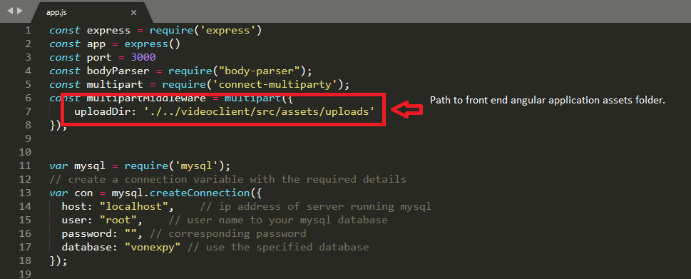

Step 5:

Currently, I configured 2 videos per page we can change that configuration in the displayvideos.component.ts file under angular application.

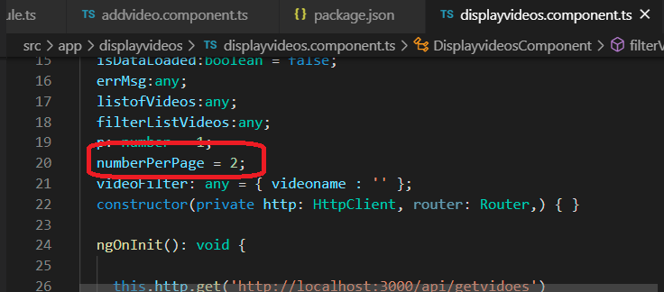

**End**

Screen shot of the application:

List videos.

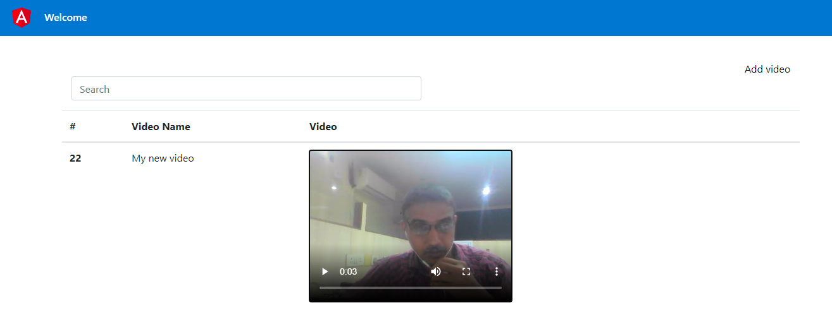

Add videos.

