**Exp. 1 Design A LED Flasher**

**Circuit Diagram:**

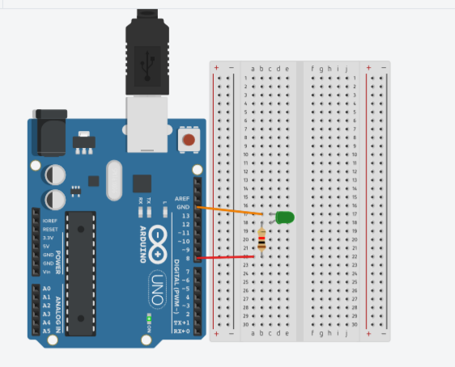

**Theory:-**

Concept Used:

* In Breadboard, the rows on top and bottom are connected in series whereas in middle the connections in columnwise.
* In arduino when Code is passed , it sends signals to LED connected in form of 0 & 1; i.e. when LED is to be switched off ‘0’ is passed else ‘1’ is passed.
* The positive part is connected to digital pins and negative part is connected to ground(GND).

Learning & Observations:

* I learned how to link hardware and software.
* I learned the use of breadboard for connecting LED and resistor in series.
* I observed that LED keeps on blinking infinite times due to code written in loop() .

Problems & Troubleshooting:

* There was problem while uploading code to Arduino , as the port selected was incorrect hence, to solve it I change the PORT.
* LED was not glowing , so had to replace it.
* LED was not bright due to high resistance , so changed the resistor.

Precautions:

* Arduino Board should be kept at dry place.
* Correct Board/Port is to be selected.
* All connections should be tight.
* Proper resistor should be used , so that required amount of current should be passed.

Learning Outcomes:

* How to make proper connection between Arduino and Breadboard.
* Understand the basic code to make LED blink .