**Exp. 4 Smart Phone**

**Controlled Device**

**Circuit Diagram:**

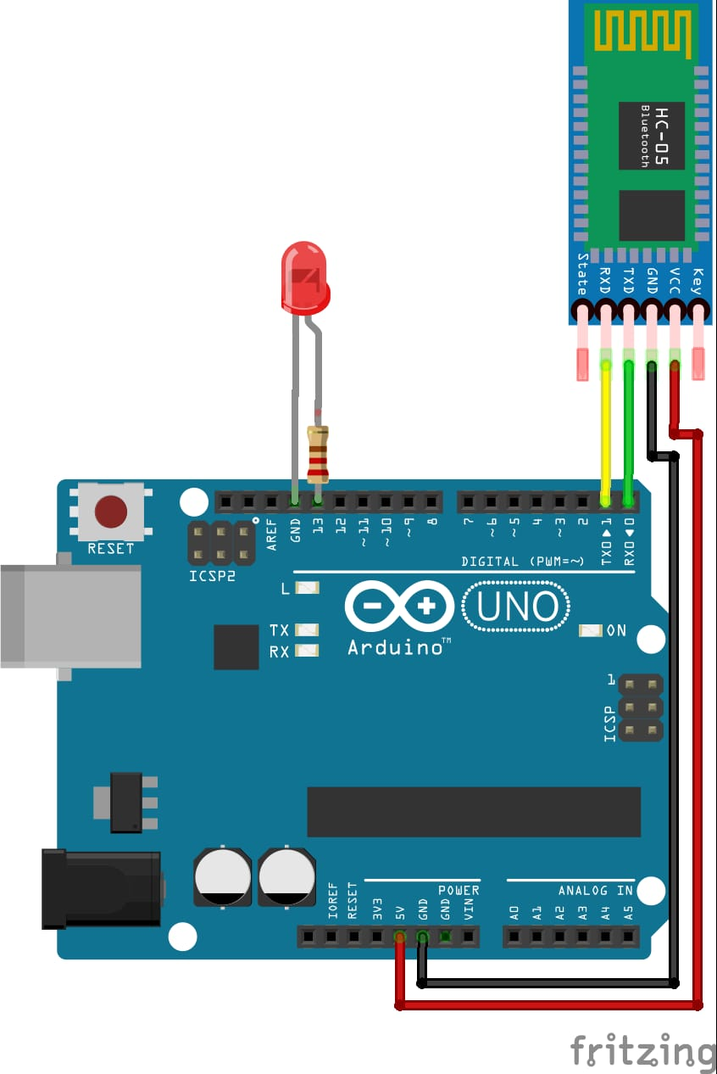

**Theory:-**

# Concept Used:

* the android app is designed sending serial data to the Bluetooth module when certain button is pressed.
* The Bluetooth module at other end receives the data and send to ardunio through the TX pin of Bluetooth module (RX pin of Arduino).
* The Code fed to Arduino checks the received data and compares.If received data is 1 the LED turns on turns OFF when received data is 0.

# Learning and Observations:

* How to control arduino and its coding.
* Controlling of LED through bluetooth.
* Relation between software and hardware.
* Connect Arduino to smartphone Wirelessly.

# Problems& Troubleshooting:

* To select the right port and type of arduino.
* To check the loose connections.
* To check the connections according to the codes
* To check the continuity of the circuit
* To check the flow of current in the circuit
* Errors in code

# Precautions:

* Handle tools carefully
* Remove Bluetooth module Tx Rx connection before uploading the program.
* Do not connect arduino till the circuit is complete
* Do not connect LEDs without a variable resistor
* Appropriate Bluetooth module to be used.

# Outcomes:

* How to make connections between Arduino and Bluetooth device using Breadboard.
* Connect Arduino to phone wirelessly.