Exp. 7 Programmable Digital Data Display System

**Circuit Diagram:**

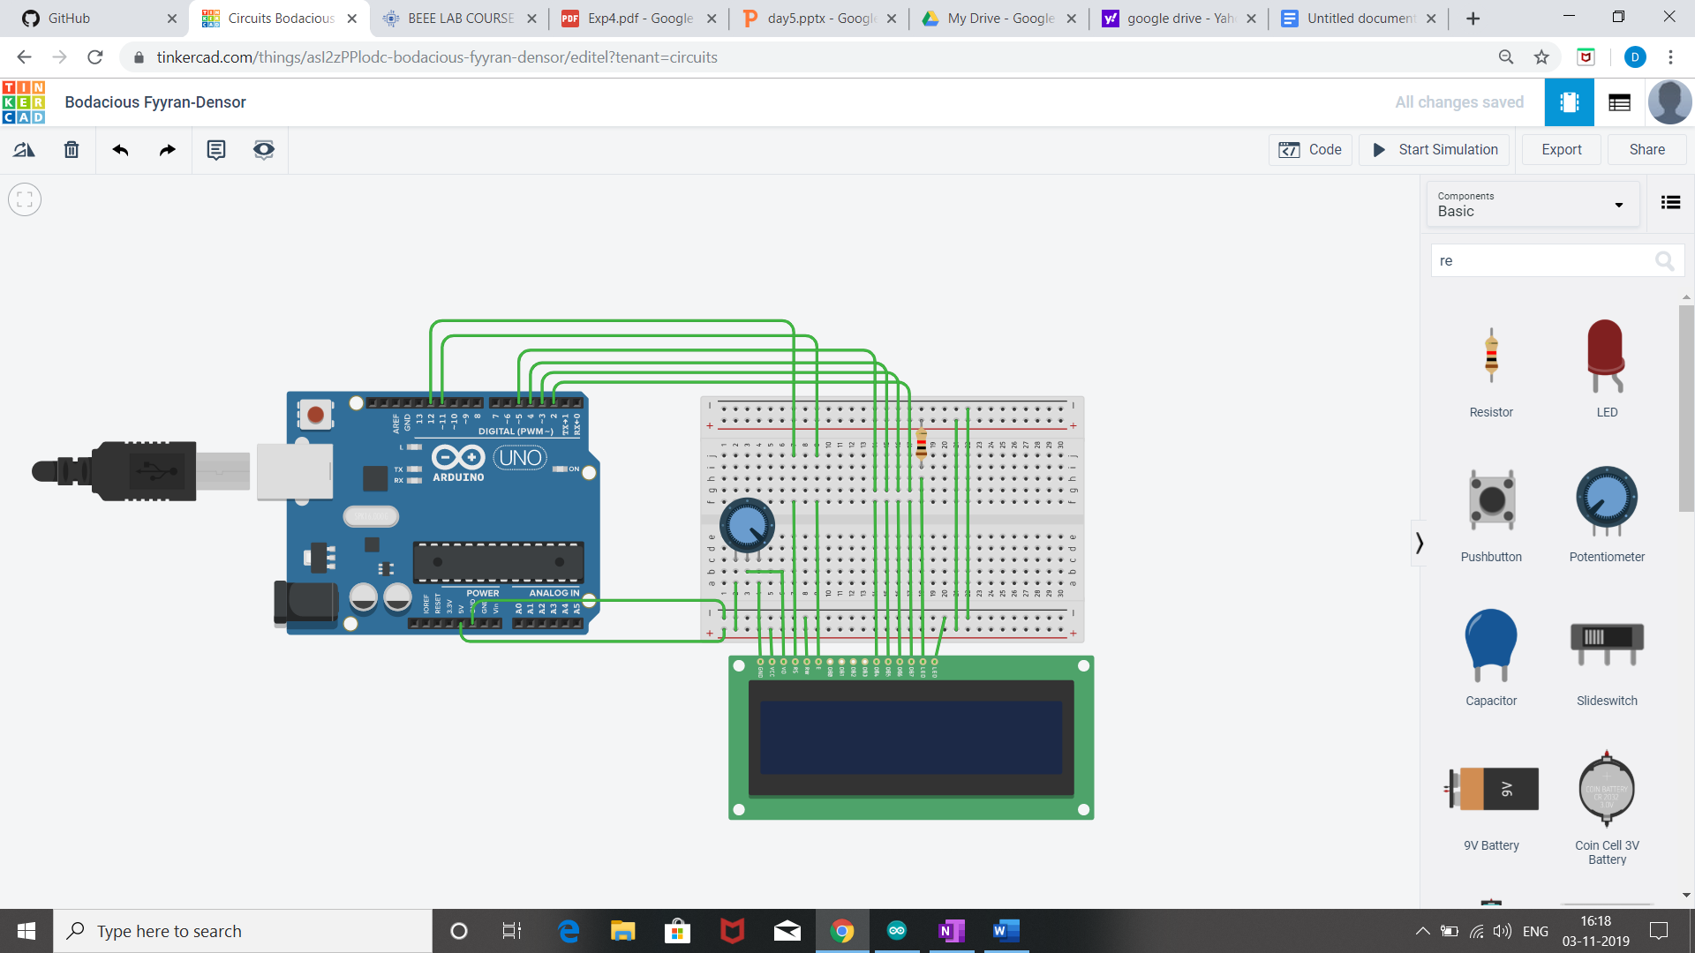

Theory:-

Concept used:

* We have used the concept of LDR(liquid crystal display).
* The LDR is a special type of resistor which allows a lower voltage to pass through it (high resistance) whenever its dark and higher voltages to pass (low resistance) whenever there is a high intensity of light.
* We have used the potentiometer for variable resistance.

Learning and observation:

* The Liquid Crystal library works with all LCD displays that are compatible with the driver.
* Potentiometer keeps voltage difference constant.
* A digital data display of hello world can be seen when you turn on the circuit.
* A in-built library #include <LiquidCrystal.h> is used to reduce the code which already contain the details of connections.

Problem and Troubleshooting:

* Correct Port should be selected.
* End wires of potentiometer should be connected 0 and 5 volt connecting middle wire change the voltage difference.
* Connection should not be loose.

Precautions:

* Arduino Board should be kept at dry place.
* Correct Board/Port is to be selected.
* All connections should be tight.
* Avoid dropping or applying mechanical impact on LDR as it can damage display surface.
* Check the working of LDR beforehand.

Learning outcome:

* I have learnt the use of input library function(<liquidcrystal.h>) for lcd .
* I have learnt how to change the movement of cursor at different location of on display screen.