Report

Section A - Directory structure

I have created index.html, pay.html and success.html which are all collected in a HTML folder. Bookshop.css is embedded in a CSS folder and BookstoreJS.js is put in a JavaScript folder. Each sub folder is stored in the main folder called Assignment. The CSS file is linked to the html file due to the <link> tag and the file is linked inside the “ href “ which allows CSS to be displayed on the HTML content. JavaScript is linked with the <script> tag and “src” allows JavaScript to be called onto to the html.

Section B - Frontend

Section C – RESTful

Screenshot of raw data in JSON sent to the server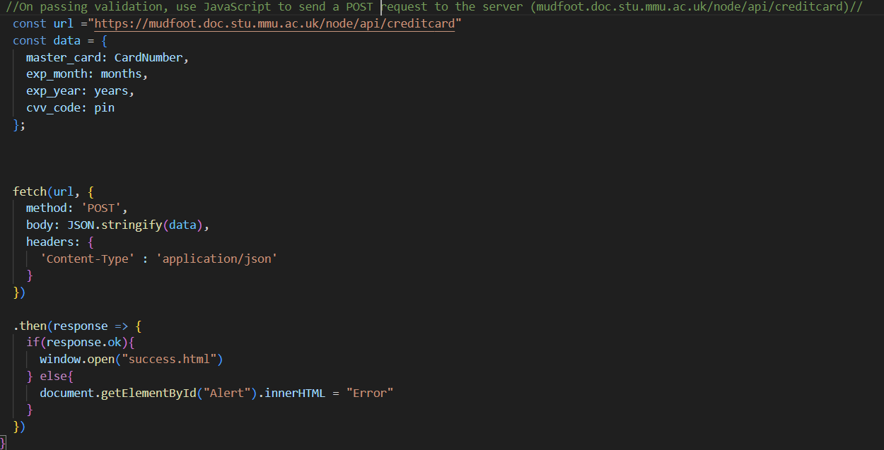

Screenshot of JavaScript verification of wrong credit card details FAILING the verification process.

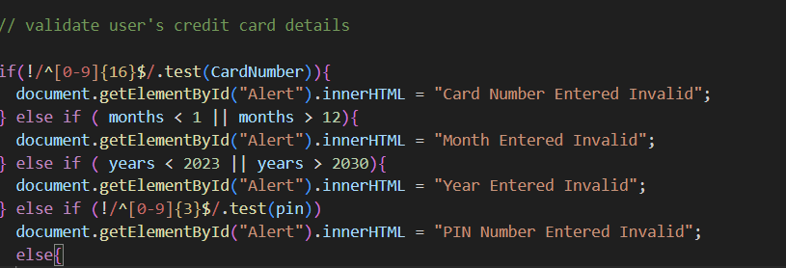

Screenshot of on success (200 OK from the server) the message.

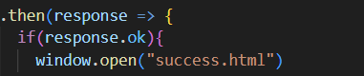



Section D - Usability and accessibility checklist

* Good page design and structure -

It has professional look and clear structure so when user access the website, they can clearly see the text and design of the books. When they look at the books and the information about each book it looks concise and neat. It also has a good page length which allows users not scroll down the page too much. In CSS I’ve added padding and margin to allow spaces between text and image.

* Navigation – The navigation bar has links to the Home, About Us and Contact Us page. This allows quick access to links for the user. I’ve designed the navigation bar by adding styles from CSS so when the user hovers over the link it changes colour, so they recognise it. The user will find it easy to use and it has good consistency when the navigation bar appears on different pages.
* Add ‘alt’ text attribute to images – For accessibility features if a picture does not upload then a sentence of what the image is appears.
* Don’t underline text that isn’t a link – Any text that isn’t link I’ve added “text-decoration: none” so that text isn’t underlined. This allows the user to read the content and is easy to understand.
* Use accessible fonts (e.g. sans serif such as Arial, Verdana)

- I’ve used a standard font (Arial, Verdana) so is easier for the user to read and allows the website to look clean.