|  |  |  |
| --- | --- | --- |
| **EX NO**: 1  **DATE**: 02.02.2023 | **DESIGN A WEB PAGE USING HTML TAGS** | **NAME:** VASUGI M  **ROLL.NO:** 21ADR057 |

**AIM:**

To create a web page by using basic html tags and visualise it.

**PROGRAM:**

**EXERCISE 1.html:**

<!DOCTYPE html>

<head>

<title>ex1</title>

<style>

h4{

color: green;

}

h3{

color: orangered;

}

</style>

</head>

<body style="background: rgb (249, 166, 166);">

<h1 style="color: rgb (43, 225, 43);"><ins>DEPARTMENT OF FOOD TECHNOLOGY</ins></h1>

<h3 style="color: rgb (105, 240, 245);">Head of the Department</h3>

<p> Dr. R. Basker (w.e.f 1.8.2022) </p>

<h3>Programms offered:</h3>

<ul>

<li>Btech Food Technology</li>

<li>MTech Food Technology</li>

</ul>

<table border="2" cellpadding="5">

<tr>

<th>BRANCH</th>

<th>INTAKE</th>

</tr>

<tr>

<td>BTech Food Technology</td>

<td>60</td>

</tr>

<tr>

<td>MTech Food Technology</td>

<td>18</td>

</tr>

</table>

<h3><ins>VISION:<ins></h3>

<p>To become a center of excellence to meet the global challenges in the diversified field of Food Technology. </p>

<h3>MISSION</h3>

<ul>

<li>To impart quality Education through effective teaching learning methods</li>

<li>To encourage students to pursue research activities and to collaborate with industries to promote consultancy activities. </li>

<li>To develop engineers who can participate in the technical advancement and social upliftment of the society. </li>

</ul>

<HR>

<h3><ins>OBJETIVE</ins></h3>

<p>The objective of Food Tech department is to disseminate the knowledge above latest technologies in food related technical concepts to the students so that they cater the demand of builders/contractors and construction industry in and around the institution as well as to the needs of the country and abroad</p>

<HR>

<h3><ins>Program Educational Objectives (PEOs)</ins></h3>

<ul>

<li>To impart quality Education through effective teaching learning methods. </li>

<li>To encourage students to pursue research activities and to collaborate with industries to promote consultancy activities. </li>

<li>To develop engineers who can participate in the technical advancement and social upliftment of the society.</li>

</ul>

<HR>

<h3><ins>Programme Outcomes</ins></h3>

<p>Graduates of Food Technology will:</p>

<ul>

<li><b>Engineering knowledge:</b>Apply the knowledge of mathematics, science, engineering fundamentals, and an engineering specialization to the solution of complex engineering problems.</li>

<hr>

<li>

<b> Problem analysis:</b>Identify, formulate, review research literature, and analyze complex engineering problems reaching substantiated conclusions using first principles of mathematics, natural sciences, and engineering sciences. </li>

<hr>

<li><b>Ethics:</b>Apply ethical principles and commit to professional ethics and responsibilities and norms of the engineering practice. </li>

</ul>

<hr>

<h3><ins>PROGRAM SPECIFIC OUTCOMES (PSOs)</ins></h3>

<ol>

<mark style="color: rgb (8, 8, 8);"> <li>Understand the requirement of the industry and perform effectively with professional skills. </li></mark>

<mark style="color: rgb (7, 7, 7);"> <li>Apply advanced and innovative techniques and methodologies in food and beverages related Practices.</li></mark>

</ol>

<img src="https://kongu.ac.in/departments/foodtech/images/header.png" height="200px" width="1000px">

<br>

<hr>

<h4>MENU</h4>

<ol>

<li><a href="https://kongu.ac.in/departments/foodtech.php#" style="color: rgb (113, 0, 128);">LABORATORY</a></li>

<li><a href="https://kongu.ac.in/departments/foodtech.php#" style="color: rgb (128, 0, 128);">HIGHLIGHTS</a></li>

<li><a href="https://www.kongu.ac.in/departments/civil.php#" style="color: rgb (128, 0, 111);">PATENTS</a></li>

</ol>

<h4 >To get konwledge about faculties of FOOD TECHNOLOGY:</h4>

<br>

<a href="C:\Users\vasug\OneDrive\Desktop\21ADR057 EX1\faculty.html">FACULTY DETAILS</a>

<br>

<p style="text-align: center;">Designed and maintained by KEC CELL</p>

<footer>

<h4>VASUGI M</h4>

<h4>21ADR057</h4>

</footer>

</body>

</html>

**OUTPUT:**

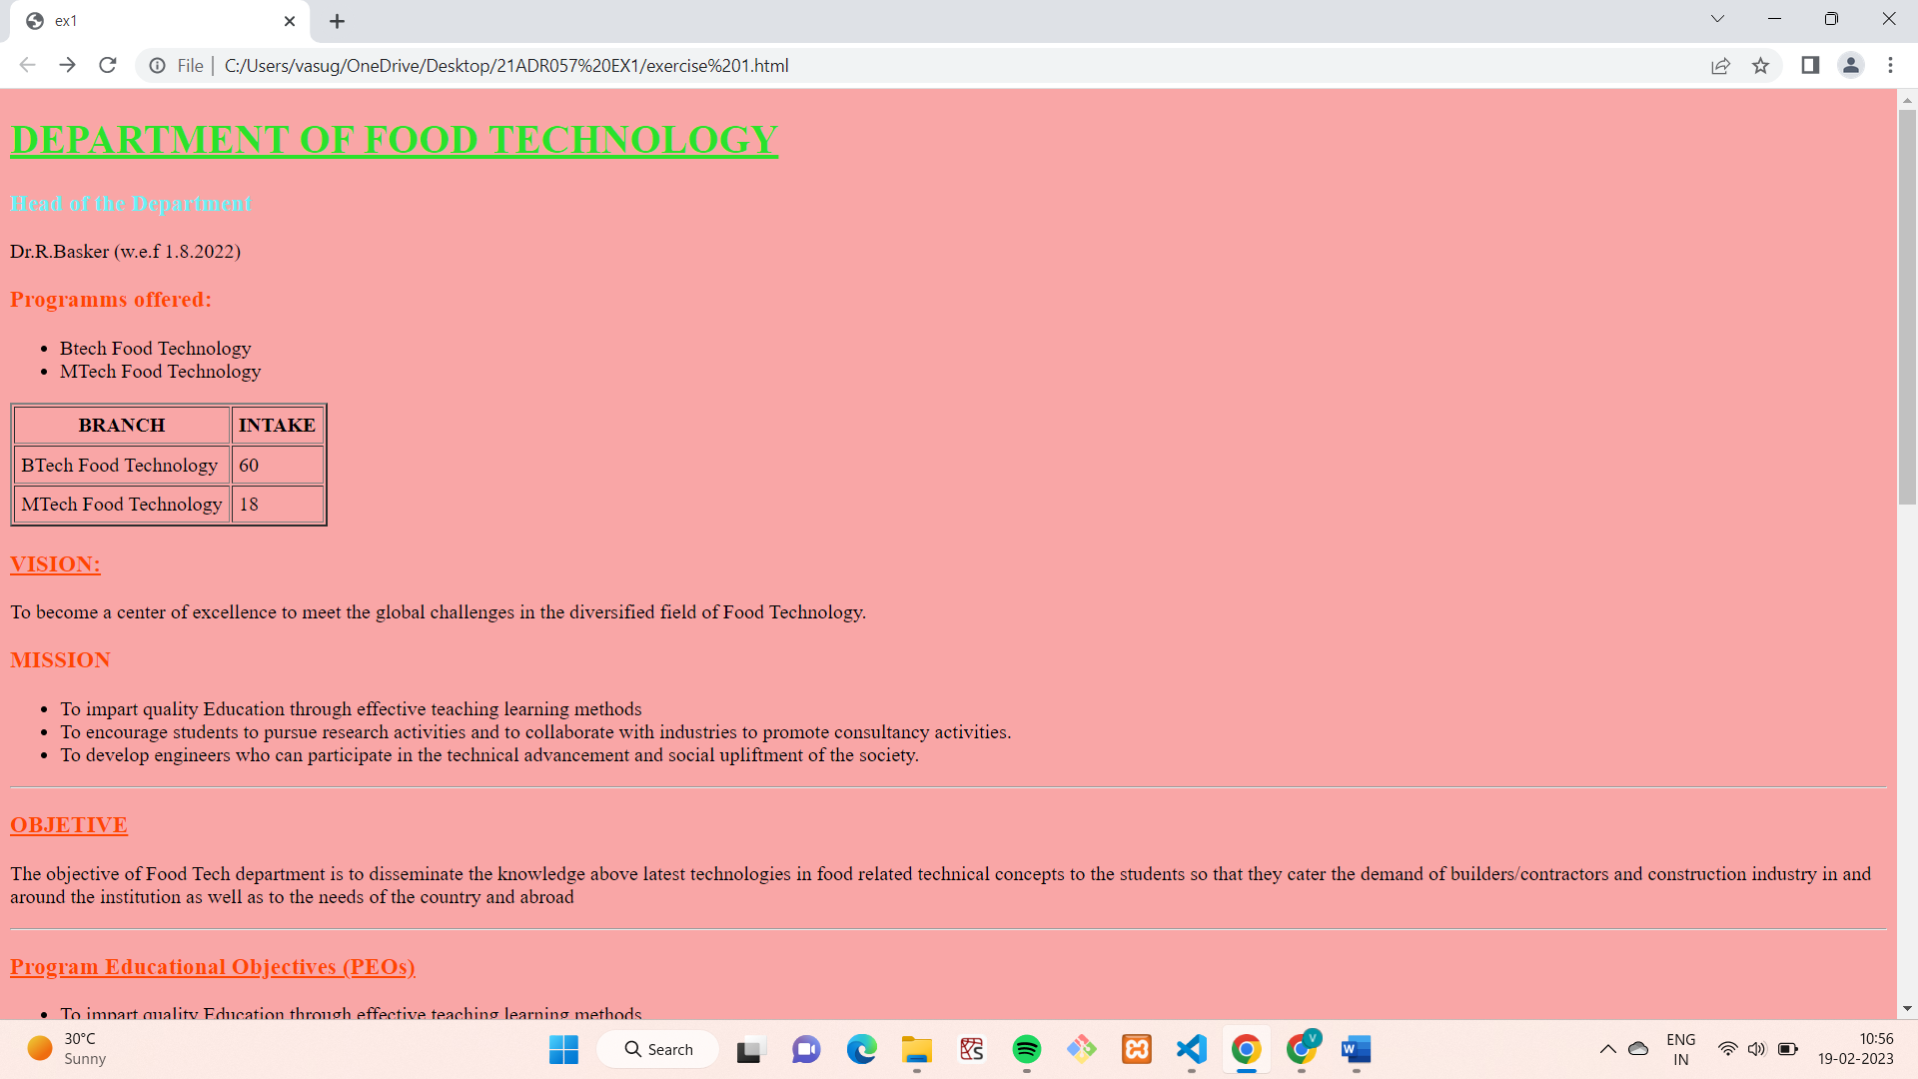

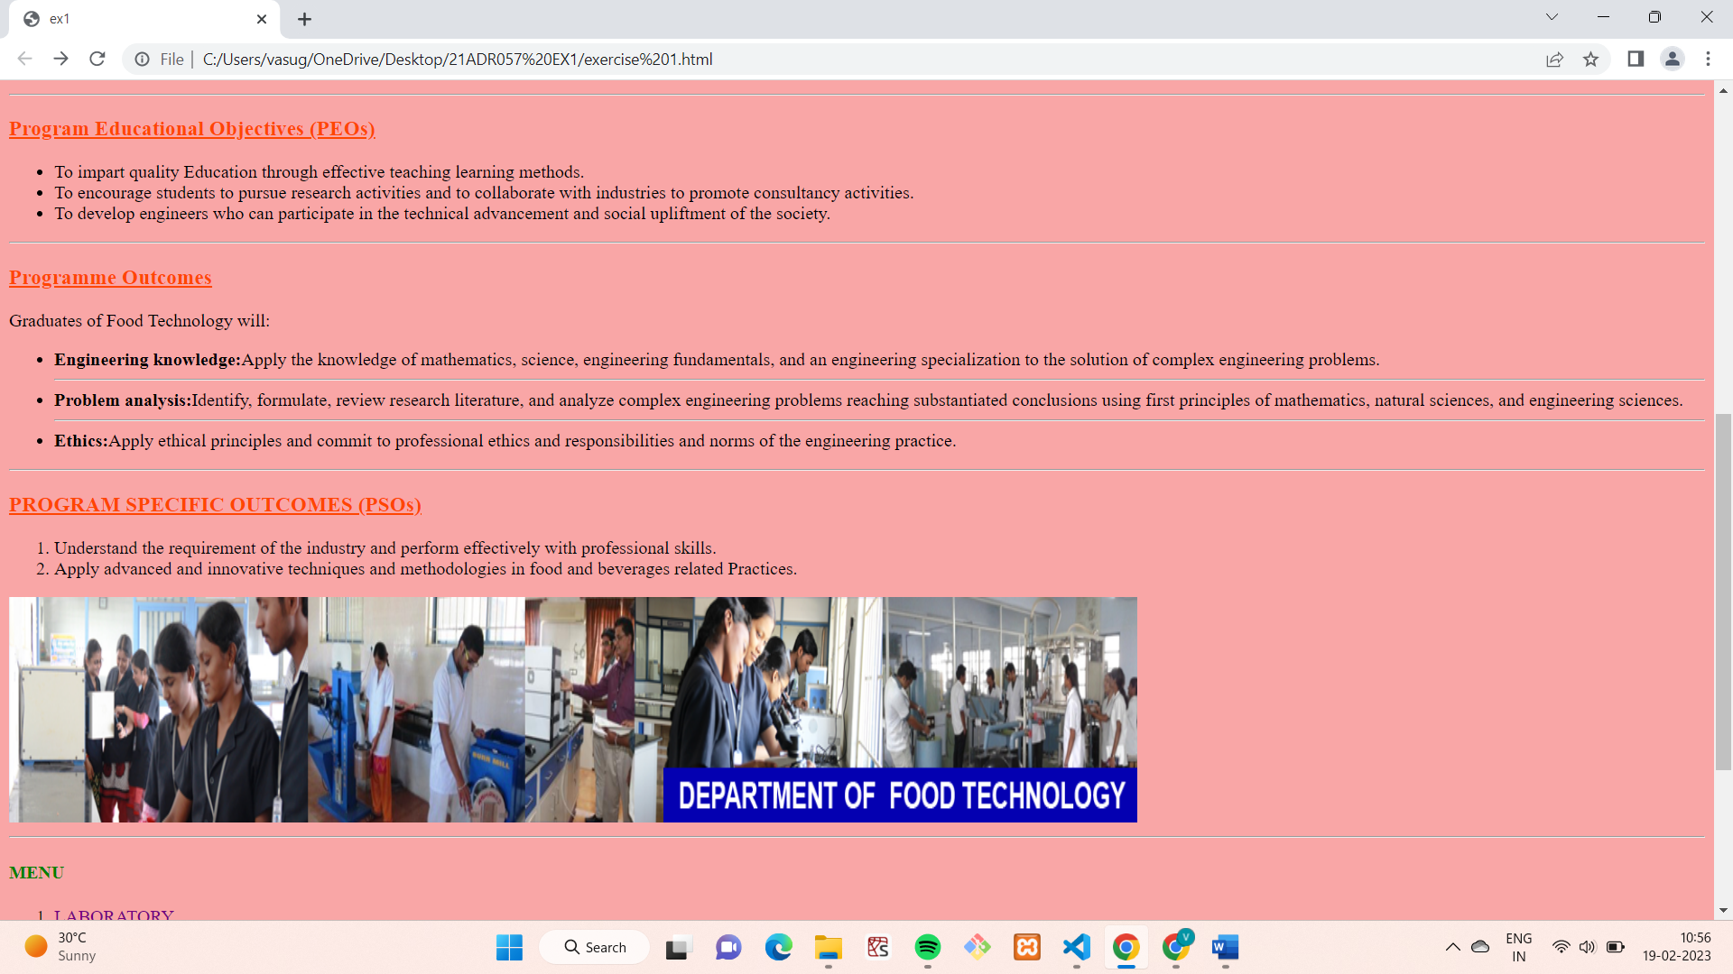

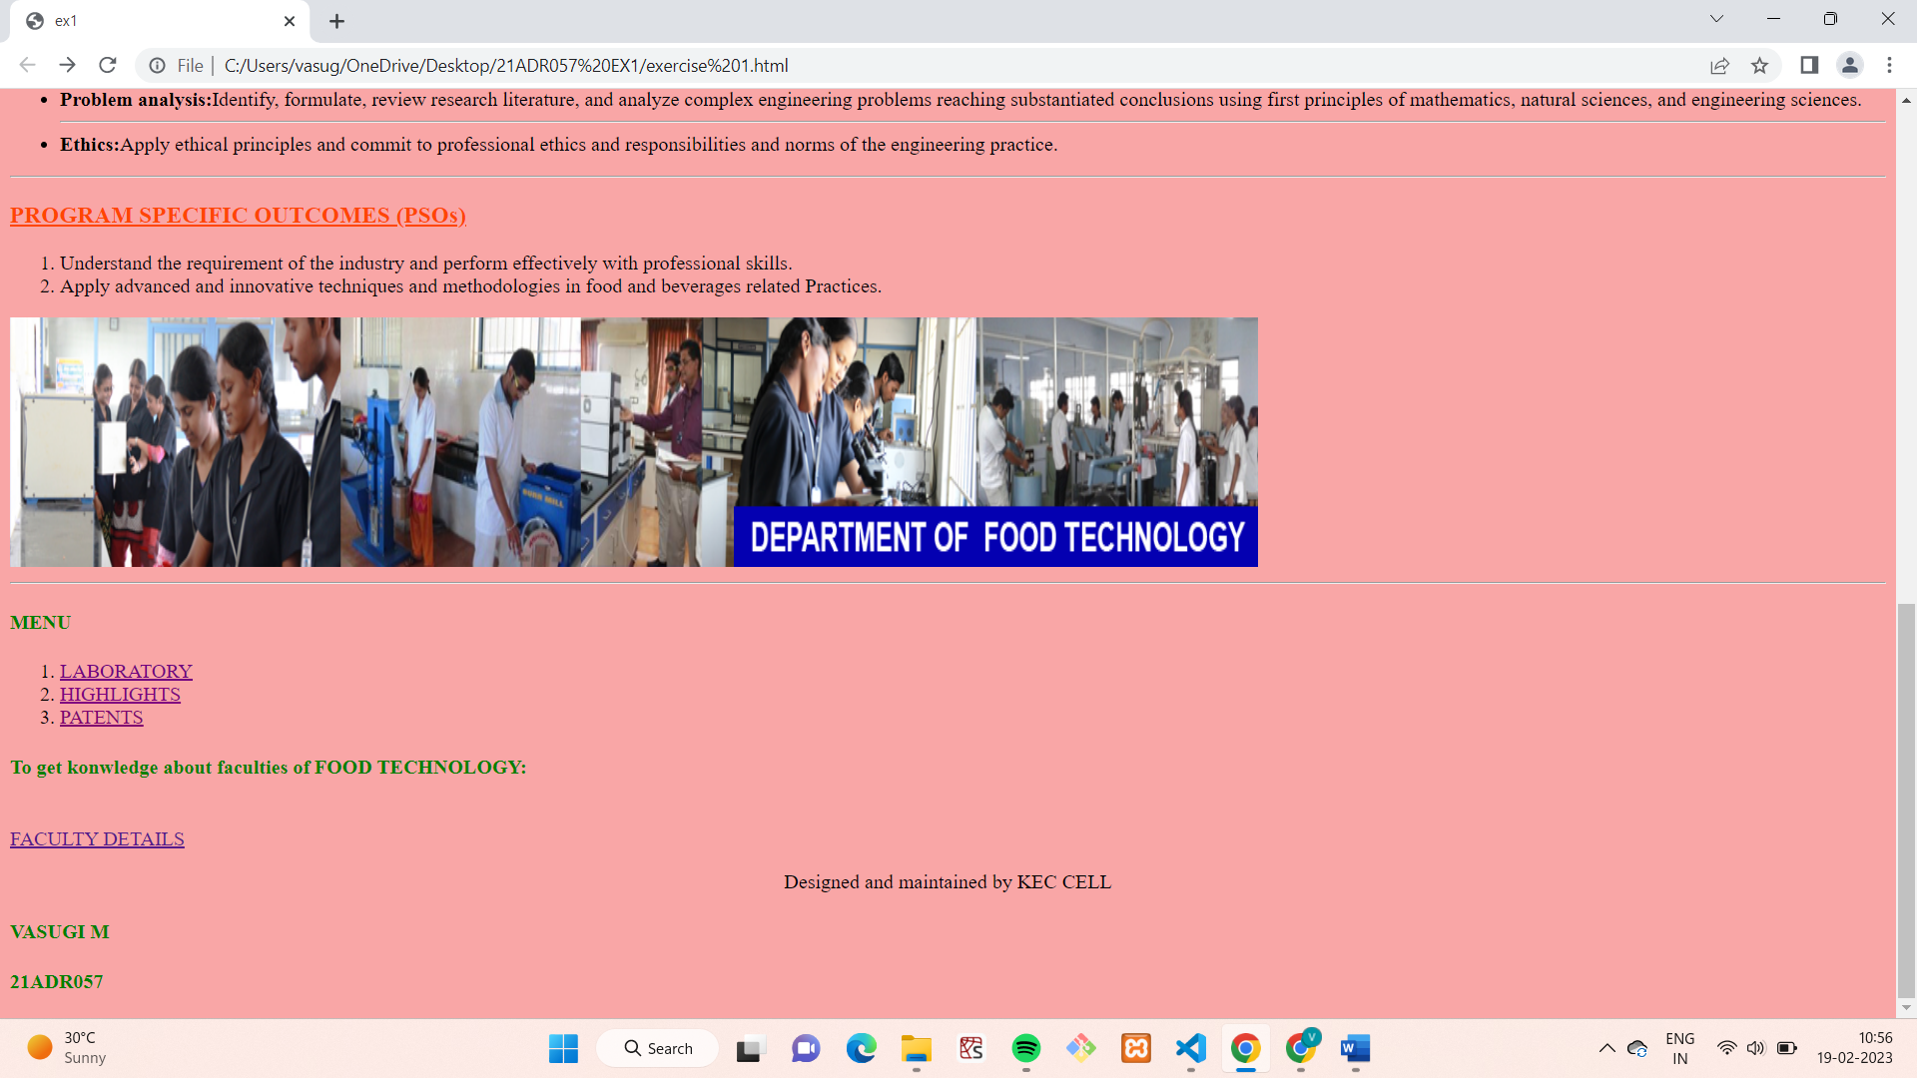

**FACULTY.html:**

<!DOCTYPE html>

<html lang="en">

<head>

<style>

table

{

border: 2px solid black;

padding: 5px 5px 5px 5px;

}

tr

{

border: 2px solid black;

padding: 5px 5px 5px 5px;

}

td{

border: 2px solid black;

padding: 5px 5px 5px 5px;

}

</style>

<title>FOOD TECH FACULTY DETAILS</title>

</head>

<body bgcolor="violet">

<h2 style="color: rgb (214, 233, 13);">FACULTIES OF FOOD TECHNOLOGY</h2>

<br>

<h4>TOTAL NUMBER OF FACULTIES = 14</h4>

<br>

<h4>Faculty Details:</h4>

<br>

<table style="background-color: rgb (149, 239, 128);">

<tr>

<td>NAME</td>

<td>QUALIFICATION</td>

<td>SPECILALIZATION</td>

<td>EXPERIENCE</td>

</tr>

<tr>

<td> Dr. R. Basker</td>

<td>B.E/M.TECH/Ph D</td>

<td>Process Engineering</td>

<td>22 Years</td>

</tr>

<tr>

<td> Dr. V. Chitra Devi</td>

<td>B.E/M.TECH/Ph D</td>

<td>Bio fuels, Process calculation</td>

<td>24 Years</td>

</tr>

<tr>

<td>Dr. A. Sudha</td>

<td> BSc/ M.Sc./ M.Phil./Ph D</td>

<td>Food Chemistry</td>

<td>18 Years</td>

</tr>

<tr>

<td> Mr. S. Shivaswamy</td>

<td>B.E/M.TECH</td>

<td>Dairy Engineering</td>

<td>12 Years</td>

</tr>

<tr>

<td> Dr. R. Basker</td>

<td>B.E/M.TECH/Ph D</td>

<td>Process Engineering</td>

<td>22 Years</td>

</tr>

<tr>

<td> Dr. V. Arun Joshy</td>

<td>B.E/M.TECH/Ph D</td>

<td>Non thermal food processing Engineering</td>

<td>3 Years</td>

</tr>

<tr>

<td> K. Kavivarshini</td>

<td>B.E/M.TECH</td>

<td>Drying Engineering</td>

<td>29+ Years</td>

</tr>

</table>

<p>

<h4>Graduates of Food Technology will:</h4>

<br>

Explore the ideas and methodologies in developing innovative food processing techniques and food products.

<br>

Adapt multidisciplinary approach to solve food industry problems and ensure food quality and safety

</p>

<p style="text-align: center;">Designed and maintained by KEC CELL</p>

<footer>

<h4>VASUGI M</h4>

<h4>21ADR057</h4>

</footer>

</body>

</html>

**OUTPUT:**

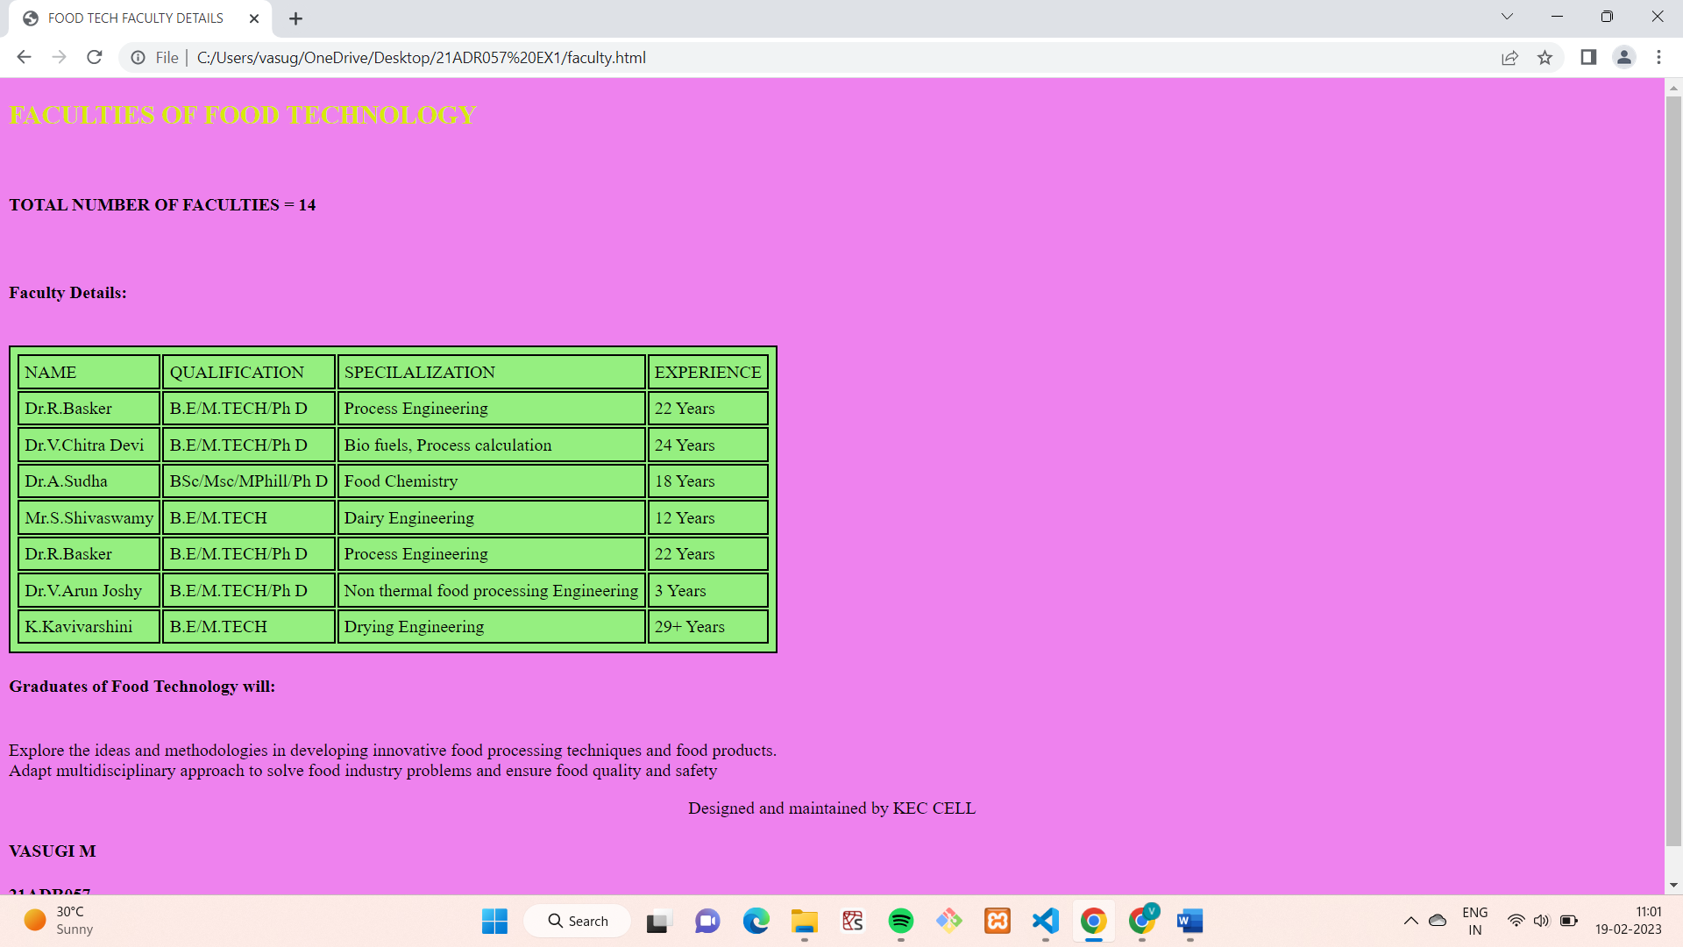

**RESULT:**

Thus, a web page is designed using basic html tags and visualized successfully.