**Create a chatbot using python**

Team Leader: ROHINEE G – 211521104127

Members:

SHRUTHI P – 211521104146

UMA MEENAKSHI R – 211521104173

VASUMATHI D – 211521104175

YUVASREE G – 211521104189

PHASE 4

# **Chatbot:**

Chatbot, short for chat robot, is a computer program designed to simulate conversation with human users, especially over the internet. These artificial intelligence (AI) applications are increasingly becoming integral components of various industries, offering automated and interactive communication.

Purpose and Benefits: Chatbots serve diverse purposes, ranging from customer support and information retrieval to entertainment and task automation. They operate in messaging apps, websites, and other platforms, providing users with a conversational interface to interact with services and obtain information. The benefits of chatbots include improved efficiency, 24/7 availability, and enhanced user experiences.

Examples of Industries: Chatbots find applications across a wide array of industries. In customer service, they assist in answering frequently asked questions and troubleshooting. E-commerce platforms employ chatbots for product recommendations and order tracking. Healthcare chatbots can provide initial medical information, and educational chatbots assist in learning processes. As technology advances, the versatility of chatbots continues to expand, making them a valuable asset in modern digital ecosystems.

# **Data preprocessing:**

Data preprocessing is a crucial phase in the development of chatbots, involving the cleaning and transformation of raw data to enhance its quality and usability. This preparatory step significantly influences the performance and effectiveness of chatbot models.

Importance of Data Preprocessing: Effective data preprocessing is vital for several reasons. It helps in handling missing or inaccurate data, standardizing formats, and reducing noise. By ensuring data consistency and reliability, preprocessing contributes to the overall robustness of chatbot models, enhancing their ability to generate accurate and relevant responses.

Steps in Data Preprocessing:

* Data Cleaning: Identify and handle missing or inconsistent data points.
* Data Transformation: Standardize formats, scale numerical values, and encode categorical variables.
* Data Reduction: Reduce dimensionality or eliminate irrelevant features to simplify model training.
* Data Integration: Combine data from multiple sources to create a comprehensive dataset.

In the development of chatbots, data preprocessing plays a pivotal role in ensuring that the underlying models can effectively understand and respond to user inputs. The nature of conversational data often requires specialized preprocessing techniques to handle nuances and variations in language.

* Handling Natural Language Complexity: Conversational data is rich in natural language complexities such as slang, abbreviations, and variations in sentence structures. Data preprocessing addresses these challenges by normalizing language, converting diverse expressions into a standardized format, and ensuring consistency in the training dataset.
* Entity Recognition and Tagging: Identifying and tagging entities within the conversation, such as names, locations, or specific terms relevant to the chatbot's domain, is a key preprocessing task. This enhances the chatbot's ability to extract meaningful information from user inputs and generate contextually relevant responses.
* Context Preservation: In chatbot conversations, context is crucial for understanding user intent. Data preprocessing involves methods to preserve and convey context effectively. This can include maintaining conversation history, tracking user interactions, and structuring the data to enable the chatbot to grasp the context of ongoing conversations.
* Dealing with Noisy Data: Conversational data can be noisy, containing irrelevant or misleading information. Data preprocessing aims to filter out noise, handling issues such as misspellings, irrelevant symbols, or excessive use of punctuation. This step ensures that the chatbot is trained on clean and meaningful data.
* Adapting to User Behaviour: As users interact with a chatbot, their behavior may introduce variations in language usage. Data preprocessing helps the chatbot adapt to evolving user behavior by continuously analyzing and incorporating new patterns into the training dataset, ensuring that the model stays relevant over time.

**Text preprocessing:**

In the realm of chatbot development, text preprocessing is a critical step aimed at refining textual data to enhance the performance of natural language processing (NLP) models. By cleaning and structuring text data, chatbots can better understand and respond to user inputs.

Common Techniques:

* Tokenization: Breaking down sentences or phrases into individual words or tokens.
* Stemming: Reducing words to their base or root form to handle variations.
* Stop Word Removal: Eliminating common, non-informative words (e.g., "the," "and") to focus on meaningful content.
* Lowercasing: Converting all text to lowercase for uniformity.

Contribution to Chatbot Performance: Text preprocessing significantly contributes to the accuracy and efficiency of chatbots. It enables models to identify patterns, understand context, and generate coherent responses. By streamlining the input data, chatbots can better handle variations in user queries and deliver more relevant and contextually appropriate answers.

**Code:**

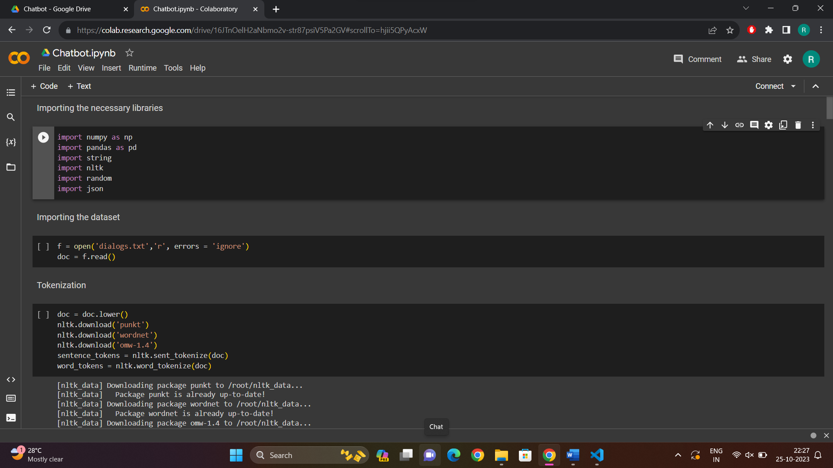

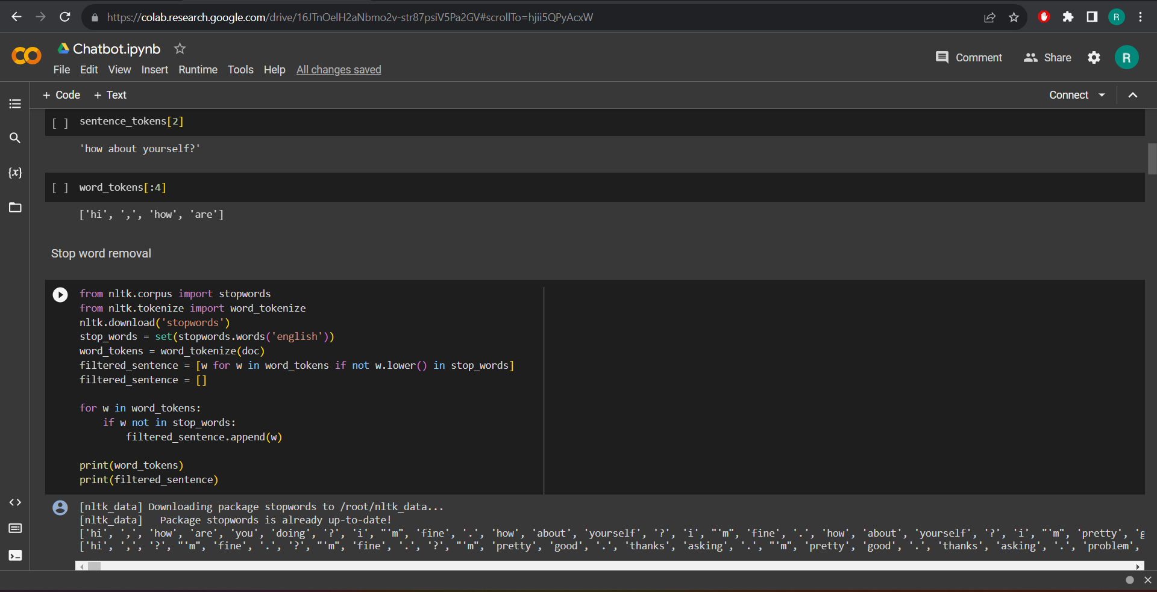

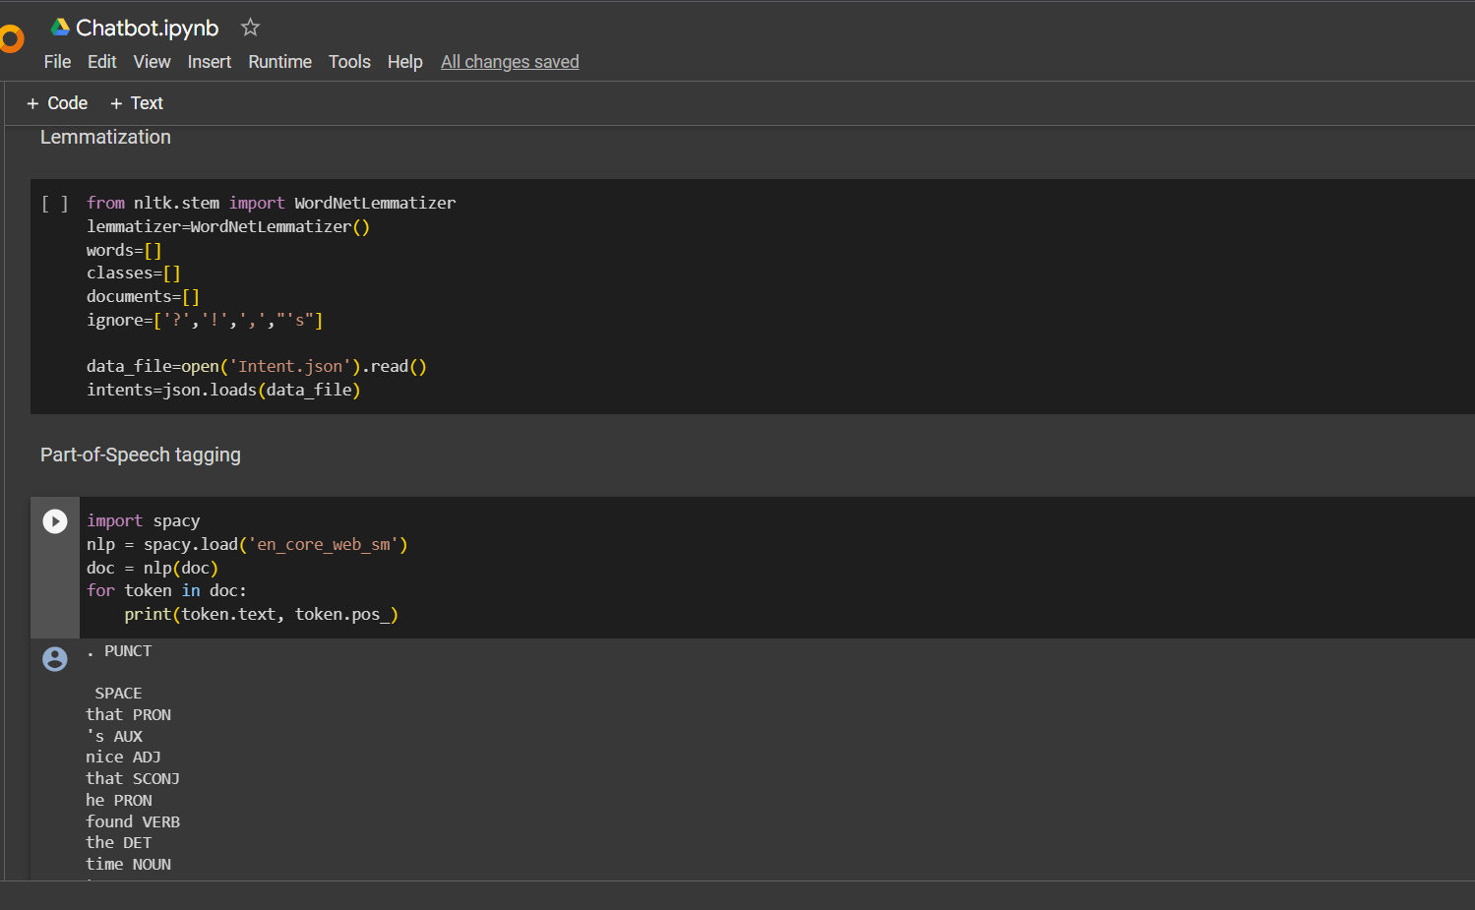

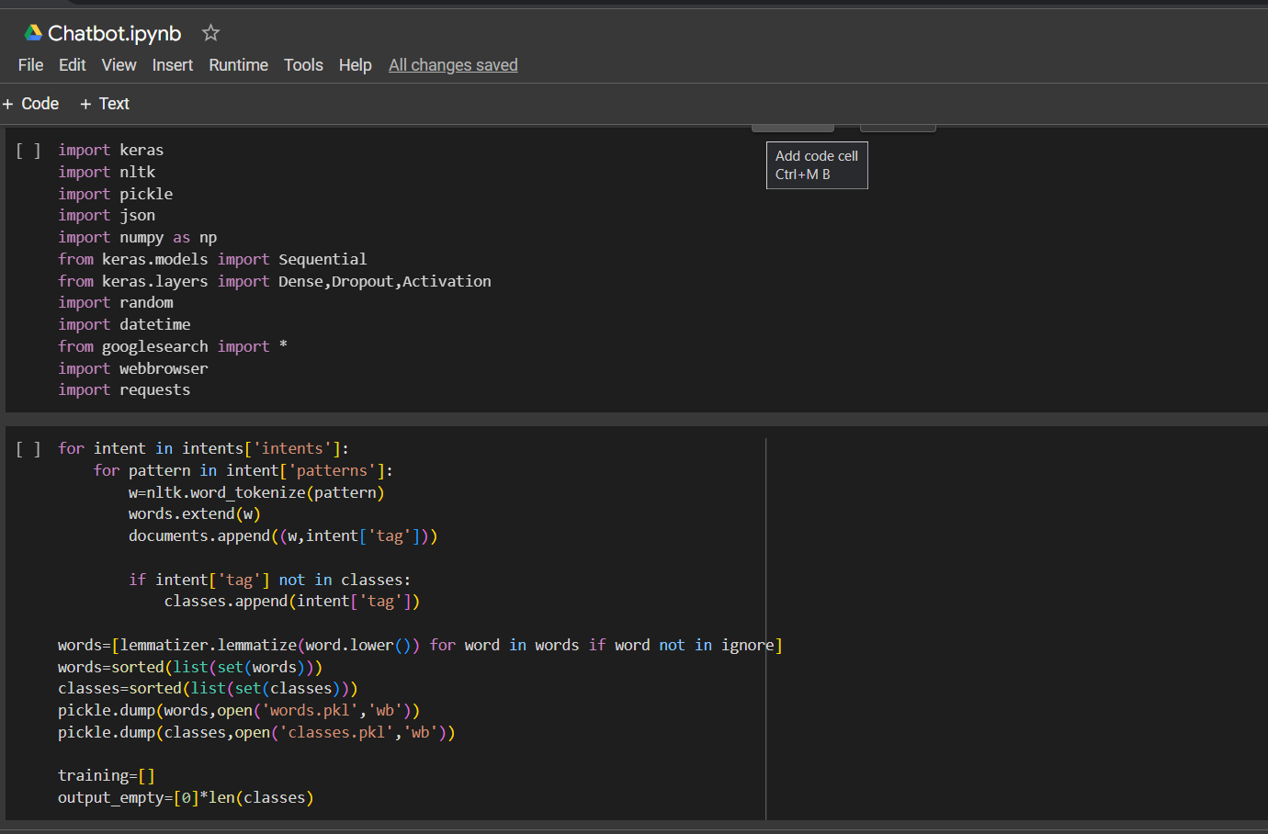

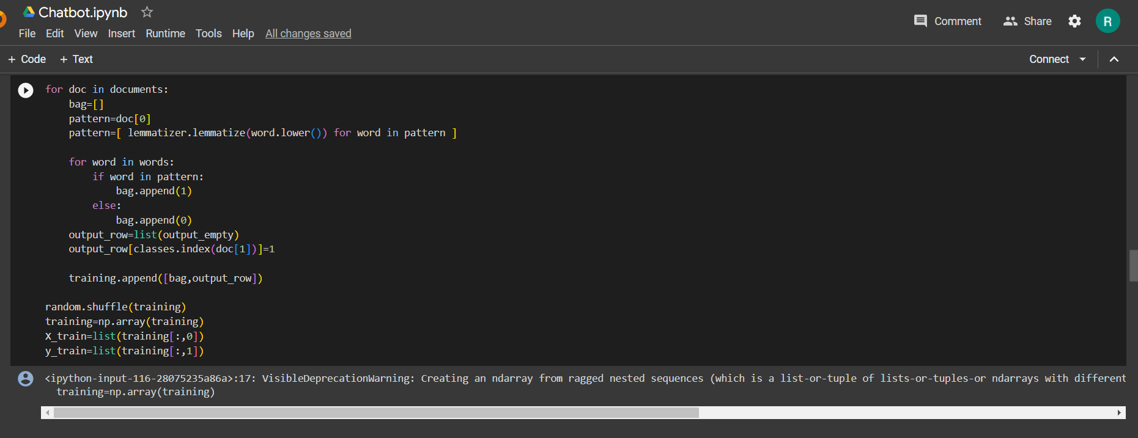

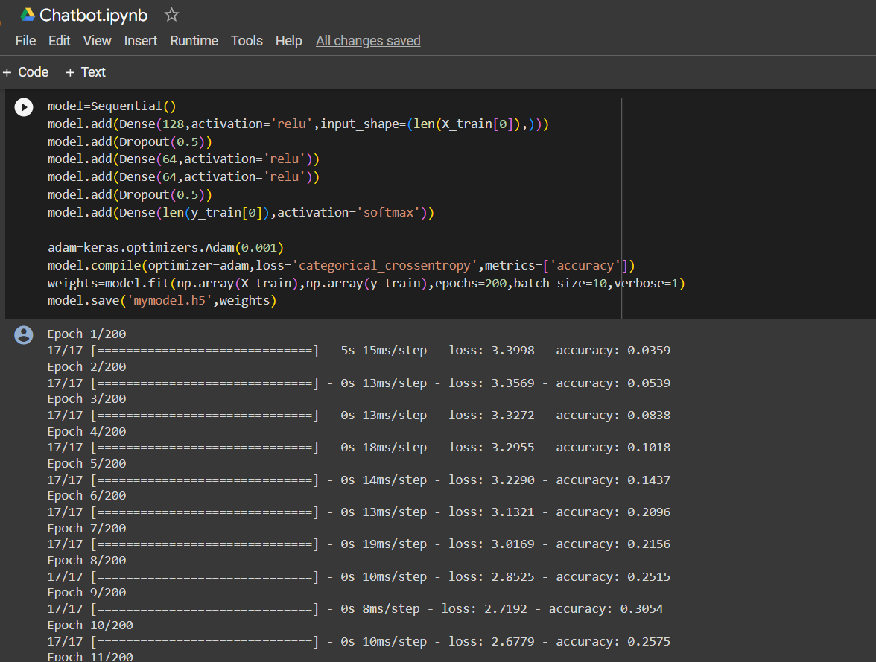

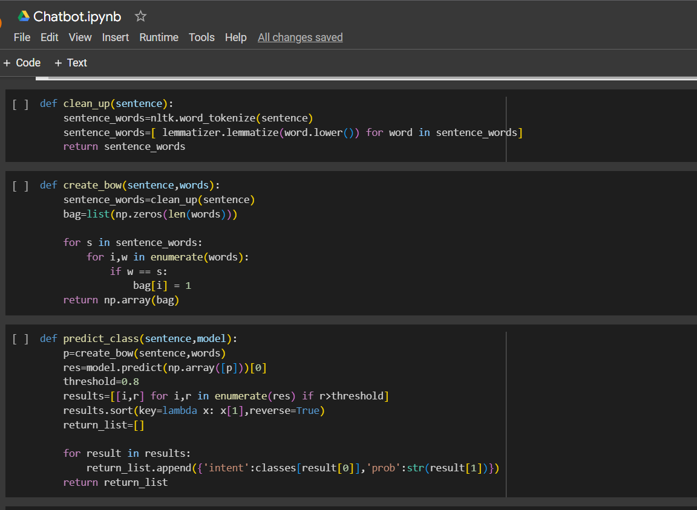

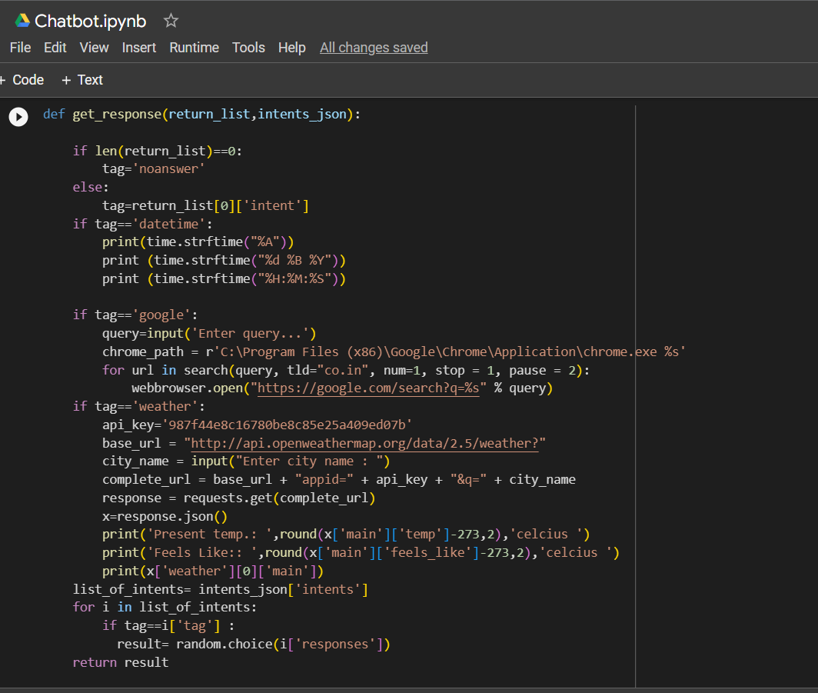

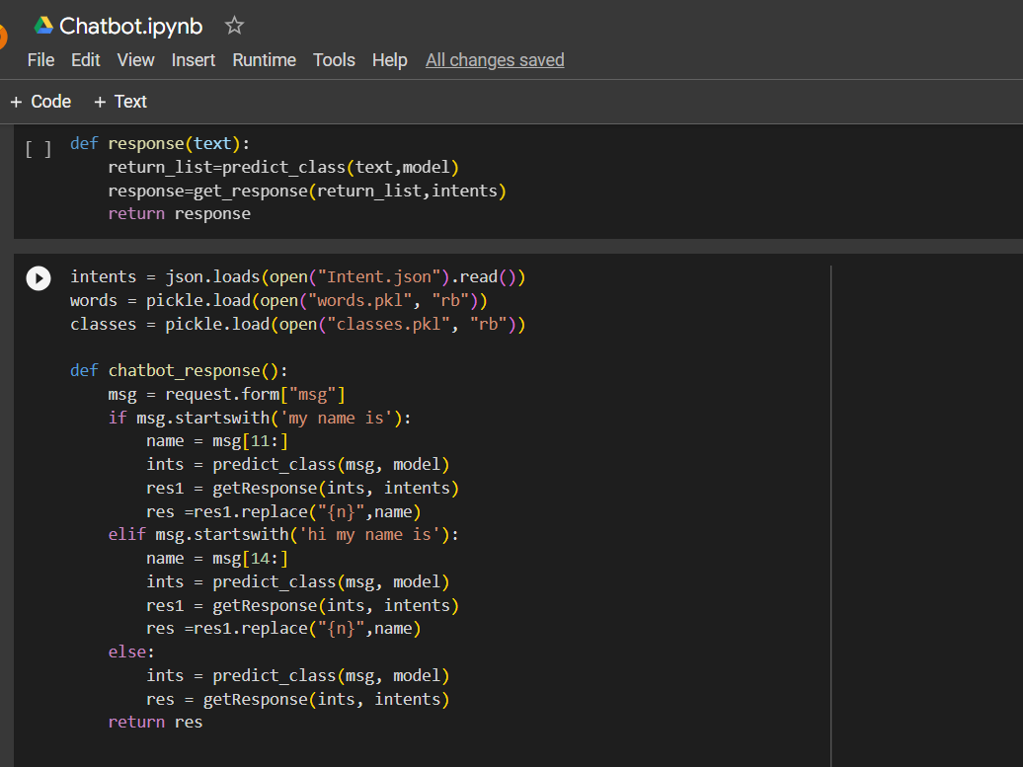

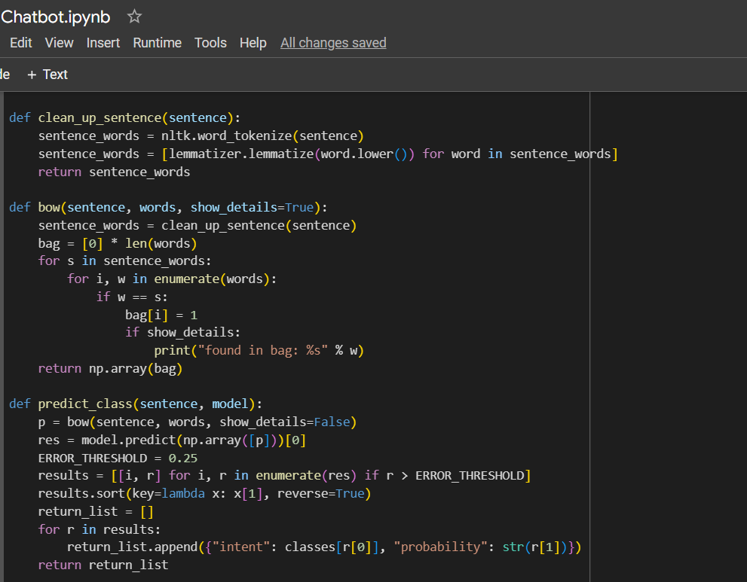

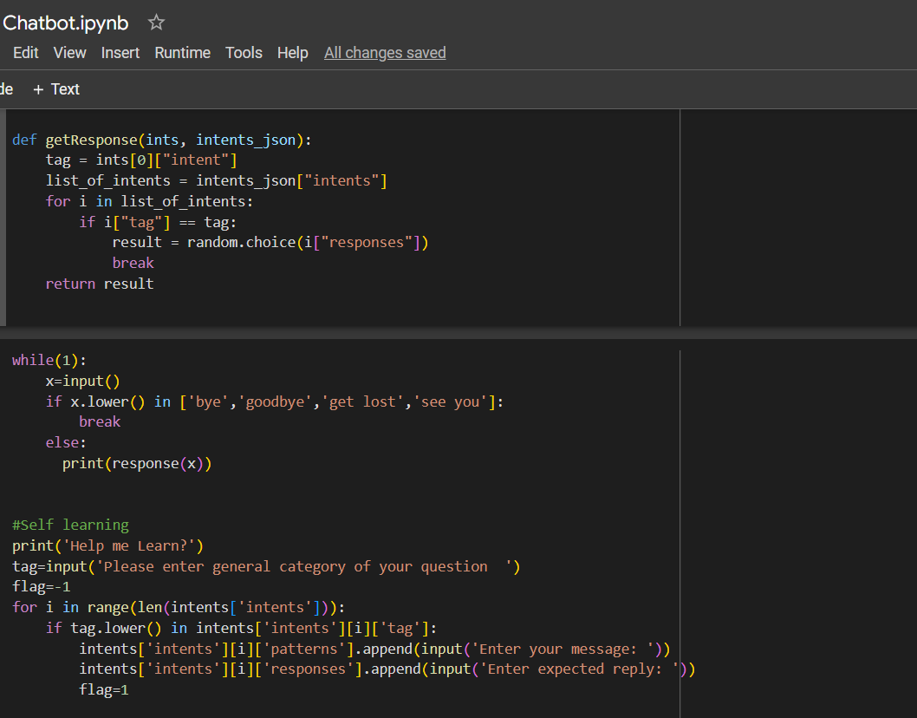

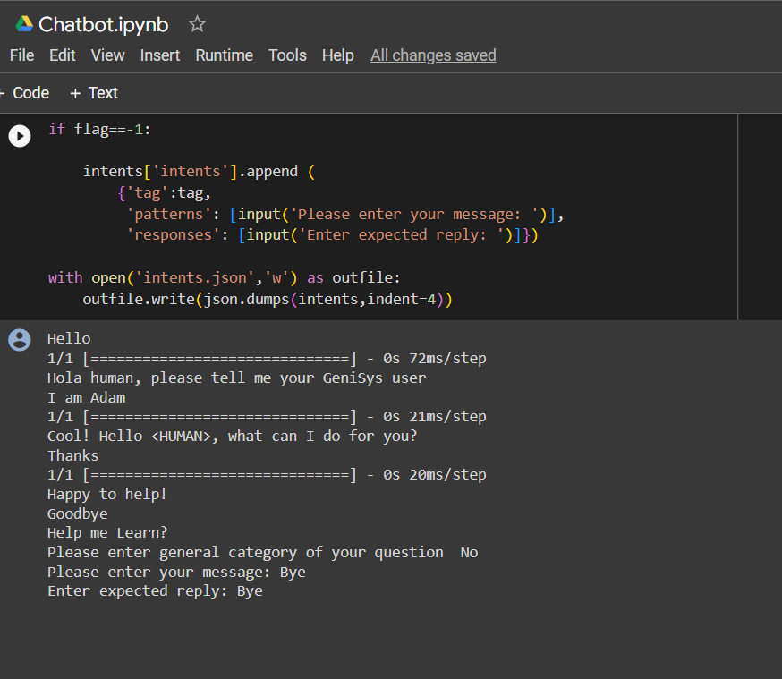

**CONCLUSION:**

Thus, a chatbot, with the ability of self-learning, is created successfully with python.