

Vellore Institute of Technology, Chennai

BCSE207L
Programming For Data Science



Project: - Credit Risk Modeling Using Machine Learning

(For Loan Approval Predication)

Submitted by: -
AARUSH GUPTA (24BDS1071)
VASUN (24BDS1112)

Submitted to: -
PROF. VIJAYALAKSHMI A
TABLE OF CONTENTS
ABSTRACT 3
1. Introduction 4
2. Literature Review 5
3. Problem Statement and Novelty of the Project 6
4. Dataset Description 7
5. Architecture 8
6. Exploratory Data Analysis and Data Visualization 8
7. Statistical Analysis 13
8. Machine Learning Models 13
9. SHAP-Based Explainability 18
10. Counterfactual Analysis and Eligibility Advisor 18
11. Interactive Dashboard 19
12. Evaluation Metrics 21
13. Results and Performance Analysis 22
14. Discussion and Limitations 28
15. Conclusion 29
16. Data Availability 29
17. References 29
18. R Codes 30
19. GitHub Repositories 44

ABSTRACT

Loan approval models usually return only an approved or rejected label, so applicants cannot see why they were declined and loan officers cannot audit the decision. This paper presents an integrated, explainable loan eligibility prediction system built on a Random Forest classifier trained on 614 historical loan applications. SHapley Additive exPlanations (SHAP) give global and per-applicant explanations. A counterfactual module and a rule-based eligibility improvement advisor turn those explanations into concrete changes, and an applicant risk categorization layer groups each application into a Low, Medium or High indicator band based on predicted approval probability. All components run in an interactive Streamlit dashboard. On a held-out test set of 154 applications the Random Forest reached 76.62% accuracy, an F1-score of 83.49% and an AUC of 0.78, the highest AUC among the four classifiers compared. Five-fold cross-validation gave 75.89 ± 2.57% accuracy and 0.76 ± 0.02 AUC. SHAP identified credit history as the dominant driver (mean absolute SHAP value 0.15, about 2.5 times that of the next feature). The counterfactual search found an approval path, by reducing the loan amount alone, for 6 of 35 test applications predicted as rejected (17.1%). Observed approval rates rose from 11.5% in the High band to 66.7% in the Medium band and 80.7% in the Low band. The bands are application risk indicators derived from predicted approval probability. They are not estimates of the probability that a borrower will default.
Loan approval prediction, Explainable AI, SHAP, Counterfactual explanation, Random Forest, Credit decision support, Interactive dashboard, Machine learning

Introduction

Access to credit is central to household and business growth, and banks process large volumes of loan applications every day. Manual assessment is slow, inconsistent and open to subjective bias. Machine learning is therefore widely used to automate eligibility screening, and ensemble models such as Random Forests are popular because they handle mixed tabular data and non-linear relationships well.

Accuracy alone is not enough in a financial setting. A rejected applicant usually receives a single outcome with no reason attached. Applicants cannot learn what to improve, loan officers cannot verify that the model relies on legitimate factors, and regulators in many jurisdictions expect lenders to be able to justify automated decisions. Black-box models, however accurate, leave these needs unmet.
Explainable AI (XAI) addresses this gap. SHAP assigns each input feature a contribution to an individual prediction, based on Shapley values from cooperative game theory [2]. Counterfactual explanations answer a different and more practical question: what is the smallest change to the application that would flip the decision? [3] Used together, they move a system from reporting an outcome to supporting a decision.
This work builds an end-to-end system around that idea. A trained Random Forest predicts approval likelihood. SHAP explains why. A counterfactual search and an eligibility improvement advisor suggest what can be done. An applicant risk categorization layer summarizes the result in an easily understood band, and an interactive dashboard presents everything in one place.
The main contributions of this paper are as follows.
- An integrated loan eligibility framework that combines approval prediction, SHAP explanations, counterfactual analysis, an improvement advisor and risk categorization in a single pipeline.
- A constrained counterfactual search that changes only the loan amount and repayment term, which an applicant can realistically adjust, and leaves personal attributes fixed.
- A risk categorization scheme defined on predicted approval probability, with an explicit distinction from credit-default risk.
- An interactive Streamlit dashboard that delivers predictions, explanations and guidance without requiring technical knowledge.
- A leak-free empirical comparison of four classifiers on a loan approval dataset, with global and local explainability analysis.

Literature review

Machine learning for credit decisions has been studied for more than two decades. Early work relied on logistic regression and discriminant analysis because of their transparency. Later studies showed that tree ensembles and boosted models usually outperform linear scorecards on accuracy, at the cost of interpretability. More recent work therefore pairs high-performing models with post hoc explanation methods.
Two families of explanation methods are most relevant here. Feature attribution methods such as LIME [4] and SHAP [2] describe how much each feature contributed to a prediction. For tree-based models, TreeSHAP computes exact Shapley values efficiently [5]. Counterfactual methods, introduced for automated decision settings by Wachter et al. [3] and extended by tools such as DiCE [6], generate alternative inputs that would change the model outcome, giving users a route to recourse.

Table 1. Summary of representative literature on explainable and ensemble-based credit decision models.

Author (Year) | Model/Method | Key contribution | Limitations/Research gaps
Breiman (2001) [1] | Random Forest | Robust ensemble of decorrelated trees for tabular classification | Individual predictions are hard to interpret without post hoc tools
Ribeiro et al. (2016) [4] | LIME | Local surrogate explanations for any classifier | Explanations can be unstable between runs
Lundberg & Lee (2017) [2] | SHAP | Unified, theoretically grounded feature attribution | Describes the model, not what the applicant should change
Lundberg et al. (2020) [5] | TreeSHAP | Exact, fast explanations for tree ensembles | Attribution only; no recourse guidance
Wachter et al. (2018) [3] | Counterfactual explanations | Explanations without opening the black box | Does not enforce feasibility of suggested changes
Mothilal et al. (2020) [6] | DiCE | Diverse counterfactual sets with feasibility constraints | Needs careful choice of mutable features per domain
Chen & Guestrin (2016) [7] | XGBoost | Strong gradient boosting performance on tabular data | Lower transparency than single trees or linear models

The literature shows two gaps.Studies that do add explainability tend to stop at feature attribution, which tells an applicant what mattered but not what to do next. This paper addresses that gap by combining attribution, counterfactual recourse, an improvement advisor and a risk indicator in one deployable dashboard.

Problem Statement
Financial institutions face significant losses due to inaccurate credit risk assessments. Traditional scoring methods often fail to capture non-linear relationships in data or handle imbalanced datasets where the number of approved loans far outweighs defaults. There is a critical need for a system that can:
- Automate the decision-making process for loan approvals.
- Handle missing data and outliers effectively to ensure model reliability.
- Provide high predictive accuracy even when class distributions are imbalanced

Novelty of the Project
The proposed Credit Risk Modelling system is novel in its approach to combining high predictive accuracy with interpretability and balanced data handling. Unlike traditional credit scoring models, this project leverages Random Forest and Decision Tree algorithms to capture complex, non-linear patterns in borrower data.
Additionally, the project incorporates specific data science techniques to solve real-world financial data issues:
- Logarithmic Transformation: Normalizes skewed features like ApplicantIncome to ensure model stability and better convergence.
- Data Balancing (Oversampling): Uses RandomOverSampler to eliminate the common bias toward "Approved" cases, ensuring high-risk defaults are correctly identified.
- Integrated Risk Scoring: Generates a normalized probability score (0-1) that categorizes applicants into specific risk levels, supporting faster decision-making for loan officers.
- Unified Visualization: Consolidates performance metrics, feature correlations, and risk distributions into a single analytical framework.

Dataset description

The dataset (Dataset.csv) is a loan application dataset of 614 records and 13 columns: a Loan_ID, 11 applicant and loan attributes, and the target Loan_Status (Approved = Y, Rejected = N). The attributes fall into three groups.
- Applicant demographics: Gender, Married, Dependents, Education, Self_Employed.
- Financial attributes: ApplicantIncome, CoapplicantIncome, Credit_History (1 = meets credit guidelines, 0 = does not).
- Loan attributes: LoanAmount (in thousands), Loan_Amount_Term (months), Property_Area (Rural, Semiurban, Urban).
The target is imbalanced: 422 applications (68.7%) were approved and 192 (31.3%) rejected. The data were split 75:25 with a fixed random seed (42).
- Training set: 460 applications (322 approved, 138 rejected). Minority-class oversampling is applied to this set only, giving 644 records (322 per class).
- Testing set: 154 applications (100 approved, 54 rejected), kept at the original class distribution.

Dataset characteristics
- Binary classification: the task is to predict approved or rejected.
- Class imbalance: an approved-to-rejected ratio of about 2.2 to 1. Random oversampling of the minority class is used on the training data [8], and results are reported with and without it.
- Mixed data types: numerical (income, loan amount, term) and categorical (gender, marital status, education, dependents, employment, property area) attributes require encoding.
- Missing values: 149 cells are missing across seven attributes: Credit_History (50), Self_Employed (32), LoanAmount (22), Dependents (15), Loan_Amount_Term (14), Gender (13) and Married (3).
- Skewed income: median applicant income is 3,812 and the mean is 5,403, with a maximum of 81,000, so log transformation is applied.

Significance of the dataset
- Decision support: loan approval is a high-stakes decision where transparency matters to both lenders and applicants.
- Challenges: skewed income, missing values, correlated income features and demographic attributes require careful modelling and explanation.

Architecture
The system processes an application through six stages: (1) data pre-processing and feature encoding, (2) approval probability prediction with a Random Forest, (3) SHAP-based explanation, (4) counterfactual analysis, (5) loan eligibility improvement advice and (6) applicant risk categorisation. The results are presented through an interactive dashboard. Figure 1 illustrates the pipeline.
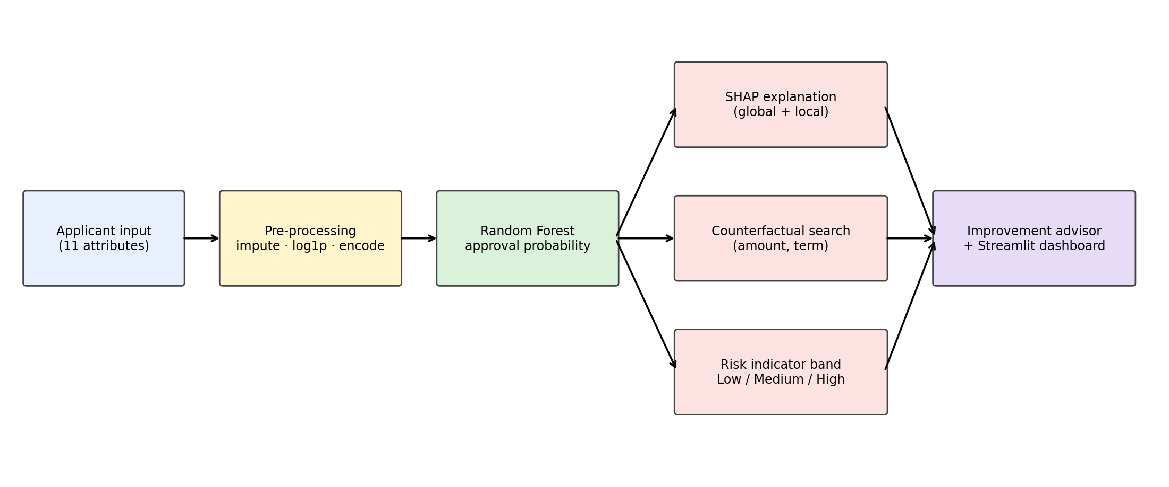
The applicant enters details through the dashboard. The input is encoded and aligned with the saved training feature columns (feature_columns.pkl), so the live input has exactly the structure the model was trained on. The Random Forest returns a predicted approval probability and a binary decision. The SHAP explainer attributes this prediction to individual features. For rejected applications the counterfactual engine searches for a smaller loan amount or longer term that would reach approval. The advisor turns these results and simple financial rules into plain-language recommendations, and the risk categoriser maps the probability to an indicator band.

EXPLORATORY DATA ANALYSIS AND DATA VISUALIZATION

Exploratory Data Analysis (EDA) is an important stage of the Credit Risk Modelling project that helps understand the dataset, identify patterns and discover relationships between different applicant attributes and loan approval status. Various statistical methods and graphical visualizations are used to examine the distribution of data and identify important factors affecting loan decisions.

The analysis is performed using R programming with the ggplot2 library. Different types of visualizations are created to understand applicant characteristics, financial information and loan approval patterns.

Data Exploration

The dataset is initially examined using functions such as head(), str() and colSums(is.na()) to understand its structure, variable types and missing values. Numerical attributes are also analyzed using boxplots to identify the distribution of values and potential outliers.

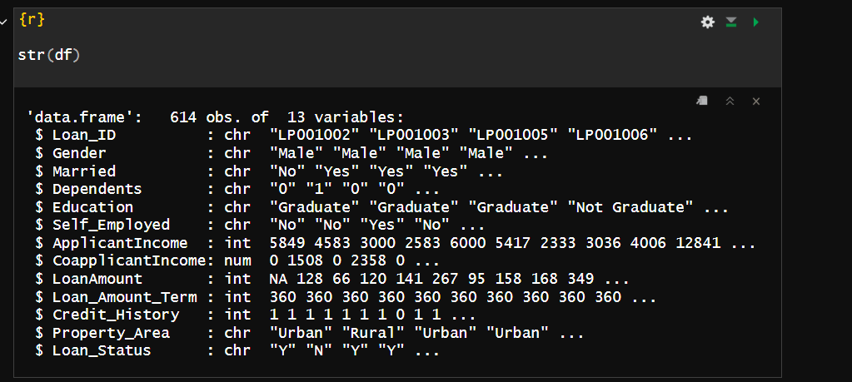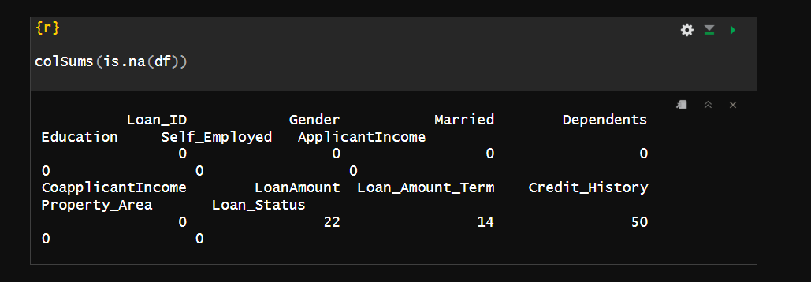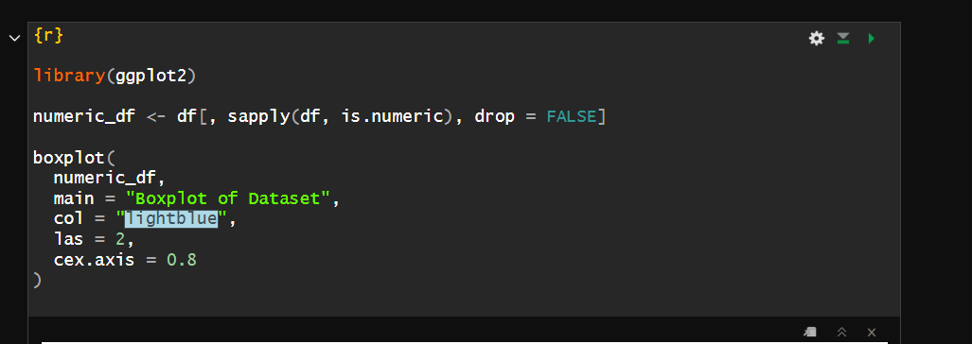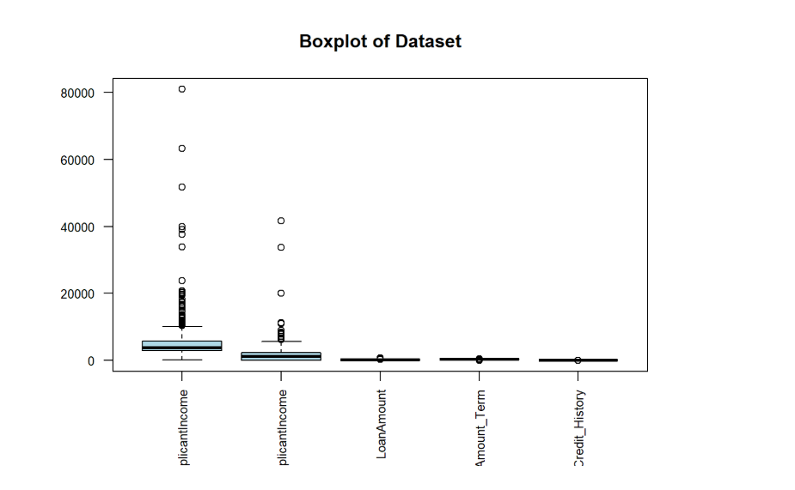

Categorical Data Analysis

Bar charts are used to analyze categorical attributes such as Gender, Marital Status, Education, Dependents and Property Area. These visualizations help compare applicant distributions and understand how different categories are represented in the dataset.

Additional comparisons are performed between these attributes and loan approval status to identify patterns in approved and rejected applications.

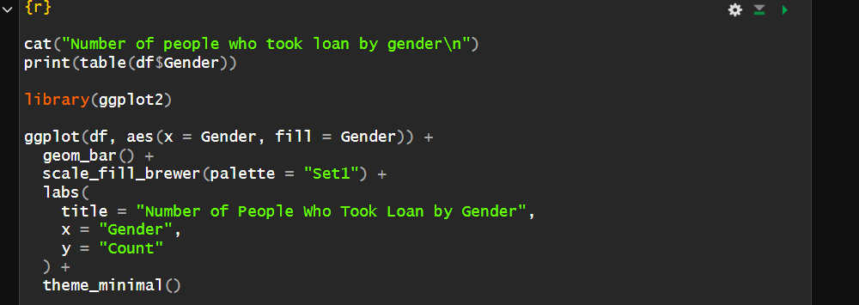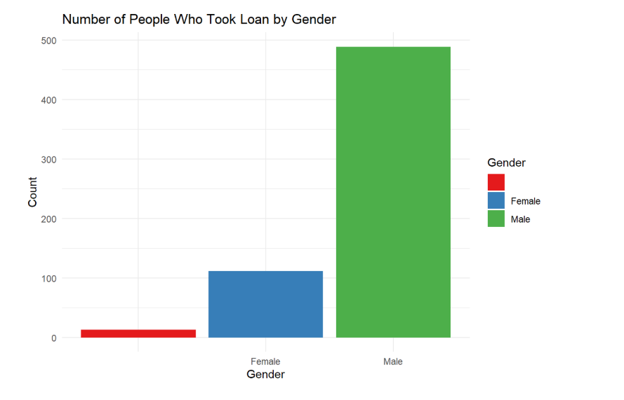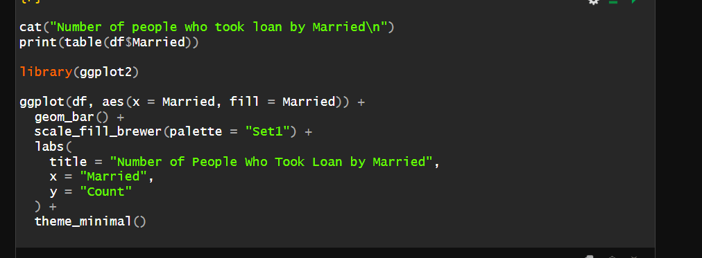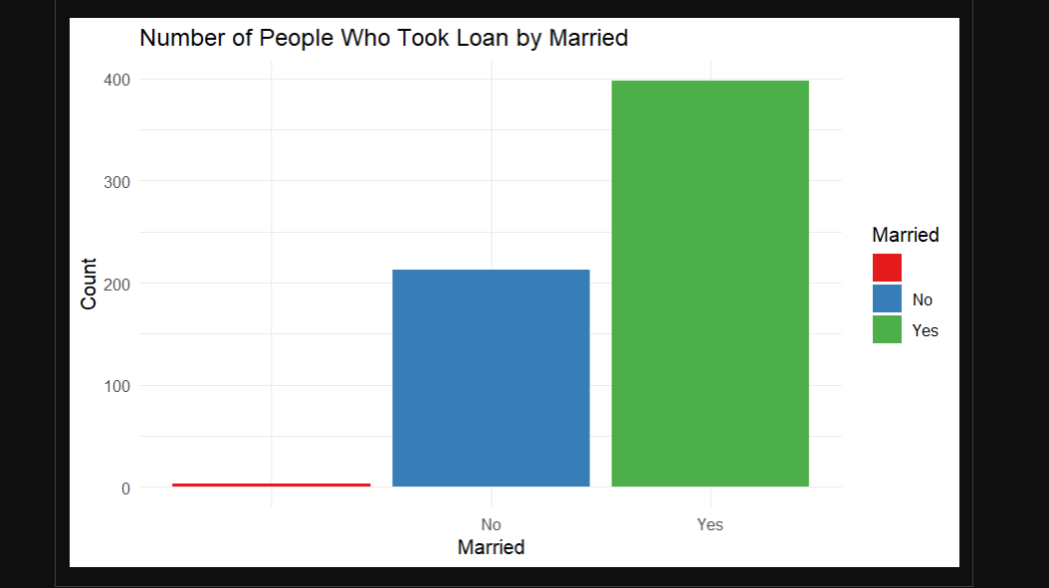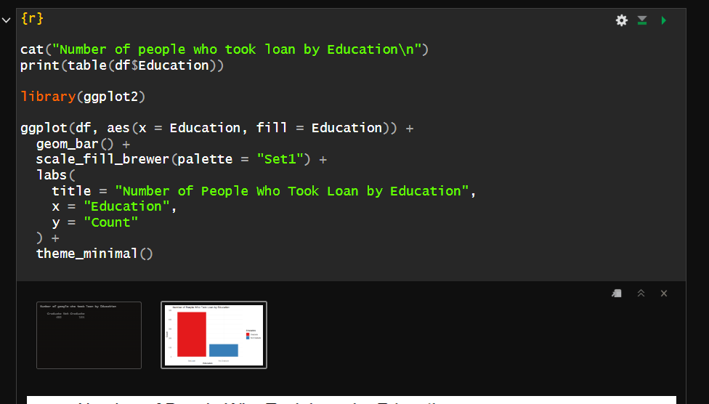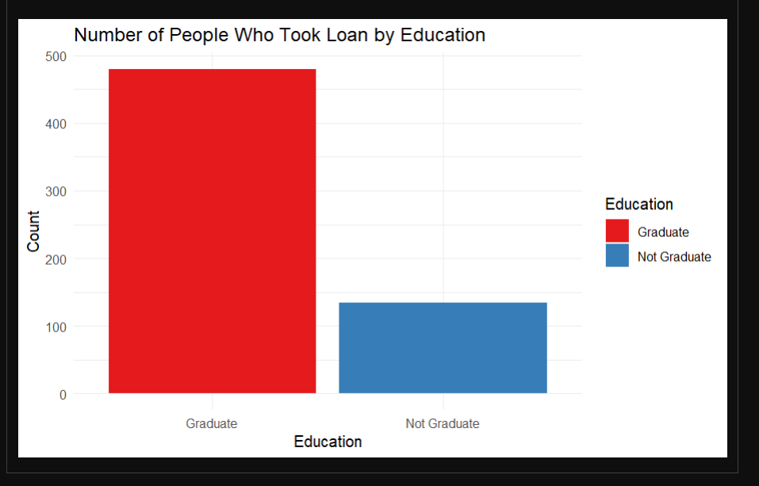

Numerical Data Analysis

Histograms and density plots are used to study the distribution of numerical attributes such as Applicant Income, Loan Amount, Loan Amount Term and Total Income. Logarithmic transformations are applied to selected numerical variables to reduce skewness and improve data distribution.

Boxplots are also used to compare loan amounts and identify variations in financial characteristics.

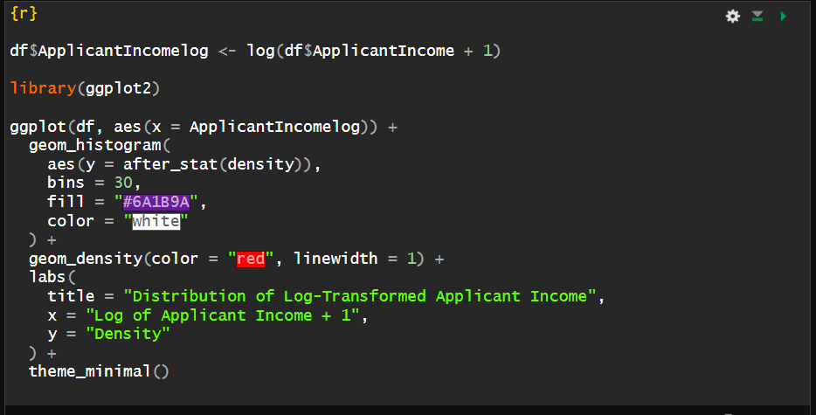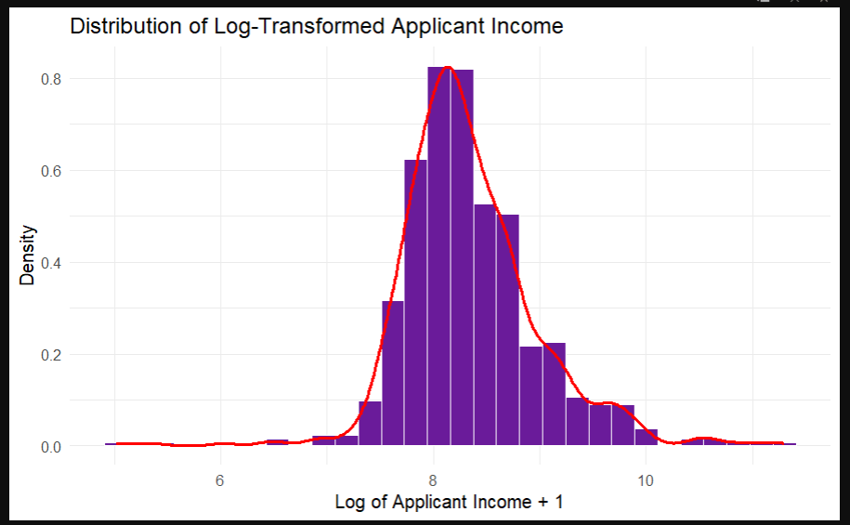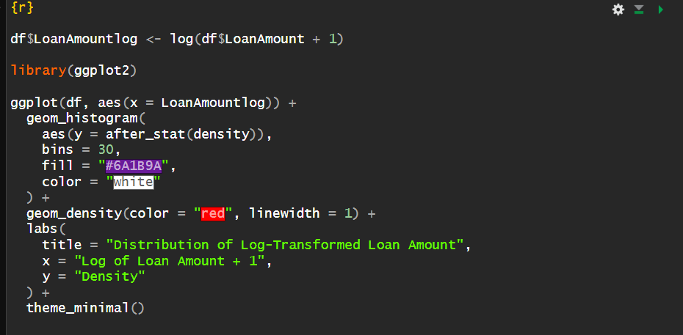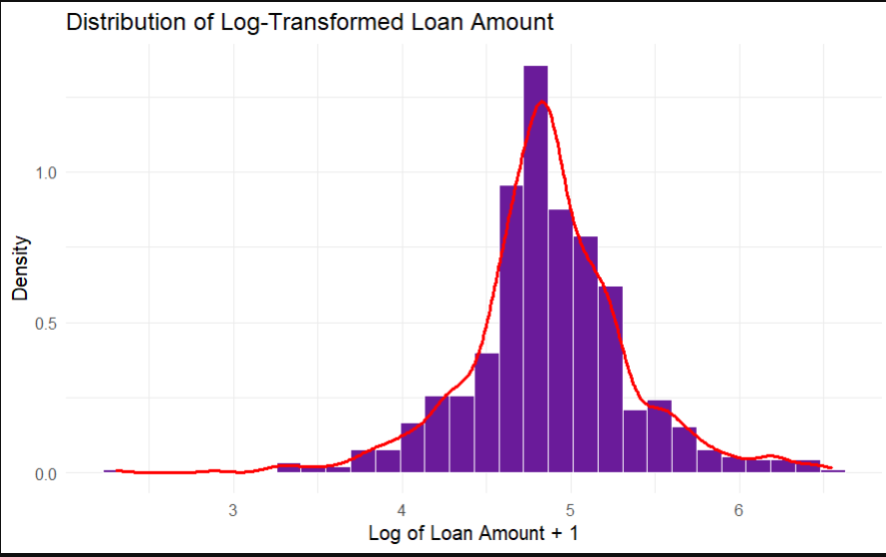

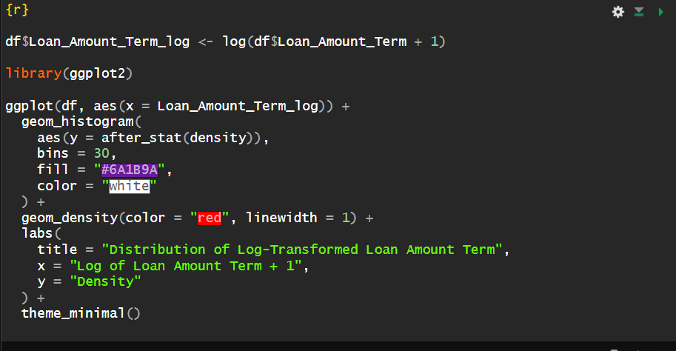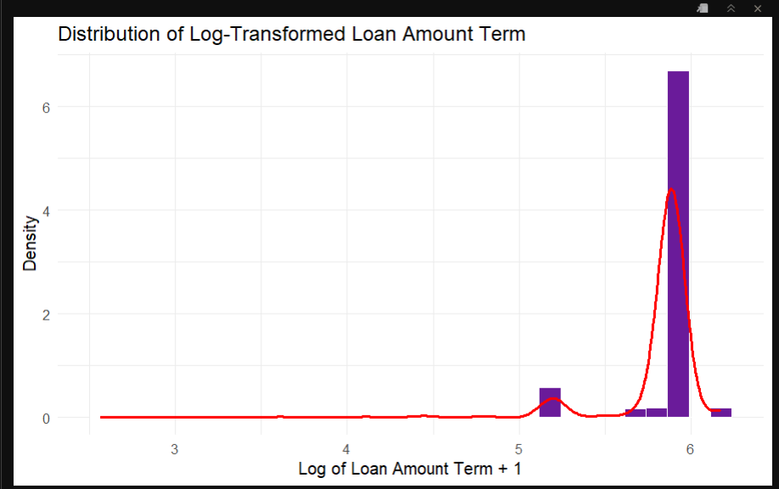

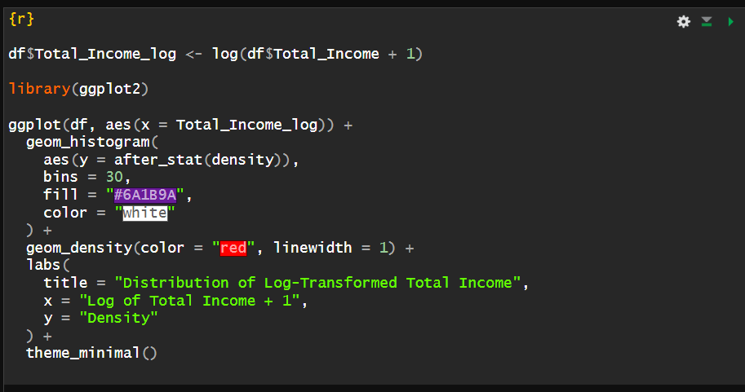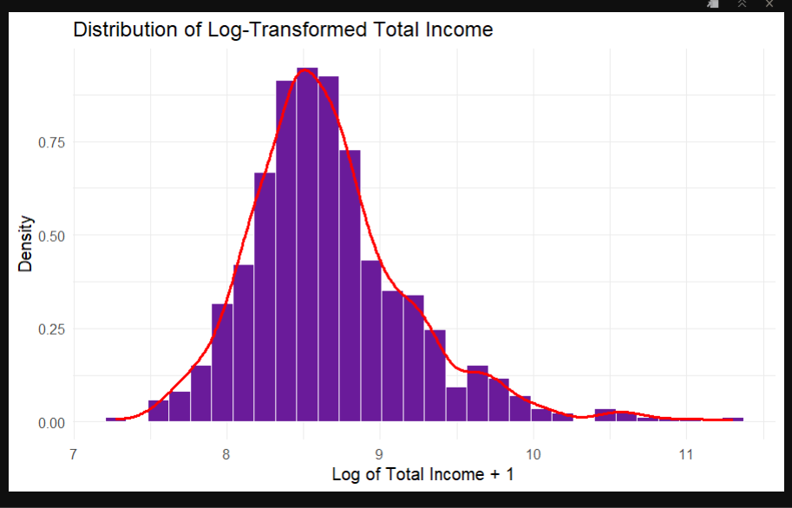

6.4 Correlation Analysis

A correlation heatmap is generated to visualize the relationships between numerical variables. It helps identify positive and negative correlations among attributes and provides insights into the relationships between applicant income, co-applicant income, loan amount and other numerical features.

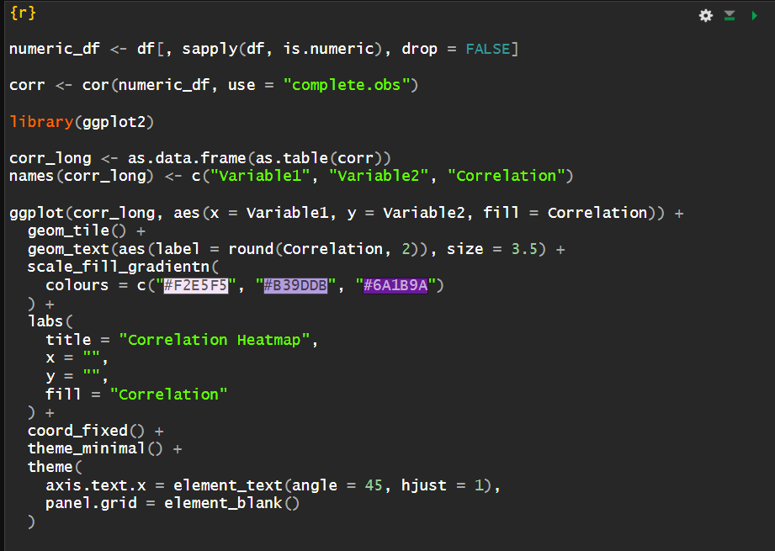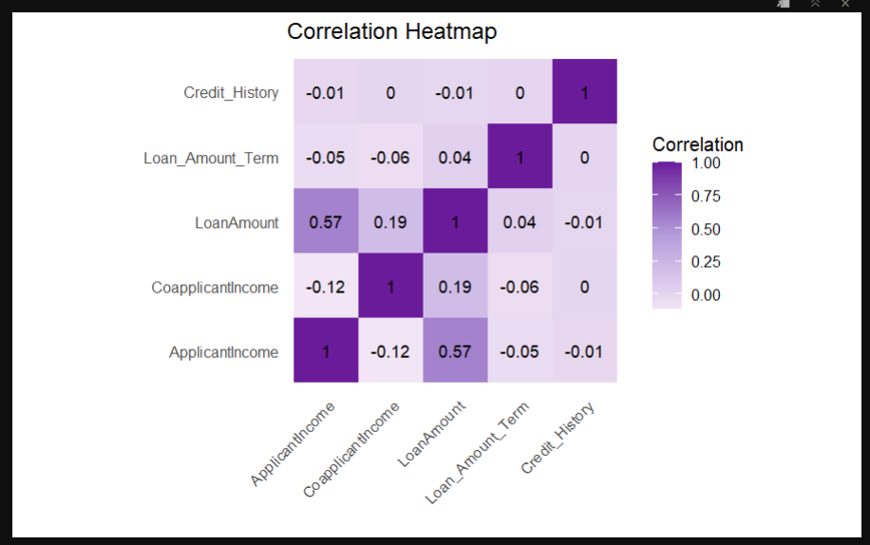

6.5 Loan Approval Analysis

Additional visualizations are used to examine loan approval patterns based on Credit History, Education, Gender, Marital Status and Property Area. Scatter plots and boxplots help understand the relationship between applicant income, loan amount and loan approval status.

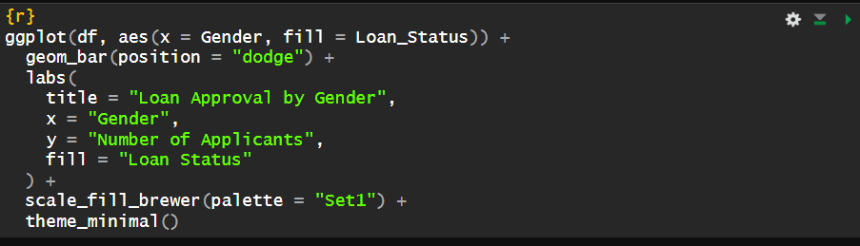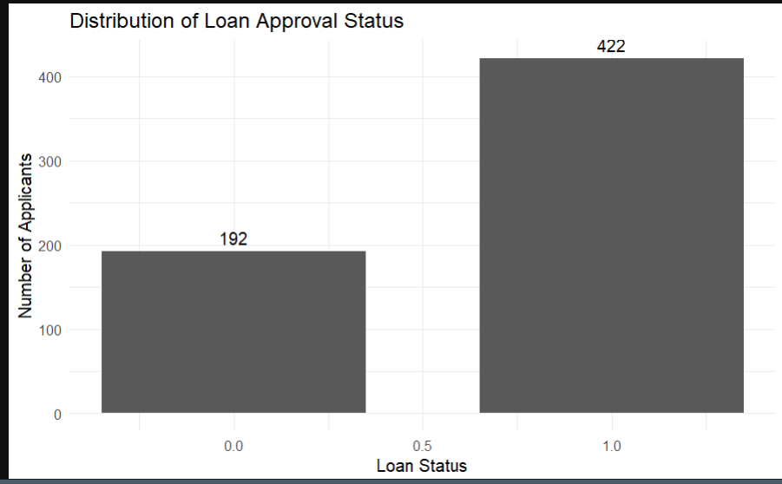

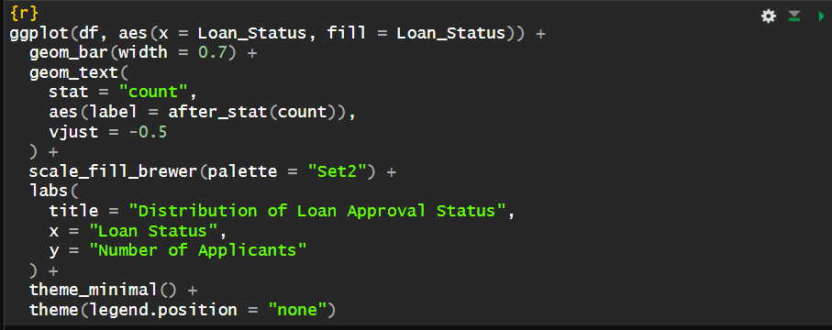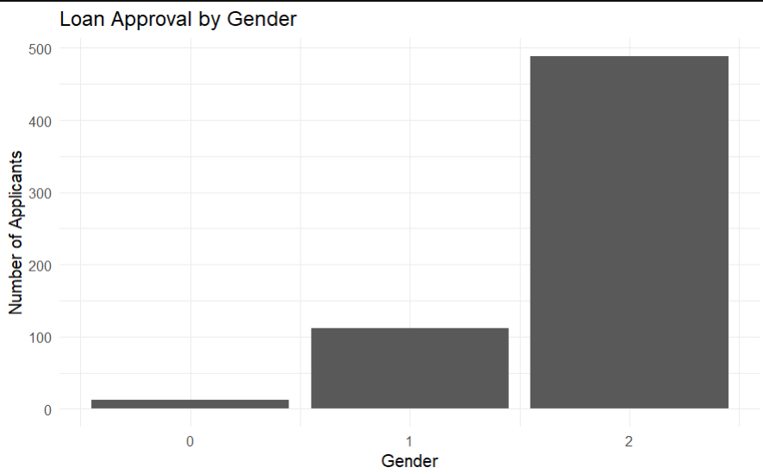

STATISTICAL ANALYSIS

Statistical analysis is performed to understand the dataset using measures such as mean, median, minimum, maximum and standard deviation. Numerical attributes like Applicant Income, Co-applicant Income, Loan Amount and Total Income are analyzed to understand their distributions and variations. Categorical attributes are examined using frequency distributions. Correlation analysis is also used to identify relationships between numerical variables. This analysis helps summarize the dataset and identify important factors for loan approval prediction.

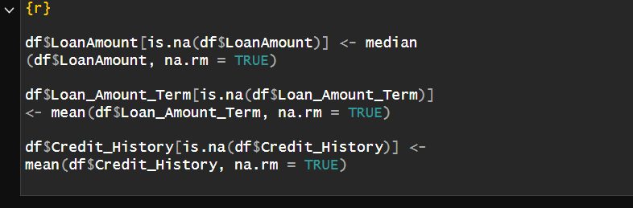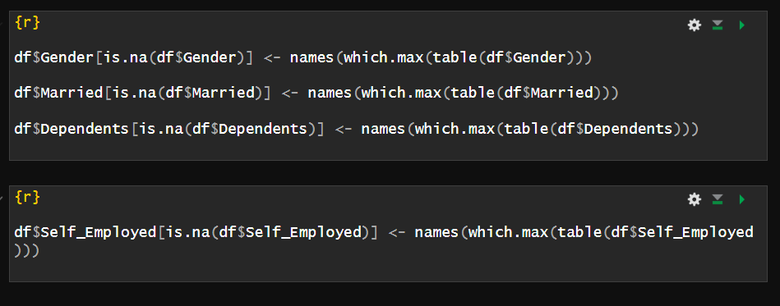

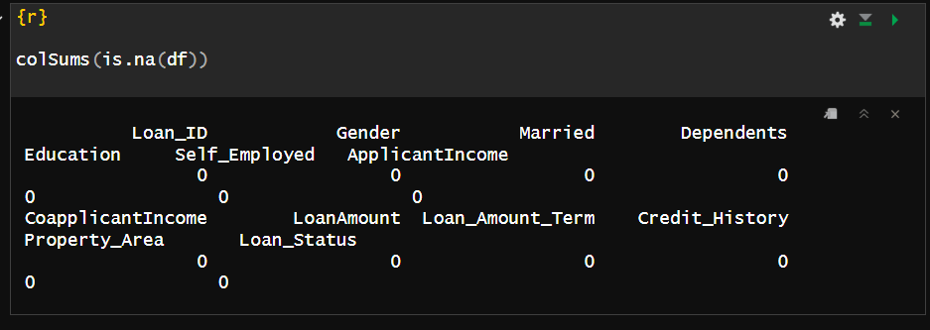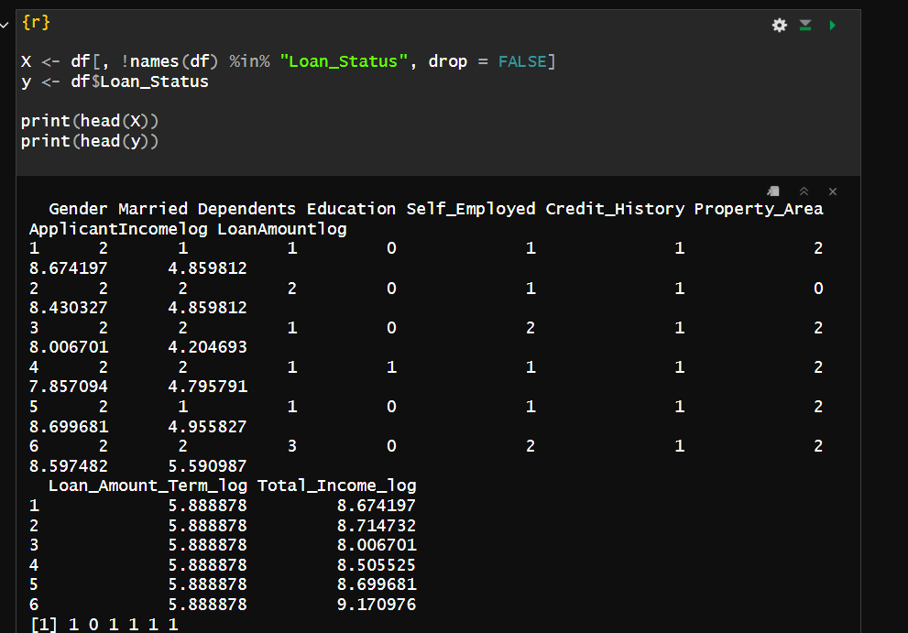

Models

Four classifiers from scikit-learn [8] are compared: Logistic Regression, Decision Tree, K-Nearest Neighbours (k = 3) and Random Forest. All use default hyperparameters apart from the neighbour count and a fixed random seed. The Random Forest is selected as the final model and is the basis of the explainability pipeline.

Logistic Regression
A linear model that estimates the log-odds of approval as a weighted sum of features. It is highly interpretable and serves as the transparent baseline.

Decision Tree
A single tree that partitions the feature space with threshold rules. It is easy to read but prone to overfitting and high variance.

K-Nearest Neighbour
A distance-based classifier that assigns the majority label of the three nearest training applicants. It is sensitive to feature scaling and to noise in small datasets.

Random Forest
Random Forest builds many decision trees on bootstrap samples with random feature subsets and averages their votes [1]. Its key properties are as follows.
- Bagging: training each tree on a different sample reduces variance.
- Feature randomness: decorrelates trees and improves generalisation.
- Probability output: the fraction of trees voting for approval gives a predicted approval probability, used for risk categorisation and counterfactual search.
- Compatibility with TreeSHAP: exact, efficient Shapley values can be computed.
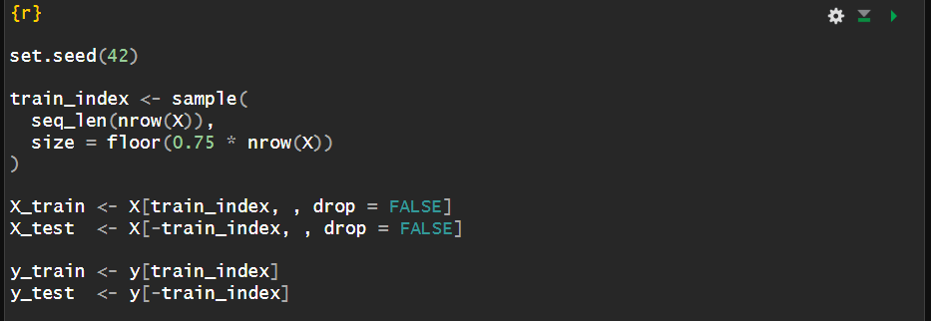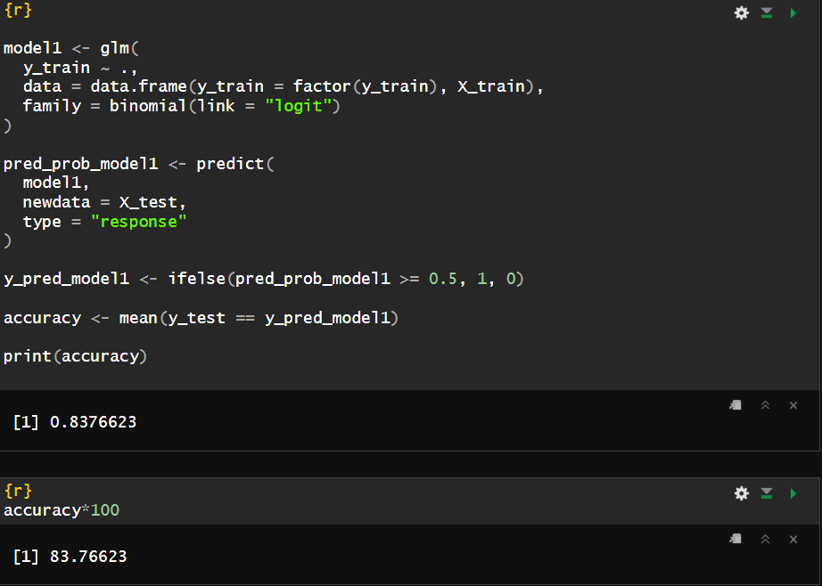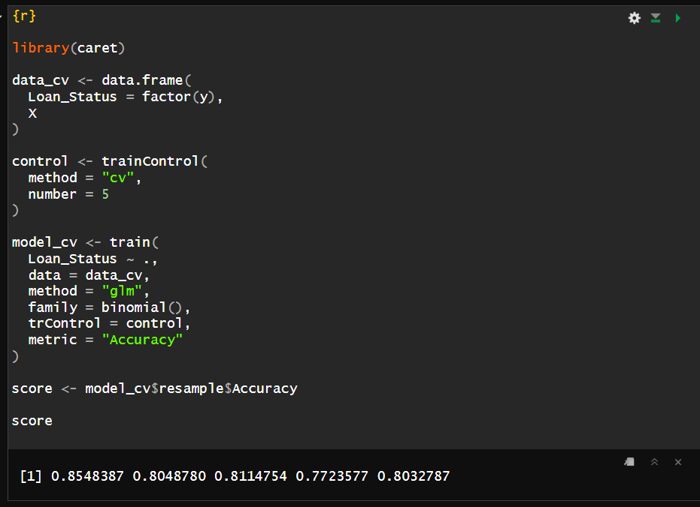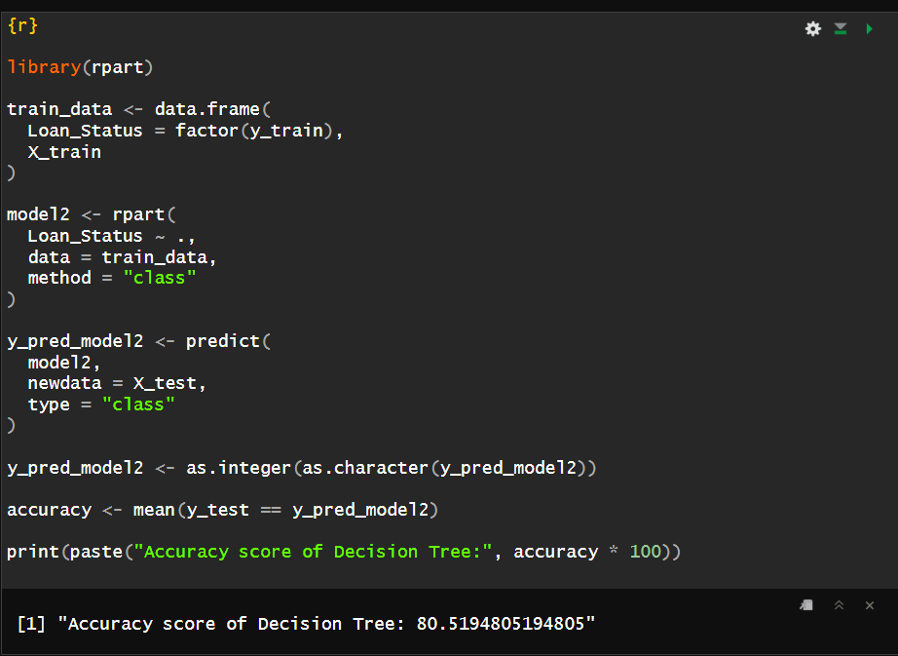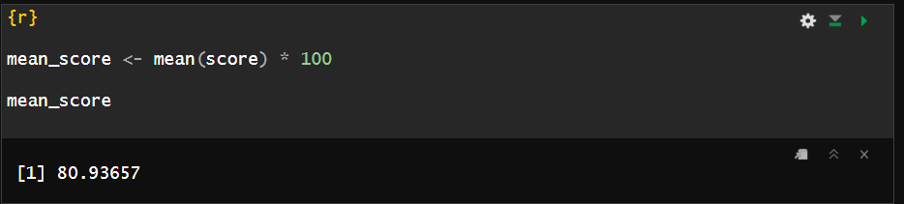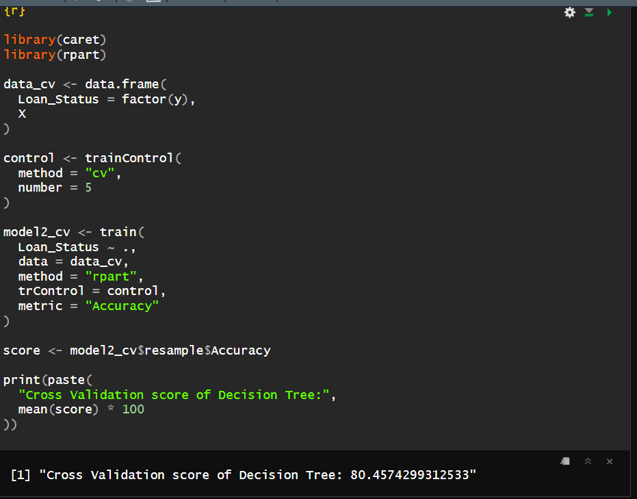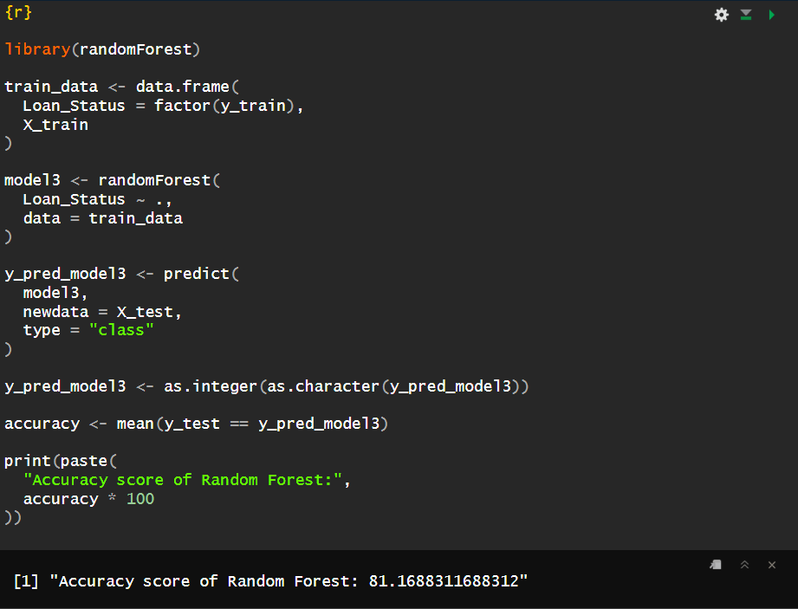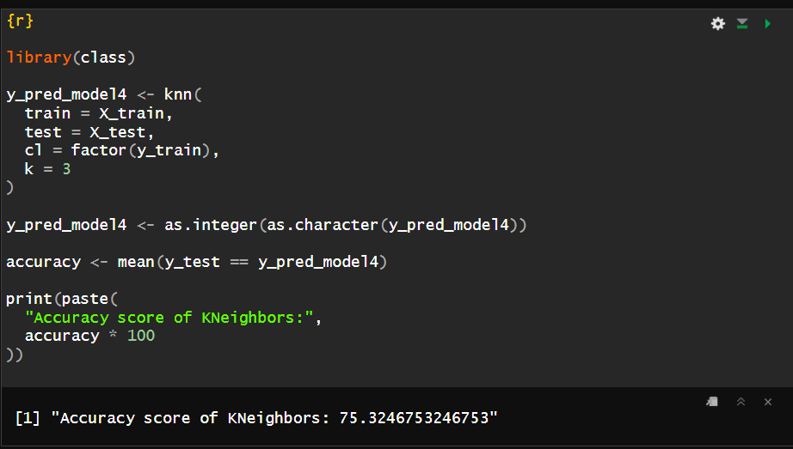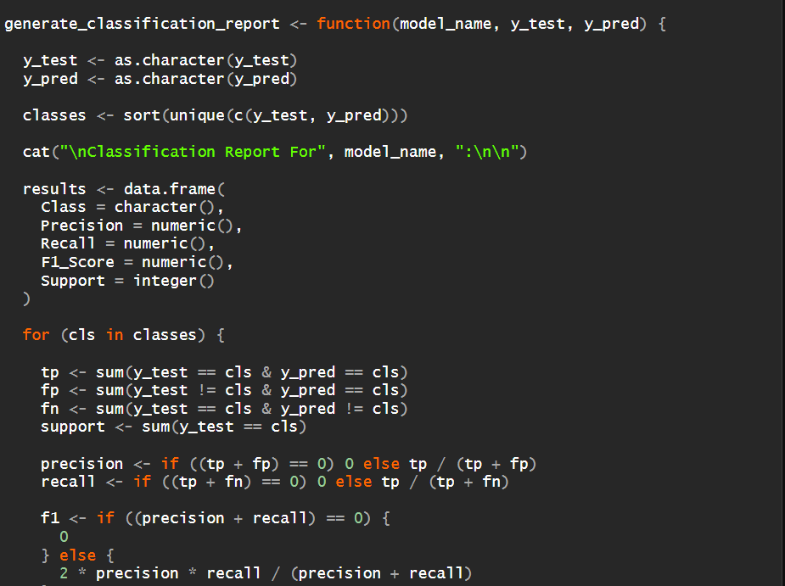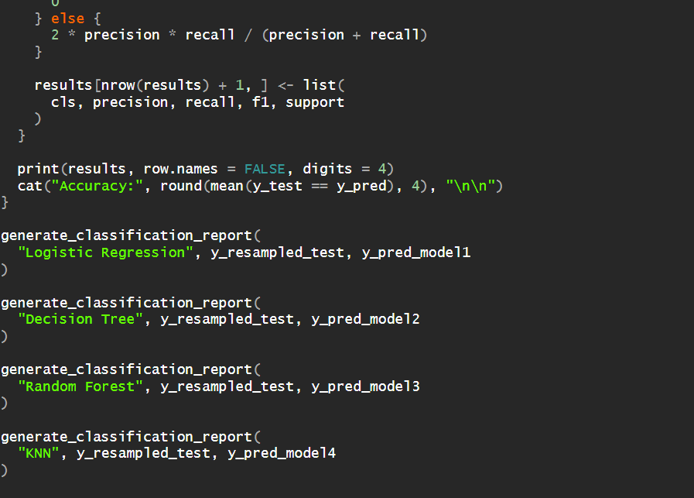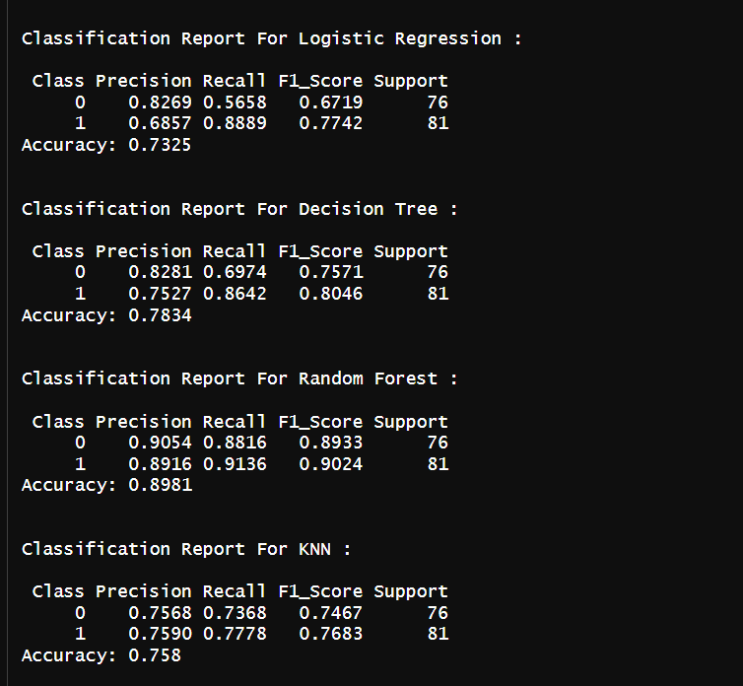

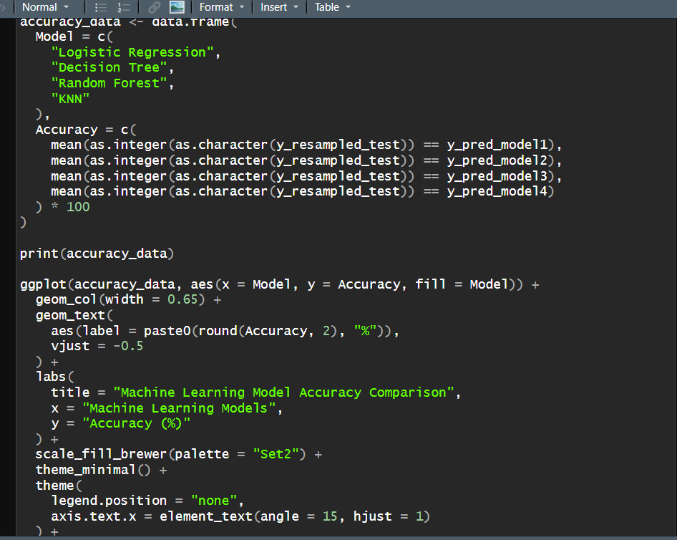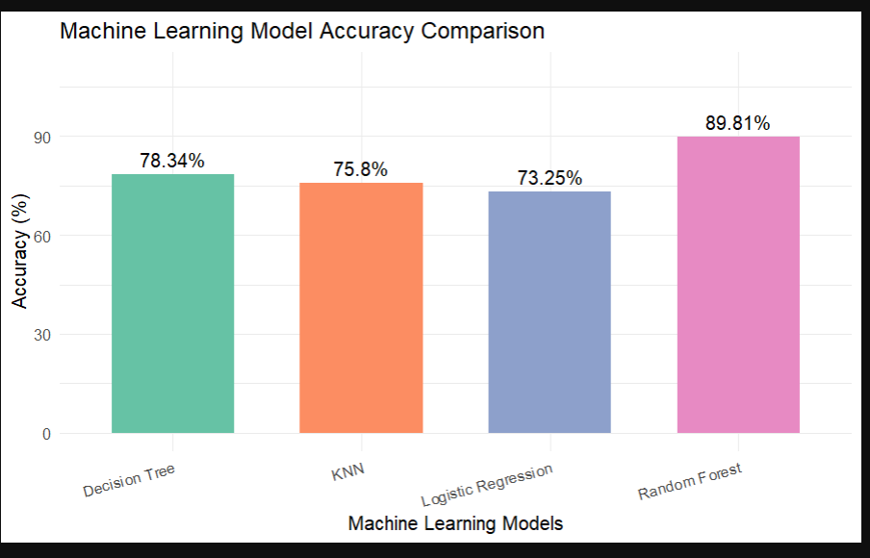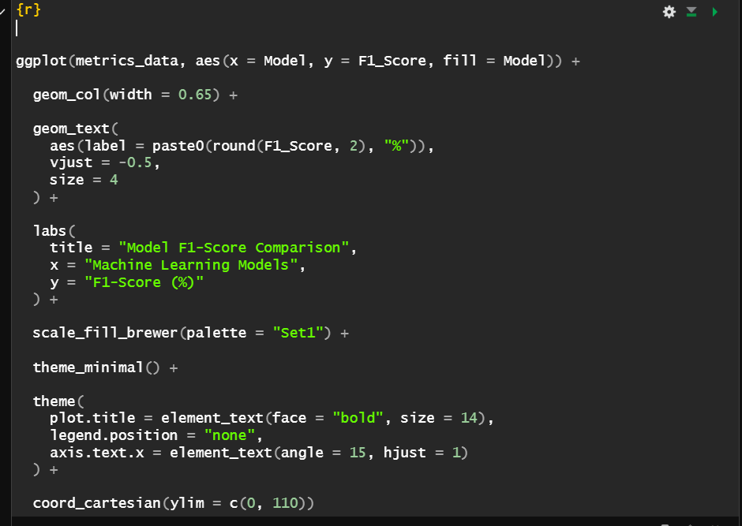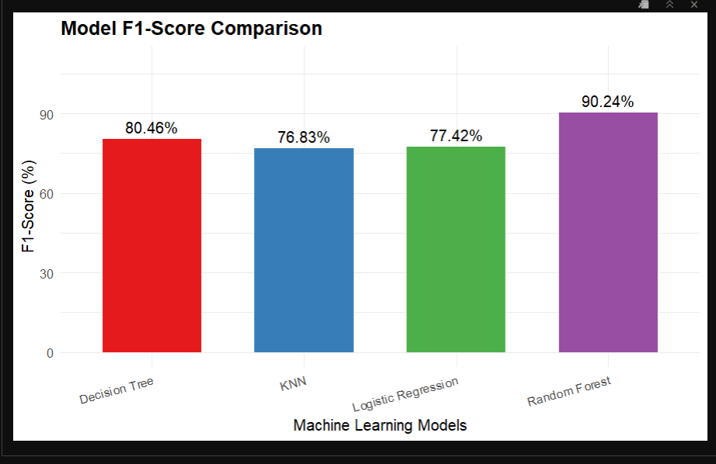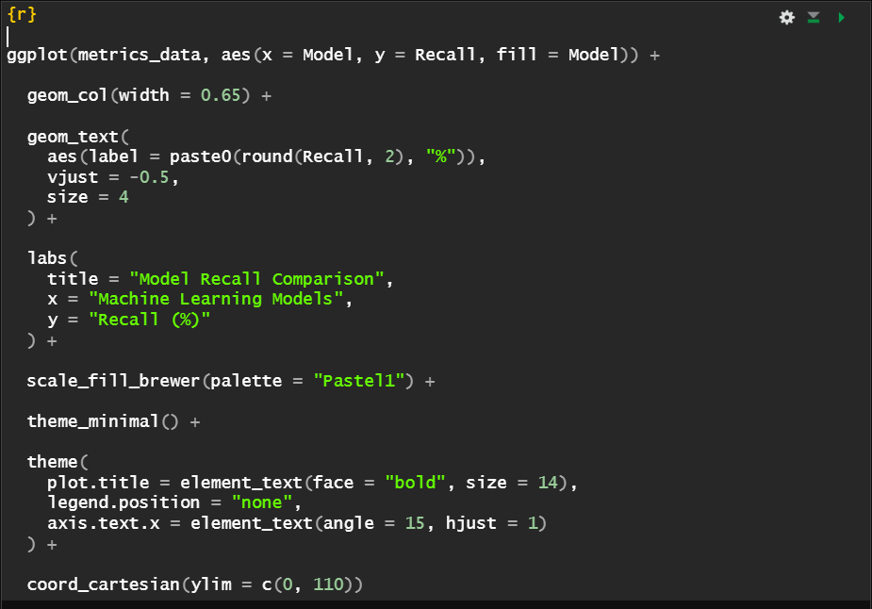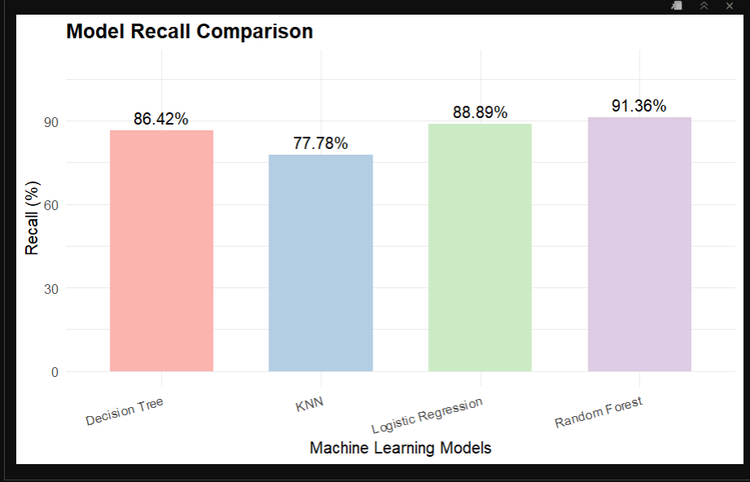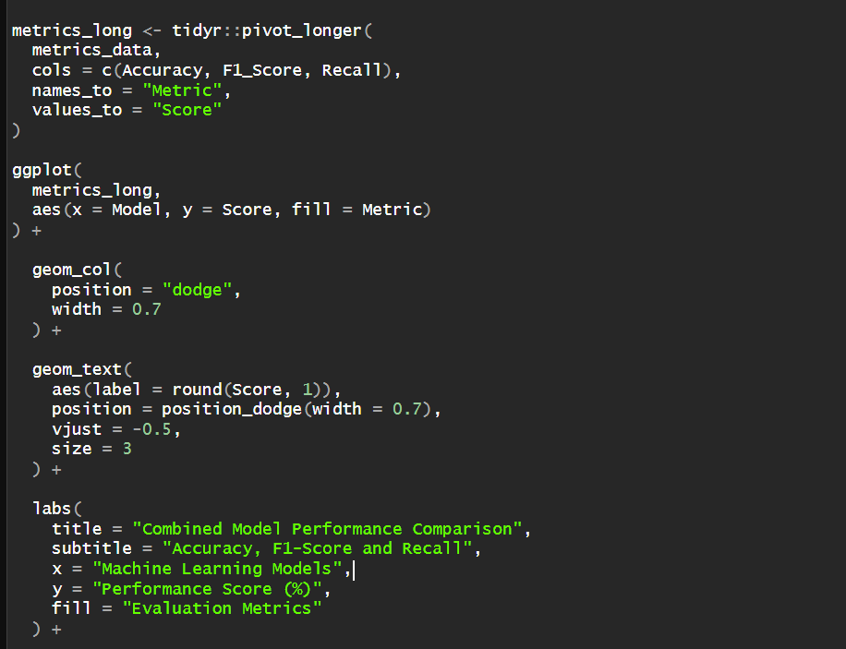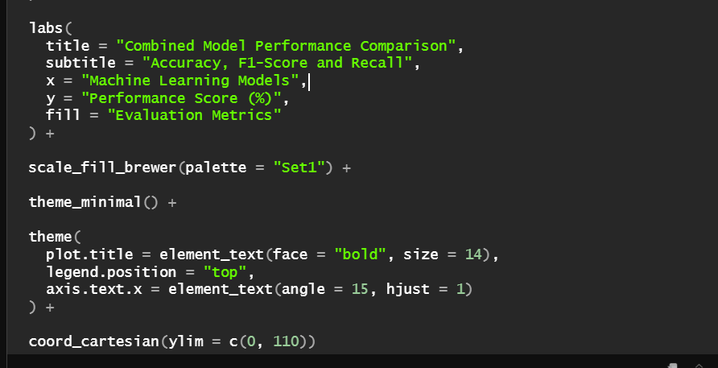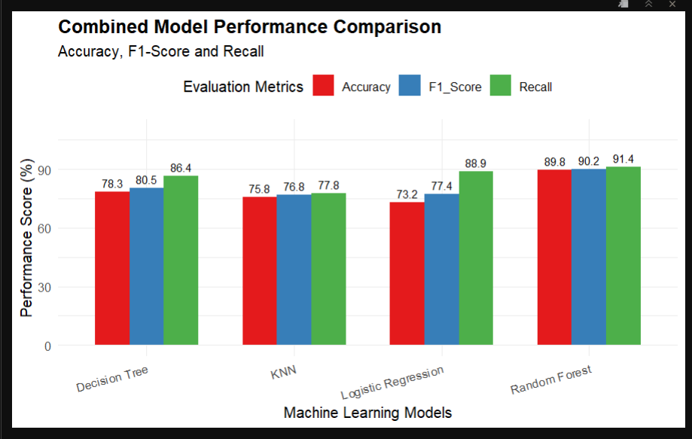

SHAP-based explainability
SHAP expresses a prediction as a base value plus the sum of feature contributions [2]:

where φ₀ is the average model output and φᵢ is the contribution of feature i. TreeSHAP computes these values exactly for tree ensembles [5]. The explainer is built on the saved Random Forest with a background sample of 100 applications, and explanations are computed for the approved class (class 1) on a random sample of 50 applications. The framework produces three views.
- Global importance (bar plot): mean absolute SHAP value per feature.
- Summary (beeswarm) plot: the direction and spread of each feature's effect, coloured by feature value.
- Local explanation (waterfall plot): for one applicant, how each feature pushes the probability up or down from the base value.

Counterfactual analysis
For an applicant x whose model prediction is rejection, the counterfactual engine seeks a modified application x′ that the modelapproves, with the smallest change: 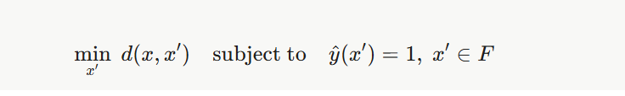
The feasible set F is a fixed grid over the two features an applicant can adjust. The loan amount is scaled by 1.0, 0.9, 0.8, 0.7, 0.6 and 0.5, and the loan term is kept, extended by 60 months, extended by 120 months or set to 480 months (capped at 480). All other attributes, including credit history, income and personal attributes, stay fixed. Among the grid points the model approves, the one with the lowest change score is returned:
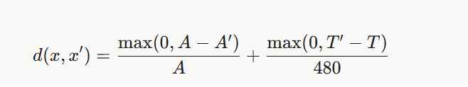
where A and A′ are the original and new loan amounts and T and T′ are the original and new terms. Ties are broken by the higher approval probability. If no grid point is approved, the system reports that no feasible change was found instead of suggesting an unrealistic one.

Loan eligibility improvement advisor
The advisor is a transparent rule set that complements the counterfactual search. It raises a recommendation when any of the following holds: credit history is poor; the requested loan exceeds three times annual income; there is no co-applicant income; the term is shorter than 180 months; or the estimated EMI exceeds 40% of monthly income. It also adds a message matching the predicted approval probability (below 0.40, 0.40 to 0.70, or above 0.70).

Applicant risk categorization
Each application is assigned an indicator band from its predicted approval probability p. The thresholds are design choices made for this project.
Table 2. Application risk indicator bands.
Predicted approval probability | Application risk indicator | Interpretation
p ≥ 0.70 | Low | High predicted loan approval likelihood
0.40 ≤ p < 0.70 | Medium | Moderate predicted loan approval likelihood
p < 0.40 | High | Low predicted loan approval likelihood

Interactive dashboard
The system is deployed as a Streamlit web application. The user enters application details and receives the decision, approval probability, risk indicator, EMI summary, SHAP plots, counterfactual suggestions and improvement advice.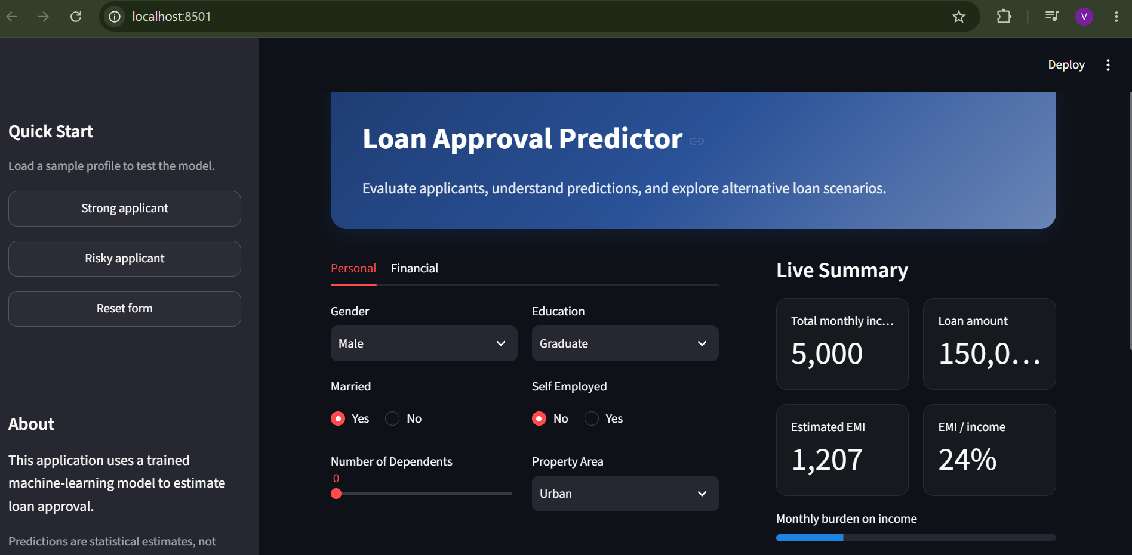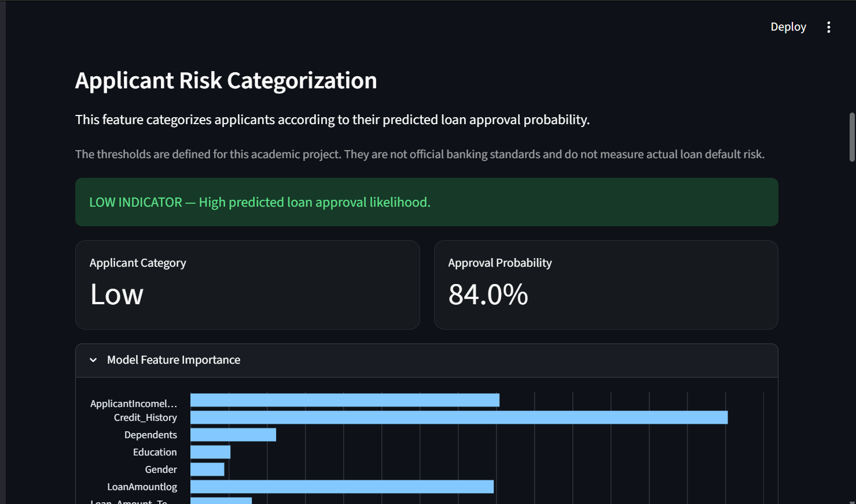

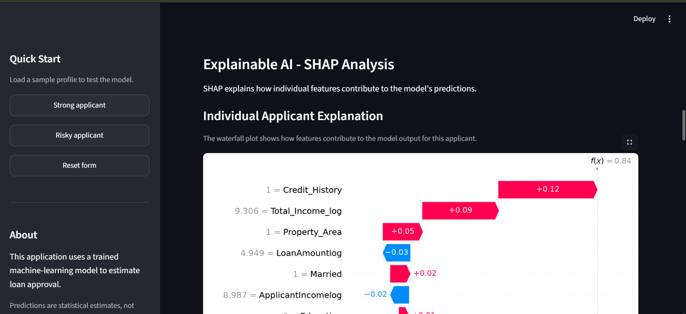
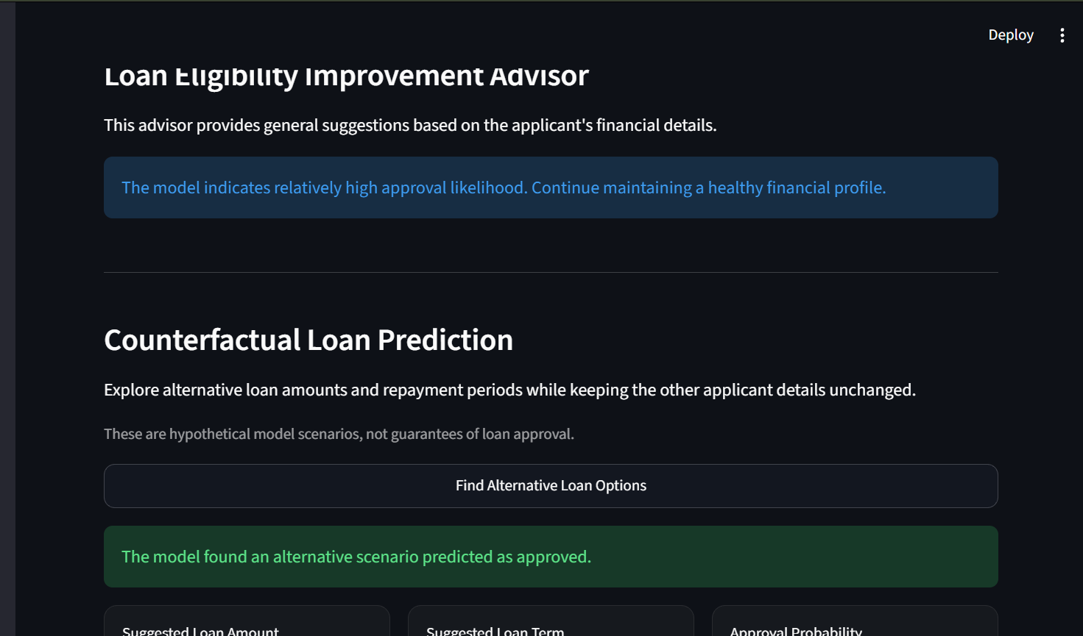
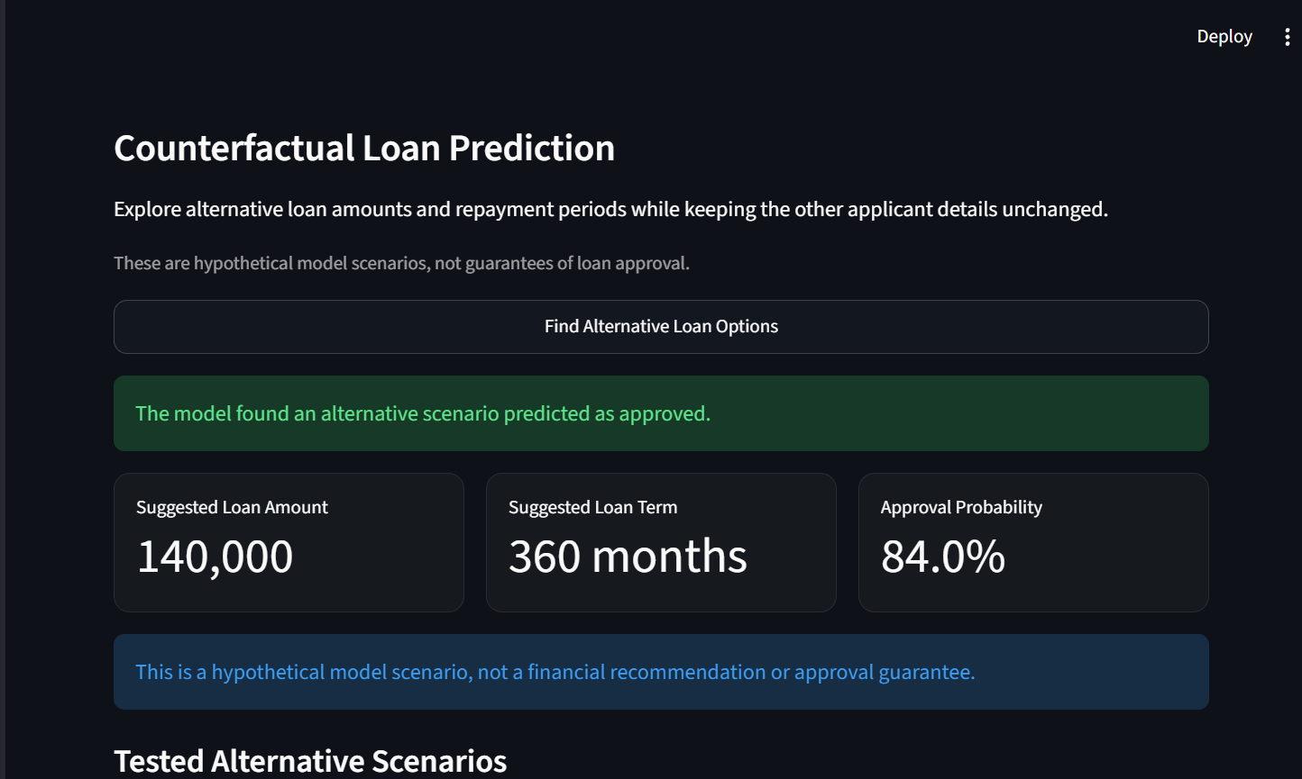

Evaluation metrics
Classification measures such as Precision, Recall, Accuracy, F1-score, Specificity, Confusion Matrix, Receiver Operating Characteristic (ROC) and Area Under the Curve (AUC) were used to assess model performance. A positive is an approved application.

Confusion matrix
Summarizes true positives (TP), false positives (FP), true negatives (TN) and false negatives (FN).

Precision
Proportion of predicted approvals that were actually approved:


Recall
Proportion of actual approvals that the model identified:


Accuracy
Percentage of correctly classified applications:


F1-score
Harmonic mean of precision and recall:


Specificity
Proportion of actual rejections correctly identified:


ROC and AUC
The ROC curve plots recall against the false positive rate across thresholds. AUC measures the ability to separate approved from rejected applications, where a higher value indicates better discrimination.

Counterfactual and explanation metrics
- Validity: percentage of applications predicted as rejected for which a feasible counterfactual was found.
- Proximity: average relative loan amount reduction needed, and average probability before and after the change.
- Band calibration: observed approval rate within each risk indicator band.

Results
The Random Forest gives the best discrimination (AUC 0.78) and the best accuracy and F1-score on the held-out test set, although accuracy differences between it and Logistic Regression are small. All models were trained on the oversampled training set and evaluated on the 154 test applications at their original class distribution.

Table 3. Hold-out test performance (n = 154; oversampling on the training set only).
Model | Acc (%) | Prec (%) | Rec (%) | F1 (%) | Spec (%) | AUC
Logistic Regression | 75.32 | 75.41 | 92.00 | 82.88 | 44.44 | 0.70
Decision Tree | 65.58 | 73.74 | 73.00 | 73.37 | 51.85 | 0.62
K-Nearest Neighbours | 67.53 | 75.51 | 74.00 | 74.75 | 55.56 | 0.66
Random Forest (proposed) | 76.62 | 77.12 | 91.00 | 83.49 | 50.00 | 0.78

Table 4. Five-fold stratified cross-validation, mean ± standard deviation (oversampling inside training folds).

Model | Acc (%) | Prec (%) | Rec (%) | F1 (%) | Spec (%) | AUC
Logistic Regression | 75.58 ± 4.37 | 79.27 ± 0.96 | 87.21 ± 7.04 | 82.97 ± 3.67 | 49.97 ± 2.75 | 0.71 ± 0.05
Decision Tree | 71.16 ± 3.30 | 79.11 ± 1.36 | 78.89 ± 6.09 | 78.90 ± 3.21 | 54.16 ± 5.09 | 0.67 ± 0.02
K-Nearest Neighbours | 69.05 ± 2.91 | 78.49 ± 2.00 | 75.81 ± 5.04 | 77.04 ± 2.78 | 54.09 ± 7.37 | 0.69 ± 0.02
Random Forest (proposed) | 75.89 ± 2.57 | 79.51 ± 0.74 | 87.42 ± 4.14 | 83.25 ± 2.19 | 50.51 ± 1.99 | 0.76 ± 0.02

Predictive performance

The Random Forest reaches 76.62% test accuracy, 77.12% precision, 91.00% recall, an F1-score of 83.49% and an AUC of 0.78. Logistic Regression is close in accuracy (75.32%) but has a lower AUC (0.70), so the forest ranks applicants better. The single Decision Tree (65.58%) and K-Nearest Neighbours (67.53%) trail both, consistent with overfitting on a small dataset. Cross-validation confirms the ordering: the Random Forest and Logistic Regression are statistically indistinguishable on accuracy (75.89 ± 2.57% against 75.58 ± 4.37%), while the forest has the higher and more stable AUC (0.76 ± 0.02 against 0.71 ± 0.05).
All models favour approvals. The Random Forest correctly identifies 91 of 100 approved applications but only 27 of 54 rejected ones (specificity 50.00%), producing 27 false approvals and 9 false rejections (Fig. 3). Oversampling raised specificity modestly, from 44.44% to 50.00% for the Random Forest and from 38.89% to 44.44% for Logistic Regression, with little change in accuracy (75.97% for the Random Forest without oversampling). With only 154 test applications, differences of a few percentage points are within sampling noise, so the main claim is not that the Random Forest is far more accurate than the baselines, but that it gives competitive accuracy with the best AUC and with exact SHAP explanations available.
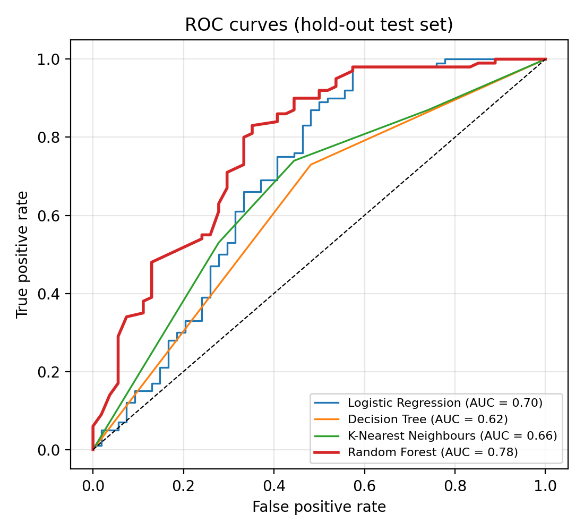
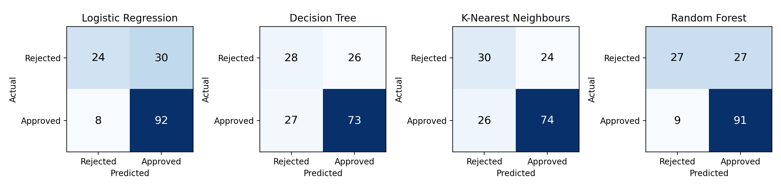

A note on protocol: oversampling the full dataset before splitting yields a higher Random Forest accuracy of 87.7%, but 43.6% of the resulting test rows have exact copies in the training set. That figure reflects memorised duplicates rather than generalisation and is therefore not reported as a result.

Global explainability
The SHAP bar plot (Fig. 4) shows that Credit_History is by far the most influential feature, with a mean absolute SHAP value of 0.15. It is followed by Total_Income_log (0.06), LoanAmountlog (0.06), ApplicantIncomelog (0.05) and Property_Area (0.04). Dependents and Married contribute about 0.02 each, and Education, Loan_Amount_Term_log and the remaining two features (Gender, Self_Employed) contribute about 0.01 or less.
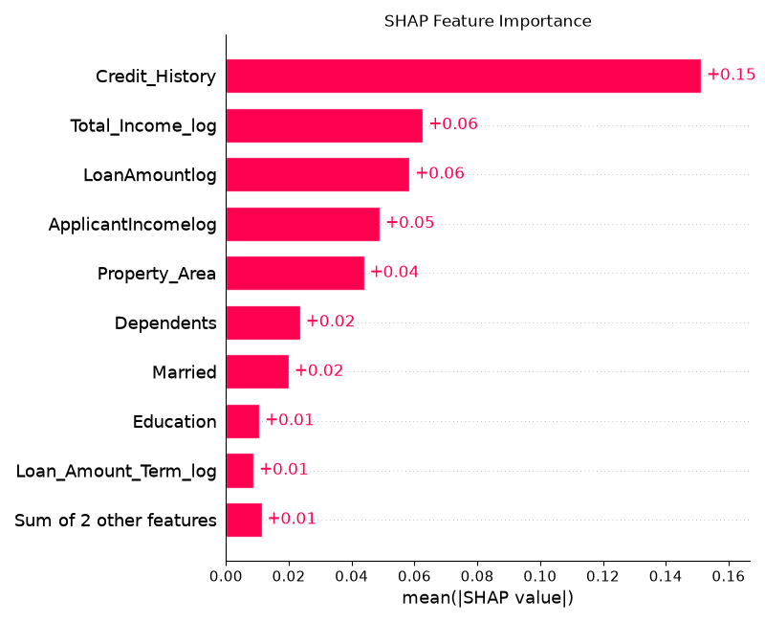
The summary plot shows the direction of these effects. A good credit history pushes the predicted approval probability up by roughly 0.1, while a poor credit history pushes it down by 0.4 to 0.6, the largest single effect in the model. Higher total income raises the probability, and larger loan amounts lower it. These directions match lending practice, which supports the validity of the model's reasoning. Gender and marital status receive small but non-zero attributions, which is a fairness concern discussed below.
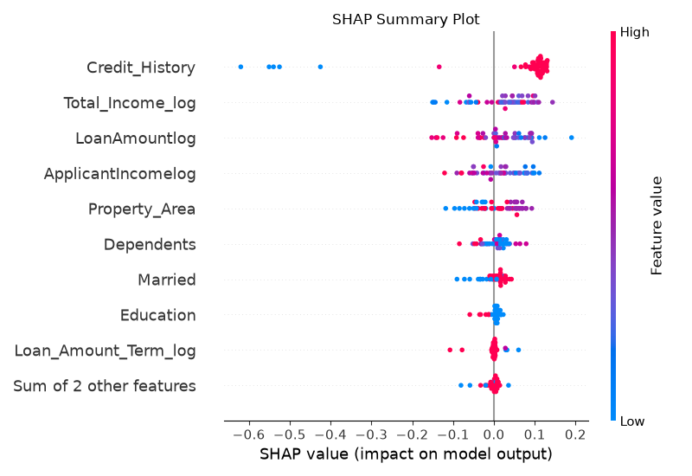

Local explainability

shows the explanation for one applicant with a predicted approval probability of 0.67, against a base value of 0.587. Credit_History = 1 adds 0.11, Total_Income_log adds 0.07, Married adds 0.04 and Property_Area (Semiurban) adds 0.04. These are partly offset by ApplicantIncomelog (−0.08), LoanAmountlog (−0.07, a loan of about 229 thousand) and Dependents (−0.03). This applicant is approved and falls in the Medium band (0.40 to 0.70). The opposite signs on ApplicantIncomelog and Total_Income_log, which have identical values here because there is no co-applicant income, show how SHAP splits credit between correlated features.
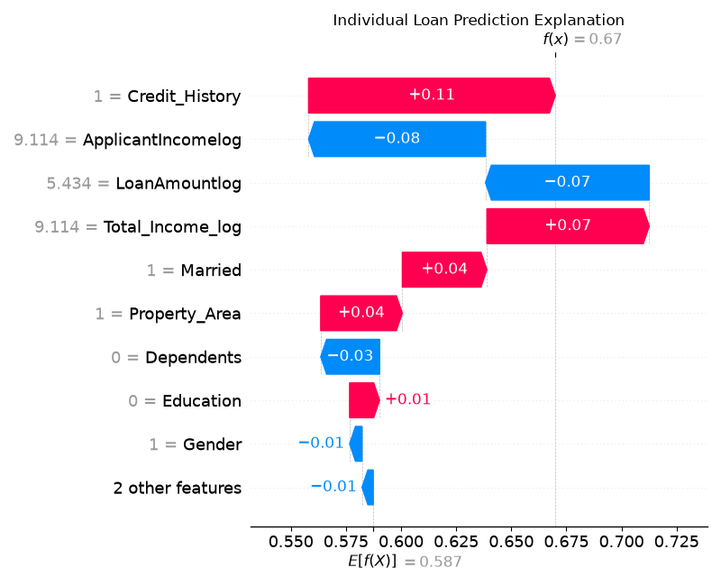

Counterfactual and advisor results
The Random Forest predicted rejection for 35 of the 154 test applications. The counterfactual grid search found a feasible path to approval for 6 of them (17.1%).

Table 5. Counterfactual analysis on test applications predicted as rejected.
Metric | Value
Applications predicted as rejected | 35
Feasible counterfactual found | 6 (17.1%)
Changes needed | Loan amount reduction only; no term change
Mean loan amount reduction | 23.1% (range 9.3% to 49.7%)
Mean approval probability, before → after | 0.447 → 0.517
Rejected applications with poor credit history | 23 of 35

All six successful cases needed only a reduction in the loan amount, and extending the term never helped. These applicants were borderline, with predicted probabilities of 0.40 to 0.48, so a smaller loan moved them just over the 0.5 decision boundary. The remaining 29 applications could not be approved by changing amount or term alone. 23 of the 35 rejected applications have a poor credit history, which SHAP identifies as the dominant driver, so no change to the loan can offset it. This shows the limit of the current counterfactual space and motivates the advisor's non-model rules, such as improving credit history or adding a co-applicant.

Risk categorization analysis
Table 6 shows how the 154 test applications fall into the indicator bands, and the approval rate actually observed in each. The approval rate rises steadily from High to Low, so the bands order applications sensibly.

Table 6. Application risk indicator distribution on the test set.

Indicator band | Applications | Observed approval rate
Low (p ≥ 0.70) | 83 | 80.7%
Medium (0.40 ≤ p < 0.70) | 45 | 66.7%
High (p < 0.40) | 26 | 11.5%

Sample Code (Model Training)

## Random Forest Classifier

library(randomForest)

train_data <- data.frame(
Loan_Status = factor(y_resampled_train),
X_resampled_train
)

model3 <- randomForest(
Loan_Status ~ .,
data = train_data
)

y_pred_model3 <- predict(
model3,
newdata = X_resampled_test,
type = "class"
)

y_pred_model3 <- as.integer(as.character(y_pred_model3))

accuracy <- mean(
as.integer(as.character(y_resampled_test)) == y_pred_model3
)

print(paste(
"Accuracy score of Random Forest:",
accuracy * 100
))

Limitations

- The dataset is small (614 applications; 154 in the test set), so performance estimates are noisy. Cross-validation standard deviations of 2 to 4 points on accuracy illustrate this.
- Specificity is only about 50%. About half of the rejected applications are predicted as approved, so the model is not suitable for unsupervised decisions.
- The model predicts historical approval decisions, so it can inherit biases in those decisions. Gender and marital status are used as inputs. SHAP exposes their small influence but does not remove it.
- Credit_History is missing for 50 applications and is imputed with the mean (about 0.84), which produces fractional values for a binary variable that the dashboard never supplies.
- Counterfactuals change only loan amount and term, so they cannot help applicants whose rejection is driven by credit history. They are model-based associations, not guarantees of approval by any lender.
- Risk indicators reflect approval likelihood, not repayment behaviour, and must not be interpreted as default risk.
- SHAP values are computed on a random sample of 50 applications, and correlated income features share attribution between them.
- The evaluated models were re-trained with the same configuration as the deployed model. The deployed model file should be re-trained on the training partition only if it is to be evaluated directly.

Conclusion
This work presented an integrated, explainable loan eligibility prediction system that goes beyond a simple approved or rejected label. A Random Forest trained on 614 applications reached 76.62% accuracy and an AUC of 0.78 on a held-out test set, with the best AUC among four classifiers. SHAP showed that credit history dominates decisions, followed by income and loan amount. A constrained counterfactual search and a rule-based advisor converted these explanations into guidance, finding a loan-amount reduction that reaches approval for 17.1% of rejected test applications. The risk categorisation layer grouped applications into Low, Medium and High bands whose observed approval rates were 80.7%, 66.7% and 11.5%. The whole pipeline is delivered through an interactive dashboard that non-technical users can operate.
The contribution lies in combining prediction, explanation, recourse and presentation in one framework, not in a large accuracy gain. The risk indicators describe the likelihood of approval, not the likelihood of default, and this distinction is kept throughout the system.
Future work includes validating on larger multi-lender datasets, auditing fairness and removing demographic inputs, widening counterfactuals to credit history and co-applicant income, comparing gradient boosting and calibrated models under the same explanation pipeline, and evaluating usability with real applicants and loan officers.

Data availability
The dataset that supports the findings of this study (Dataset.csv, 614 records) is available at https://www.kaggle.com/datasets/altruistdelhite04/loan-prediction-problem-dataset. The trained model, feature columns, SHAP script and dashboard code are available.

References
- Breiman, L. Random forests. Machine Learning 45(1), 5–32 (2001).
- Lundberg, S. M. & Lee, S.-I. A unified approach to interpreting model predictions. Advances in Neural Information Processing Systems 30 (2017).
- Wachter, S., Mittelstadt, B. & Russell, C. Counterfactual explanations without opening the black box: Automated decisions and the GDPR. Harvard Journal of Law & Technology 31(2), 841–887 (2018).
- Ribeiro, M. T., Singh, S. & Guestrin, C. “Why should I trust you?”: Explaining the predictions of any classifier. Proc. 22nd ACM SIGKDD, 1135–1144 (2016).
- Lundberg, S. M. et al. From local explanations to global understanding with explainable AI for trees. Nature Machine Intelligence 2, 56–67 (2020).
- Mothilal, R. K., Sharma, A. & Tan, C. Explaining machine learning classifiers through diverse counterfactual explanations. Proc. ACM FAccT, 607–617 (2020).
- Chen, T. & Guestrin, C. XGBoost: A scalable tree boosting system. Proc. 22nd ACM SIGKDD, 785–794 (2016).
- Pedregosa, F. et al. Scikit-learn: Machine learning in Python. Journal of Machine Learning Research 12, 2825–2830 (2011).
- Chawla, N. V., Bowyer, K. W., Hall, L. O. & Kegelmeyer, W. P. SMOTE: Synthetic minority over-sampling technique. Journal of Artificial Intelligence Research 16, 321–357 (2002)

R codes

# Load libraries

library(dplyr)
library(tidyr)
library(ggplot2)
library(caret)
library(rpart)
library(rpart.plot)
library(randomForest)
library(class)

# Read dataset

df <- read.csv("Dataset.csv")

# Explore dataset

head(df)
tail(df)
dim(df)
str(df)
summary(df)
colSums(is.na(df))

# Check duplicate records

sum(duplicated(df))
df <- distinct(df)

# Check numerical columns

numeric_columns <- names(df)[sapply(df, is.numeric)]

# Initial boxplot

df %>%
select(all_of(numeric_columns)) %>%
pivot_longer(cols = everything(),
names_to = "Feature",
values_to = "Value") %>%
ggplot(aes(x = Feature, y = Value)) +
geom_boxplot() +
theme_minimal() +
theme(axis.text.x = element_text(angle = 45, hjust = 1)) +
labs(title = "Boxplot of Numerical Features")

# Handle missing values

mode_value <- function(x) {
values <- na.omit(x)
if (length(values) == 0) {
return(NA)
}
names(sort(table(values), decreasing = TRUE))[1]
}

for (col in names(df)) {
if (is.numeric(df[[col]])) {
df[[col]][is.na(df[[col]])] <- median(df[[col]], na.rm = TRUE)
} else {
df[[col]][is.na(df[[col]])] <- mode_value(df[[col]])
}
}

# Check missing values after preprocessing

colSums(is.na(df))

# Exploratory Data Analysis

# Gender distribution

if ("Gender" %in% names(df)) {
ggplot(df, aes(x = Gender, fill = Gender)) +
geom_bar() +
theme_minimal() +
labs(title = "Gender Distribution")
}

# Marital status distribution

if ("Married" %in% names(df)) {
ggplot(df, aes(x = Married, fill = Married)) +
geom_bar() +
theme_minimal() +
labs(title = "Marital Status Distribution")
}

# Education distribution

if ("Education" %in% names(df)) {
ggplot(df, aes(x = Education, fill = Education)) +
geom_bar() +
theme_minimal() +
labs(title = "Education Distribution")
}

# Loan status distribution

ggplot(df, aes(x = Loan_Status, fill = Loan_Status)) +
geom_bar() +
theme_minimal() +
labs(title = "Loan Approval Status Distribution",
x = "Loan Status",
y = "Count")

# Statistical analysis

summary(df)

df %>%
select(where(is.numeric)) %>%
summarise(
across(
everything(),
list(
Mean = ~mean(.),
Median = ~median(.),
SD = ~sd(.),
Minimum = ~min(.),
Maximum = ~max(.)
)
)
)

# Correlation analysis

correlation_data <- df %>%
select(where(is.numeric))

correlation_matrix <- cor(correlation_data)

print(correlation_matrix)

# Correlation heatmap

correlation_df <- as.data.frame(as.table(correlation_matrix))

ggplot(correlation_df,
aes(Var1, Var2, fill = Freq)) +
geom_tile() +
scale_fill_gradient2(
low = "blue",
mid = "white",
high = "red",
midpoint = 0
) +
theme_minimal() +
theme(axis.text.x = element_text(angle = 45, hjust = 1)) +
labs(title = "Correlation Heatmap",
x = "",
y = "")

# Feature Engineering

if (all(c("ApplicantIncome", "CoapplicantIncome") %in% names(df))) {
df$Total_Income <- df$ApplicantIncome + df$CoapplicantIncome
df$ApplicantIncomelog <- log1p(df$ApplicantIncome)
df$Total_Income_log <- log1p(df$Total_Income)
}

if ("LoanAmount" %in% names(df)) {
df$LoanAmountlog <- log1p(df$LoanAmount)
}

if ("Loan_Amount_Term" %in% names(df)) {
df$Loan_Amount_Term_log <- log1p(df$Loan_Amount_Term)
}

# Distribution of transformed features

if ("ApplicantIncomelog" %in% names(df)) {
ggplot(df, aes(x = ApplicantIncomelog)) +
geom_histogram(bins = 30, fill = "skyblue", color = "black") +
theme_minimal() +
labs(title = "Applicant Income Distribution")
}

if ("LoanAmountlog" %in% names(df)) {
ggplot(df, aes(x = LoanAmountlog)) +
geom_histogram(bins = 30, fill = "lightgreen", color = "black") +
theme_minimal() +
labs(title = "Loan Amount Distribution")
}

if ("Loan_Amount_Term_log" %in% names(df)) {
ggplot(df, aes(x = Loan_Amount_Term_log)) +
geom_histogram(bins = 30, fill = "orange", color = "black") +
theme_minimal() +
labs(title = "Loan Amount Term Distribution")
}

if ("Total_Income_log" %in% names(df)) {
ggplot(df, aes(x = Total_Income_log)) +
geom_histogram(bins = 30, fill = "purple", color = "black") +
theme_minimal() +
labs(title = "Total Income Distribution")
}

# Boxplots of transformed features

transformed_columns <- intersect(
c("ApplicantIncomelog",
"LoanAmountlog",
"Loan_Amount_Term_log",
"Total_Income_log"),
names(df)
)

if (length(transformed_columns) > 0) {
df %>%
select(all_of(transformed_columns)) %>%
pivot_longer(cols = everything(),
names_to = "Feature",
values_to = "Value") %>%
ggplot(aes(x = Feature, y = Value)) +
geom_boxplot(fill = "lightblue") +
theme_minimal() +
theme(axis.text.x = element_text(angle = 45, hjust = 1)) +
labs(title = "Boxplot of Transformed Features")
}

# Loan status comparison

if ("Education" %in% names(df)) {
ggplot(df, aes(x = Education, fill = Loan_Status)) +
geom_bar(position = "dodge") +
theme_minimal() +
labs(title = "Loan Approval by Education")
}

if ("Property_Area" %in% names(df)) {
ggplot(df, aes(x = Property_Area, fill = Loan_Status)) +
geom_bar(position = "dodge") +
theme_minimal() +
labs(title = "Loan Approval by Property Area")
}

if ("Gender" %in% names(df)) {
ggplot(df, aes(x = Gender, fill = Loan_Status)) +
geom_bar(position = "dodge") +
theme_minimal() +
labs(title = "Loan Approval by Gender")
}

# Remove unnecessary original columns

columns_to_remove <- intersect(
c("ApplicantIncome",
"CoapplicantIncome",
"LoanAmount",
"Loan_Amount_Term",
"Total_Income",
"Loan_ID"),
names(df)
)

df <- df %>%
select(-all_of(columns_to_remove))

# Encode target variable

df$Loan_Status <- trimws(as.character(df$Loan_Status))

df$Loan_Status <- factor(
df$Loan_Status,
levels = c("N", "Y")
)

# Encode categorical variables

categorical_columns <- names(df)[
sapply(df, function(x) is.character(x) || is.factor(x))
]

categorical_columns <- setdiff(categorical_columns, "Loan_Status")

for (col in categorical_columns) {
df[[col]] <- as.integer(factor(df[[col]])) - 1
}

# Check processed dataset

str(df)
head(df)
summary(df)

# Prepare features and target variable

X <- df %>%
select(-Loan_Status)

y <- df$Loan_Status

# Remove rows with missing target values, if any

valid_rows <- !is.na(y)

X <- X[valid_rows, , drop = FALSE]
y <- droplevels(y[valid_rows])

# Convert features to numeric

X <- as.data.frame(
lapply(X, function(x) as.numeric(as.character(x)))
)

# Replace any remaining missing or infinite feature values

for (col in names(X)) {
X[[col]][!is.finite(X[[col]])] <- median(
X[[col]][is.finite(X[[col]])],
na.rm = TRUE
)
}

# Split training and testing data

set.seed(123)

train_index <- createDataPartition(
y,
p = 0.75,
list = FALSE
)

X_train <- X[train_index, , drop = FALSE]
X_test <- X[-train_index, , drop = FALSE]

y_train <- droplevels(y[train_index])
y_test <- factor(y[-train_index], levels = levels(y))

# Balance training data using upsampling

train_data <- data.frame(
X_train,
Loan_Status = y_train
)

train_data <- upSample(
x = train_data %>% select(-Loan_Status),
y = train_data$Loan_Status,
yname = "Loan_Status"
)

X_train_balanced <- train_data %>%
select(-Loan_Status)

y_train_balanced <- train_data$Loan_Status

# Logistic Regression

model1 <- glm(
Loan_Status ~ .,
data = train_data,
family = binomial
)

logistic_probability <- predict(
model1,
newdata = X_test,
type = "response"
)

logistic_prediction <- ifelse(
logistic_probability >= 0.5,
"Y",
"N"
)

logistic_prediction <- factor(
logistic_prediction,
levels = levels(y_test)
)

# Decision Tree

model2 <- rpart(
Loan_Status ~ .,
data = train_data,
method = "class"
)

decision_prediction <- predict(
model2,
newdata = X_test,
type = "class"
)

decision_prediction <- factor(
decision_prediction,
levels = levels(y_test)
)

# Random Forest

set.seed(123)

model3 <- randomForest(
Loan_Status ~ .,
data = train_data,
ntree = 500,
importance = TRUE
)

random_forest_prediction <- predict(
model3,
newdata = X_test
)

random_forest_prediction <- factor(
random_forest_prediction,
levels = levels(y_test)
)

# KNN

# Scale data using training data parameters

train_mean <- sapply(X_train_balanced, mean)
train_sd <- sapply(X_train_balanced, sd)

train_sd[train_sd == 0] <- 1

X_train_scaled <- scale(
X_train_balanced,
center = train_mean,
scale = train_sd
)

X_test_scaled <- scale(
X_test,
center = train_mean,
scale = train_sd
)

# Apply KNN

knn_prediction <- knn(
train = X_train_scaled,
test = X_test_scaled,
cl = y_train_balanced,
k = 5
)

knn_prediction <- factor(
knn_prediction,
levels = levels(y_test)
)

# Classification Report Function

classification_report <- function(actual, predicted) {

actual <- factor(actual, levels = c("N", "Y"))
predicted <- factor(predicted, levels = c("N", "Y"))

cm <- confusionMatrix(
predicted,
actual,
positive = "Y"
)

print(cm)

precision <- cm$byClass["Precision"]
recall <- cm$byClass["Recall"]
f1 <- cm$byClass["F1"]
accuracy <- cm$overall["Accuracy"]

return(
data.frame(
Accuracy = as.numeric(accuracy),
Precision = as.numeric(precision),
Recall = as.numeric(recall),
F1_Score = as.numeric(f1)
)
)
}

# Evaluate Logistic Regression

cat("Logistic Regression Results\n")

logistic_report <- classification_report(
y_test,
logistic_prediction
)

print(logistic_report)

# Evaluate Decision Tree

cat("Decision Tree Results\n")

decision_report <- classification_report(
y_test,
decision_prediction
)

print(decision_report)

# Evaluate Random Forest

cat("Random Forest Results\n")

random_forest_report <- classification_report(
y_test,
random_forest_prediction
)

print(random_forest_report)

# Evaluate KNN

cat("KNN Results\n")

knn_report <- classification_report(
y_test,
knn_prediction
)

print(knn_report)

# Compare all models

model_comparison <- data.frame(
Model = c(
"Logistic Regression",
"Decision Tree",
"Random Forest",
"KNN"
),
Accuracy = c(
logistic_report$Accuracy,
decision_report$Accuracy,
random_forest_report$Accuracy,
knn_report$Accuracy
),
Precision = c(
logistic_report$Precision,
decision_report$Precision,
random_forest_report$Precision,
knn_report$Precision
),
Recall = c(
logistic_report$Recall,
decision_report$Recall,
random_forest_report$Recall,
knn_report$Recall
),
F1_Score = c(
logistic_report$F1_Score,
decision_report$F1_Score,
random_forest_report$F1_Score,
knn_report$F1_Score
)
)

print(model_comparison)

# Accuracy comparison graph

ggplot(model_comparison,
aes(x = Model, y = Accuracy, fill = Model)) +
geom_bar(stat = "identity") +
theme_minimal() +
labs(title = "Model Accuracy Comparison",
x = "Machine Learning Models",
y = "Accuracy") +
theme(axis.text.x = element_text(angle = 30, hjust = 1))

# Precision comparison graph

ggplot(model_comparison,
aes(x = Model, y = Precision, fill = Model)) +
geom_bar(stat = "identity") +
theme_minimal() +
labs(title = "Model Precision Comparison",
x = "Machine Learning Models",
y = "Precision") +
theme(axis.text.x = element_text(angle = 30, hjust = 1))

# Recall comparison graph

ggplot(model_comparison,
aes(x = Model, y = Recall, fill = Model)) +
geom_bar(stat = "identity") +
theme_minimal() +
labs(title = "Model Recall Comparison",
x = "Machine Learning Models",
y = "Recall") +
theme(axis.text.x = element_text(angle = 30, hjust = 1))

# F1 score comparison graph

ggplot(model_comparison,
aes(x = Model, y = F1_Score, fill = Model)) +
geom_bar(stat = "identity") +
theme_minimal() +
labs(title = "Model F1 Score Comparison",
x = "Machine Learning Models",
y = "F1 Score") +
theme(axis.text.x = element_text(angle = 30, hjust = 1))

# Combined performance comparison

model_comparison_long <- model_comparison %>%
pivot_longer(
cols = c(Accuracy, Precision, Recall, F1_Score),
names_to = "Metric",
values_to = "Score"
)

ggplot(model_comparison_long,
aes(x = Model, y = Score, fill = Metric)) +
geom_bar(stat = "identity",
position = "dodge") +
theme_minimal() +
labs(title = "Overall Model Performance Comparison",
x = "Machine Learning Models",
y = "Performance Score") +
theme(axis.text.x = element_text(angle = 30, hjust = 1))

# Random Forest feature importance

importance(model3)

varImpPlot(
model3,
main = "Random Forest Feature Importance"
)

# Decision Tree visualization

rpart.plot(
model2,
main = "Decision Tree for Loan Approval Prediction",
extra = 104,
fallen.leaves = TRUE
)

# Cross-validation for Logistic Regression

set.seed(123)

control <- trainControl(
method = "cv",
number = 5
)

logistic_cv <- train(
Loan_Status ~ .,
data = train_data,
method = "glm",
family = binomial,
trControl = control
)

print(logistic_cv)

# Cross-validation for Decision Tree

set.seed(123)

decision_cv <- train(
Loan_Status ~ .,
data = train_data,
method = "rpart",
trControl = control
)

print(decision_cv)

# Save trained model and feature columns

saveRDS(
model3,
"loan_model.rds"
)

saveRDS(
names(X_train),
"feature_columns.rds"
)

# Final output

cat("Project execution completed successfully.\n")
cat("Random Forest model saved as loan_model.rds\n")
cat("Feature columns saved as feature_columns.rds\n")

print(model_comparison)
GitHub Repositories
The source code and related project files for the Credit Risk Modelling using Machine Learning for Loan Approval Prediction project are maintained in a GitHub repository. The repository provides a centralized platform for storing, managing, and accessing the project resources.
The GitHub repository includes the following components:
- Source Code: Contains the R scripts used for data preprocessing, exploratory data analysis, feature engineering, model training, and evaluation.
- Dataset: Includes the dataset used for developing and testing the loan approval prediction models, subject to its usage and distribution permissions.
- Documentation: Provides project details, implementation steps, required libraries, and instructions for executing the code.
- Model Files: Stores the trained model files and related supporting files, where applicable.
Repository Link: https://github.com/Vasun0505/Credit-Risk-Modeling-Using-Machine-Learning

