**UIT2512---Operating Systems Practices Lab**

# Implementation of SJF CPU Scheduling Algorithm (Non Preemptive & Preemptive) in Python

# Name: Vasundhara.B

# Roll no: 3122 21 5002 119

**Aim:**

To write a python code to implement SJF CPU Scheduling Algorithm (Non Preemptive & Preemptive)

**CODE:**

def preemptive(n,d,at,bt):

    i = 0

    ll = []

    for i in range(0, sum(bt)):

        l = [j for j in d  if j[1] <= i]

        l.sort(key=lambda x: x[0])

        d[d.index(l[0])][0] -= 1

        for k in d:

            if k[0] == 0:

                t = d.pop(d.index(k))

                ll.append([k, i + 1])

    ct = [0] * (n)

    tat = [0] * (n)

    wt = [0] * (n )

    for i in ll:

        ct[i[0][2]] = i[1]

    for i in range(len(ct)):

        tat[i] = ct[i] - at[i]

        wt[i] = tat[i] - bt[i]

    print('PID\tBT\tAT\tCT\tTAT\tWT')

    for i in range(len(ct)):

        print("{}\t{}\t{}\t{}\t{}\t{}".format("P"+str(i+1),bt[i], at[i], ct[i], tat[i], wt[i]))

    print('Average Waiting Time = ', sum(wt)/len(wt))

    print('Average Turnaround Time = ', sum(tat)/len(tat))

def non_preemptive(d):

    d.sort(key=lambda x: x[1])

    s="|"+"_"*d[0][0]+"P"+str(d[0][2]+1)+"|"

    d[0].append(d[0][0])

    c=d[0][0]

    d.sort(key=lambda x: x[0])

    for i in d:

        if i[1]!=0:

            s+="_"*i[0]+"P"+str(i[2]+1)+"|"

            c+=i[0]

            i.append(c)

    print("GANTT CHART \n")

    print(s)

    tat = []

    WT = []

    d.sort(key=lambda x: x[2])

    print('\nPID\tAT\tBT\tCT\tTAT\tWT')

    for i in d:

        p="P"+str(i[2]+1)

        tt=i[3]-i[1]

        wt=tt-i[0]

        tat.append(tt)

        WT.append(wt)

        print(f"{p}\t{i[1]}\t{i[0]}\t{i[3]}\t{tt}\t{wt}")

    print('Average Waiting Time = ', sum(WT)/n)

    print('Average Turnaround Time = ', sum(tat)/n)

if __name__=="__main__":

    n = int(input('Enter no of processes: '))

    d = [0] * (n )

    at = [0] * (n )

    bt = [0] * (n )

    for i in range(n):

        at[i] = int(input('Enter the arrival time for process {} : '.format(i + 1)))

        bt[i] = int(input('Enter the burst time for process {} : '.format(i + 1)))

        d[i] = [bt[i], at[i], i]

    ch=int(input("Enter 1 for preemptive and 2 for non-preemptive:"))

    print()

    if ch==1:

        preemptive(n,d,at,bt)

    else:

        non_preemptive(d)

**OUTPUT:**

**(ii) NON - PREEMPTIVE SCHEDULING (QUESTION 1 FROM TUTORIAL 2)**

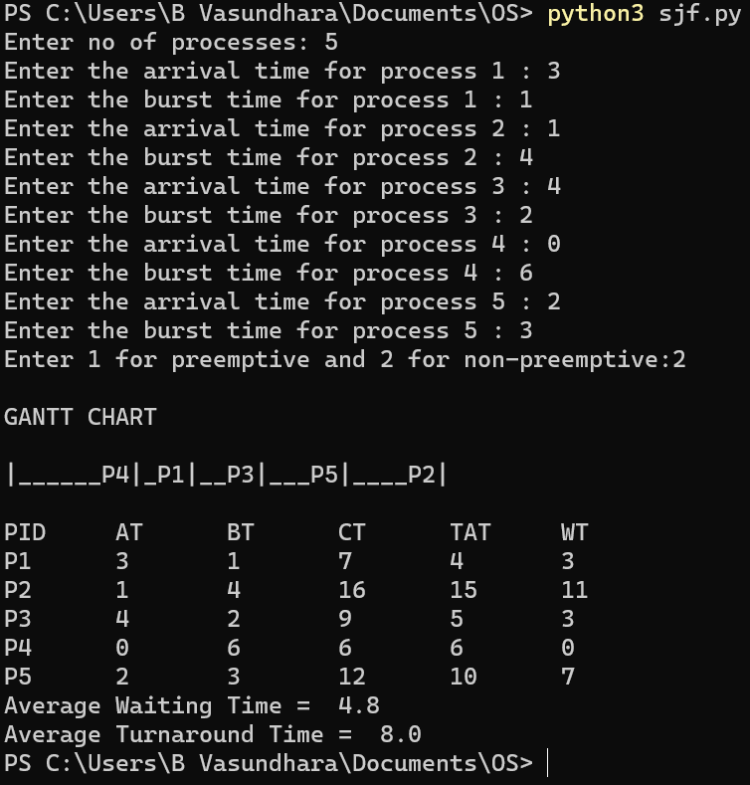

**(ii) PREEMPTIVE SCHEDULING (QUESTION 4 FROM TUTORIAL 2)**

