**UIT2502---Data Analytics and Visualization Lab**

**Ex 1 a: Basic Numpy Exercise**

**Name:** Vasundhara.B

**Roll No:** 3122 21 5002 119

1. Import numpy as np and see the version

**CODE:**

**OUTPUT:**



1. How to create a 1D array?

**CODE:**

**OUTPUT:**



1. How to create a boolean array?

**CODE:**

**OUTPUT:**



1. How to extract items that satisfy a given condition from 1D array?

**CODE:**

**OUTPUT:**



1. How to replace items that satisfy a condition with another value in numpy array?

**CODE:**

**OUTPUT:**



1. How to replace items that satisfy a condition without affecting the original array?

**CODE:**

**OUTPUT:**

1. How to reshape an array?

**CODE:**

**OUTPUT:**

1. How to stack two arrays vertically?

**CODE:**

**OUTPUT:**

1. How to stack two arrays horizontally?

**CODE:**

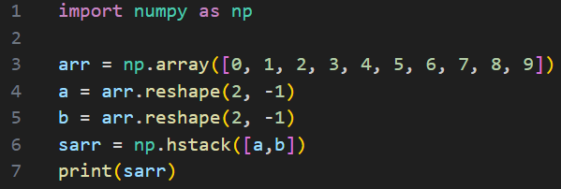

**OUTPUT:**



1. How to generate custom sequences in numpy without hardcoding?

**CODE:**

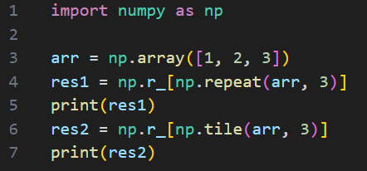

**OUTPUT:**



1. How to get the common items between two python numpy arrays?

**CODE:**

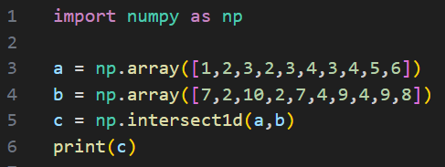

**OUTPUT:**



1. How to remove from one array those items that exist in another?

**CODE:**

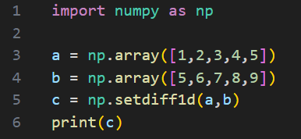

**OUTPUT:**



1. How to get the positions where elements of two arrays match?

**CODE:**

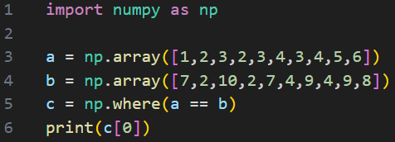

**OUTPUT:**



1. How to extract all numbers between a given range from a numpy array?

**CODE:**

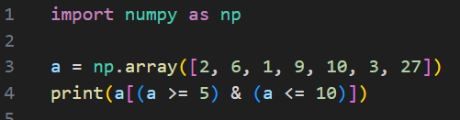

**OUTPUT:**



1. How to make a python function that handles scalars to work on numpy arrays?

**CODE:**

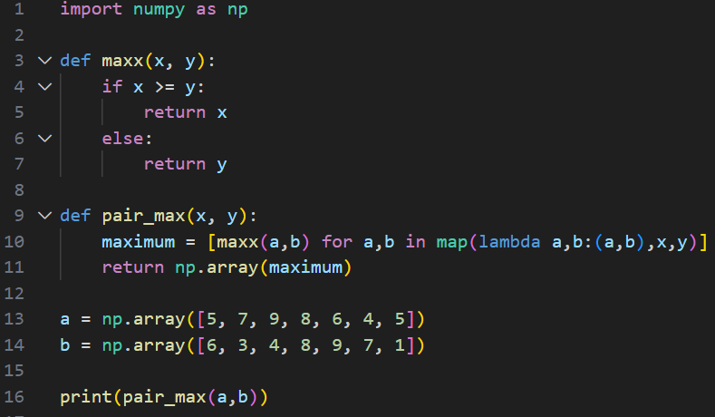

**OUTPUT:**



1. How to swap two columns in a 2d numpy array?

**CODE:**

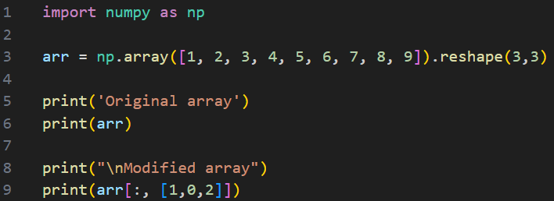

**OUTPUT:**

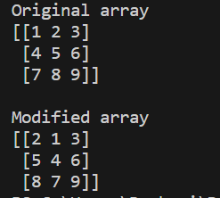

1. How to swap two rows in a 2d numpy array?

**CODE:**

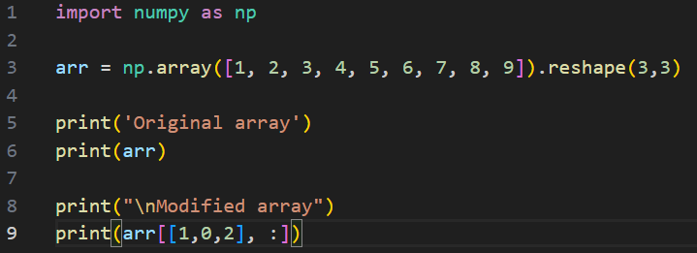

**OUTPUT:**

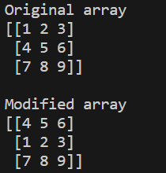

1. How to reverse the rows of a 2D array?

**CODE:**

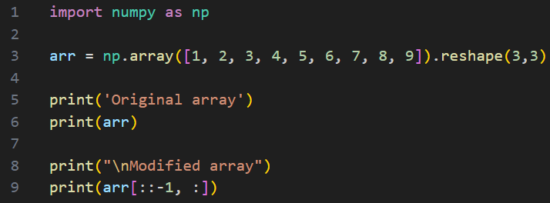

**OUTPUT:**

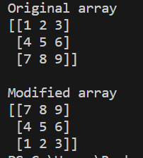

1. How to reverse the columns of a 2D array?

**CODE:**

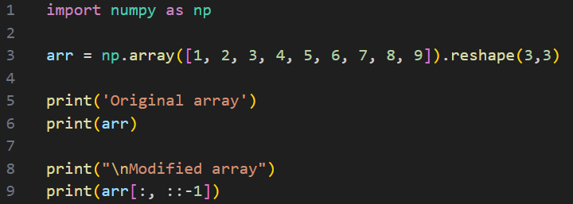

**OUTPUT:**

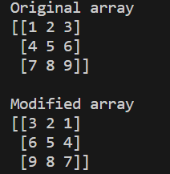

1. How to create a 2D array containing random floats between 5 and 10?

**CODE:**

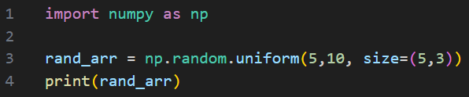

**OUTPUT:**

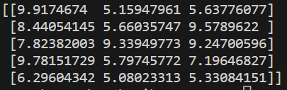

1. How to print only 3 decimal places in python numpy array?

**CODE:**

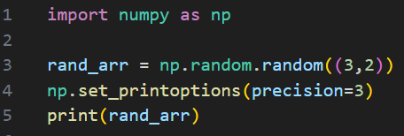

**OUTPUT:**

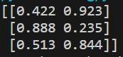

1. How to pretty print a numpy array by suppressing the scientific notation (like 1e10)?

**CODE:**

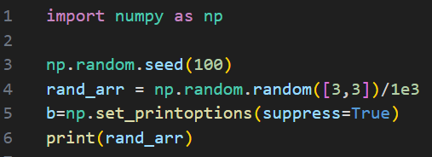

**OUTPUT:**

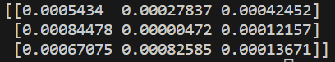

1. How to limit the number of items printed in output of numpy array?

**CODE:**

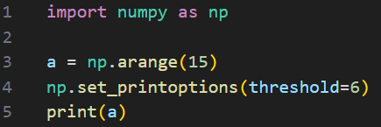

**OUTPUT:**



1. How to print the full numpy array without truncating?

**CODE:**

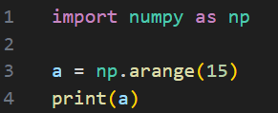

**OUTPUT:**



1. How to import a dataset with numbers and texts keeping the text intact in python numpy?

**CODE:**

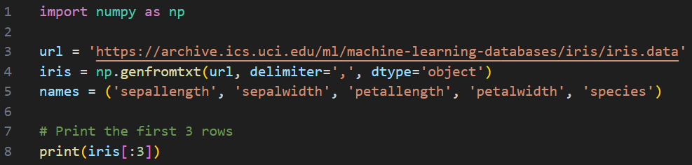

**OUTPUT:**

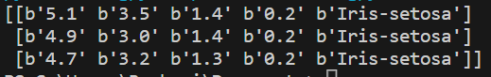

1. How to extract a particular column from 1D array of tuples?

**CODE:**

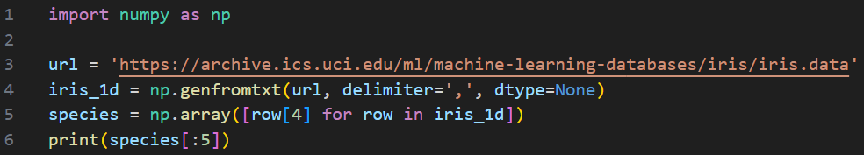

**OUTPUT:**

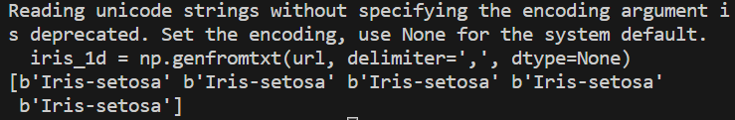

1. How to convert a 1d array of tuples to a 2d numpy array?

**CODE:**

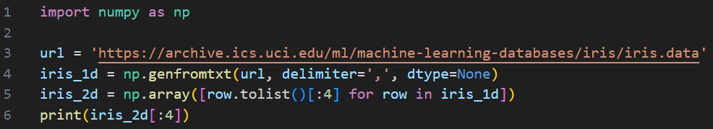

**OUTPUT:**

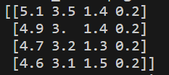

1. How to compute the mean, median, standard deviation of a numpy array?

**CODE:**

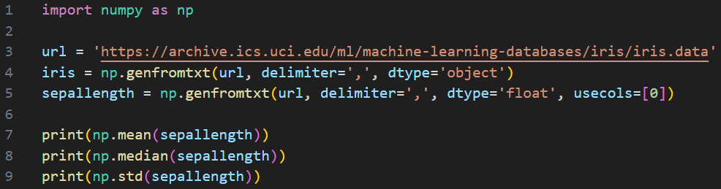

**OUTPUT:**

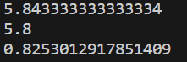

1. How to normalize an array so the values range exactly between 0 and 1?

**CODE:**

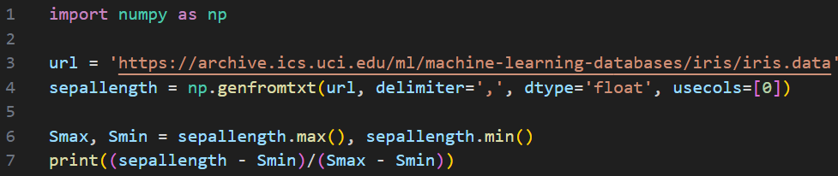

**OUTPUT:**

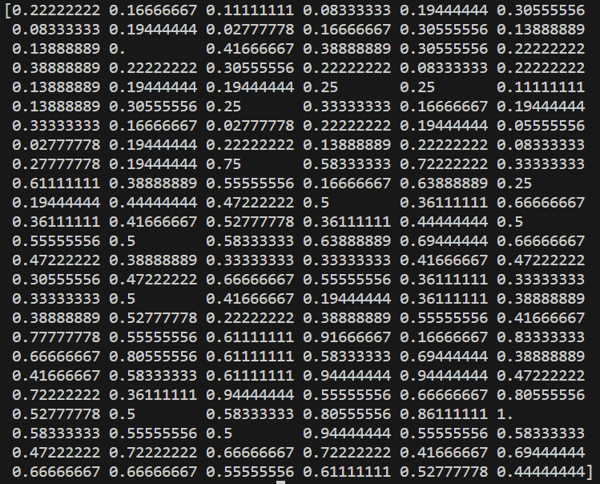

1. How to compute the softmax score?

**CODE:**

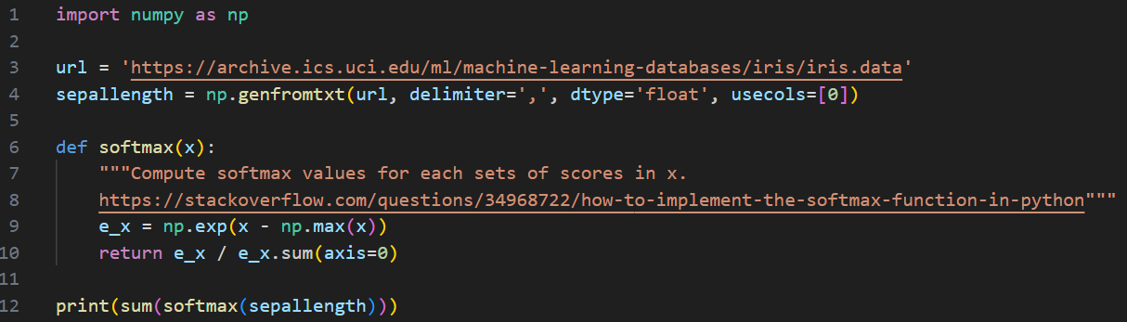

**OUTPUT:**



1. How to find the percentile scores of a numpy array?

**CODE:**

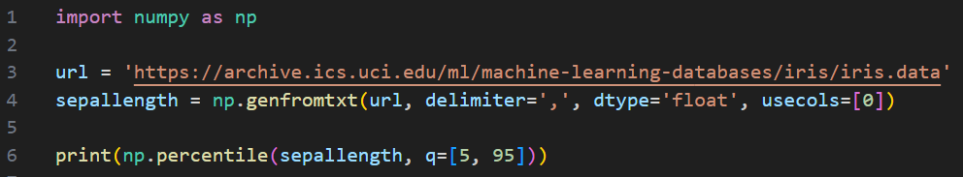

**OUTPUT:**



1. How to insert values at random positions in an array?

**CODE:**

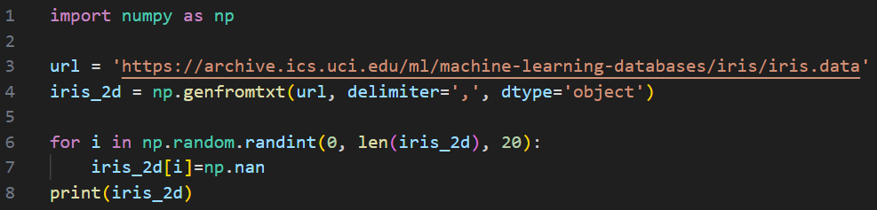

**OUTPUT:**

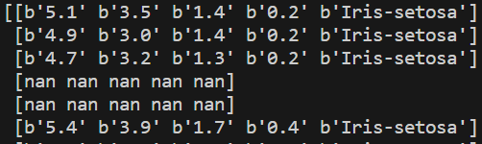

**.**

**.**

**.**

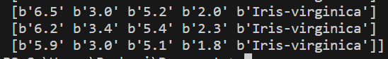

1. How to find the position of missing values in numpy array?

**CODE:**

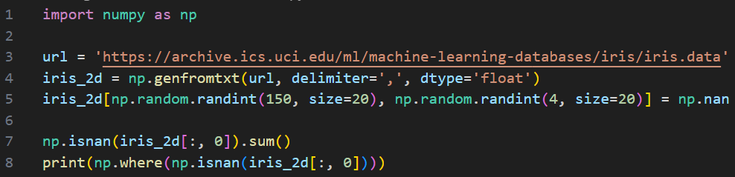

**OUTPUT:**



1. How to filter a numpy array based on two or more conditions?

**CODE:**

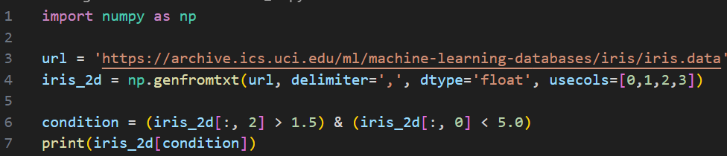

**OUTPUT:**

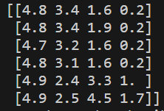

1. How to drop rows that contain a missing value from a numpy array?

**CODE:**

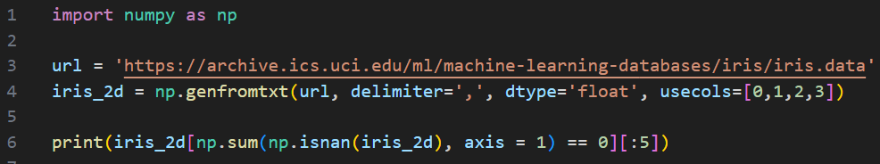

**OUTPUT:**

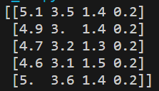

1. How to find the correlation between two columns of a numpy array?

**CODE:**

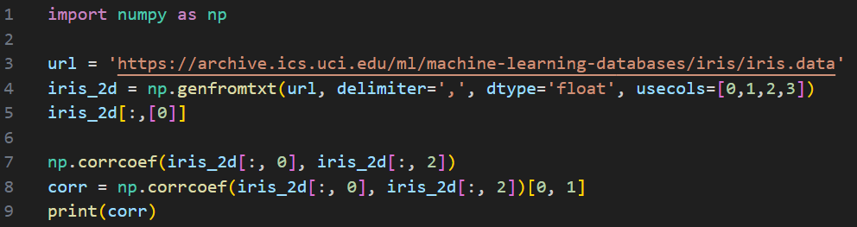

**OUTPUT:**



1. How to get the second largest value of an array when grouped by another array?

**CODE:**

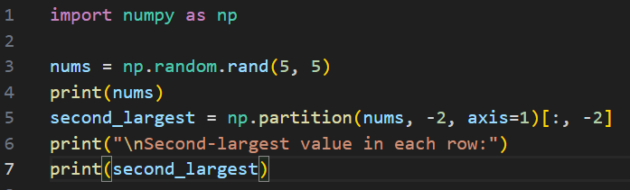

**OUTPUT:**

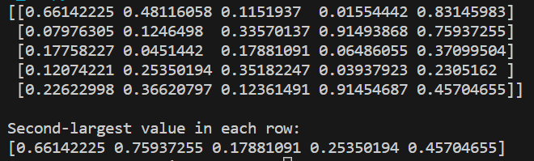

1. How to sort a 2D array by a column?

**CODE:**

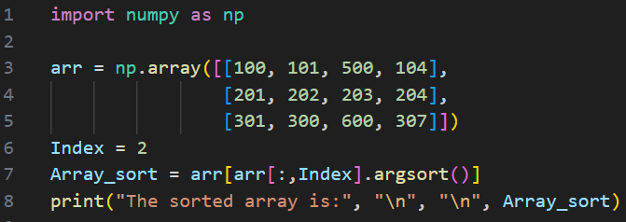

**OUTPUT:**

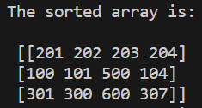

1. How to find the most frequent value in a numpy array?

**CODE:**

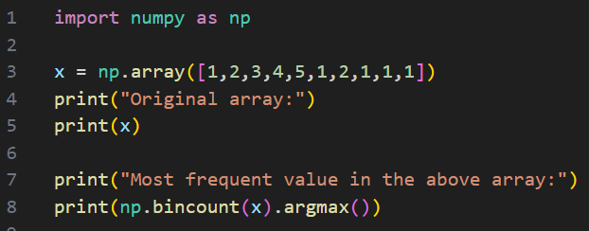

**OUTPUT:**

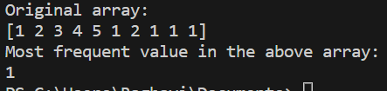

1. How to find the position of the first occurrence of a value greater than a given value?

**CODE:**

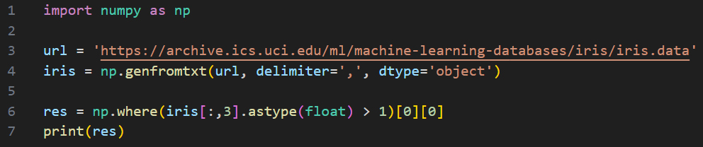

**OUTPUT:**



1. How to replace all values greater than a given value to a given cutoff?

**CODE:**

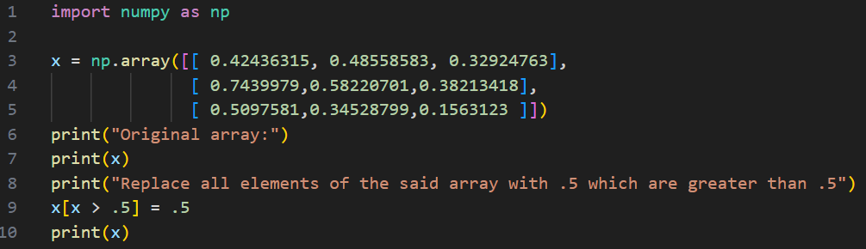

**OUTPUT:**

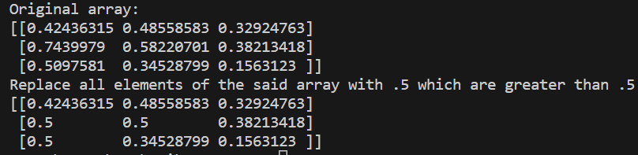

1. How to get the positions of top n values from a numpy array?

**CODE:**

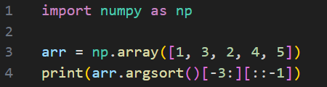

**OUTPUT:**



1. How to compute the row wise counts of all possible values in an array?

**CODE:**

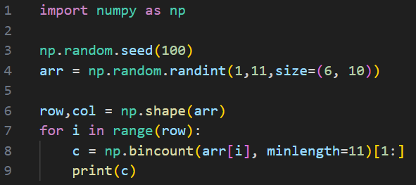

**OUTPUT:**

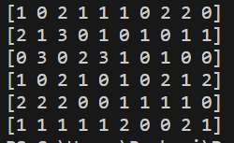

1. How to convert an array of arrays into a flat 1d array?

**CODE:**

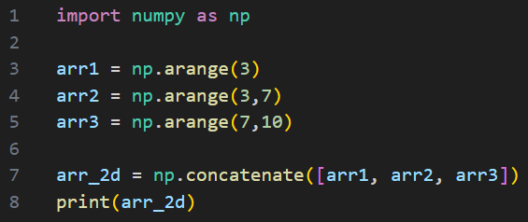

**OUTPUT:**

