**UIT2502---Data Analytics and Visualization Lab**

**Ex 1c: Game Application using NumPy**

**Name:** Vasundhara.B

**Roll No:** 3122 21 5002 119

**TIT-TAC-TOE**

**Objective:**

The objective of Tic-Tac-Toe is to be the first player to form a line of three of their own symbols (either "X" or "O") horizontally, vertically, or diagonally on the game board.

**Game Setup:**

The game is played on a 3x3 grid, initially empty.

There are two players, traditionally denoted as "X" and "O."

**Gameplay:**

Players take turns placing their symbol ("X" or "O") on an empty cell of the grid.

Player "X" typically goes first.

**Winning:**

A player wins the game if they have three of their symbols in a row, column, or diagonal. There are eight possible winning combinations:

Top row: [0, 0], [0, 1], [0, 2]

Middle row: [1, 0], [1, 1], [1, 2]

Bottom row: [2, 0], [2, 1], [2, 2]

Left column: [0, 0], [1, 0], [2, 0]

Middle column: [0, 1], [1, 1], [2, 1]

Right column: [0, 2], [1, 2], [2, 2]

Diagonal from top left to bottom right: [0, 0], [1, 1], [2, 2]

Diagonal from top right to bottom left: [0, 2], [1, 1], [2, 0]

**Draw (Tie):**

If all cells on the grid are filled and no player has formed a winning line, the game is a draw (tie).

**Game Over:**

The game ends when one player wins by forming a line of three symbols or when the game is a tie.

**Playing the Game:**

Players take turns entering the row and column numbers where they want to place their symbol.

The game enforces valid moves and prevents players from placing their symbols on occupied cells.

**Usage of NumPy in the application:**

**Importing NumPy:** The first line of the code **import numpy as np** imports the NumPy library and assigns it the alias "np." This alias is commonly used to refer to NumPy functions and classes throughout the code.

**Creating the Game Board:** The game board is created using the **np.full()** function. This function creates a new NumPy array with a specified shape and fills it with a given value. In this case, a 3x3 game board is created with all cells initially filled with a space character (" ").

**CODE:**

import pygame

import numpy as np

# Initialize Pygame

pygame.init()

# Constants for the game

WINDOW_SIZE = 300

GRID_SIZE = 3

CELL_SIZE = WINDOW_SIZE // GRID_SIZE

WHITE = (255, 255, 255)

LINE_COLOR = (0, 0, 0)

LINE_WIDTH = 10

FONT_SIZE = 50

FONT = pygame.font.Font(None, FONT_SIZE)

# Create the game window

window = pygame.display.set_mode((WINDOW_SIZE, WINDOW_SIZE))

pygame.display.set_caption("Tic-Tac-Toe")

# Create the game board using NumPy

board = np.full((GRID_SIZE, GRID_SIZE), "")

# Function to draw the grid lines

def draw_grid():

    for i in range(1, GRID_SIZE):

        pygame.draw.line(window, LINE_COLOR, (0, i * CELL_SIZE), (WINDOW_SIZE, i * CELL_SIZE))

        pygame.draw.line(window, LINE_COLOR, (i * CELL_SIZE, 0), (i * CELL_SIZE, WINDOW_SIZE))

# Function to check for a win

def check_win(player):

    return (

        any(np.all(board == player, axis=0)) or

        any(np.all(board == player, axis=1)) or

        np.all(np.diag(board) == player) or

        np.all(np.diag(np.fliplr(board)) == player)

    )

# Main game loop

current_player = "X"

game_over = False

winner = None

while not game_over:

    for event in pygame.event.get():

        if event.type == pygame.QUIT:

            game_over = True

        elif event.type == pygame.MOUSEBUTTONDOWN and not check_win("X") and not check_win("O"):

            row = event.pos[1] // CELL_SIZE

            col = event.pos[0] // CELL_SIZE

            if board[row, col] == "":

                board[row, col] = current_player

                current_player = "O" if current_player == "X" else "X"

    window.fill(WHITE)

    draw_grid()

    for row in range(GRID_SIZE):

        for col in range(GRID_SIZE):

            if board[row, col] != "":

                text = FONT.render(board[row, col], True, LINE_COLOR)

                text_rect = text.get_rect(center=(col * CELL_SIZE + CELL_SIZE // 2, row * CELL_SIZE + CELL_SIZE // 2))

                window.blit(text, text_rect)

    if check_win("X"):

        game_over = True

        winner = "X"

    elif check_win("O"):

        game_over = True

        winner = "O"

    elif np.all(board != ""):

        game_over = True

        winner = "Tie"

    pygame.display.flip()

if winner == "Tie":

    print("It's a tie!")

else:

    print("Player {} wins!".format(winner))

pygame.display.flip()

# Wait for 5 seconds

pygame.time.wait(5000)

pygame.quit()

**OUTPUT:**

1. **PLAYER “X” WINS**

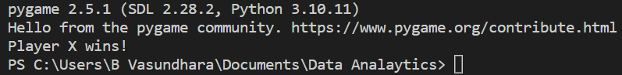

1. **IT’S A DRAW**

**

**

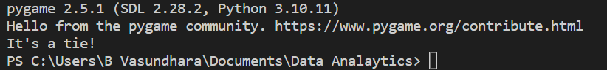

1. **WHEN THE GAME IS STOPPED MIDWAY**

