
INTRODUCTION
The Increased volumetric use of Electric Vehicles (EVs) presents new safety challenges, particularly at the charging stations. Thermal runaway heating leads to a state wherein EV batteries result in firing. This project proposes an IoT-enabled automatic fire detection and extinguishing system for EV charging stations in the interests of safety, reducing response time and protecting life and infra.
Motivation: With the increase in electric vehicles, charging stations are becoming sites of fire incidents resulting from malfunctioning batteries. Traditional fire-fighting systems are typically slow, ineffective, or both. This project is aimed at creating a practical real-time IoT-based solution to prevent the disaster and provide a safe environment for the public.
OBJECTIVES
- Enable Early Detection and Automated Response: Detect fire threats such as flames, smoke, and heat with high accuracy using state-of-the-art sensors, and actuation of suppression agent is also immediate without human interference to reduce damages.
- Ensure Electrical and Operational Safety: Automatically disconnect the power supply during fire conditions, while providing real-time alerts via GSM/Wi-Fi and maintaining post-fire monitoring for re-ignition risks.
- Remote Monitoring and Scalability: Provide an IoT-integrated dashboard for remote monitoring and controlling the system, while the system is modular/cost-effective and easily configurable in EV stations.
SCOPE OF THE PROJECT
- Real-Time Fire and Hazard Detection: Sensors that can continuously monitor the EV charging environment to fire finding, smoke finding, or heat anomaly detection would provide a sure point for immediate detection of fire risk.
- Remote Monitoring and Post-Fire Surveillance: The relay modules immediately will/cut the power supply to the charging station, thus eliminating any electrical dangers during fire incidents.
- Remote Monitoring and Post-Fire Surveillance: It ensures real-time IoT-based monitoring and keeps sensors working continuously even after suppression to detect the highly potential user re-ignition and maintain absolute safety.
METHODOLOGY
- Requirements Analysis and Sensor Integration: Identify potential fire-prone situations and safety standards, and integrate sensors (DHT11, MQ-2, Flame) for heat, smoke, fire detection.
- System Development and Programming: Program control logic for fire detection, triggering suppression, and communication handling inside Arduino Mega.
- Communication and Monitoring Setup: Implement GSM/Wi-Fi module control through a real-time alert and remote monitoring via an IoT dashboard.
- Testing and Deployment: Test the system in simulated fire conditions and deploy an extendable prototype suitable for EV charging stations.
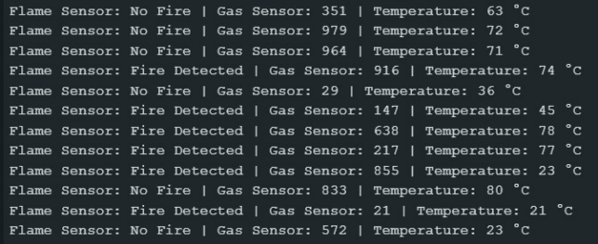
ARCHITECTURE
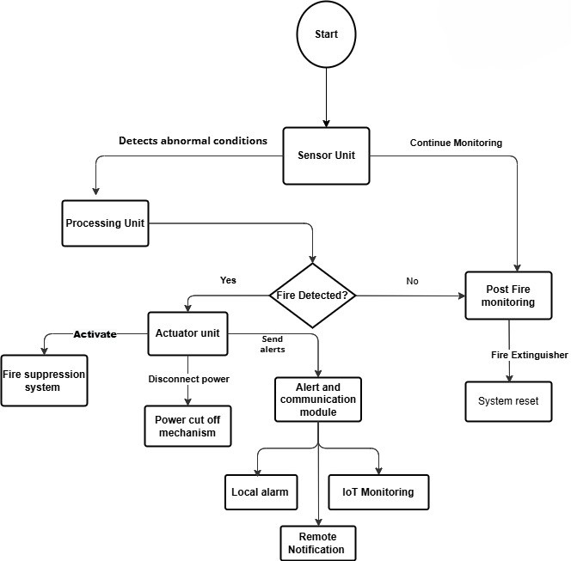
The flowchart presents the functioning of a smart fire detection system. The system employs sensors to monitor for abnormal conditions. Upon the detection of fire, these sensors trigger an actuator unit which initiates the suppression operation and cuts off power to that location. Local and remote alerts are sent for fire incidents. In case of no fires detected, the system continues to monitor until completion, and there are post-fire checks for safety and restart readiness.
RESULT AND DISCUSSION
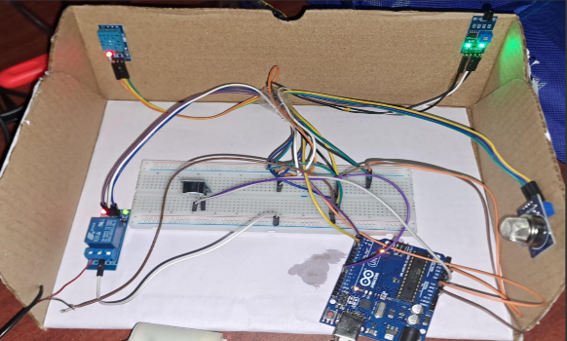
The system is highly sensitive and has relatively low latency such that fires are detected and automatically suppressed to reduce damage quickly. Timely remote alerts; the scalability of different charging environments; and simple accommodation to these environments, since they all come with cloud data logging support, were ensured through IoT integration.

CONCLUSION
A nationwide network of IoT fire safety systems drastically increases safety for EV charging infrastructure. In real-time, it detects, suppresses, and notifies fire hazards to minimize risks. Scalable and cost-efficient, the system intends to protect EV assets and personnel in view of sustainable urban mobility and public safety.
REFERENCES
[1] S. Kamel, A. Jamal, K. Omri, and M. Khayyat, "An IoT-based Fire Safety Management System for Educational Buildings: A Case Study," International Journal of Advanced Computer Science and Applications, vol. 13, no. 7, pp. 1–9, 2022.
[2] J. Orosz and T. Sebestyén, “Electric Vehicle Fire Extinguishing System,” Procedia Engineering, vol. 172, pp. 543–550, 2017.
[3] M. Rahman, S. Hossain, and T. Ahmed, “IoT-Based Fire Detection System with Automatic and Manual Extinguishing System,” International Journal of Engineering Research & Technology (IJERT), vol. 12, no. 5, pp. 102–108, 2023.

