Contents and purpose

This document contains functional requirements of SDN_LockedUsers and SDN_pre-matched_byRunDate reports which will be available in SSRS.

SDN_BlockedUsers

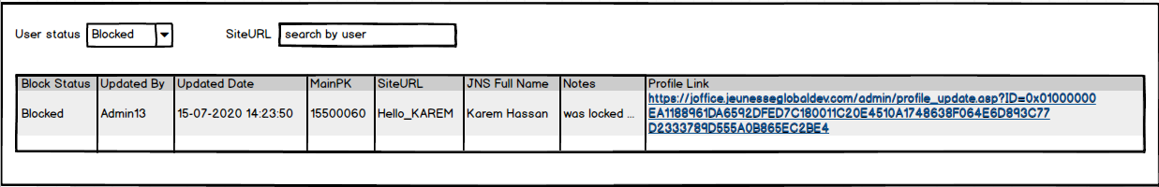

The report show all information about locking and unlocking a profile. As report filter we can choose:

* User Status (in what status user was moved after validation run, or all)
* (optional) Search by SiteURL

SDN_pre-matched_byRunDate

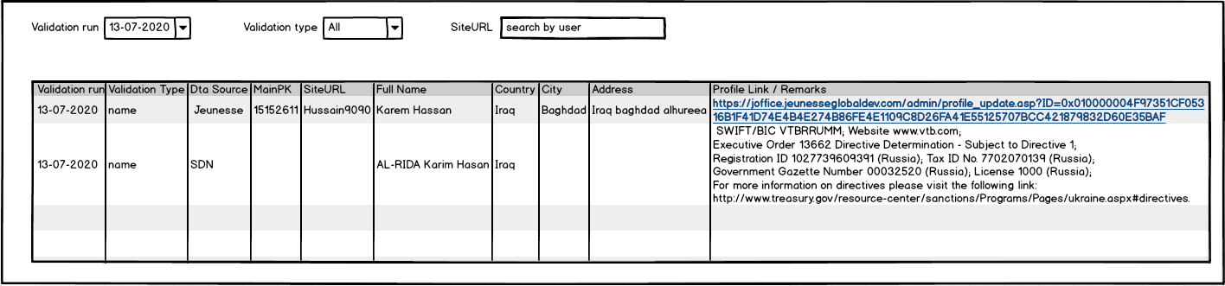

The report show all information about pre-matched users against users from SDN sanction list. As report filter we can use:

* Validation run (when current check was made)
* Validation type (we can choose name matching either address matching or all)
* (optional) Search by SiteURL

PBI list

1. SSRS: SDN_BlockedUsers
2. SSRS: SDN_pre-matched_byRunDate
3. JOffice updates
4. DB design
5. OFAC comparison\whitelist core
6. Historic user data translation

SSRS: SDN_BlockedUsers

Should be based on dbo.SDN_BlockProfiles_Log table. To get a data for the report use next sproc:

dbo.sp_RPT_SDN_BlockedUsers

@UserStatus INT

,@SiteURL VARCHAR(50) = NULL

SSRS: SDN_pre-matched_byRunDate

Should be based on dbo.SDN_Match_Log table. To get a data for the report use next sproc:

dbo.sp_RPT_SDN_PreMatched_byRunDate

@ValidationRun VARCHAR(1000)

,@ValidationType VARCHAR(100)

,@SiteURL VARCHAR(50) = NULL

JOffice updates

1. Insert new users or update existing (SiteURL, fname, lname, country, city, address1, address2, address3, country2, city2, shipaddr1, shipaddr2, shipaddr3)
2. Block/Unblock functionality

Insert new users or update existing:

Inserted data (SiteURL, fname, lname, country, city, address1, address2, address3, country2, city2, shipaddr1, shipaddr2, shipaddr3) should be in English (need to use Google API for translation). For insert or update use next sproc:

dbo.sp_SDN_UpsertSDN_MainProfile_new

@MainFK INT -- MainPK for new or updated user

,@SiteURL VARCHAR(50) -- new or updated SiteURL

,@fname NVARCHAR(50) -- new or updated fname

,@lname NVARCHAR(50) -- new or updated lname

,@country VARCHAR(50) -- new or updated country

,@city NVARCHAR(50) -- new or updated city

,@address1 NVARCHAR(250) -- new or updated address1

,@address2 NVARCHAR(250) -- new or updated address2

,@address3 NVARCHAR(250) -- new or updated address3

,@country2 VARCHAR(2) -- new or updated country2

,@city2 NVARCHAR(50) -- new or updated city2

,@shipaddr1 NVARCHAR(250) -- new or updated shipaddr1

,@shipaddr2 NVARCHAR(250) -- new or updated shipaddr2

,@shipaddr3 NVARCHAR(250) -- new or updated shipaddr3

Block/Unblock functionality:

Should be added new page on JOffice named “SDN compliance”. Should contain:

* check box: “Block profile” with tooltip “Please check checkbox Block profile if the profile is compliance with SDN list”
* text box(max Length of 1000 symbols): “Notes”
* button: “Save”

To get current profile status:

dbo.sp_SDN_GetProfileCurrentStatus

@MainFK INT -- User's MainPK

Pressing on “Save” button should execute next sproc:

dbo.sp_SDN_SetProfileCurrentStatus

@MainFK INT NOT NULL -- MainPK of user

,@Blocked BIT NOT NULL -- Action Block(true) or Unblock(false)

,@EnteredMainFK INT NOT NULL -- Who made this change(MAinPK of Admin)

,@Notes VARCHAR(1000)

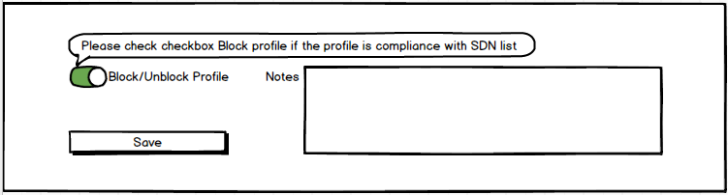

DB design

