1. ENV set up

1) prepare binary

. build source

. run sigfox_cfg2_make_factory_image.bat (development\sigfox_cfg2\source\pca10040\s132\arm5_no_packs)

. check firmware bin (development\sigfox_cfg2\binary)

. edit SFM20R_factory_write.cmd

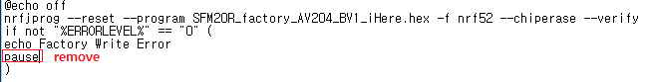

2) setting firmware path

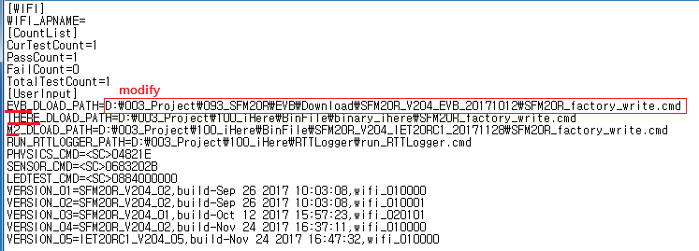

3) setting RTTLogger path (development\sigfox_cfg2\tools\RTTLogger)

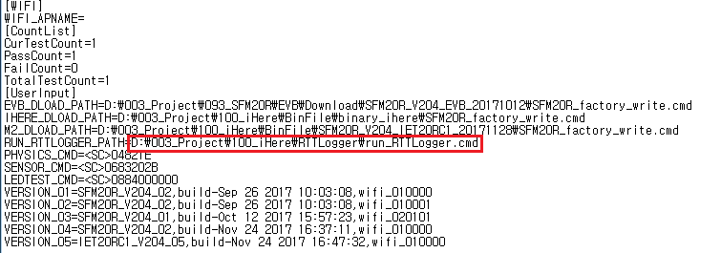

4) setting firmware version

. get firmware version

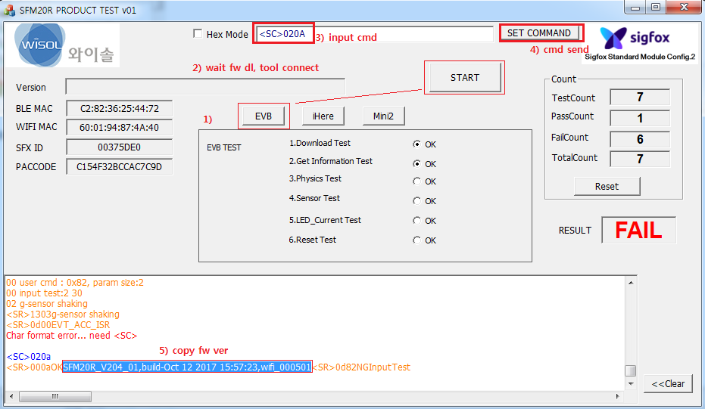

. set fw ver (it can set up to 5)

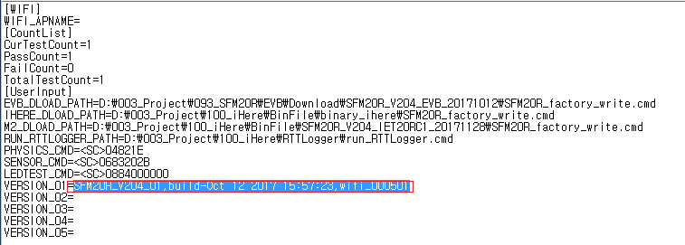

5) update command parameter

PHYSICS_CMD=<SC>0482**1E**

-> "1E" is timeout

SENSOR_CMD=<SC>0683**202B**

-> 202B : bettery level min32,max43

LEDTEST_CMD=<SC>0884**000000**

-> 000000 (RF Test Parameter, If it is 0, do not check.) wifi, ble, gps (sigfox is CW mode)

eg.) <SC>0884C4C45A : wifi C4 -60dbm, ble C4 -60dbm, gps 90sec

2. Test Guide

check jumper setting and power setting. *EVB Only

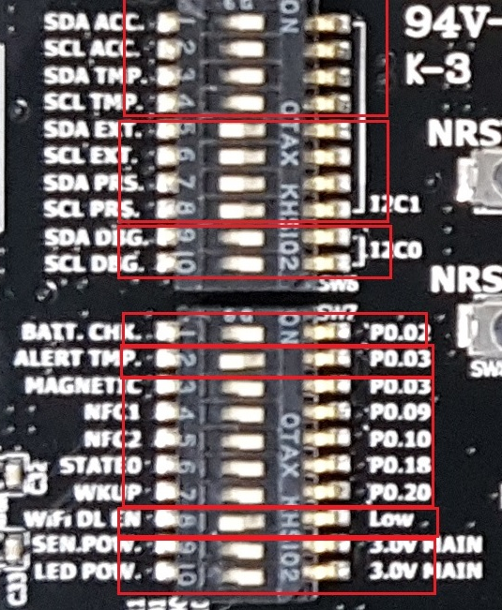

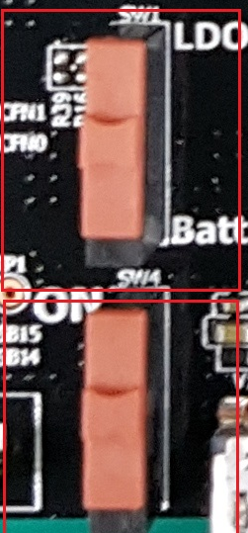

Test procedure

1) connect target device with J-Link

2) click START

3) Physics Test

- test input device (key, NFC, Magnetic ...)

4) LED check and Check current consumption

5) If there is a NRST (reset) key, press it. (EVB, M2)

6) close cmd window (M2 Only)