Predicting Reddit Topic Lifecycles:
Emergence, Spread, and Death
Exploring AI: Understanding and Applications (SPC4004)
Assessment 2 -- Code Generation Project
Vasyl Shcherbatykh
GitHub: https://github.com/Vasylffff/redit

1. Problem Definition & Dataset Justification

What This Project Does
Every day, thousands of stories appear on Reddit. Some disappear within hours. Others spread across multiple communities, generate thousands of comments, and dominate the platform for days. This project asks: can we predict which stories will grow, how they will spread, and when they will die, using only early engagement signals?
The system tracks topics through their complete lifecycle: emergence (a new story appears in 1-3 posts), growth (it gains momentum), spread (it crosses into new subreddits), decline (engagement drops), and death (the story stops generating new posts). At each stage, a separate machine learning model makes predictions about what will happen next.

The Machine Learning Tasks
The project applies multiple types of machine learning to different lifecycle stages:
- Binary classification: given a word pair with 1-3 posts today, will it reach 5+ posts within 3 days? Input features: post count, total upvotes, subreddit count, best comment count, average comments, upvotes per post, best velocity, average velocity. Output: grow (1) or not (0).
- Multi-class classification: given a topic's current state (surging, growing, stable, cooling, dying, dead), what state will it be in tomorrow? Input: current engagement metrics plus previous state. Output: one of six states.
- Binary classification with temporal features: given a topic that has just dropped below its activity threshold, will it revive (ongoing story) or stay dead (one-shot event)? Input: peak size, number of previous peaks, consistency, active days. Output: revive (1) or dead (0).
- Regression (attempted): given a topic at 1-3 posts, how many posts will it reach at peak? This task was attempted using multiple approaches including Szabo-Huberman log-linear models (2010) but did not achieve useful accuracy (R-squared = 0.22), which itself became a finding.
Five classifiers were compared across seven tasks: Random Forest, Extra Trees, Gradient Boosting, Logistic Regression, and Decision Tree, with 36 hyperparameter configurations tested.

Why This Problem Matters
Understanding how topics emerge and die online has practical applications in several areas. News monitoring systems need to identify which stories are gaining traction before they peak. Content moderators need to anticipate which topics will spread across communities. Researchers studying misinformation need to understand how stories propagate between subreddits and whether spread patterns can be detected early.
From a machine learning perspective, the problem is interesting because it requires prediction at different timescales and granularities. Post-level prediction (will this individual post survive?) works well at short horizons but degrades beyond 24 hours. Topic-level prediction (will this story grow?) follows the opposite pattern: it improves at longer horizons because topics follow momentum while individual posts are chaotic. This inverse relationship between post and topic predictability was one of the project's key discoveries.

Why This Dataset
The system operates at two levels. At the post level, it incorporates text-based features including VADER sentiment scoring of 972,353 comments and comment engagement patterns such as the Gini coefficient of upvote distribution. At the topic level, the system is content-agnostic: it tracks co-occurring word pairs in titles purely through numerical engagement signals such as post counts, upvotes, and velocity, without interpreting what those words mean. This design was motivated by the observation that viral content of any type, whether political news, game announcements, or internet memes, follows similar spread patterns driven by human attention rather than content meaning.
Five subreddits were chosen to represent different community types: r/politics and r/news (fast-moving political discussion), r/worldnews (international affairs), r/technology (industry news), and r/Games (entertainment). This diversity tests whether the same models generalise across communities with different engagement patterns. For example, r/politics posts have an average lifecycle of 11 hours while r/Games posts survive 49 hours.
The dataset was self-collected rather than using an existing corpus because the project requires repeated observations of the same posts over time. Existing Reddit datasets typically provide single snapshots. Hourly collection over 13 days produced 216,944 post snapshots capturing how each post's engagement changed hour by hour, which is essential for velocity and trajectory features.

Dataset
The dataset was entirely self-collected over 13 days (26 March to 7 April 2026) using Reddit's public JSON endpoints. Five subreddits were tracked: r/technology, r/news, r/worldnews, r/politics, and r/Games. Data was collected hourly via Windows Task Scheduler running on two machines, with results merged to improve coverage.
Metric | Value
Post snapshots | 216,944
Comment snapshots | 972,353
Unique posts tracked | 6,826
Collection frequency | Hourly
Raw JSON files | 5,140
Co-occurrence pairs analysed | 200,000+ per day

Posts were assigned lifecycle states (surging, alive, cooling, dying, dead) based on upvote and comment velocity thresholds computed per subreddit, providing natural labels without manual annotation. Topics were represented as two-word pairs extracted from titles, following the co-occurrence approach described by Szabo and Huberman (2010) for tracking content popularity.
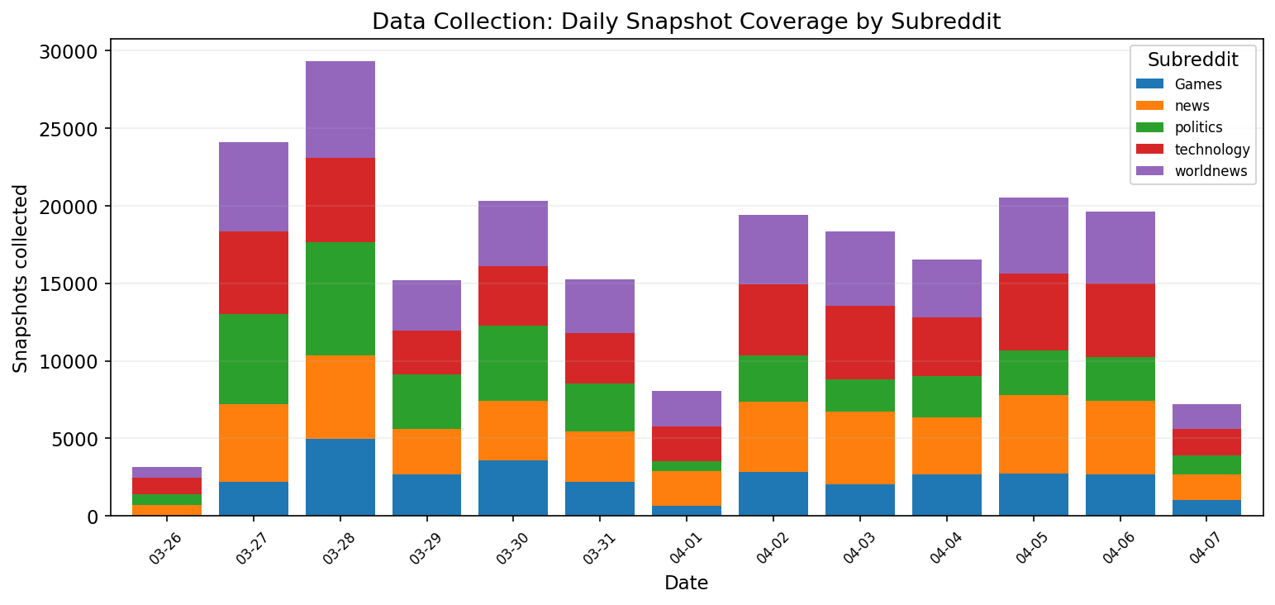
Figure 1: Daily data collection coverage by subreddit across the 13-day collection period.

2. Initial Code & Explanation of AI Use
The project was developed using three AI tools across multiple sessions. Development began on 24 March 2026 with OpenAI Codex, where the initial prompt was:
"ok i want to make a project that will analyse redit flow and predict it. Firstly i wnat to take a new data"
This session produced the initial data collection pipeline, including Reddit API access attempts via PRAW, an Apify-based fallback, and ultimately a free public JSON endpoint scraper. The session spanned 352 prompts over 7 days (24-31 March) and established the core architecture: hourly collection, history building, gap patching, and prediction dataset generation.
A second Codex session (31 March) performed a major pipeline refactoring documented in a formal handover summary. This session separated prediction tracking from live monitoring, redesigned the lifecycle state model, and fixed critical scheduler bugs.
Claude Code (Anthropic, Claude Opus 4.6) was used from 31 March onwards for analysis and modelling. This included sentiment analysis, comment engagement features, multi-horizon prediction, and the complete topic lifecycle pipeline developed on 7-8 April.
All subsequent development was conversational: the developer directed priorities, questioned results, and pushed exploration when AI suggested premature ceilings. The choice to pursue topic lifecycle prediction rather than stopping at post-level models was entirely developer-driven.

3. Critique of Initial Code

Bugs
- datetime.UTC attribute incompatible with Python 3.10, present across 12 files
- f-string backslash syntax errors causing runtime failures
- scikit-learn version incompatibility requiring pinning to 1.7+
- Windows Task Scheduler crashed in non-interactive mode due to WPF popup windows
- Unicode em dash characters corrupted under Windows cp1252 encoding
- CSV headers contained hidden UTF-8 BOM characters, breaking manifest validation

Algorithmic Limitations
No topic-level analysis. The initial system predicted individual post trajectories using a five-layer Markov chain, but had no mechanism to detect that multiple posts referred to the same underlying story. The concept of a "topic" was entirely absent from the original codebase.
Single-keyword vocabulary. When topic analysis was first introduced, it used individual keywords ("trump", "iran"). This proved too generic: the keyword "trump" appeared in 2,192 posts and carried no discriminative signal. The transition to co-occurrence pairs was a critical improvement that the AI did not initially suggest.
Uniform model selection. Random Forest was applied to every task with near-default hyperparameters. Subsequent testing across five classifiers and 36 parameter configurations revealed that Logistic Regression outperforms Random Forest on the core emergence detection task (0.860 vs 0.829 ROC AUC), indicating the underlying signal is linear rather than requiring complex feature interactions.
Incorrect topic death definition. The initial code classified a topic as dead after a single day below two posts. Analysis of 8,880 drop events revealed a 13.1% false-death rate, with 44.8% of topics peaking at 8-11 posts reviving after apparent death. A two-consecutive-day threshold reduced false deaths to 6.8%.
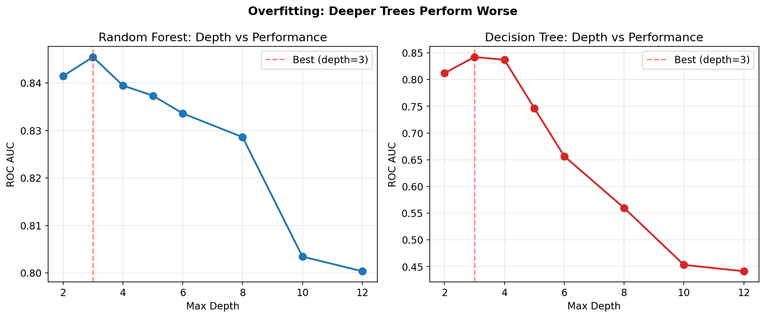
Figure 2: Overfitting analysis. Both Random Forest and Decision Tree perform worse with deeper trees. Optimal depth is 3-5, not the default 8-12.

4. Iterative Development & Justification

Phase 1: Data Collection (March 24-26)
Iteration 1: Data collection pivots. Reddit API was applied for but not approved. Apify (commercial scraper) was tried as fallback. The developer then discovered Reddit’s public JSON endpoints provide post metadata without authentication, reducing cost to zero. The AI-generated code required fixing six bugs across 12 files (Python 3.11 incompatibility, Task Scheduler crashes, encoding corruption) before collection could begin.
Iteration 2: Automated hourly collection. Five cadences were built: hourly (new), 2-hourly (rising), 4-hourly (hot), twice daily (top/day), daily (top/week). Task Scheduler ran on two machines, results merged to fill gaps.

Phase 2: Post-Level Prediction (March 27 - April 1)
Iteration 3: Tracking pool (Codex session 2). A pool was added to follow the same posts over time. It was split into a fixed prediction cohort and a rolling live shortlist — without this, most posts were observed only once, making trajectory prediction unreliable. Dead posts were dropped via a three-tier system: active (hourly), dormant (6-hourly), dropped (archived).
Iteration 4: History building and dead definition. Raw snapshots were merged into a unified timeline. Gap patching fixed velocity corruption from missed collections — gaps showed zero velocity even for active posts, faking dead-post signals. The deeper problem was definitional: the initial “dead” label was too blunt and triggered during collection gaps. This led to the variance collapse method — a post is dead when its velocity variance drops sharply and stays low, more reliable than a simple threshold. The dying/dead distinction motivated adding “dying” as a separate early-warning state, so posts are flagged before they fully stop.
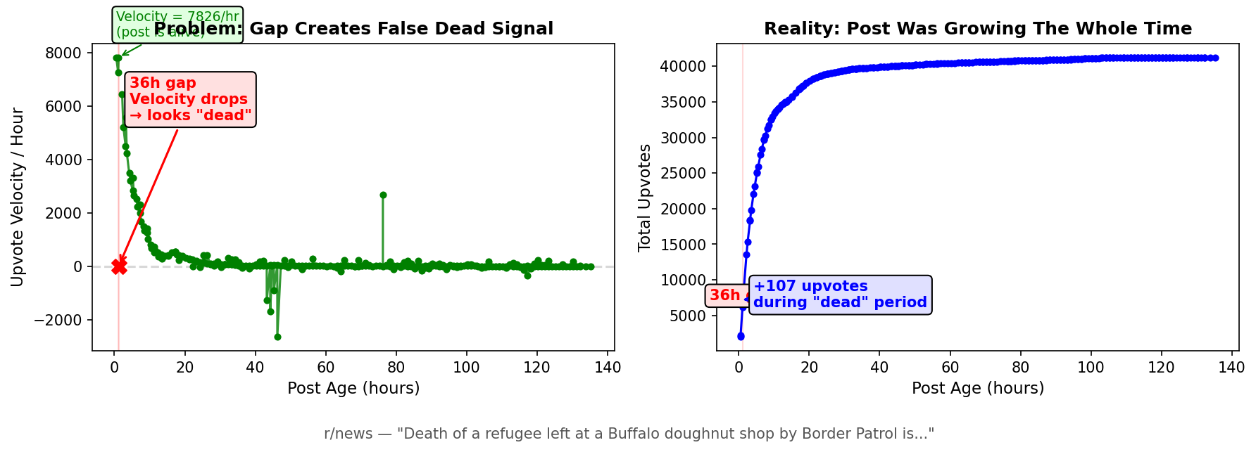

Iteration 5: VADER sentiment analysis. 972,353 comments were scored using VADER. The finding was counterintuitive: negative comment sentiment correlates with longer post survival (alive average -0.006 vs dead +0.045). Controversy drives engagement; apathy kills posts.
Iteration 6: Comment engagement features. The Gini coefficient of comment upvote distribution was introduced to measure whether discussion is concentrated (a few dominant comments) or diffuse. This became the strongest single post-level predictor at 46% feature importance.
Iteration 7: Multi-horizon classifiers and learning to evaluate models. Seventeen classifiers were built for prediction horizons from 1 hour to 7 days. ROC AUC decayed from 0.843 (1 hour) to approximately 0.57 (7 days). Understanding these results required learning what ROC AUC actually measures — I initially confused it with accuracy and had to work through the basics. But this learning process led to the project’s most important methodological insight: at 7 days, accuracy paradoxically rises to 85% while ROC drops to 0.57. Since 86% of posts are dead at 7 days, predicting “everything dies” achieves high accuracy but zero discriminative power. ROC AUC exposes this. I later applied this understanding to challenge the AI’s framing of emerging keyword detection, questioning whether the metric measured what we claimed it measured.

Phase 3: Topic Lifecycle Prediction (April 7-8)
Post-level prediction worked well at short horizons but degraded beyond 24 hours. The frustration was clear: I could predict individual post flow but not keywords or topics. I wanted to predict general flow — not individual posts but the overall story. I also wanted magnitude prediction: how much will it grow, not just whether it will grow. Testing Szabo-Huberman log-linear models for magnitude prediction failed (R²=0.22), confirming that classification (will it grow?) works but regression (by how much?) does not. The transition to topic-level prediction was my initiative, not suggested by the AI.
Iteration 8: Co-occurrence pair detection. The transition from single keywords to two-word pairs was the most significant methodological improvement. Pairs such as "russian+tanker" and "birthright+citizenship" represent specific stories rather than generic vocabulary. Temporal validation (trained on days 1-8, tested on days 9-13) achieved 0.813 ROC AUC for detecting topics at 1-3 posts that would grow to 5 or more.
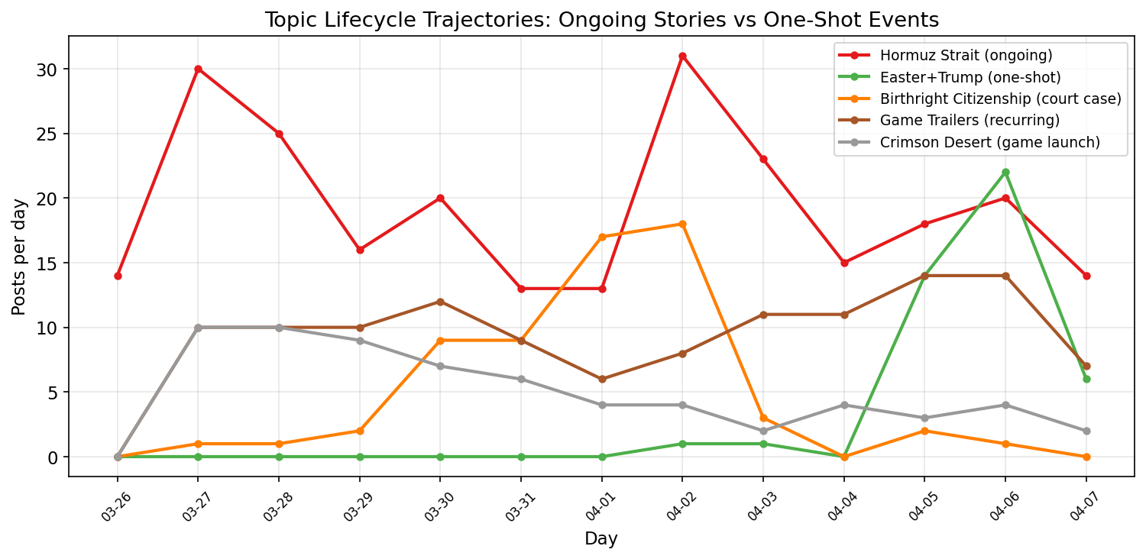
Figure 3: Topic lifecycle trajectories across 13 days. Ongoing stories (Hormuz Strait) show repeated surges and recoveries. One-shot events (Easter+Trump) spike once and die.
Iteration 9: Content-agnostic detection. The same algorithm detected entirely different content types: "official+trailer" (122 posts, game announcements), "hormuz+strait" (252 posts, geopolitical crisis), "crimson+desert" (65 posts, game launch), and "media+social" (127 posts, technology policy). The model operates on engagement patterns alone and does not process text content. A political scandal and a viral game trailer follow identical spread dynamics from the classifier's perspective.
Iteration 10: Growth peak detection. A classifier was trained to predict whether a topic had already reached its peak or would continue growing, using the first two days of data. ROC AUC: 0.958. The dominant features were post count growth between day 1 and day 2 (52.7% importance) and upvote growth (38.1%).
Iteration 11: Topic death prediction. A model to predict whether a topic would die the following day achieved 0.890 ROC AUC. Current post count (46.1%) and subreddit coverage (17.1%) were the dominant features. Losing subreddit presence is a strong signal of imminent death.
Iteration 12: Death speed classification. After a topic peaks, will it die within 0-1 days (quick death) or survive 2+ days (slow death)? ROC AUC: 0.996. The decisive feature was the decline rate on the first day after the peak (67.8% importance). A sharp drop signals rapid death; gradual decline indicates an ongoing story.
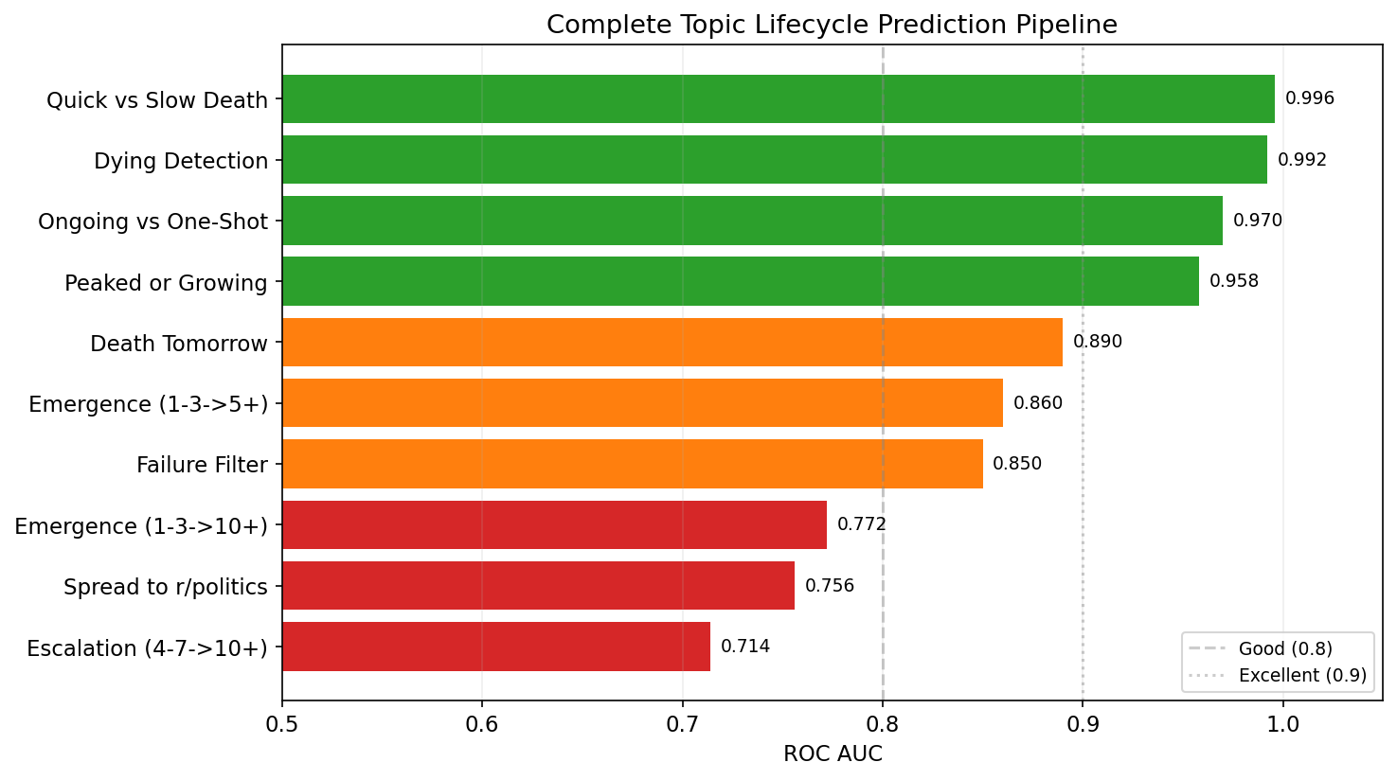
Figure 4: Complete topic lifecycle prediction pipeline. Green bars indicate ROC AUC above 0.9; orange indicates above 0.8.
Iteration 13: Subreddit spread prediction. A per-target classifier predicted whether a topic would appear in a new subreddit the following day. Predicting spread to r/politics achieved 0.756 ROC AUC. Analysis of spread patterns revealed that r/politics breaks stories first (47,580 times), contrary to the expectation that r/news would lead. The most common spread route was news to worldnews (2,354 instances).
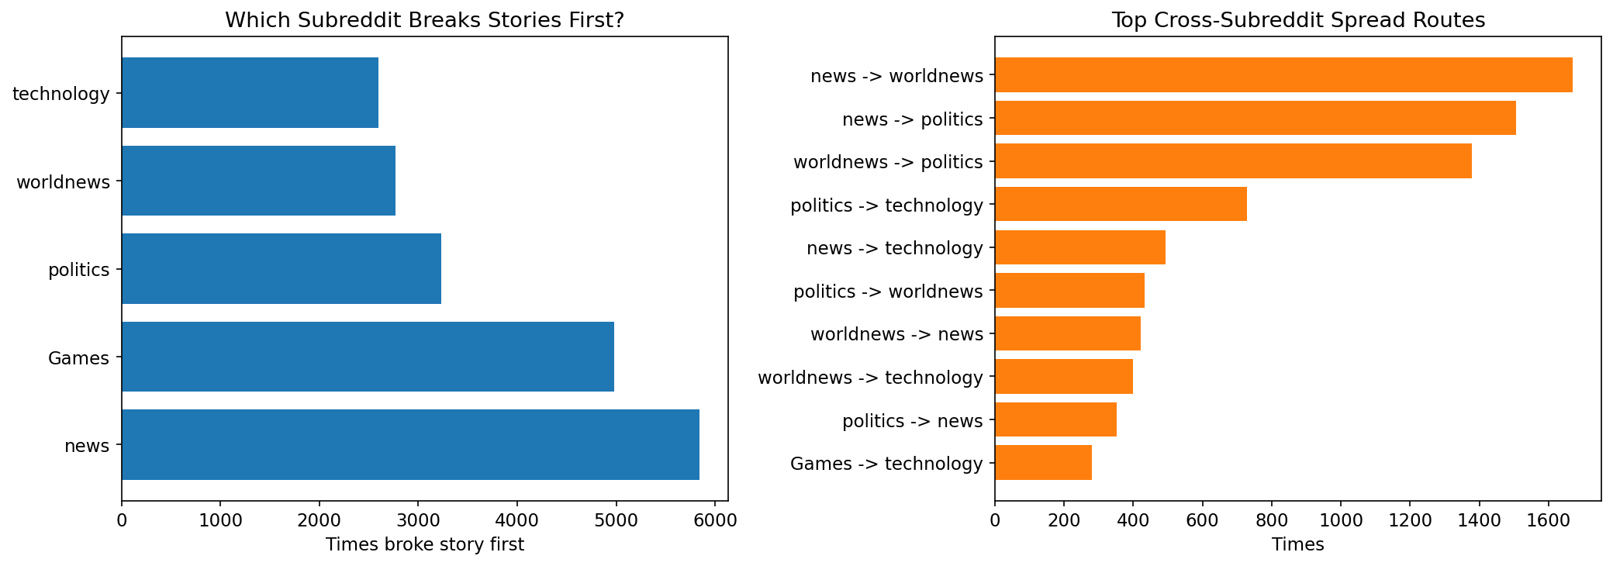
Figure 5: Left: which subreddit breaks stories first. Right: most common cross-subreddit spread routes.
Iteration 14: Ongoing story vs one-shot event classification. When a topic drops below its activity threshold, the system predicts whether it will revive (ongoing story) or remain dead (one-shot event). ROC AUC: 0.970. The strongest feature was the number of previous peaks (21.5% importance). Ongoing stories exhibit multiple surges and dips; one-shot events peak once.
Signal | Ongoing story | One-shot event | Ratio
Multiple peaks | 0.9 | 0.1 | 15.5x
Consistency (active/total days) | 0.4 | 0.1 | 4.6x
Active days | 3.2 | 0.8 | 4.0x
Peak posts | 3.8 | 1.6 | 2.3x

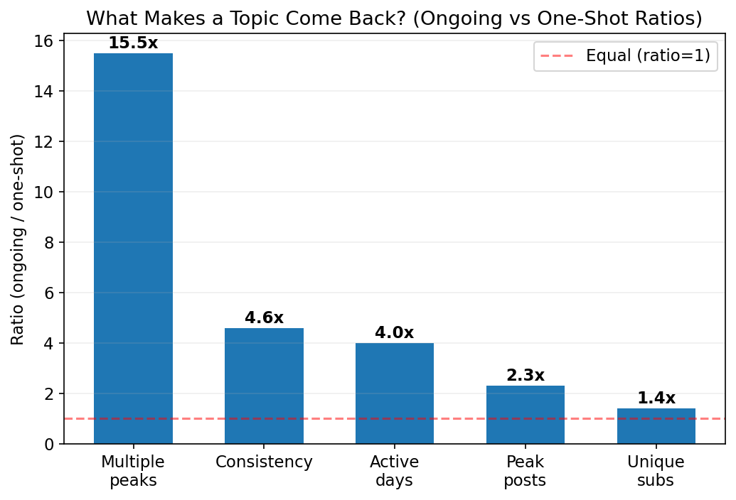
Figure 6: Feature ratios distinguishing ongoing stories from one-shot events. The number of previous peaks is the strongest signal at 15.5x.
Iteration 15: Topic death definition analysis. The original one-day death definition was found to have a 13.1% false-death rate. Topics with higher peak post counts revived more frequently: 44.8% for topics peaking at 8-11 posts versus 22.8% for topics peaking at 3-4 posts. Adopting a two-consecutive-day definition reduced false deaths to 6.8%.
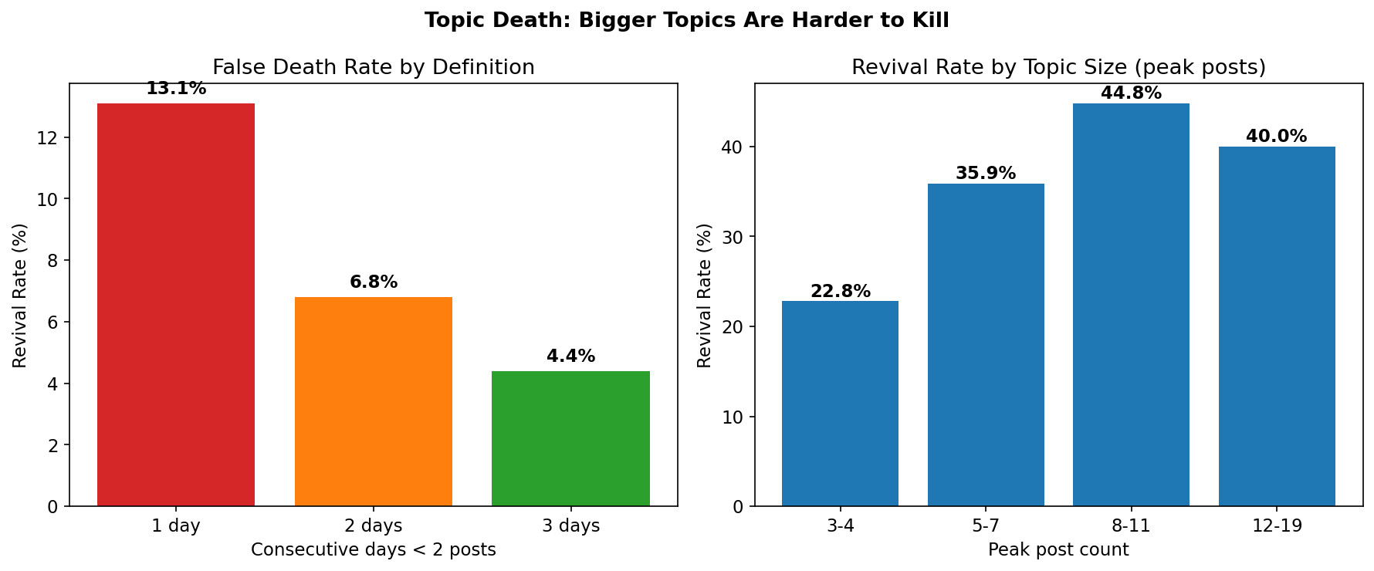
Figure 7: Left: false death rates by definition strictness. Right: revival rates by topic size. Larger topics are substantially more likely to revive.
Iteration 16: Noise filtering. A classifier trained to identify topics that would fail to grow achieved 0.824 ROC AUC. At 99% confidence, 87% of all word pairs could be discarded as noise with 99.5% precision, reducing the monitoring set from approximately 36,000 to 5,000 candidates per day.
Iteration 17: Model comparison and hyperparameter tuning. Five classifiers were compared across all seven lifecycle tasks. No single model dominated.
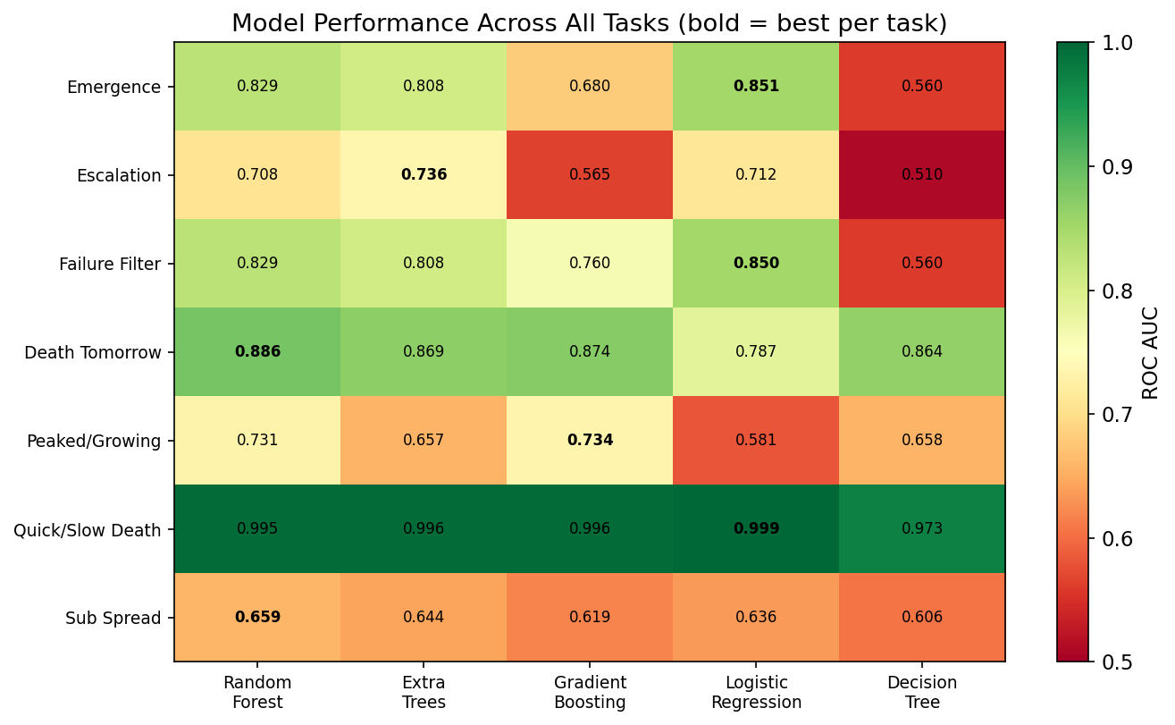
Figure 8: Model performance across all tasks. Bold values indicate the best model per task. Logistic Regression wins on emergence detection; Random Forest wins on death prediction.
Model | Default ROC | Tuned ROC | Improvement
Decision Tree | 0.577 | 0.842 | +0.265
Gradient Boosting | 0.713 | 0.835 | +0.122
Random Forest | 0.820 | 0.846 | +0.027
Logistic Regression | 0.859 | 0.860 | +0.001

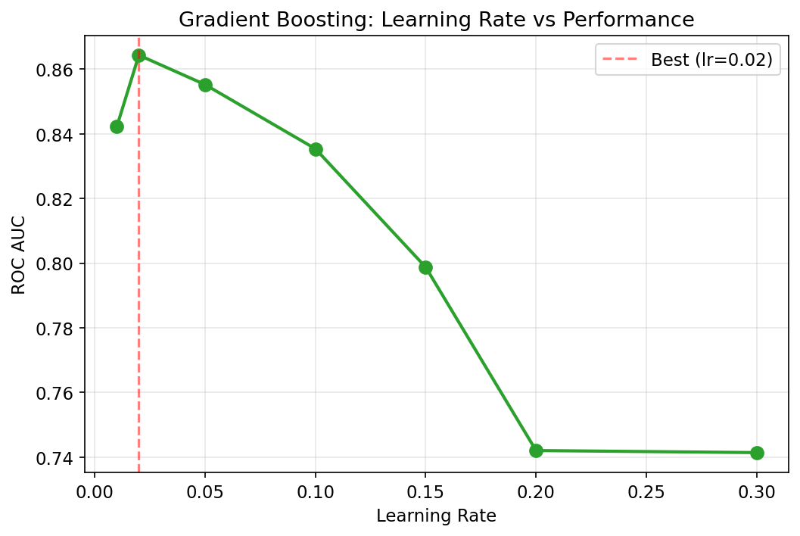
Figure 9: Gradient Boosting learning rate tuning. Performance peaks at 0.02 and degrades substantially at higher rates due to overfitting.

5. Final Code Evaluation and Reflection

Complete Lifecycle Pipeline
Lifecycle Stage | Task | Best ROC AUC | Best Model
Filter | Discard noise (87% filtered) | 0.850 | Logistic Regression
Birth | Detect emerging topic (1-3 to 5+ posts) | 0.860 | Logistic Regression
Growth | Has it peaked or still growing? | 0.958 | Gradient Boosting
Spread | Will it reach r/politics? | 0.756 | Random Forest
Decline | Topic dying state detection | 0.992 | Random Forest
Death | Will it die tomorrow? | 0.890 | Random Forest
Death speed | Quick death or slow death? | 0.999 | Logistic Regression
Revival | Ongoing story or one-shot? | 0.970 | Random Forest

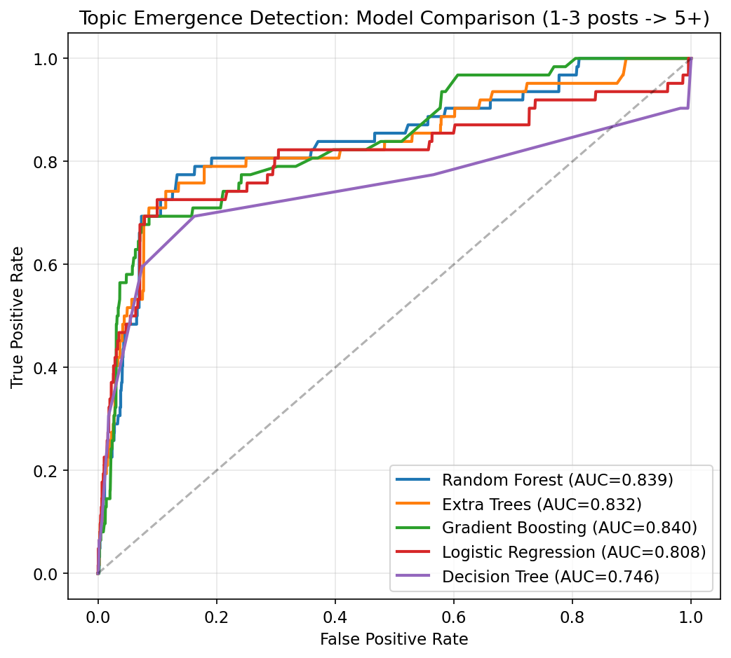
Figure 10: ROC curves comparing five classifiers on topic emergence detection.

Topic State Transitions
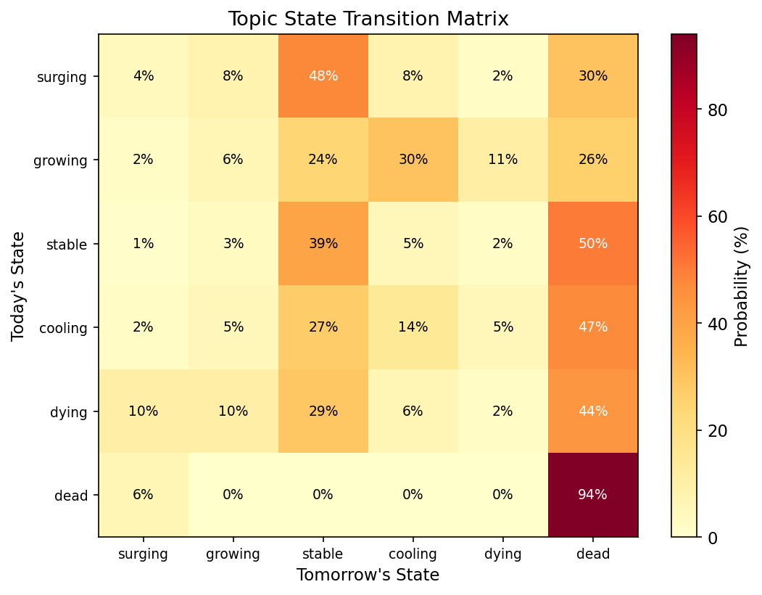
Figure 11: Topic state transition matrix. Surging topics have only a 4% chance of remaining surging the next day. Dead topics stay dead 94% of the time, but 6% revive.
The transition matrix reveals that topic states are highly transient. Surging topics most commonly transition to stable (48%) or dead (30%). Notably, dying topics revive to stable 44% of the time, confirming that topic death is not permanent and reinforcing the need for the ongoing-vs-one-shot classifier.

What Does Not Work
Magnitude prediction. The system detects whether a topic will grow (0.86 ROC) but cannot predict how large it will become. The Szabo-Huberman log-linear model (2010) was tested and achieved R-squared of only 0.22. Random Forest regression, power-law percentile ranges, and growth multiplier classifiers all failed because at 1-3 posts, 99.5% of word pairs remain small and the model cannot distinguish a future 10-post topic from a future 22-post topic.
Exact timing. Regression models for "days until death" produced R-squared of -0.5, performing worse than predicting the mean. Binary classification of the same events works well; regression on the exact timing does not.
Revival timing. Predicting when a dead topic will revive achieved only 0.578 ROC AUC. Revival depends on external real-world events (new developments in an ongoing story), which cannot be predicted from historical engagement metrics. However, predicting which topics are the type that revives works at 0.970 ROC AUC.

Limitations
- 13 days of data limits rare event learning (approximately 62 topic growth events in test sets)
- Daily topic granularity; hourly resolution would provide more signal for early detection
- No natural language processing at the topic level; ongoing stories are distinguished from one-shot events by trajectory shape only
- Magnitude prediction remains unsolved from early engagement signals
- All findings are correlational; causal mechanisms cannot be established from observational data

6. Reflection on AI-Assisted Coding

Where AI Was Effective
AI tools enabled rapid prototyping across the entire pipeline. The initial collection system, history builder, and prediction framework were functional within the first session. Algorithm selection (Random Forest, VADER, Gini coefficient) and boilerplate code generation were particularly effective, allowing the developer to focus on experimental design rather than implementation mechanics.

Where AI Was Misleading
Default model assumptions. I noticed that both Codex and Claude Code used Random Forest for every single task: “wait so we using random forest everywhere?” This prompted the five-classifier comparison, which revealed Logistic Regression outperforms Random Forest on the core emergence detection task (0.860 vs 0.829 ROC AUC), indicating the signal is linear. This was not discovered until I explicitly requested comparison.
Redundant feature suggestions. Claude Code recommended using post-level activity state labels (surging, alive, cooling, dying, dead) as features for topic prediction. I rejected this: “alive/surging state labels don’t help they never should have i don’t know why claud suggested using them.” These labels are discretised velocity values — using both velocity AND states is redundant. At topic level, the raw signals (velocity, comments, upvotes) matter, not the discretised buckets.
Premature ceiling claims. AI declared performance ceilings multiple times during development. Each time, I pushed past: discovering the topic lifecycle pipeline, co-occurrence pair detection, subreddit spread prediction, ongoing-vs-one-shot classification, and the post-topic bridge via first-post comment count. The shift from post-level to topic-level prediction itself was my initiative — the AI had not suggested this direction.
Hyperparameter negligence. Default or near-default parameters were used throughout until I requested tuning. Decision Tree improved by +0.265 ROC AUC and Gradient Boosting by +0.122 simply by adjusting tree depth and learning rate — basic tuning the AI should have suggested from the start.

Validation Approach
- Temporal validation: models trained on days 1-8, tested on days 9-13
- Feature importance analysis to verify models learn real patterns rather than artefacts
- Multiple classifier comparison to avoid algorithm selection bias
- Testing of established research models (Szabo-Huberman) against project data
- Honest reporting of negative results alongside positive ones

Ethical Considerations
- 1.1-second rate limiting between all API requests
- Aggregate analysis only; no individual user identification or profiling
- Public data only, accessed via Reddit's documented JSON endpoints without authentication
- Transparent documentation of all AI tools used throughout development

References
Hutto, C.J. and Gilbert, E.E. (2014) 'VADER: A Parsimonious Rule-based Model for Sentiment Analysis of Social Media Text', Proceedings of the International AAAI Conference on Web and Social Media.
Pedregosa, F. et al. (2011) 'Scikit-learn: Machine Learning in Python', Journal of Machine Learning Research, 12, pp. 2825-2830.
Szabo, G. and Huberman, B.A. (2010) 'Predicting the Popularity of Online Content', Communications of the ACM, 53(8), pp. 80-88.

