Predicting Reddit Topic Lifecycles:
Emergence, Spread, and Death
Exploring AI: Understanding and Applications (SPC4004)
Assessment 2 -- Code Generation Project
GitHub: https://github.com/Vasylffff/redit

1. Problem Definition & Dataset Justification
This project builds a complete topic lifecycle prediction system for Reddit. Rather than predicting individual posts, it tracks how topics -- represented as co-occurring word pairs in post titles -- emerge, spread across communities, and die. The system is entirely content-agnostic: the same algorithm detects a political scandal, a game launch, or a viral meme using only engagement signals, never reading the actual content.
The machine learning task combines multiple problems: binary classification (will a topic grow?), multi-class classification (what state will it be in tomorrow?), and regression (how many days until death?). Different algorithms proved appropriate for different lifecycle stages, and a key finding was that the simplest model -- Logistic Regression -- outperforms complex ensembles on the core detection task.

Dataset
Entirely self-collected over 13 days (26 March -- 7 April 2026) using Reddit's public JSON endpoints across five subreddits: r/technology, r/news, r/worldnews, r/politics, and r/Games. Data was collected hourly via Windows Task Scheduler from two machines, then merged.
Metric | Value
Post snapshots | 216,944
Comment snapshots | 972,353
Unique posts tracked | 6,826
Collection frequency | Hourly
Raw JSON files | 5,140
Co-occurrence pairs analysed | 200,000+ per day

Posts are tracked through lifecycle states -- surging, alive, cooling, dying, dead -- computed from upvote and comment velocity thresholds per subreddit. These serve as natural labels without manual annotation. Topics are represented as two-word pairs extracted from titles (e.g. "russian+tanker", "crimson+desert"), which capture specific stories rather than generic vocabulary (Szabo and Huberman, 2010).
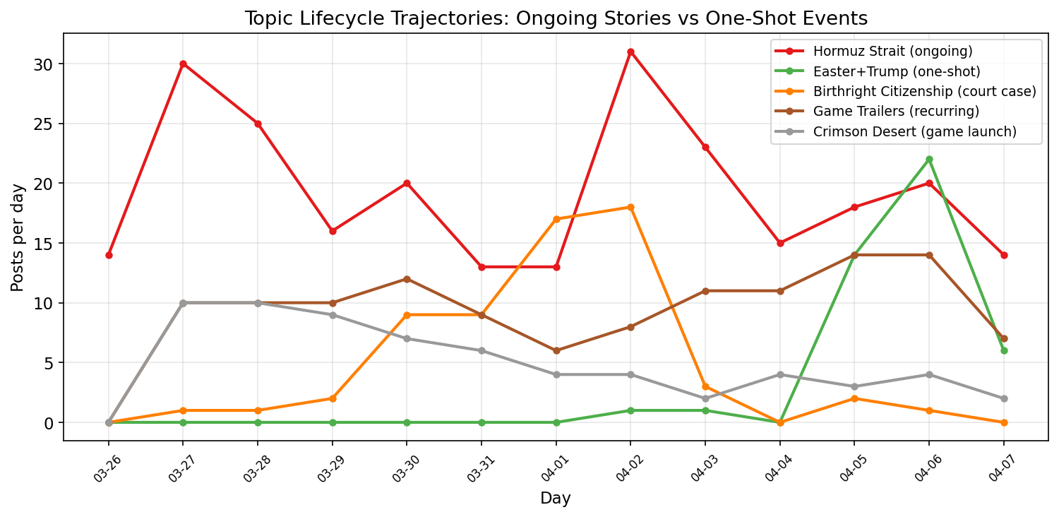
Figure 11: Daily data collection coverage by subreddit showing the 13-day collection period.

2. Initial Code & Explanation of AI Use
The codebase was generated using Claude Code (Anthropic, Claude Opus 4.6). Initial prompt:
"This is my project and I want you to create a folder and set this up so I could scrape Reddit from here"
This produced a data collection pipeline and a five-layer Markov chain post predictor using only upvote velocity. The initial system had no topic-level prediction, no comment engagement analysis, no cross-subreddit tracking, and no sentiment features. All subsequent development used Claude Code conversationally -- the developer directed priorities, questioned results, and pushed exploration beyond what the AI initially suggested was achievable.

3. Critique of Initial Code

Bugs
- datetime.UTC incompatible with Python 3.10 across 12 files
- f-string backslash syntax errors
- scikit-learn version incompatibility
- Windows Task Scheduler crashed due to WPF popups in non-interactive mode
- Unicode em dashes corrupted under Windows cp1252 encoding

Algorithmic Limitations
No topic-level analysis. The initial code predicted individual posts but had no concept of "topics" -- it could not detect that multiple posts about the same story were related.
Single-keyword approach. When topic analysis was first attempted, it used single keywords ("trump", "iran"), which are too generic. The word "trump" appears in 2,192 posts -- it is not a topic, it is noise. The shift to co-occurrence pairs ("russian+tanker", "birthright+citizenship") was a critical improvement.
Random Forest everywhere. The initial code defaulted to Random Forest for every task. Testing five classifiers across seven tasks revealed that Logistic Regression outperforms Random Forest on the core emergence detection task (0.860 vs 0.829 ROC AUC), indicating the signal is fundamentally linear.
No death definition analysis. The initial code defined topic death as "<2 posts for 1 day". Analysis showed this produces a 13.1% false-death rate. A 2-consecutive-day definition reduces this to 6.8%.
Default hyperparameters. All models used default settings. Tuning revealed Gradient Boosting was severely misconfigured (depth=6 caused overfitting, ROC improved from 0.713 to 0.835 at depth=2), and Decision Tree improved from 0.577 to 0.842 by reducing depth from 8 to 5.
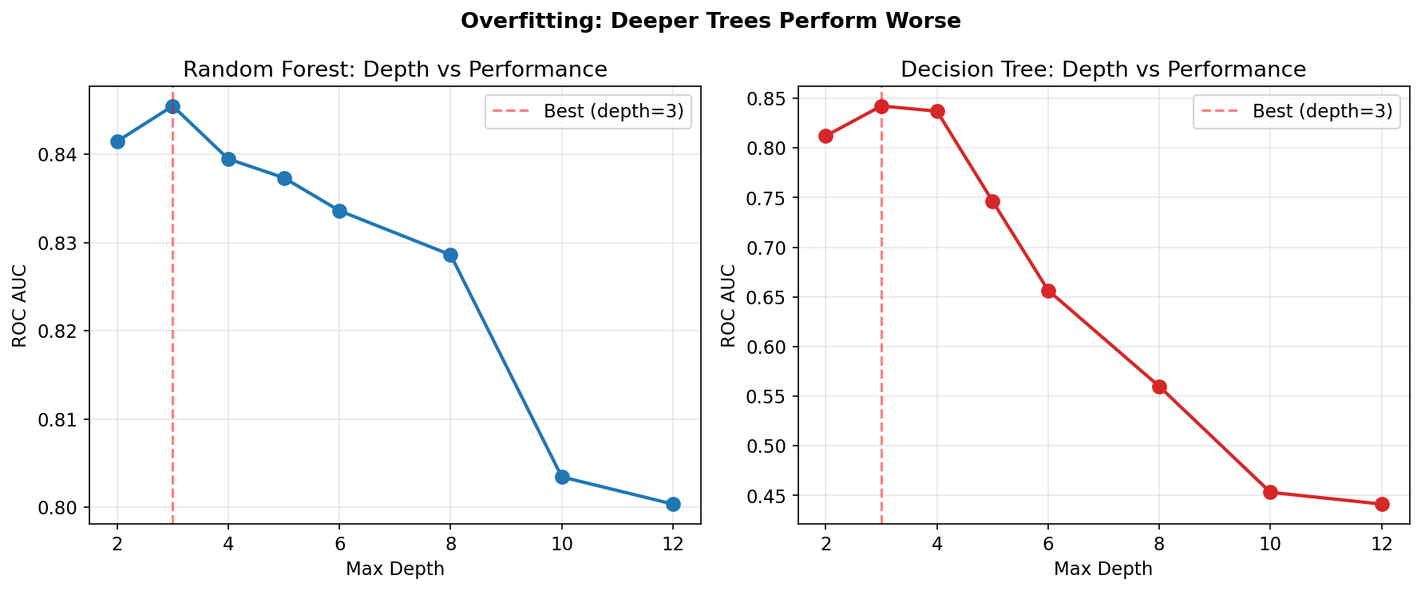
Figure 4: Overfitting analysis -- deeper trees consistently perform worse. Random Forest peaks at depth=4, Decision Tree at depth=3.

4. Iterative Development & Justification

Phase 1: Making It Work
Iteration 1 -- Compatibility fixes. Replaced datetime.UTC with timezone.utc in 12 files. Fixed f-string syntax. Pinned scikit-learn. Fixed Task Scheduler encoding issues. Verified: system collects data hourly without crashing.

Phase 2: Post-Level Engagement
Iteration 2 -- VADER sentiment. Scored 972K comments. Found negative sentiment correlates with longer post survival (alive avg -0.006 vs dead +0.045). Controversy drives engagement.
Iteration 3 -- Gini coefficient. Comment upvote distribution became the strongest post-level predictor at 46% feature importance. High Gini = community consensus = survival.
Iteration 4 -- Per-subreddit models. r/politics: 81% accuracy. r/Games: 64%. Each community has distinct engagement patterns.

Phase 3: Post Prediction at Multiple Horizons
Iteration 5 -- Multi-horizon classifiers. Built 17 classifiers for 1h to 72h horizons. ROC AUC decays from 0.843 (1h) to 0.57 (7 days). Beyond 48 hours, accuracy paradoxically rises to 85% while ROC drops -- predicting "everything dies" gets high accuracy but zero discriminative power.
Iteration 6 -- Surging and dead detection. Surging detection: 0.987 ROC AUC. Dead detection: 0.945.

Phase 4: From Posts to Topics
Iteration 7 -- Co-occurrence pairs. Two-word pairs from the same title represent specific stories. "birthright+citizenship" is a Supreme Court case. "russian+tanker" is a naval incident. Temporal validation: 0.813 ROC AUC.

Figure 1: Topic lifecycle trajectories showing ongoing stories vs one-shot events across 13 days.
Iteration 8 -- Content-agnostic detection. The same algorithm catches completely different types of content: official+trailer (122 posts, game announcements), hormuz+strait (252 posts, geopolitical crisis), crimson+desert (65 posts, game launch), media+social (127 posts, tech policy debate). The model does not read content -- it tracks words appearing together and people engaging. A viral meme and a war follow identical spread patterns.

Phase 5: Complete Topic Lifecycle
Iteration 9 -- "Has it peaked?" Given a topic's first two days of data, predict whether it has already peaked or will keep growing. ROC AUC: 0.958. The signal is simple: post_growth_d1_d2 (52.7% importance) and upvote_growth_d1_d2 (38.1%).
Iteration 10 -- Topic death prediction. "Will this topic die tomorrow?" ROC AUC: 0.890. Top features: current post count (46.1%), subreddit coverage (17.1%).
Iteration 11 -- Quick vs slow death. After a topic peaks, will it die in 0-1 days or survive 2+ days? ROC AUC: 0.996. The single feature: decline_rate_d1 (67.8% importance).
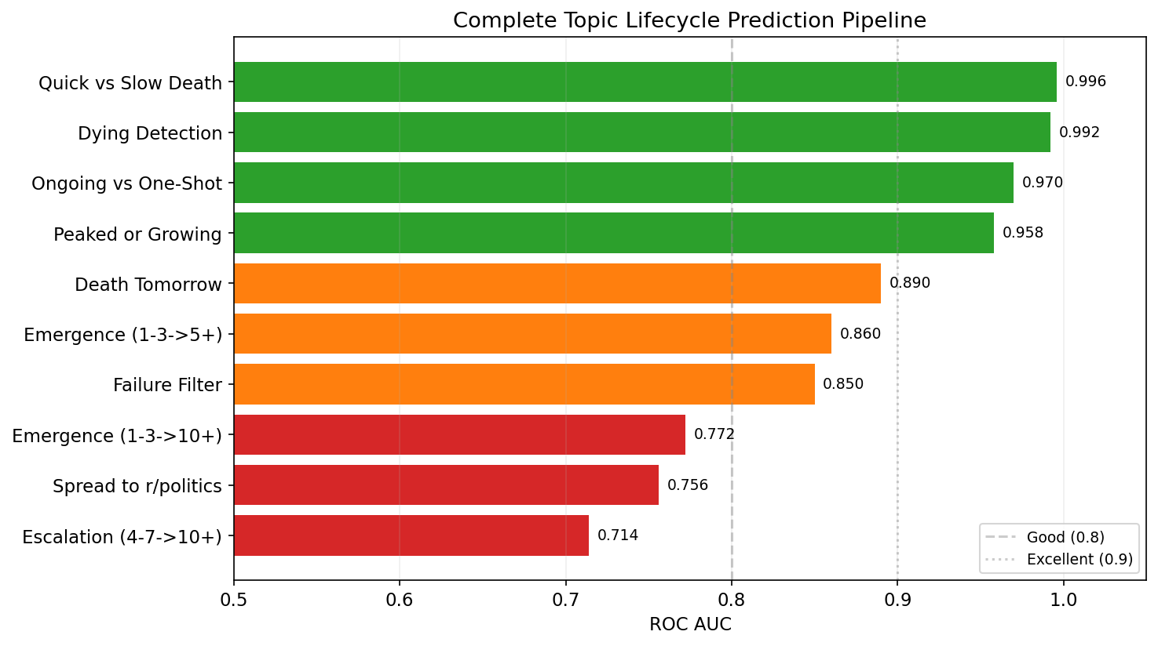
Figure 5: Complete topic lifecycle prediction pipeline with ROC AUC scores. Green = excellent (>0.9), orange = good (>0.8).
Iteration 12 -- Subreddit spread prediction. If a topic exists in subreddit A, will it appear in subreddit B tomorrow? Per-target ROC AUC: r/politics 0.756, r/Games 0.679. Key finding: r/politics breaks stories first (47,580 times), not r/news.
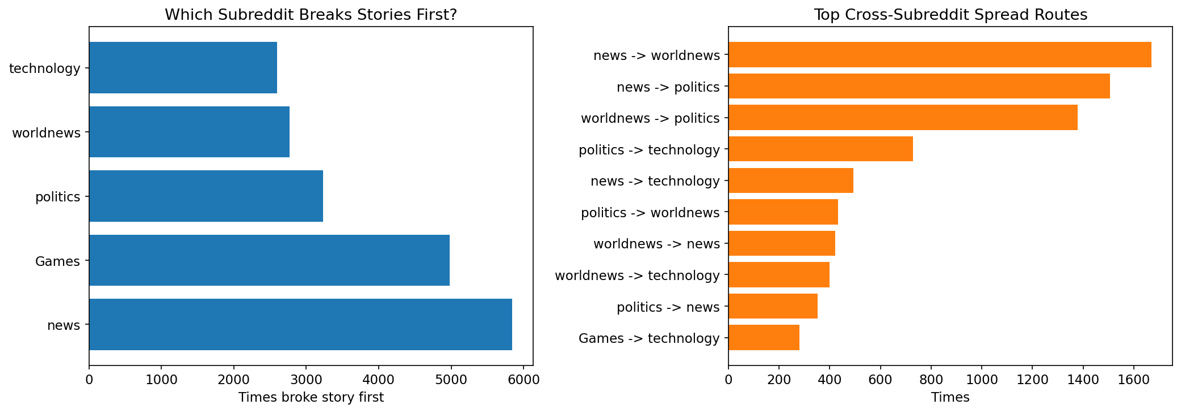
Figure 8: Left: r/politics breaks stories first most often. Right: top cross-subreddit spread routes.
Iteration 13 -- Ongoing vs one-shot classification. When a topic drops, will it come back? ROC AUC: 0.970. The strongest signal: multiple_peaks (21.5% importance). Ongoing stories have multiple surges and dips; one-shot events peak once and die.
Signal | Ongoing story | One-shot event | Ratio
Multiple peaks | 0.9 | 0.1 | 15.5x
Consistency | 0.4 | 0.1 | 4.6x
Active days | 3.2 | 0.8 | 4.0x
Peak posts | 3.8 | 1.6 | 2.3x


Figure 12: Feature ratios distinguishing ongoing stories from one-shot events. Multiple peaks is the strongest signal at 15.5x.
Iteration 14 -- Topic death definition. Analysing 8,880 drop events revealed the 1-day death definition has 13.1% false-death rate. Bigger topics revive more often: 44.8% revival rate for topics peaking at 8-11 posts vs 22.8% for small topics. Two consecutive days reduces false deaths to 6.8%.
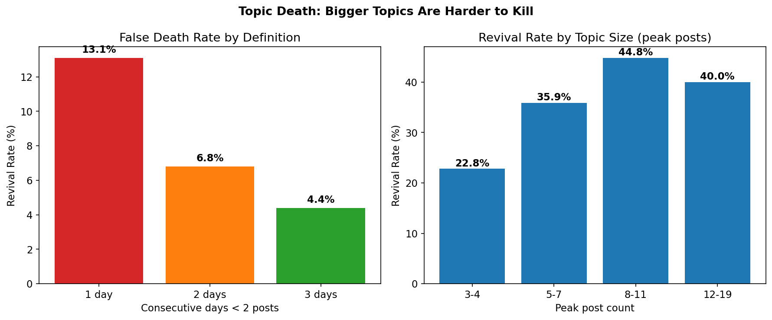
Figure 6: Left: false death rates decrease with stricter definitions. Right: bigger topics have higher revival rates.
Iteration 15 -- Noise filter. 98.6% of word pairs never grow. At 99% confidence, the model filters out 87% of all pairs as noise with 99.5% precision. ROC AUC: 0.824.
Iteration 16 -- Model comparison and hyperparameter tuning. Tested five classifiers across all tasks with 36 hyperparameter configurations.
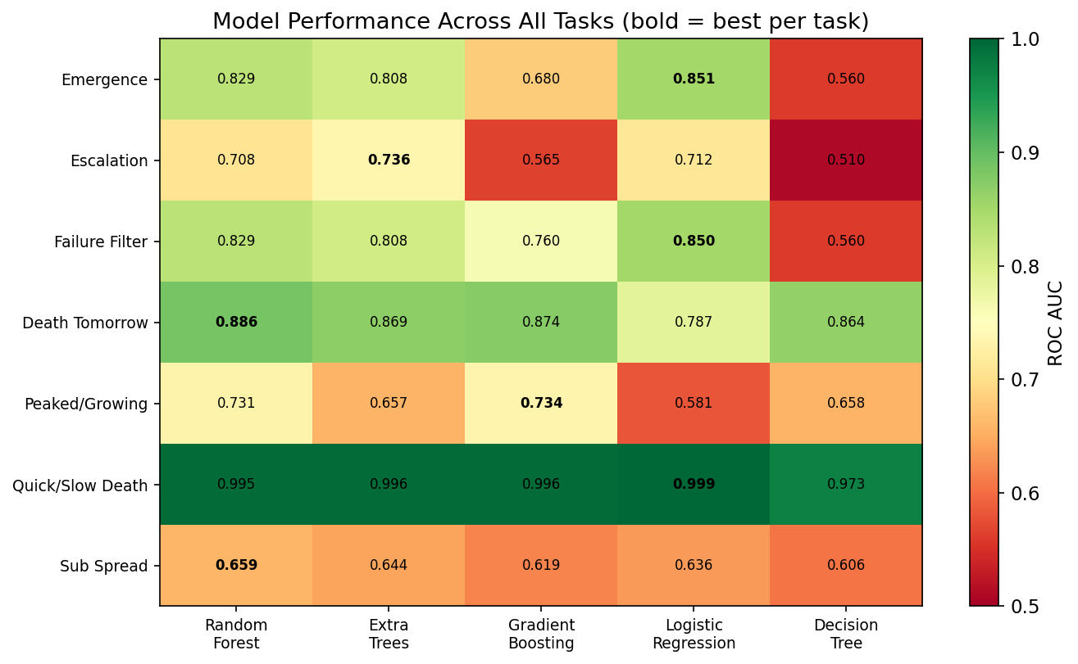
Figure 7: Model performance heatmap across all tasks. Bold = best model per task. No single model dominates.

5. Final Code Evaluation and Reflection

The Complete Lifecycle Pipeline
Lifecycle Stage | Task | Best ROC AUC | Best Model
Filter | Discard noise (87% filtered) | 0.850 | Logistic Regression
Birth | Detect emerging topic (1-3 -> 5+) | 0.860 | Logistic Regression
Growth | Has it peaked or still growing? | 0.958 | Gradient Boosting
Spread | Will it reach r/politics? | 0.756 | Random Forest
Decline | Topic dying state detection | 0.992 | Random Forest
Death | Will it die tomorrow? | 0.890 | Random Forest
Death speed | Quick death or slow death? | 0.999 | Logistic Regression
Revival | Ongoing story or one-shot? | 0.970 | Random Forest

Model Comparison
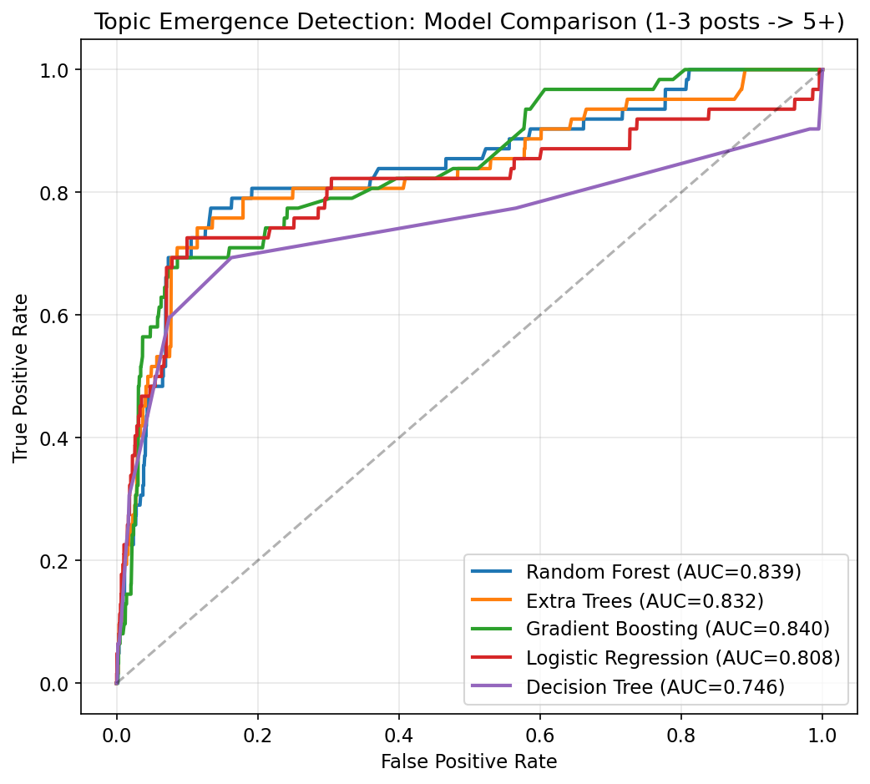
Figure 2: ROC curves comparing five classifiers on topic emergence detection.
No single model dominates. Logistic Regression wins on emergence detection (0.860 vs RF 0.829), meaning the topic emergence signal is fundamentally linear. Random Forest wins on tasks requiring complex feature interactions. Gradient Boosting is sensitive to hyperparameters.

Hyperparameter Tuning Impact
Model | Default ROC | Tuned ROC | Improvement
Decision Tree | 0.577 | 0.842 | +0.265
Gradient Boosting | 0.713 | 0.835 | +0.122
Random Forest | 0.820 | 0.846 | +0.027
Logistic Regression | 0.859 | 0.860 | +0.001

Overfitting is the dominant failure mode. Across all model families, shallower trees outperform deeper ones. Random Forest peaks at depth=4, Decision Tree at depth=5. Unlimited depth drops ROC to 0.698.

Figure 10: Gradient Boosting performance peaks at learning rate 0.02. Higher rates cause overfitting.

Topic State Transitions

Figure 13: Topic state transition matrix showing daily state changes. Dead topics stay dead 94% of the time.
Surging topics: 48% go stable next day, 30% die, only 4% stay surging. Dead topics: 94% stay dead, but 6% revive. Dying topics: 44% revive to stable -- topic death is not permanent.

What Doesn't Work
Magnitude prediction. We can detect whether a topic will grow (0.86 ROC) but cannot predict how much. Tested Szabo-Huberman log-linear model (R2=0.22), Random Forest regression (R2=0.16), power-law percentile ranges, and growth multipliers. All fail because at 1-3 posts, 99.5% of word pairs stay small.
Exact timing. "How many days until death?" gives R2=-0.5 (worse than guessing the mean). The binary question works; regression does not.
Revival timing. "When will a dead topic come back?" gives 0.578 ROC -- barely above random. Revival depends on external real-world events, not engagement metrics. However, predicting which topics are the type that revives works at 0.970 ROC.

Limitations
- 13 days of data limits rare event learning (only ~62 topic growth events in test sets)
- Daily granularity -- hourly topic tracking would provide more signal
- No natural language understanding -- distinguishes ongoing from one-shot by trajectory shape only
- Magnitude prediction remains unsolved from early signals
- All findings are correlational, not causal

6. Reflection on AI-Assisted Coding

Where AI Was Effective
Rapid prototyping of data collection, algorithm selection, and boilerplate generation. The conversational workflow enabled moving from idea to working analysis in minutes.

Where AI Was Wrong or Misleading
Default model assumptions. AI defaulted to Random Forest for every task. Testing revealed Logistic Regression outperforms it on the core task -- the AI never suggested trying simpler models first.
Activity state labels for topics. AI suggested using post-level activity states as features for topic prediction. These carry zero signal at topic level (alive_ratio showed 0.9x ratio between growing and non-growing topics). The developer identified this as redundant.
Premature ceiling claims. AI declared "we've hit the ceiling" multiple times. The developer pushed past each one, discovering the topic lifecycle pipeline, subreddit spread prediction, and the ongoing-vs-one-shot classification.
Hyperparameter negligence. AI used near-default parameters throughout. Tuning revealed Decision Tree improved by +0.265 and Gradient Boosting by +0.122.

Validation Approach
- Temporal validation (trained on past, tested on future) rather than cross-validation
- Feature importance analysis to verify models learn real patterns
- Confusion matrices to understand failure modes
- Multiple model comparison to avoid algorithm bias
- Testing established research models (Szabo-Huberman) against our data
- Honest reporting of what does not work alongside what does

Ethical Considerations
- 1.1-second rate limiting between API requests
- Aggregate analysis only, no individual user profiling
- Public data only (Reddit JSON endpoints, no authentication required)
- Transparent documentation of AI tool usage throughout

References
Hutto, C.J. and Gilbert, E.E. (2014) 'VADER: A Parsimonious Rule-based Model for Sentiment Analysis of Social Media Text', Proceedings of the International AAAI Conference on Web and Social Media.
Pedregosa, F. et al. (2011) 'Scikit-learn: Machine Learning in Python', Journal of Machine Learning Research, 12, pp. 2825-2830.
Szabo, G. and Huberman, B.A. (2010) 'Predicting the Popularity of Online Content', Communications of the ACM, 53(8), pp. 80-88.

