Predicting Reddit Post Survival Using
Comment Engagement and Sentiment Analysis
Exploring AI: Understanding and Applications (SPC4004)
Assessment 2 – Code Generation Project

GitHub Repository: https://github.com/Vasylffff/redit

1. Problem Definition & Dataset Justification

The Problem
Every day, thousands of posts are submitted to Reddit. Some surge to the front page with tens of thousands of upvotes. Most die within hours with barely any engagement. The question this project seeks to answer is: can we predict, based on a post's early signals, whether it will survive or die — and how far into the future can that prediction remain reliable?
This is framed as a binary classification problem: given a post's current state (upvotes, comments, velocity, age, comment sentiment, and comment engagement patterns), classify it as either surviving (will be in surging or alive state) or dying (will be in cooling, dying, or dead state) at a future time horizon.
The problem extends across multiple time horizons: 1 hour ahead, 4 hours, 12 hours, 24 hours, and 48 hours. This multi-horizon approach allows us to study how predictability itself decays over time — a finding that proved to be one of the project's most significant contributions.

Why This Problem Matters
Understanding post engagement dynamics has practical applications. Content creators want to know which posts to invest effort in promoting. News monitoring systems need to identify which stories are gaining traction. Researchers studying online discourse benefit from understanding what drives engagement versus apathy. From a machine learning perspective, it presents an interesting challenge: a time-series classification problem with naturally labelled data, high dimensionality, and an inherent stochastic component.

The Dataset
The dataset was entirely self-collected using Reddit's public JSON endpoints (for example, https://www.reddit.com/r/technology/new.json). No API key or authentication was required. A custom scraping system was built that runs on Windows Task Scheduler, collecting data hourly across five subreddits: r/technology, r/news, r/worldnews, r/politics, and r/Games.
Collection period: 12 days (26 March to 6 April 2026).
Metric | Value
Post snapshots | 185,048
Comment snapshots | 677,569
Unique post lifecycles | 6,292
Subreddit health observations | 2,174

Each post snapshot records: upvote count, upvote ratio, comment count, upvote velocity, comment velocity, age in minutes, rank position, and computed activity state. Comment snapshots include: full text body, comment upvote count, author, and whether it is top-level or a reply.
This dataset was chosen because it provides naturally labelled training data: lifecycle states serve as ground truth without manual annotation. The time-series structure enables trajectory prediction, and comment text enables sentiment and engagement analysis.

Activity States
Surging: Velocity significantly above subreddit median.
Alive: Velocity above minimum threshold.
Cooling: Velocity declining but above zero.
Dying: Velocity near zero.
Dead: No meaningful engagement across multiple snapshots.

2. Initial Code & Explanation of AI Use
The entire initial codebase was generated using Claude Code, Anthropic's CLI powered by Claude Opus 4.6. The first prompt was:
"This is my project and I want you to create a folder and set this up so I could scrape Reddit from here"
This produced:
- collect_reddit_free.py — Reddit scraper with 1.1s delay
- run_free_collection_schedule.py — schedule runner
- run_free_collection_window.ps1 — PowerShell Task Scheduler wrapper
- build_reddit_history.py — raw JSON to structured CSV
- predict_post_flow.py — five-layer Markov chain predictor
Additional tools: VADER sentiment analyser (Hutto and Gilbert, 2014) and scikit-learn (Pedregosa et al., 2011).

3. Critique of Initial Code

Correctness Issues
Python 3.11 incompatibility. Used datetime.UTC across 12 files; fails on Python 3.10.
f-string syntax error. Backslashes in f-strings, not permitted in Python 3.10.
Dependency mismatch. scikit-learn>=1.8.0 requires Python 3.11+.

Algorithmic Limitations
No sentiment analysis. Blind to emotional content of discussions.
No comment engagement analysis. Ignored upvote distribution patterns (Gini coefficient later proved strongest predictor).
Single-step prediction. Markov chain converges to equilibrium; cannot discriminate at longer horizons.
No per-subreddit models. r/politics (11h alive) treated same as r/Games (49h alive).

Infrastructure Issues
Task Scheduler crashed due to WPF popup dependency in non-interactive sessions and aggressive error handling treating Python stderr as fatal errors.

4. Iterative Development & Justification

Iteration 1: Compatibility and Infrastructure Fixes
Problem: Entire codebase non-functional on Python 3.10; Task Scheduler crashed silently.
Changes: Fixed datetime.UTC in 12 files, f-string syntax, scikit-learn version. Removed WPF popups, fixed error handling, replaced unicode em dashes.
Verification: All scripts run clean. Scheduler completes hourly with exit code 0.

Iteration 2: VADER Sentiment Integration
Problem: Model blind to comment sentiment.
Changes: Scored 677,569 comments with VADER. Added 5 sentiment columns. Added Layer 6 to Markov predictor.
Key finding: Negative sentiment correlates with longer survival (alive avg -0.006 vs dead +0.045). Controversy drives engagement. Decision Tree achieved 74.5% accuracy, but comment count dominated at 74% feature importance — model was counting comments, not analysing sentiment.
Verification: Consistent across all 5 subreddits and 3,520 posts.

Iteration 3: Comment Upvote Gini Coefficient
Problem: Sentiment added only 2-3% above comment volume.
Changes: Implemented Gini coefficient on comment upvote distributions. High Gini = few dominant comments (consensus); low Gini = diffuse attention (unfocused).
Key finding: Gini became #1 predictor (46% importance). Surging/alive: 0.63-0.72. Dying: 0.36. Dying posts also showed largest sentiment gap (-0.135): community endorsed angry comments. Classifier improved to 77.6%.
Why this matters: Survival depends not on whether people are happy or angry, but whether discussion has focus.
Verification: 5-fold CV. Pattern held across all subreddits.

Iteration 4: Per-Subreddit Classification
Problem: Global model ignores community-specific dynamics.
Changes: Separate Random Forest per subreddit.
Results: r/politics 81%, r/worldnews 76%, r/technology 70%, r/news 68%, r/Games 64%.
Verification: Distinct confusion matrix patterns per community.

Iteration 5: Multi-Horizon Prediction
Problem: Only single-step prediction.
Changes: 17 classifiers for 1-72h horizons, each trained on 100K-160K samples. Generated ROC curves, survival probability curves, half-life estimates.
Results: ROC AUC: 1h=0.843, 4h=0.834, 12h=0.809, 24h=0.771, 48h=0.726. Half-lives: surging ~48h, alive ~24h, cooling ~3h, dying ~1h.
Significance: Demonstrates deterministic component (first 4-12h) and stochastic component (grows over time). Boundary at ~24 hours.
Verification: 5-fold CV at each horizon. Smooth monotonic decay curve.

Additional Analyses
- Best posting hours (08:00 UTC optimal)
- Upvote velocity curves by subreddit
- Cross-subreddit propagation (1,573 stories, 11.1h median)
- Subreddit direction forecasting
- Domain and author performance analysis
- Keyword trend detection
- Title style impact (shock words: 59.1% alive vs 23.8%)
- Cross-posting success predictor (politics→news: 72%)
- Time-to-death regression (R2=0.459, MAE 9.1h)

5. Final Code Evaluation and Reflection
Classification Performance:
Model | Horizon | ROC AUC
Post survival | 1 hour | 0.843
Post survival | 4 hours | 0.834
Post survival | 12 hours | 0.809
Post survival | 24 hours | 0.771
Post survival | 48 hours | 0.726
Surging detection | 1 hour | 0.987

Confusion Matrix (4-Hour)
 | Predicted Alive | Predicted Dead
Actually Alive | 16,570 (TP) | 4,189 (FN)
Actually Dead | 3,900 (FP) | 8,057 (TN)
80% true positive rate, 67% true negative rate. Primary failure: false optimism from class imbalance.

Key Findings
1. Controversy drives engagement. Negative sentiment correlates with survival. r/politics (-0.10 sentiment) grows; r/Games (+0.38) declines.
2. Upvote concentration is the strongest predictor. Gini coefficient outperforms all other features.
3. Predictability decays over time. ROC 0.843 (1h) to 0.726 (48h). Boundary at ~24 hours.
4. Half-life varies by state. Surging ~48h, alive ~24h, cooling ~3h, dying ~1h.
5. Per-subreddit models outperform global. +10 percentage points for r/politics.

Limitations
Reply threading data mostly empty (99% zeros). 12-day window limits seasonal detection. Regression models weak (R2=0.42). All correlational, not causal.

6. Reflection on AI-Assisted Coding

Effective Uses
Rapid prototyping, algorithm selection (Random Forest, VADER, K-means), boilerplate generation, and novel suggestions (Gini coefficient, multi-horizon prediction).

Corrections Required
Task Scheduler crash: WPF + unicode em dashes; works interactively, crashes in deployment.
Timeout miscalculation: 5×100×10 comments×1.1s = 92min, exceeding 30min limit.
Misleading accuracy: 74.5% appeared good until feature importance showed 74% was just comment counting.
Version assumptions: Generated Python 3.11 code for 3.10 machine.

Validation
Execution testing, 5-fold cross-validation, feature importance analysis, confusion matrices, and cross-subreddit sanity checks on counterintuitive findings.

Ethics
1.1-second rate limiting, aggregate analysis not individual profiling, transparent AI documentation.

References
Bird, S., Klein, E. and Loper, E. (2009) Natural Language Processing with Python. O'Reilly Media.
Hutto, C.J. and Gilbert, E.E. (2014) 'VADER: A Parsimonious Rule-based Model for Sentiment Analysis of Social Media Text', Proc. ICWSM.
Pedregosa, F. et al. (2011) 'Scikit-learn: Machine Learning in Python', JMLR, 12, pp. 2825-2830.

Figures
Figure 1: ROC Prediction Decay
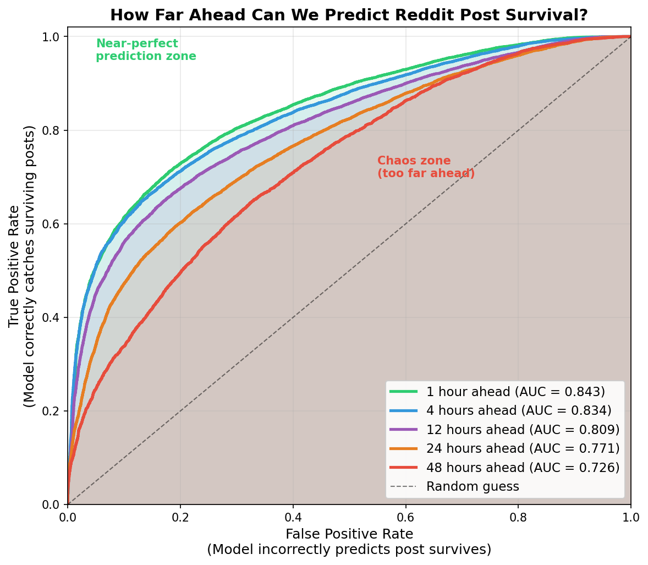
ROC curves across 5 horizons showing predictability decay from AUC=0.843 (1h) to 0.726 (48h).

Figure 2: Survival Probability Curves
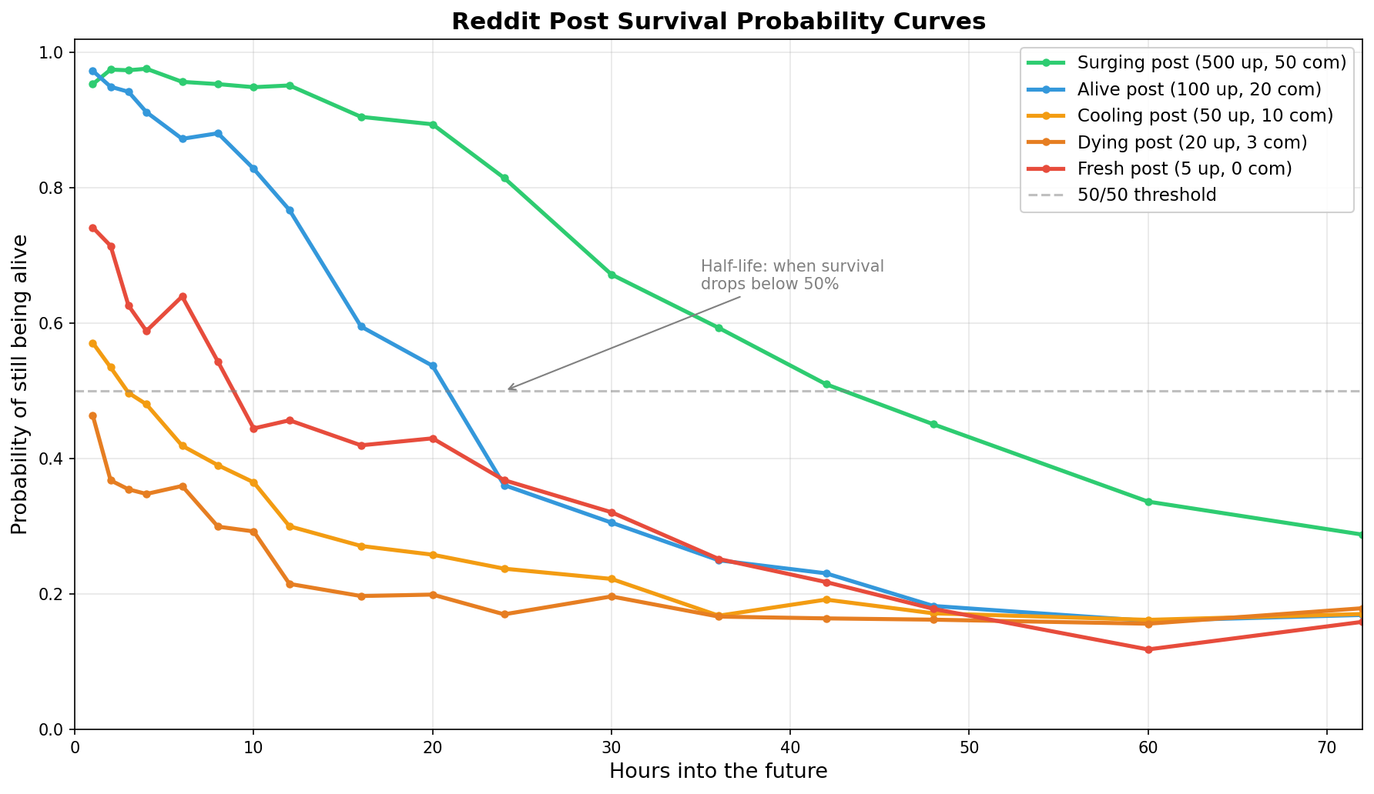
Survival probability for 5 post types over 72 hours with half-life annotations.

Figure 3: ROC Curves + Confusion Matrix
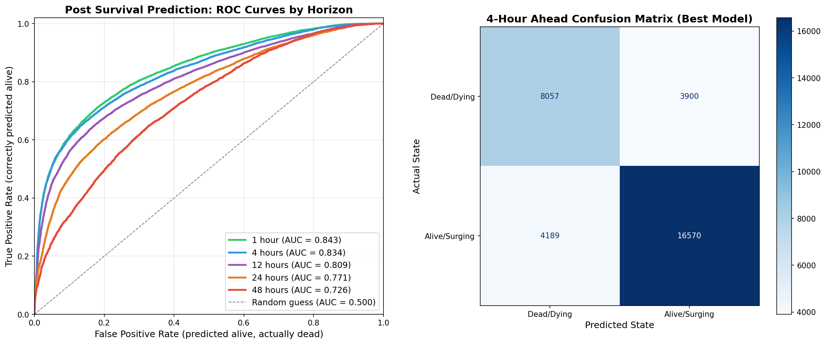
All ROC curves (left) and 4-hour confusion matrix (right).

Figure 4: Subreddit State Distribution
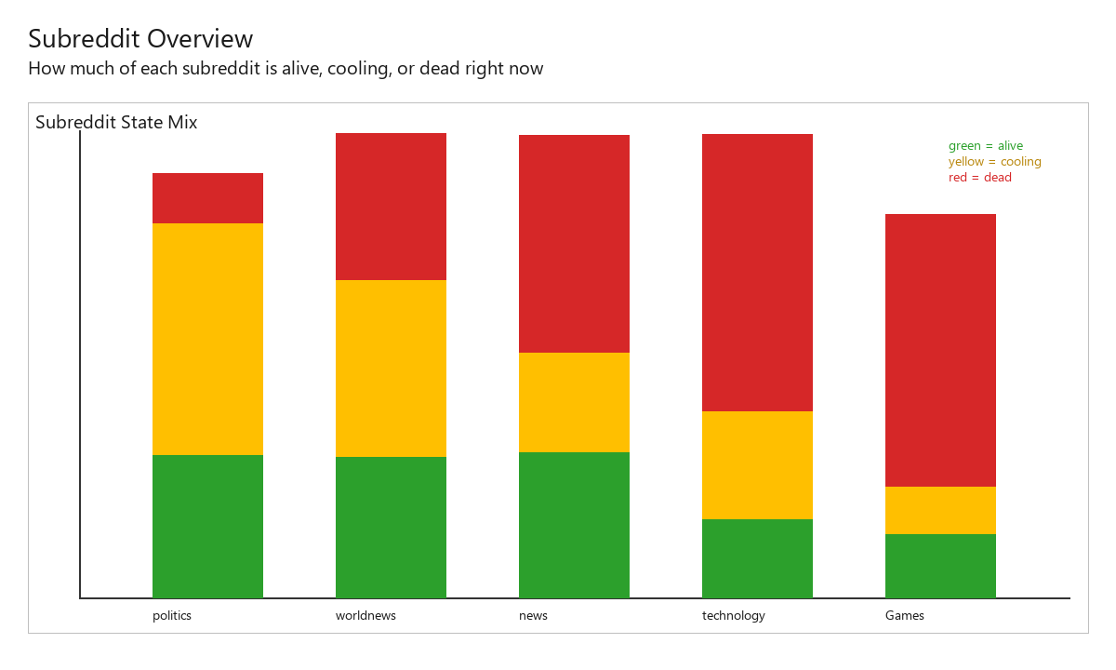
Lifecycle state distribution across subreddits.

Figure 5: Flow Trajectories
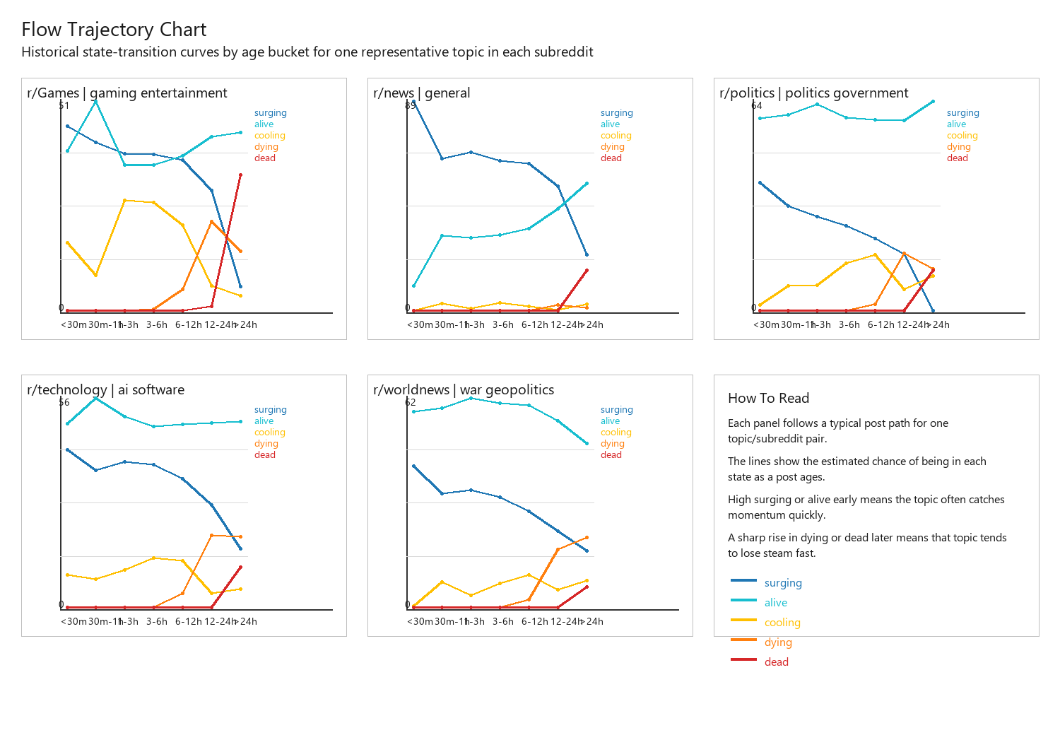
State transition patterns per subreddit.

Figure 6: Activity Dashboard
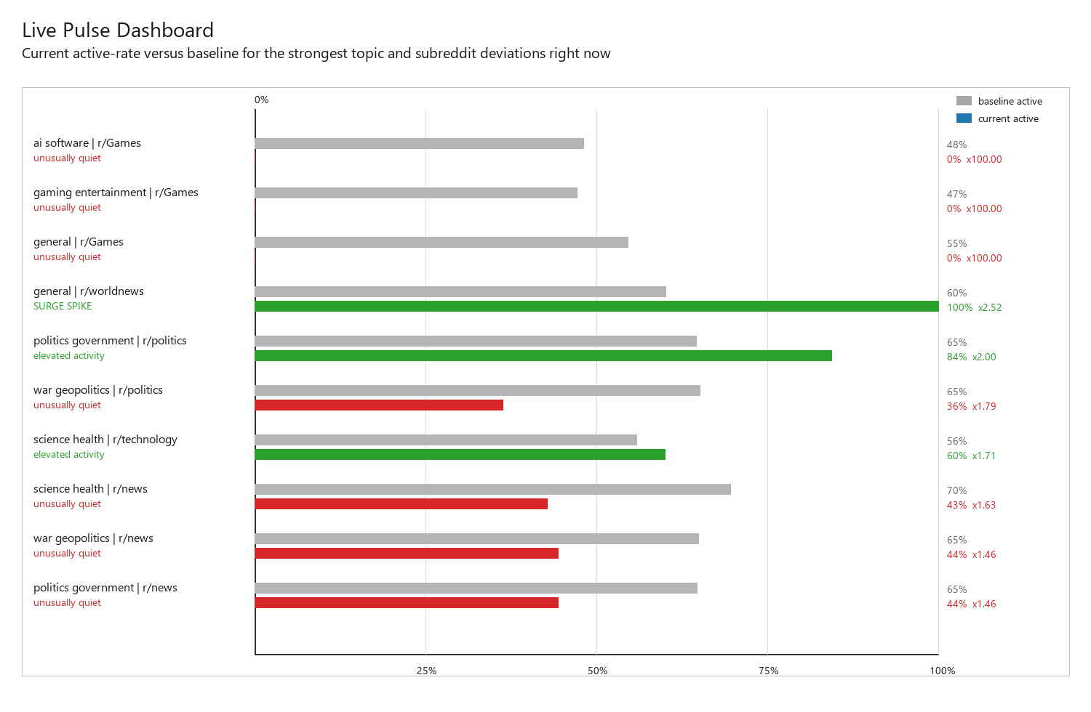
Current engagement levels across subreddits.

