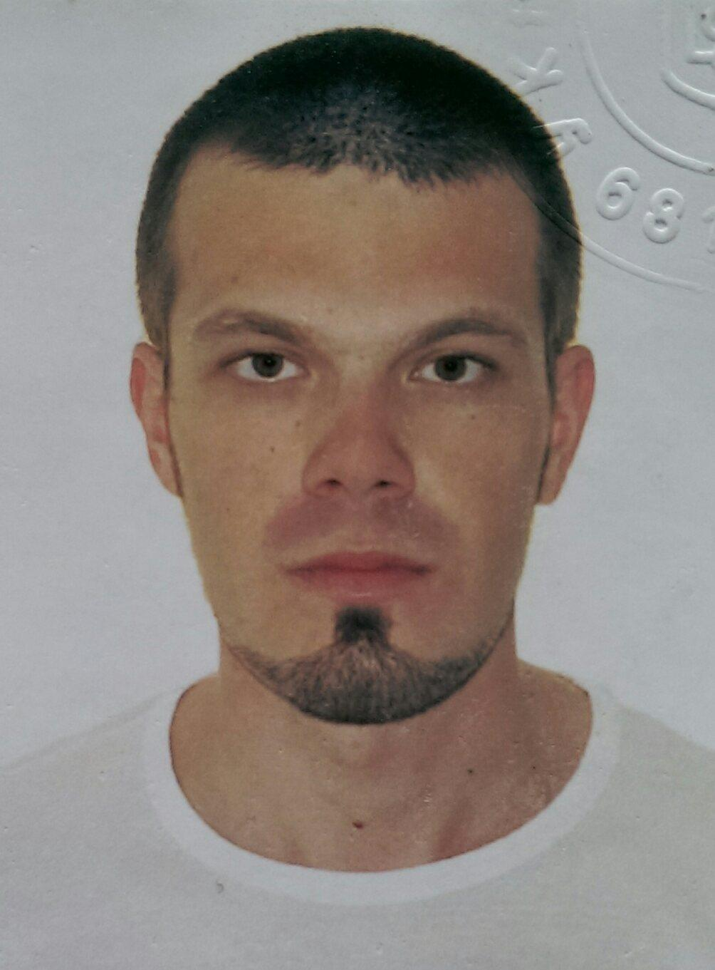 Curricular Vitae

Vasylkivskyi Ruslan

|  |  |
| --- | --- |
| Date and place of birth: | 17, March, 1989, Ukraine, Khmelnitsky reg., Dunaivtcy |
| Current residential address and contact information: | 29018, Ukraine, Khmelnitsky, 5/8 Karmelyka str..  Phone: +38 (097) 791 63 97.  e-mail: vasylkivskyi.ruslan@gmail.com |
| Education: | 1995 – 1999 School number 2, Ukraine, Khmelnitsky reg., Dunaivtcy  1999 – 2004 Gymnasium 7, Russia, Norilsk  2004 – 2007 Vocational school, Ukraine, Khmelnitskyi reg, Dunaivtcy  2007 – 2012 Khmelnitsky National University – Degree of specialist.  March 2017 – December 2017 – Circle Web Group |
| Work experience:  . | September, 2014 – November, 2017 - Company «Colormarket».  Position: Commercial administrator.  Responsibilities:  - Organization and delivery of goods to the store;  - Quality control of goods;  - Control of accounts receivable;  - Advising clients.  May, 2012 – September, 2014 – Online store «Zapad».  Position: Sales consultant of mobile phones.  Responsibilities:  - Advising clients;  - Sending goods by mail;  - Quality control and quantity of goods in the warehouse.  November, 2011 – May, 2012 – Store «Moy Dom».  Position: Sale consultant of ceramic tiles.  Responsibilities:  - Advising clients. |
| My projects: | Educational project from Circle Web Group: EVENTIDE  https://vasylkivskyiruslan.github.io/Eventide/  Educational project from Circle Web Group: STYLETOUR.  https://vasylkivskyiruslan.github.io/Styletour/  Educational project from Circle Web Group: Clever.  <https://vasylkivskyiruslan.github.io/Clever/>  Educational project from Circle Web Group: Clever:  <https://vasylkivskyiruslan.github.io/HPD/>  Working project, Pharmacy(in progress):  <https://vasylkivskyiruslan.github.io/Pharmacy/>  Active Links:   1. Personal cabinet; 2. Personal cabinet/Enter button(after fill name and password fields); 3. Basket; 4. About us; 5. Contacts; 6. Medical devices; 7. First slide in actual products slider; 8. Delivery/Learn more button. |