Site: <https://stackoverflow.com/questions>

**UI screenshot**

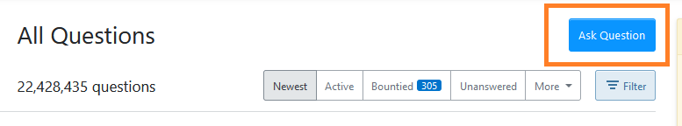

**HTML screenshot**

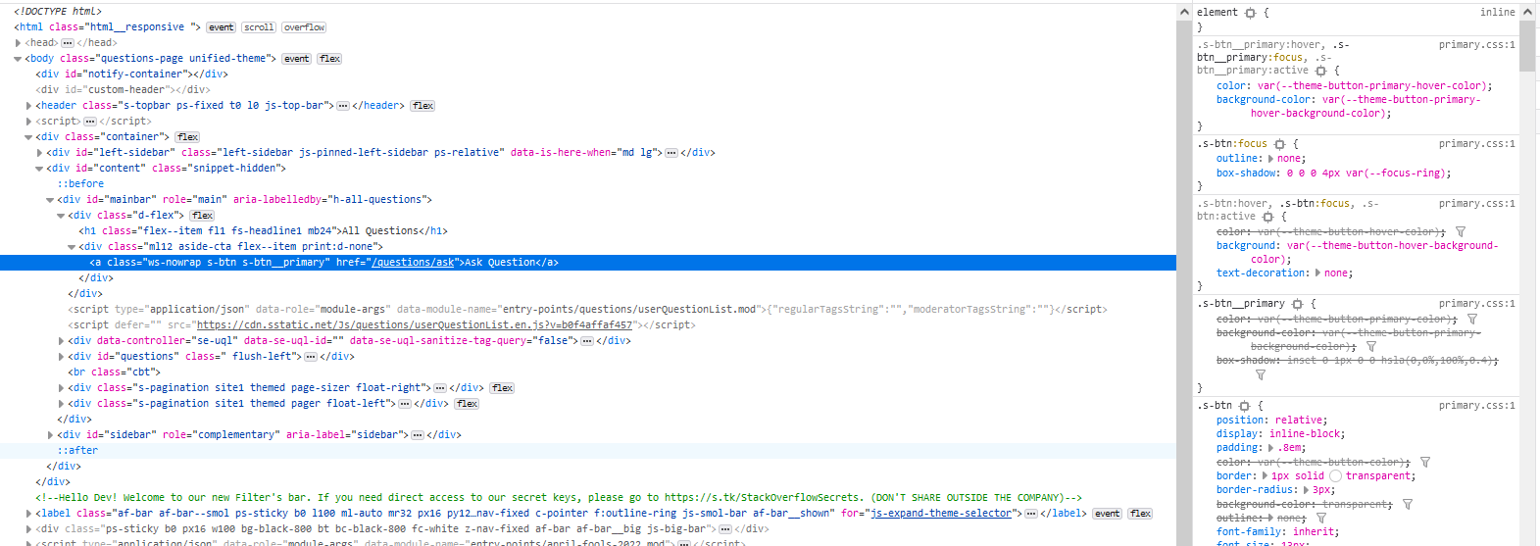

**DOM Locator**

document.getElementById("mainbar").children[0].children[1].children[0]

**CSS Locator**

#mainbar > div.d-flex > div > a

**xPath Locator**

/html/body/div[3]/div[2]/div[1]/div[1]/div/a

**UI screenshot**

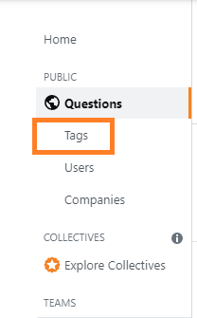

**HTML screenshot**

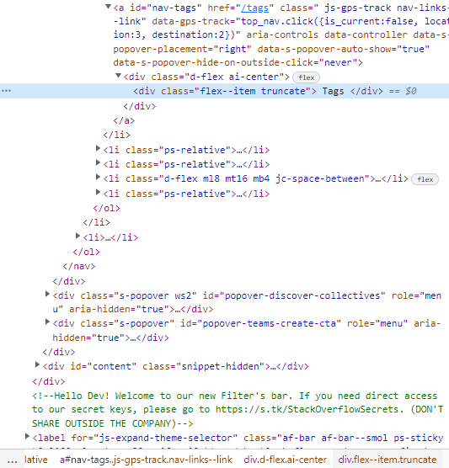

**DOM Locator**

document.getElementById("nav-tags").children[0].children[0]

**CSS Locator**

#nav-tags > div > div

**xPath Locator**

/html/body/div[3]/div[1]/div[1]/nav/ol/li[2]/ol/li[3]/a/div/div

**UI screenshot**

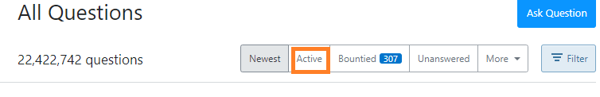

**HTML screenshot**

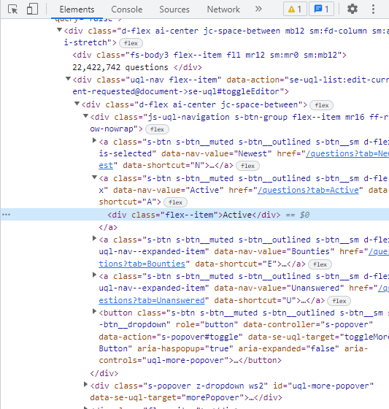

**DOM Locator**

document.getElementById("mainbar").children[3].children[0].children[1].children[0].children[0].children[1].children[0]

**CSS Locator**

#mainbar > div:nth-child(4) > div > div.uql-nav.flex--item > div > div.js-uql-navigation.s-btn-group.flex--item.mr16.ff-row-nowrap > a:nth-child(2) > div

**xPath Locator**

/html/body/div[3]/div[2]/div[1]/div[2]/div/div[2]/div/div[1]/a[2]/div

**UI screenshot**

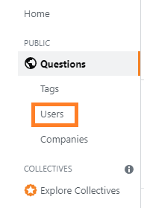

**HTML screenshot**

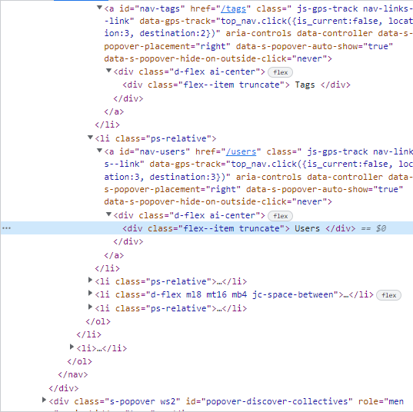

**DOM Locator**

document.getElementById("nav-users").children[0].children[0]

**CSS Locator**

#nav-users > div > div

**xPath Locator**

/html/body/div[3]/div[1]/div[1]/nav/ol/li[2]/ol/li[4]/a/div/div