**D.Y. PATIL COLLEGE OF ENGINEERING & TECHNOLOGY, KOLHAPUR**

**(An Autonomous Institute)**



**DEPARTMENT OF CSE (DATA SCIENCE)**

A

Synopsis Report

on

**“ Design Of Experiments(DOE)”**

Submitted by

|  |  |
| --- | --- |
| **Name** | **Roll No.** |
| Farahan Farid Shaikh | 02 |
| Shreyash Suresh Patil | 72 |
| Aakash Raju Mohole | 73 |
| Vinayak Dilip Vathare | 74 |
|  |  |

**Under the guidance of**

**Mrs. T . V Deokar**

**Third Year B. Tech. CSE (Data Science)**

**Academic Year 2024-25**

**INDEX**

|  |  |  |
| --- | --- | --- |
| **Sr. No.** | **Topic** | **Page Number** |
| **1.** | **Abstract** | **1** |
| **2.** | **Introduction** | **2** |
| **3.** | **Problem Definition**   1. **Problem Statement** 2. **Objectives** | **3** |
| **4.** | **System Design**   1. **System Architecture** 2. **Flowchart** | **4** |
| **5** | **Experimental Setup** | **5** |
| **5.** | **References** | **6** |

**ABSTRACT**

The DOE Mobile Application is a research-oriented platform designed to streamline the management of Design of Experiments (DOE) records. It enables users to efficiently search previous DOE experiments using multiple parameters and add new experiments to a structured database. By providing a centralized system for managing experimental data, the application improves accessibility, minimizes redundancies, and enhances decision-making efficiency.

This application is particularly beneficial for industries where experimentation and statistical analysis are essential, such as manufacturing, engineering, and scientific research. By integrating structured data input, optimized search algorithms, and secure authentication, the application ensures efficient data retrieval while maintaining data integrity. Ultimately, the DOE Mobile Application empowers professionals with a user-friendly interface to manage DOE records effectively and make informed, data-driven decisions.

**INTRODUCTION**

Design of Experiments (DOE)is a crucial methodology used in various industries such as manufacturing, engineering, and research. It enables professionals to analyze and optimize processes by determining the relationships between different variables and their impact on outcomes. However, managing and accessing past DOE data is often a challenge, leading to inefficiencies in decision-making.

The DOE Mobile Application aims to address this issue by providing a user-friendly platform that allows users to search previous DOE records and. The application will serve as a centralized system for DOE management, ensuring that researchers and professionals can retrieve relevant information quickly and effectively.

**PROBLEM DEFINITION**

1. **Problem Statement:**

Managing and retrieving past DOE data is challenging, causing inefficiencies and redundant experiments. A centralized, user-friendly platform is needed to store, search, and access DOE records for better decision-making.

1. **Objectives:**

This project, potentially sponsored by Zanvar's company, is aimed at transforming DOE data management with the following objectives:

1. Provide an intuitive and user-friendly interface for managing DOE records.
2. Enable users to retrieve experiments using required filters.
3. Facilitate structured data input for new DOE experiments.
4. Improve research efficiency by filtering data using parameters.
5. Ensure secure authentication and data privacy.
6. Optimize search algorithms for fast and accurate retrieval.
7. Allow dynamic modifications to experiment parameters before generating final results.
8. Improve usability through guided steps from home page to final results.

**SYSTEM DESIGN**

1. **System Architecture:**

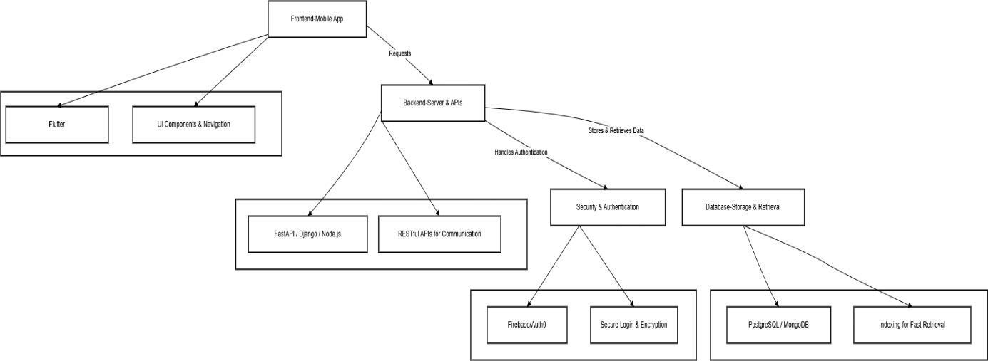

1. **Flowchart:**

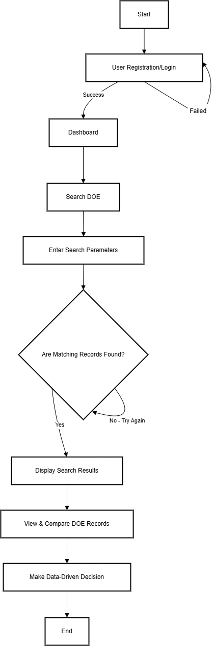

1. **Experimental Setup:**

Experimental setup includes -

The DOE Mobile Application is built using Flutter (Dart) for the frontend, Django for the backend, and NeonDB (PostgreSQL) for data storage.

* **Frontend:** Flutter (Dart), Provider (State Management), Dio (API Calls), Flutter Secure Storage.
* **Backend:** Django, Django REST Framework (DRF), Firebase/Auth0 (Authentication).
* **Database:** NeonDB (PostgreSQL) with indexing for efficient search and retrieval.
* **Data Processing:** Pandas, NumPy.

**REFERENCES**

|  |  |
| --- | --- |
| [1] |  |
| [2] | Author Names, “Paper Name”, Journal Name, Volume Number, Issue Number, Page Numbers, Publication Year |
| [3] | Author Names, “Paper Name”, Journal Name, Volume Number, Issue Number, Page Numbers, Publication Year |
|  |  |