

Merge Sort Algorithm
Team Member:
Sarou Menglong
Rin Sovandara
Choup Vannphyreak
Taing Tunvatnak
Doung Piphop
COSC 251- Data Structure
Professor, Sin Visethboti

1.Introduction

Sorting is an important topic in the computer science because many programs need to arrange data before it can be search, analysed, or displayed. In this project, our group choose to study Merge Sort, a classic sorting algorithm that use a divide and conquer approach. We implement Merge Sort along with three basic sorting algorithms such as Bubble Sort, Selection Sort, and Insertion Sort using Java by testing them on different dataset sizes and record measurement such as runtime, comparisons, and swap or movements.
2.Algorithm Explanation

Merge Sort is a divide-and-conquer sorting algorithm. Instead of comparing and swapping elements one at a time like Bubble Sort or Insertion Sort, Merge sort keep splitting the array in half each until each piece only has one element left. Then it merges those small pieces back together in the correct order, two pieces at a time, until the whole array is back together and fully sorted.
2.1. Step by Step Example
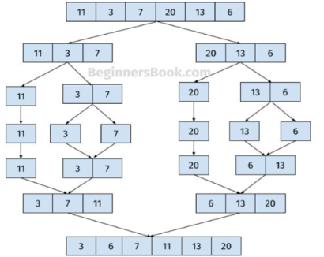

1.Divide Phase
- The main array is split down the middle into two halves: left [11, 3, 7] and Right [20, 13, 6]
- These halves are continuously split down until every element is in its own single-element list: [11], [3], [7], [20], [13], and [6]
2. Conquer and Merge Phase
- Sub-list is merged back together in sorted order step by step
- [3] and [7] merge into [3, 7], and then combine with [11] to form [3, 7, 11]
- On the right side, [13] and [6] merge into [6, 13], then combines with [20] to form [6, 13, 20]
3.Final Merge
- Finally, the left sorted sub-list [3, 7, 11] and the right sorted sub-list [6, 13, 20] are merged into one fully sorted array: [3, 6, 7, 11, 13, 20]
3.Time Complexity Analysis
Merge sort is much faster than basic sorting algorithms for large amount of data because of time complexity scales.
Case | Time Complexity | Explanation
Best Case | O (n log n) | Even if the array is already sorted, merge sort still divides it down and merge it back up, meaning it always takes the same systematic number of steps
Average Case | O (n log n) | On random data, the splitting take log n level of recursion, and each level, merging all the element take O(n) time
Worst Case | O (n log n) | The algorithm’s structure doesn’t change based on input order

4.Java Implementation

Java implementation lives in MergeSort.java, split into two methods: a public sorting () method that start the timer and kicks things off, and a private recursive sort () method that does the actual dividing. A separate merge () handles combining two sorted halve back together and also count comparison and swaps for performance tracking.
1.Splitting the array
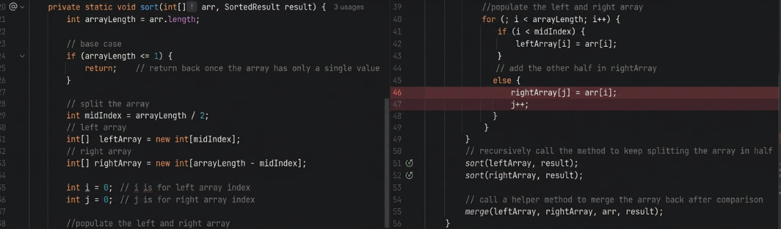
This method keeps calling itself on smaller and smaller arrays until array length is 1 or less, which is the base case that stops recursion.
2.Merging two sorted halve
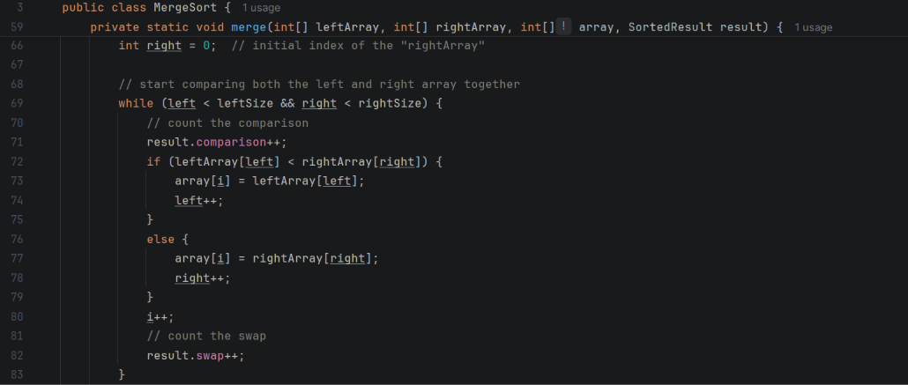
This loop compares the front of each half and place the smaller value into the main array first, moving forward one index at a time. Once one side run out, the rest of the other side just gets copied over since it’s already sorted.
3.Supporting classes
- DatasetGenertor.java: generate an array of random integer from 0 to 999,999 using fixed seed, so every algorithm is tested on exact same number
- SortedResult.java: a small class that store the comparison count, swap count, and runtime for one sort, and has a method to save all of that plus the sorted array into output file (.txt file).
- Main.java: run four algorithms such as Merge, Bubble, selection, Insertion on the same three dataset sizes and saves the result into text files under the output folder.
- BubbleSort.java, SelectionSort.java, InsertionSort.java: implement of three basic algorithms, written the same way, so the comparison is fair
5. Testing Methodology
All four algorithm, are tested on identical dataset. Main.java generates one random array per size using DataSetGenerator with a fixed seed, then clones the same array four times, one clone per algorithms so every algorithm sort exactly the same starting numbers.
We tested three dataset size as required:
- Small: 5 elements
- Medium: 1,000 elements
- Large: 1,000,000 elements
For each run, we record three metrics using the SortedResult class: number of comparisons, number of swap or movement, and runtime. All sorted output arrays are also saved to .txt file in the output folder so the result can be checked.
6. Performance Result
1.Small Dataset (n = 5)
Algorithm | Comparisons | Swaps | Runtime
Merge Sort | 6 | 12 | 5,000
Bubble Sort | 7 | 2 | 2,400
Selection Sort | 10 | 2 | 2,400
Insertion sort | 2 | 2 | 2,100

At this dataset, all four-algorithm finish in nanoseconds. Merge sort actually looks the slowest because of the overhead from recursion and create extra arrays, which is not worth it where there’s barely any data to sort.
2.Medium Dataset (n = 1000)
Algorithm | Comparisons | Swaps | Runtime
Merge Sort | 8,690 | 9,976 | 373,400
Bubble Sort | 497,960 | 242,099 | 3,394,700
Selection Sort | 499,500 | 995 | 1,841,200
Insertion sort | 242,099 | 242,099 | 1,851,1900
At the 1,000 datasets, Merge sort is clearly faster than all three algorithm and far fewer comparison overall about 8,690 compared to nearly half a million for Bubble and selection sort.
3.Large Dataset (n = 1,000,000)
Algorithm | Comparisons | Swaps | Runtime
Merge Sort | 18,673,487 | 19,951,424 | 176,428,900
Bubble Sort | 499,995,592,590 | 250,053,914,853 | 1,225,725,866,400
Selection Sort | 499,999,500,000 | 999,980 | 420,229,500,600
Insertion sort | 250,053,914,853 | 250,053,914,853 | 143,563,531,900

Bubble sort took about 20.4 minutes to finish, selection sort took about 7 minutes, and Insertion sort took almost 2.4 minutes, but Merge sort finished in just 176 milliseconds, which is 6,950 time faster than Bubble sort. Bubble sort also need 500 billion comparisons, while Merge sort only need about 18.7 million.
7. Comparison with Bubble Sort, Selection Sort, and Insertion Sort
1.Time Complexity Comparison
Algorithm | Best Case | Average Case | Worst Case | Space
Merge Sort | O (n log n) | O (n log n) | O (n log n) | O(n)
Bubble Sort | O (n) | O (n²) | O (n²) | O (1)
Selection Sort | O (n²) | O (n²) | O (n²) | O (1)
Insertion Sort | O (n) | O (n²) | O (n²) | O (1)

Merge Sorts O (n log n) stay efficient no matter the dataset size, while the other three are O (n²) in the average and worst case, which is they get much slower once n get bigger.

2.Runtime and Operations
Base on the output at the n = 1,000,000 Merge sort was about 6,950 time faster than Bubble sort, 2,380 times faster than Selection sort, and around 810 times faster than Insertion sort. The number of comparisons illustrate that, Merge sort require about 18.7 million comparisons, while Bubble and Selection Sort need about 500 billion.
3.Suitability by Dataset Size
Dataset Size | Best Choice | Explanation
small Dataset (n = 5) | Insertion Sort | very low overhead, no recursion or extra memory needed. Merge sort is actually wasted effort here
Medium Dataset (n = 1,000) | Merge Sort | Faster than the other 3 algorithm and the gap keeps growing
Large Dataset (n = 1,000,000) | Merge Sort | The fastest, the other 3 algorithm become slower.

8.Appropriate and Inappropriate Use Case
Merge sort is appropriated when a program needs predictable O (n log n) performance, especially for large datasets. It is also useful when stable sorting is important or when sorting can be performed in a way that works well with sequential data access.
Merge sort may be less appropriate when memory usage is a major limitation because the implementation create additional arrays during the sorting process. For a tiny array, a simple algorithm such as Insertion sort can be easier to understand and can perform well, especially when the data is already nearly sorted.
9. Real World Application
Merge sort is commonly used in database system and external sorting algorithms like sorting giant log files or record store on disk because predictable O (n log n) performance prevent the system from freezing up when handling huge amounts of data.
10. Conclusion
Overall, our testing confirmed that, Merge sort was slower than basic algorithm on the small dataset because of its overhead, but when the dataset size grew up to n = 1,000,000 element, it finishes about 176 milliseconds compare to over 20 minutes for Bubble sort.

11.Reference
Bro Code. (2021.). Learn Bubble Sort in 7 minutes [Video]. YouTube.
https://youtu.be/Dv4qLJcxus8?si=D8rqRq1VCK8s8PgA
Bro Code. (2021.). Learn Insertion Sort in 8 minutes [Video]. YouTube https://youtu.be/8mJ-OhcfpYg?si=-h211nkS0W7hOV2a
Bro Code. (2021.). Learn Merge Sort in 13 minutes[Video]. YouTube. https://youtu.be/3j0SWDX4AtU?si=d93IJ78oPNXy4Plo
Bro Code. (2021.). Learn Selection Sort in 8 minutes [Video]. YouTube https://youtu.be/EwjnF7rFLns?si=n07gMQvVW5Hm0Qu0
Codecademy. (n.d.). Time complexity of merge sort: A detailed analysis. https://www.codecademy.com/article/time-complexity-of-merge-sort
GeeksforGeeks. (n.d.). Merge sort – Data structure and algorithm tutorials. https://www.geeksforgeeks.org/merge-sort/
Interview Kickstart. (n.d.). Comparison among selection sort, bubble sort, and insertion sort. https://www.interviewkickstart.com/learn/comparison-among-bubble-sort-selection-sort-and-insertion-sort

