Menu_GUI Ultimate Guide: Installation, Usage, and Support

Recipe_Management_Tool_Version : RMT.A.00.02

Introduction
Welcome to MenuGUI, an innovative and user-friendly graphical interface meticulously designed to streamline recipe management. With its powerful array of tools, MenuGUI empowers users to efficiently handle every aspect of their culinary creations, from ingredient editing to interactive image integration. The program places a strong emphasis on efficiency and flexibility, allowing users to create, modify, and visualize recipe information with unparalleled ease.
In today’s fast-paced culinary world, having a reliable tool to manage recipes is essential. MenuGUI addresses this need by providing a comprehensive platform where home cooks and professional chefs alike can refine their recipes. The program supports transparent image loading, ensuring that visuals complement the textual information without distracting backgrounds. Additionally, MenuGUI incorporates customized ingredient handling, allowing users to adapt the program to various cooking processes and personal preferences. Whether you're refining recipe details, adjusting quantities, or organizing ingredients, MenuGUI offers intuitive controls tailored to meet a diverse range of culinary needs.

Key Features

Ingredient Editing
MenuGUI allows users to effortlessly modify ingredient quantities and attributes. Whether adjusting measurements for a single serving or scaling up for a larger gathering, the interface ensures that changes are both quick and straightforward. This feature is designed to save time and reduce errors in recipe preparation.

Interactive Image Loading
One of the standout features of MenuGUI is its ability to load and display images seamlessly. Users can easily integrate visuals into their recipes, with options for resizing and adjusting transparency. This not only enhances the visual appeal of recipes but also aids in the identification of ingredients and finished dishes.

Audio Integration
To further enrich the user experience, MenuGUI includes audio cues for specific actions. This feature enhances recipe engagement by providing auditory feedback, making it easier for users to follow cooking instructions and ensuring that no crucial steps are overlooked.

Advanced Synchronization
MenuGUI boasts advanced synchronization capabilities, automatically updating corresponding values, such as the duration and induction time. This feature streamlines tracking and enhances accuracy, allowing users to maintain consistency in their cooking processes without the hassle of manual adjustments.
MenuGUI is ideal for users seeking a reliable and accessible tool to manage, refine, and innovate their culinary processes. Its comprehensive feature set makes it an essential addition to any recipe toolkit, providing a perfect blend of functionality and user-friendliness.

System Requirements

Operating System
- Windows: MenuGUI is designed to run on Windows operating systems. Please ensure that your system meets the following version requirements:
  - Windows 10 or later is recommended for optimal performance and compatibility.

Additional Libraries
To ensure the smooth functioning of MenuGUI, the following libraries are required:
- PIL (Python Imaging Library): This library is essential for image processing tasks, enabling the program to load, manipulate, and display images efficiently.
- Tkinter: Serving as the backbone of the graphical user interface, Tkinter provides the necessary components for building interactive elements, making it easier for users to navigate and utilize MenuGUI.

Python Environment
- Python Version: MenuGUI is compatible with Python 3.x. Ensure that your environment is set up with the appropriate version to run the program smoothly.

Recommended Hardware
- A modern computer with at least 4GB of RAM is recommended for optimal performance, especially when handling large recipe collections or high-resolution images

Steps to Use MenuGUI
Main Window:
Upon launching MenuGUI, you will be greeted with the main window featuring a clean and organized layout. The interface includes sections for ingredient management, image display, audio settings, and recipe details.
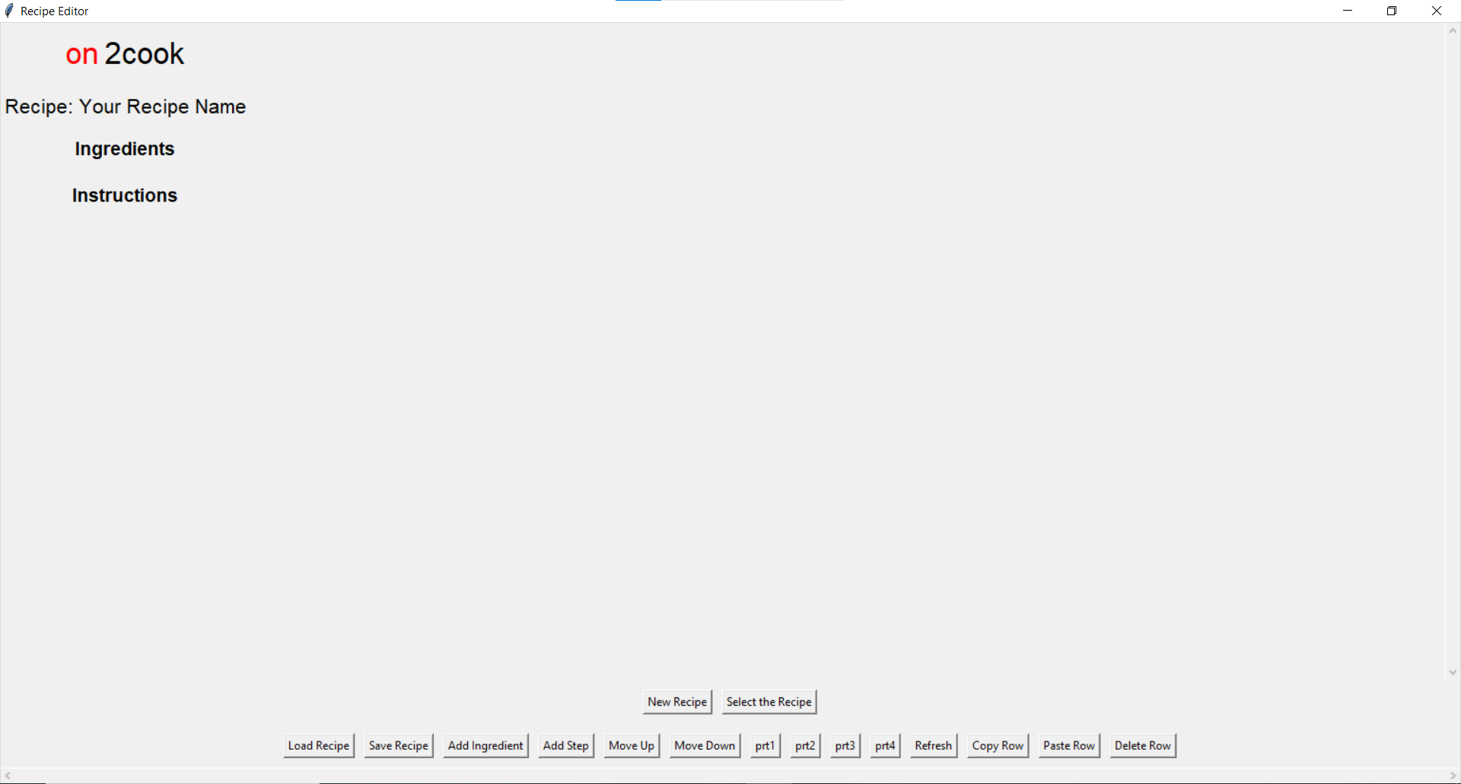

Recipe Selection:
- After launching the exe you can see various buttons on the bottom of the window, there you can see the ”load recipe” option, on clicking on the button you will be navigated to select the file from your pc, Recipe could in .txt,.zip or .json only.
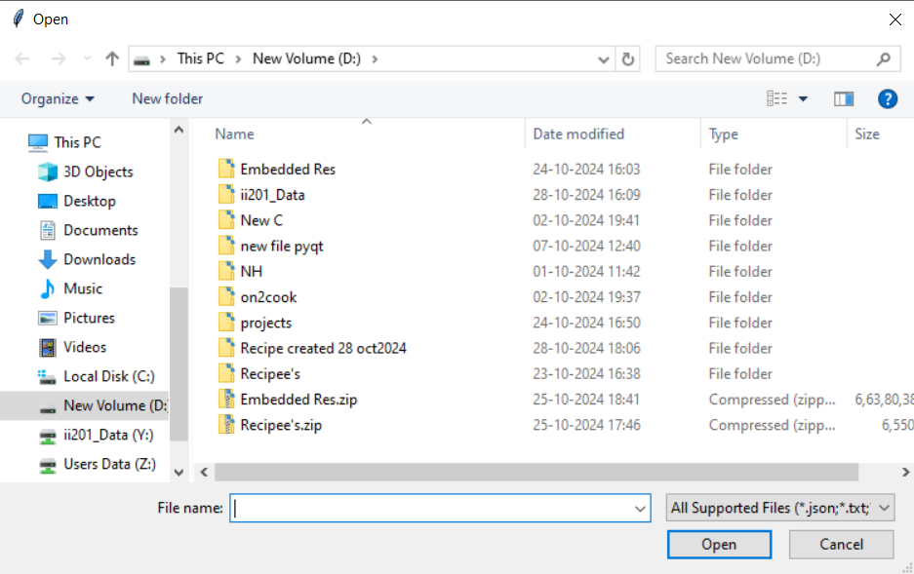

- Choose the recipe you want from your pc
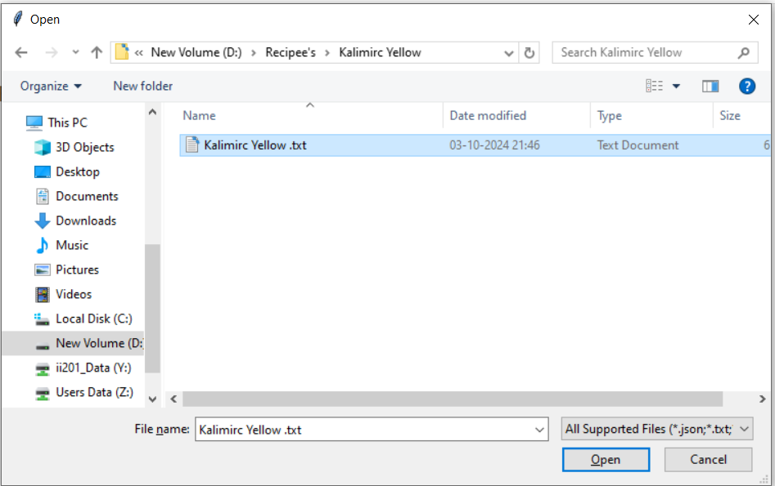
- Click on the open, and you will see the two tables, ingredients and instruction table with all the loaded values given
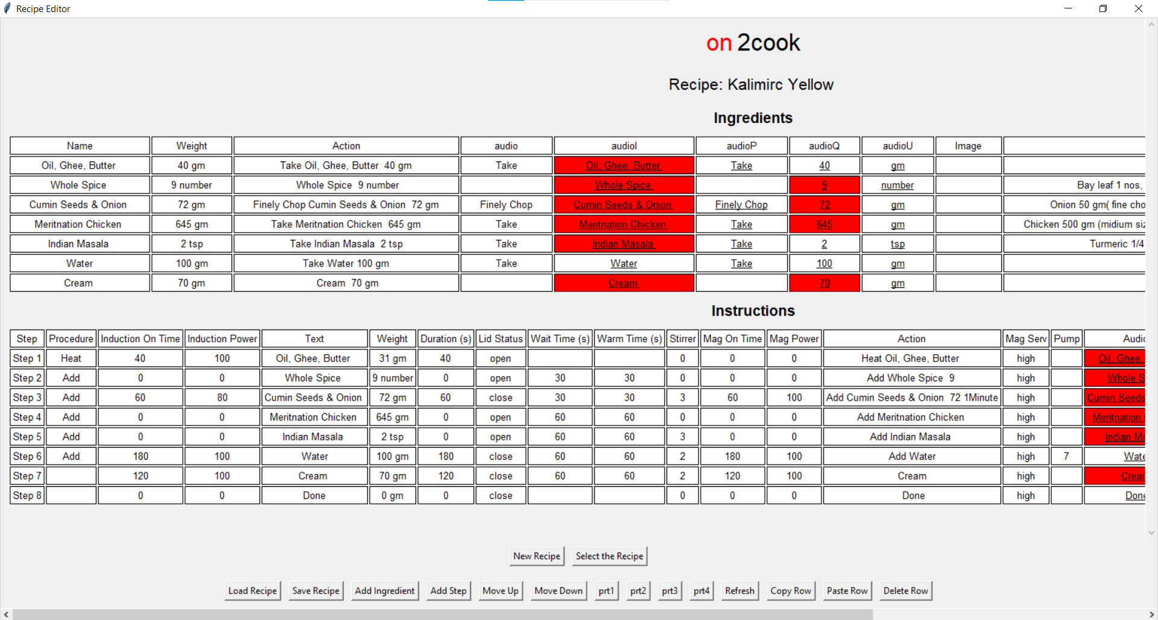
- You can scroll the menu up and down and left and right with the help of the scrollbars given in the bottom and right side of the window
- The cells whose values are underlined are all the playable cells which means it plays a sound when you click on and it would turn green if it has an mp3 audio file for the same.
- The cells represented in red are those that do not have an mp3 file and cannot play anything, and if you have the file for it and want to store an mp3 file for it, double left-click on that red cell. Click on the yes to add the file. And give the path for the same .

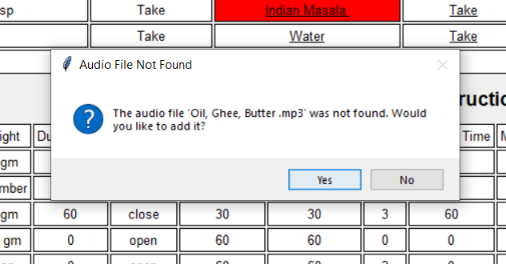

- .To edit the value of any cell in the table except the header, double-click in the cell you can manually edit those things.

Adding a New Instruction Step
- Click the "Add Step" button in the bottom button bar
- A new row will appear at the bottom of the instructions table
- Double-click each cell in the new row to enter the instruction details:
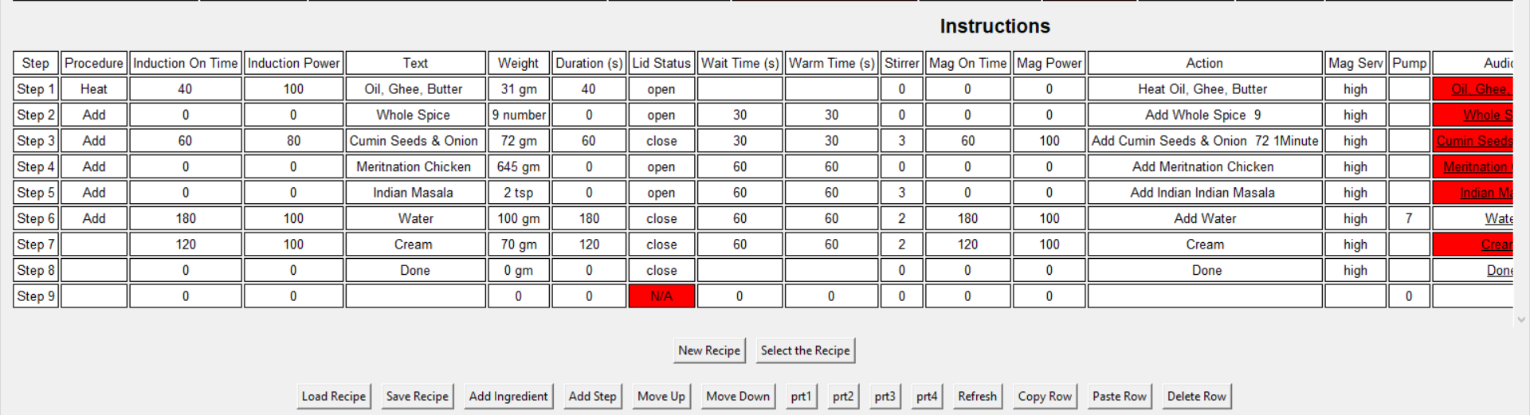
Adding a New Ingredient
- Click the "Add Ingredient" button in the bottom button bar
- A new row will appear at the bottom of the ingredients table
- Double-click each cell in the new row to enter the ingredient details:

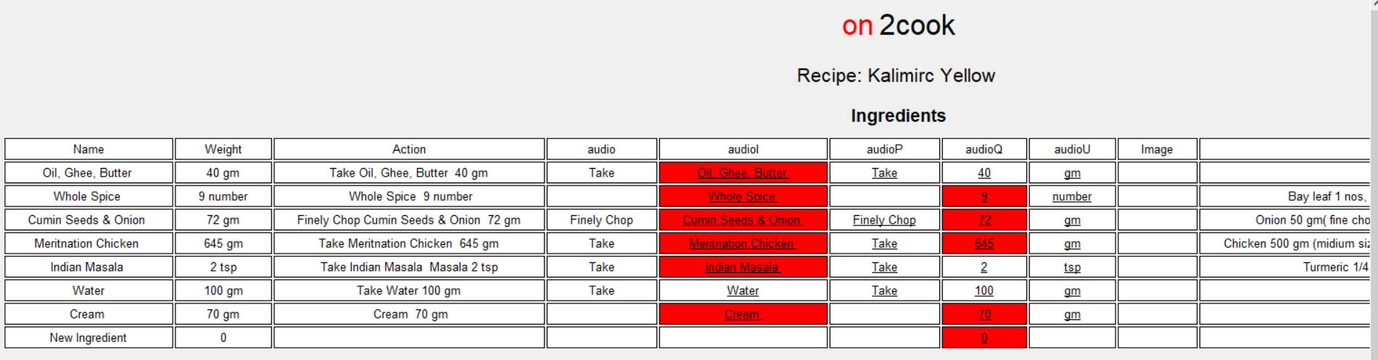
- To move any step up or down in the instruction table to perform that step before or after something you can select the step you want to move by long right-click press on the step and the selected row will turn yellow and then you can click on the ‘Move up’ or ‘Move down’ depending upon the change you want after the movement is done deselect the row by again long right-click place on the same row and you see the colour changes to white again.
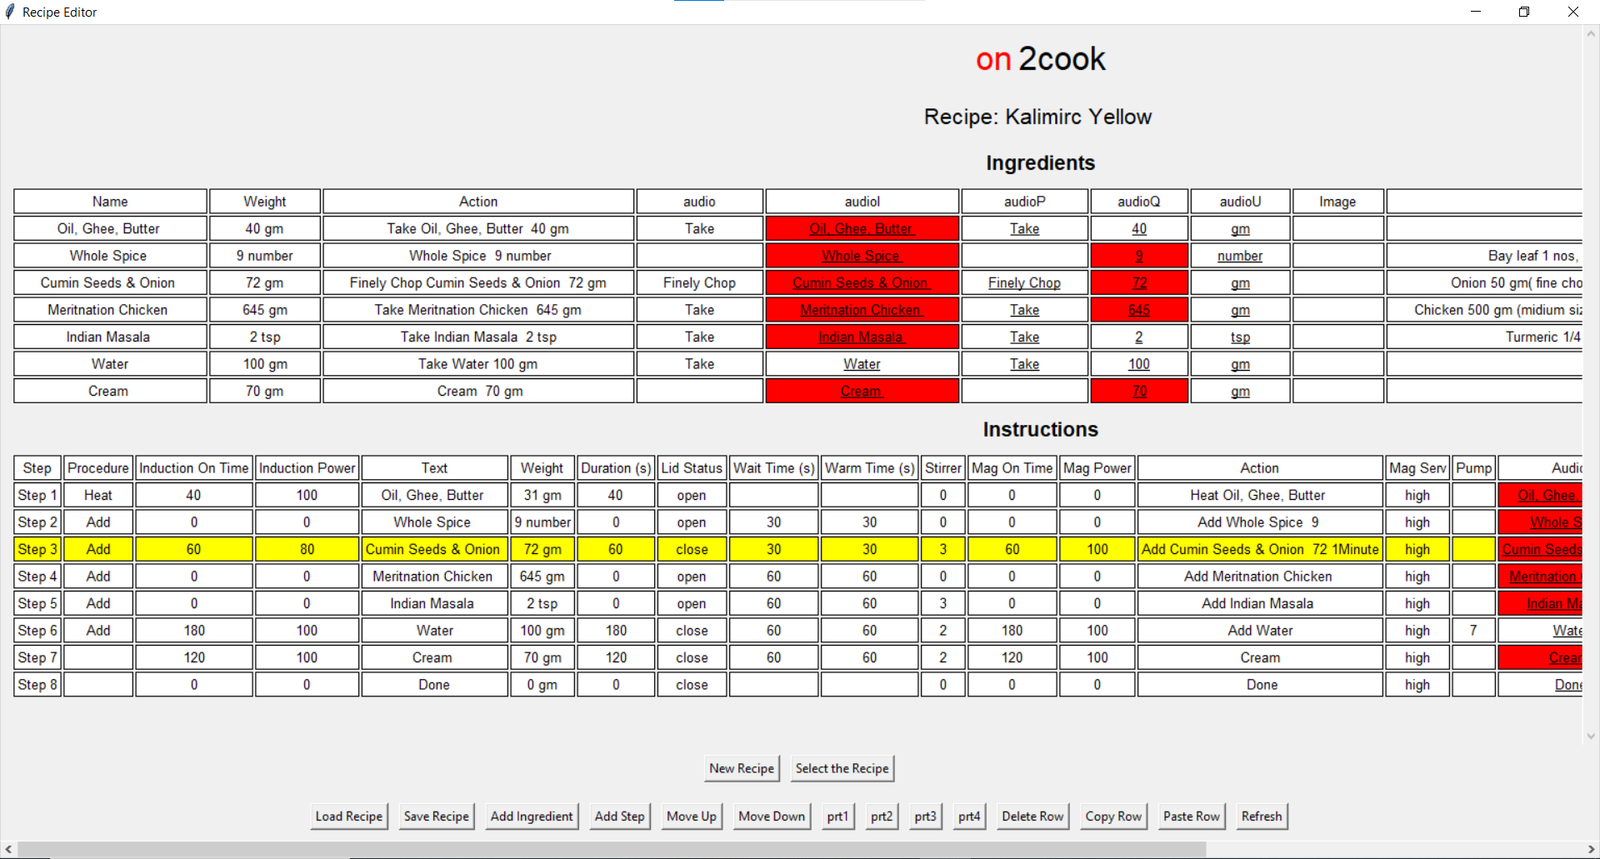
- Move up

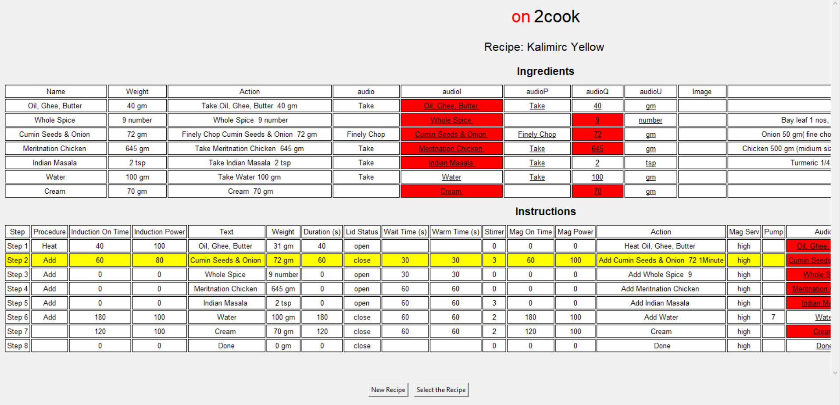

- Move down
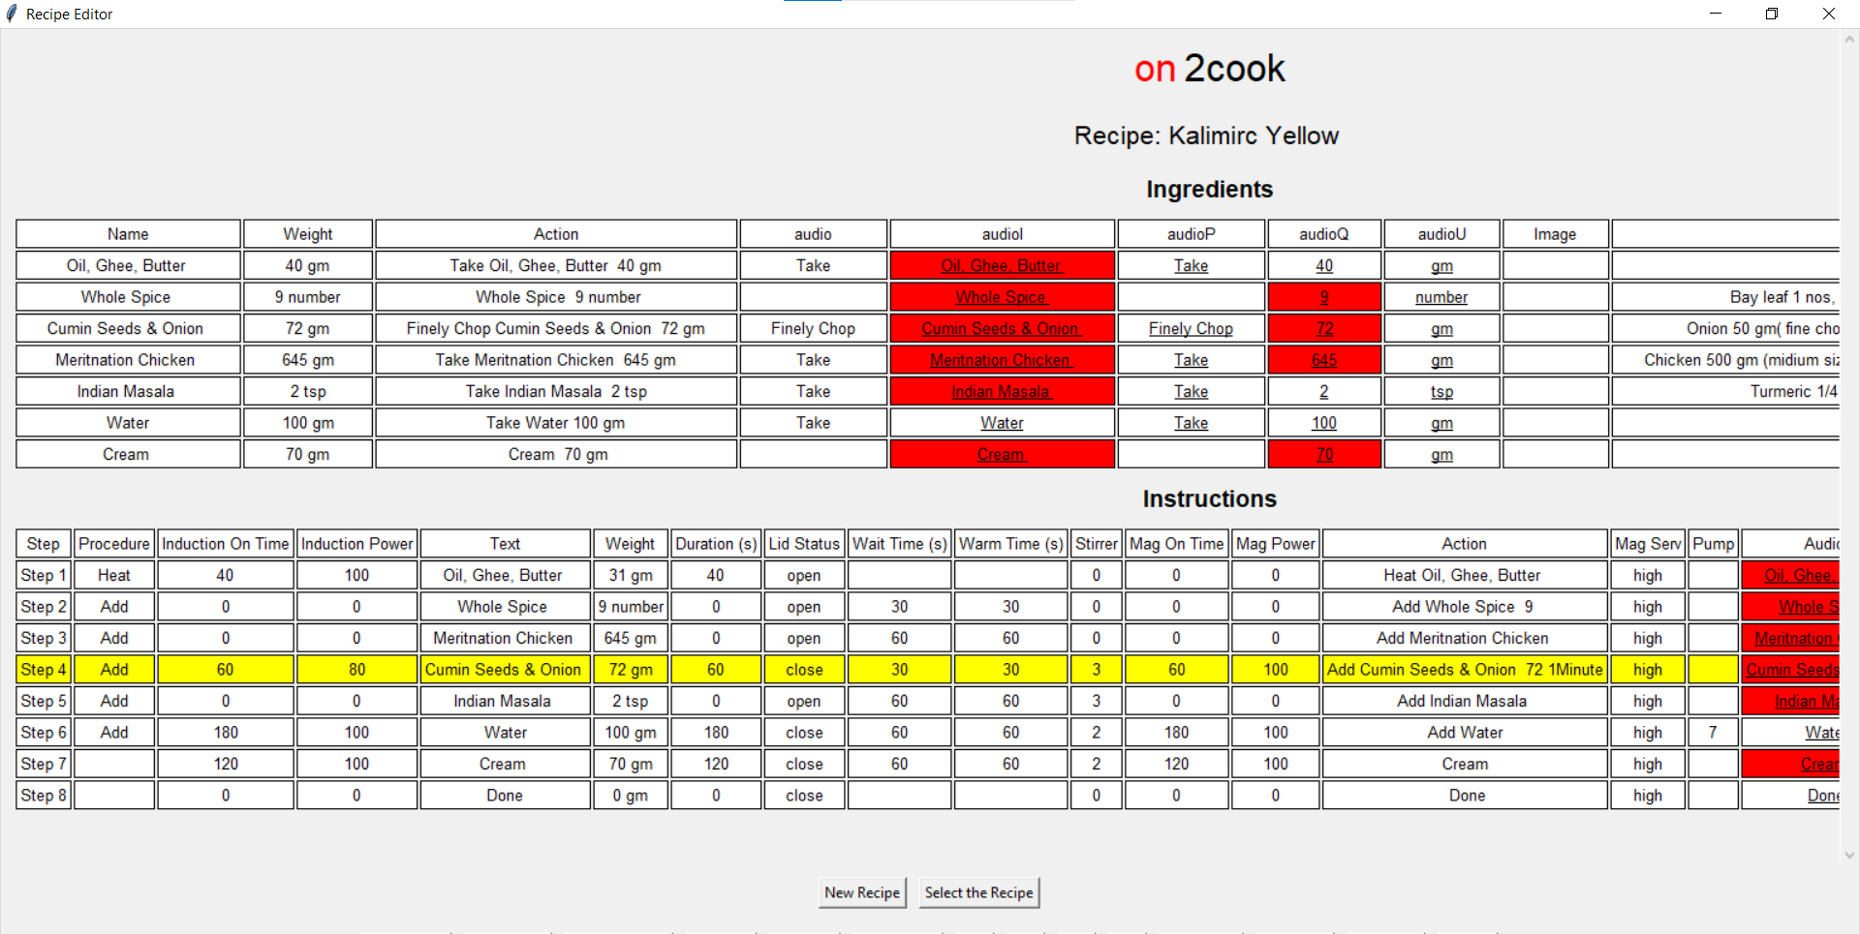
Deleting an Row
- Right-click (or long-press) on the row you want to delete
- The entire row will be highlighted, indicating it's selected
- Click the "Delete Row" button in the bottom button bar
- Confirm the deletion if prompted
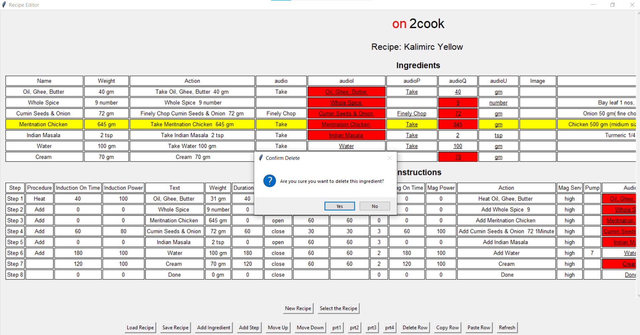

Copying and Pasting Row
To copy:
- Right-click (or long-press) on the row you want to copy
- Click the "Copy Row" button
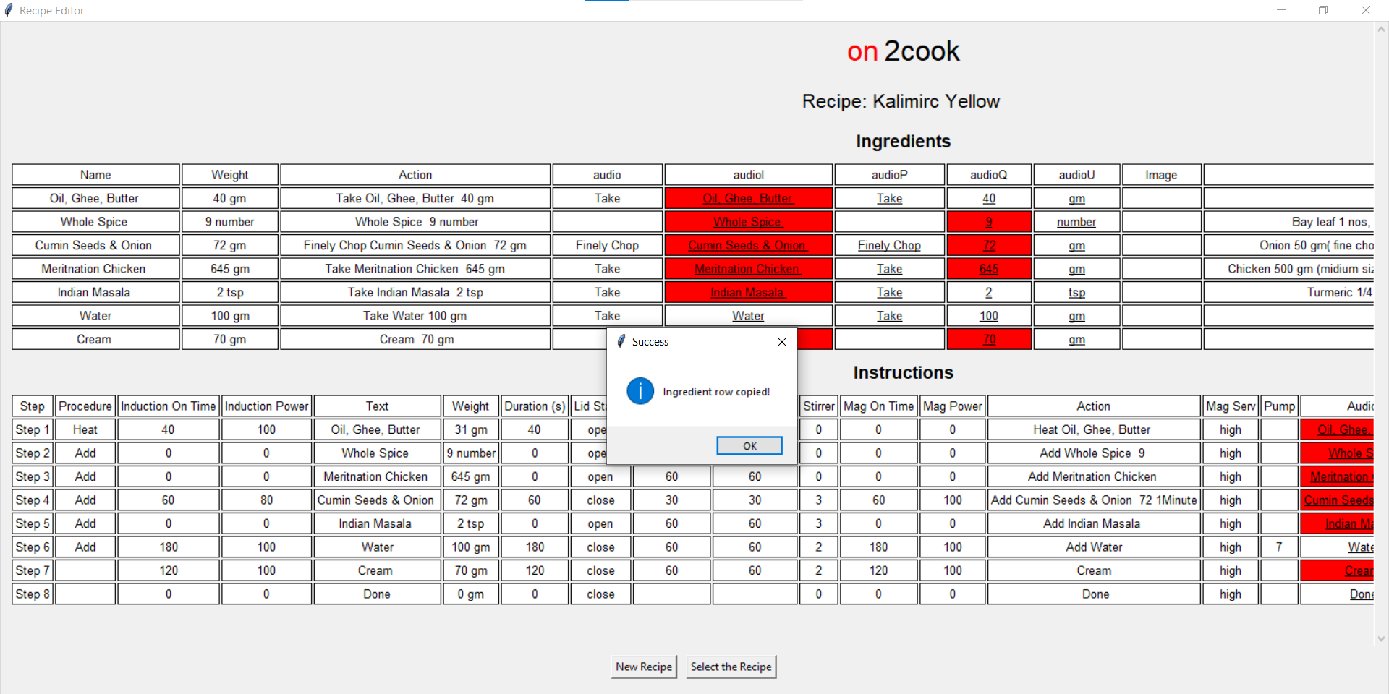
To paste:
- Right-click (or long-press) on the row where you want to insert the copied row , thr row would be pasted just below that .
- Click the " Paste Row" button
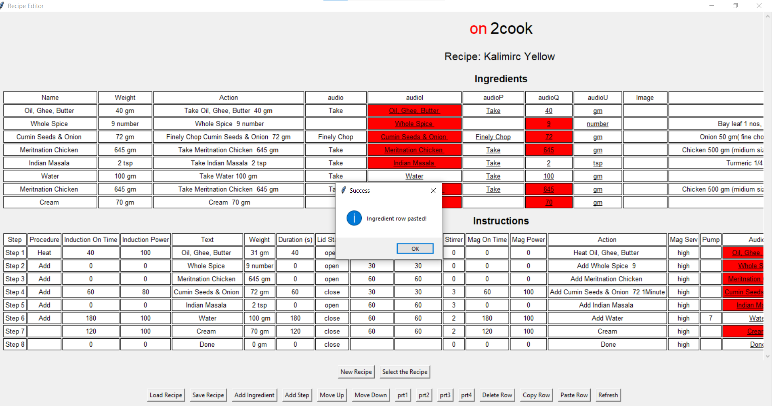

Data Validation and Error Handling
The application automatically checks for invalid entries in certain fields:
- Stirrer values: Must be between 0 and 4
- Magnetron power: Allowed values are 0, 20, 40, 60, 80, 100
- Lid status: Must be either "open" or "close"
- Induction power: Must be between 0 and 100, in steps of 10
- Skip values: Must be either "true" or "false"
Understanding Error Highlights
- Invalid entries will be highlighted in red
- Double-click on the highlighted cell to edit and correct the value
Correcting Invalid Entries
- Double-click on the highlighted cell
- Type the correct value
- Press Enter or click outside the cell to save the changes
Using PRT Buttons
- The PRT buttons (prt1, prt2, prt3, prt4) are customizable for specific actions
- These buttons can be programmed to perform various tasks based on your needs
Refreshing the Display
- Click the "Refresh" button to update the display and recheck for errors
- This is useful after making changes to the recipe or when encountering unexpected behaviour
Customizing the Application (if applicable)
- Depending on the version or configuration of the application, you may have options to customize certain aspects
- Refer to the specific documentation or support resources for more information

Saving and Exporting Recipes
Saving Changes to a Recipe
- Click the "Save Recipe" button in the bottom button bar
- Choose a location and filename in the save dialog
- Click "Save" to export the recipe as a txt file
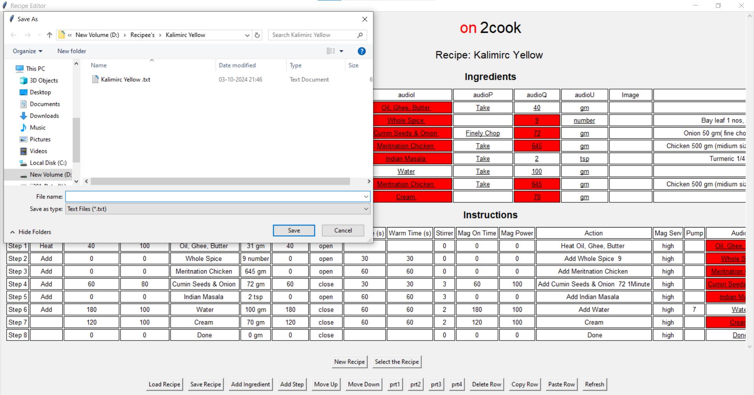
- Add the recipe name according to the name you want to save it
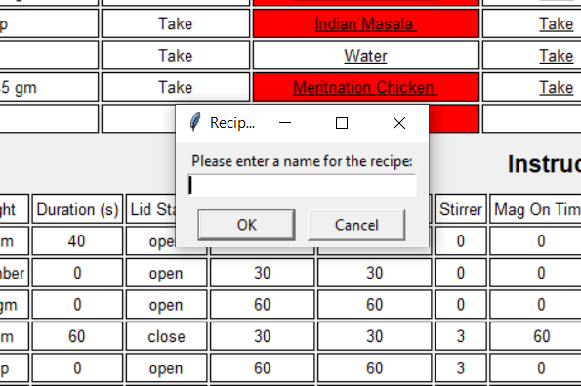

Troubleshooting

