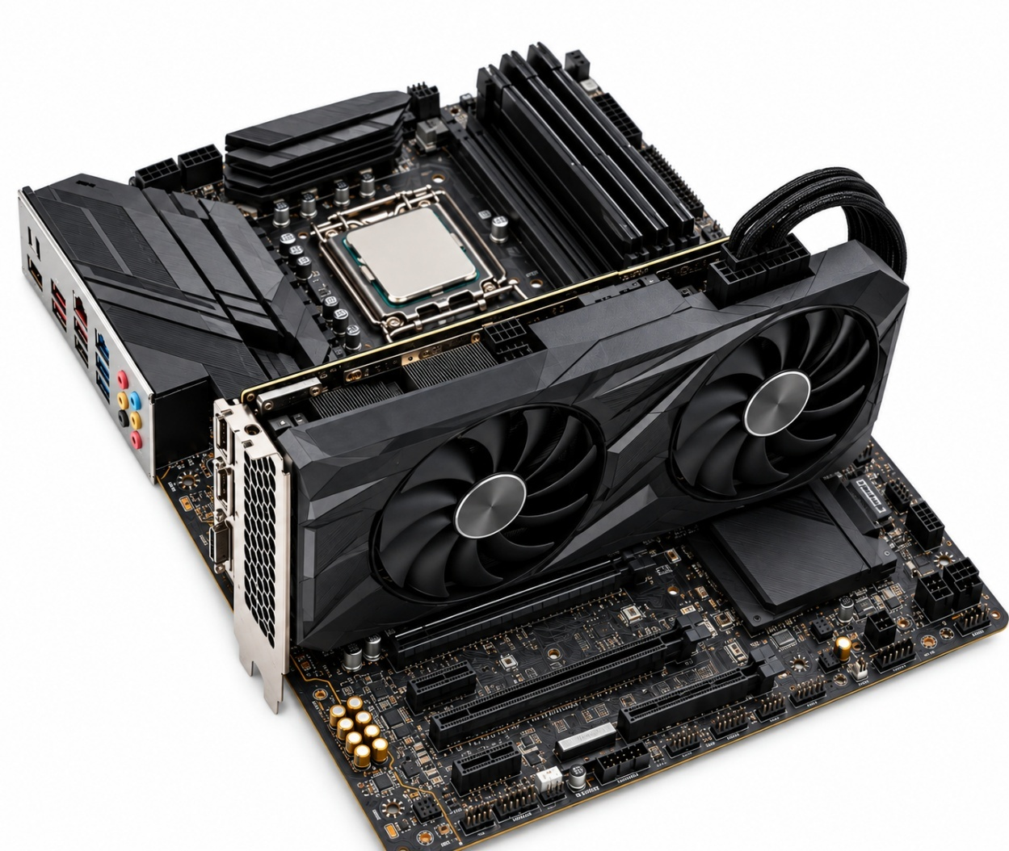
Motherboard
GPU
CPU
RAM

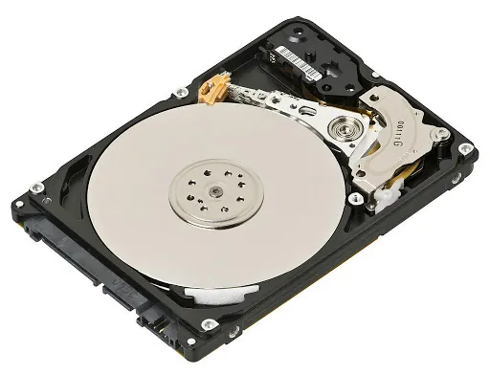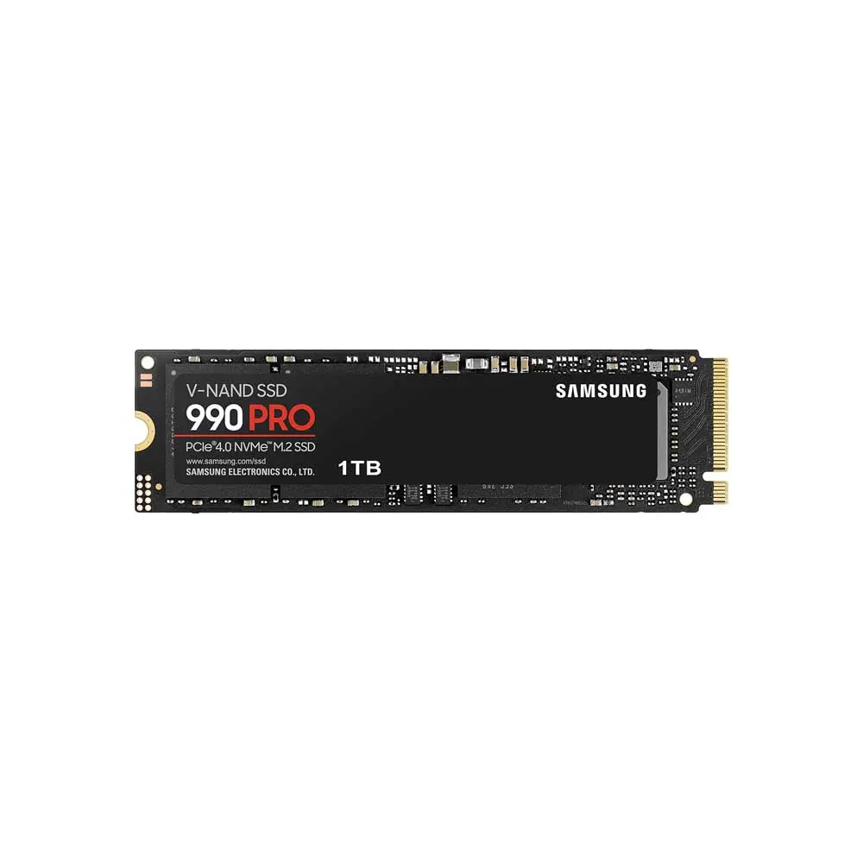
HDD SDD
Task-2
Difference Between HDD and SDD

Feature HDD SDD
Technology Use spinning magnetic disk Use flash Memory
Speed Slower Faster
Boot time Longer Very Short
Durability Less Durable due to moving parts More Durable
Noise Make some Noise Make no Noise
Price Cheaper per GB Expensive per GB

Task-3
CPU
The CPU (Central Processing Unit) handles the main calculations and game logic, such as player movement,
A faster CPU helps the game run smoothly and respond quickly to your actions.
Ram
Ram (Random Access Memory) temporarily stores the game’s data while it is running.
More RAM allows PUBG or Free Fire to load game files, maps, and background tasks efficiently, reducing lag and slowdowns.
GPU
The GPU ( Graphics Processing Unit ) renders the game’s visuals, including characters, textures, lighting A powerful GPU allows higher graphics quality and smoother frame rates (FPS).

Task-4

Graphics Card (GPU): I would upgrade the GPU because it handles the game’s graphics, textures, lighting, and visual effects.
Processor (CPU): A faster CPU would help the game process player movements, physics, and other calculations more smoothly.
RAM: I would upgrade the RAM if the PC has less than 12 GB, because sufficient RAM helps the game and other background programs run without slowdowns.
Storage (SSD): I would use an SSD with at least 100 GB of free space for the game. An SSD can also make game loading and startup much faster than a traditional HDD.

