**Practical – 1**

**(i) Aim: Find mean, median, and mode of the list [10, 12, 19, 20] using Python.**

**Code:**import numpy as np

import pandas as pd

data = [10,12,19,20]

print(np.mean(data))

print(np.median(data))

print(pd.Series(data).mode())

**Output:**

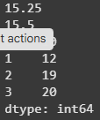

**(ii) Aim: Find mean, median, and mode of the 'cylinders' column from the Auto MPG dataset.**

**Code:**

# data_url = "/content/sample_data/Vatsal_costum_data/auto-mpg.csv" #dataset local ploaded

data_url = "https://archive.ics.uci.edu/ml/machine-learning-databases/auto-mpg/auto-mpg.data"

column_names = ["mpg", "cylinders", "displacement", "horsepower", "weight", "acceleration", "model year", "origin", "car name"]

df = pd.read_csv(data_url, names = column_names , delim_whitespace= True, na_values= "?")

print(df.head(10))

mean_cylinders = df["cylinders"].mean()

median_cylinders = df["cylinders"].median()

mode_cylinders = df["cylinders"].mode()

print("Mean of cylinders: ", mean_cylinders)

print("Median of cylinders: ", median_cylinders)

print("Mode of cylinders: ", mode_cylinders[0])

**Output:   
  
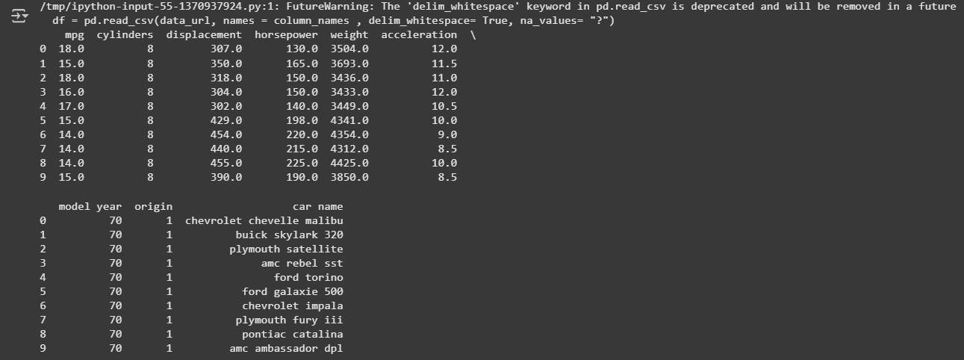**

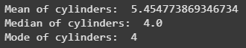

**Conclusion :**

Here, In the lab we discussed about the auto_mpg dataset and we calculated the mean, median, mode of the Cylinders. In which mean came out to be (5.45), median value was 4, mode was 4, This suggest that the average no of cylinders for car is 4-cylinder engines.